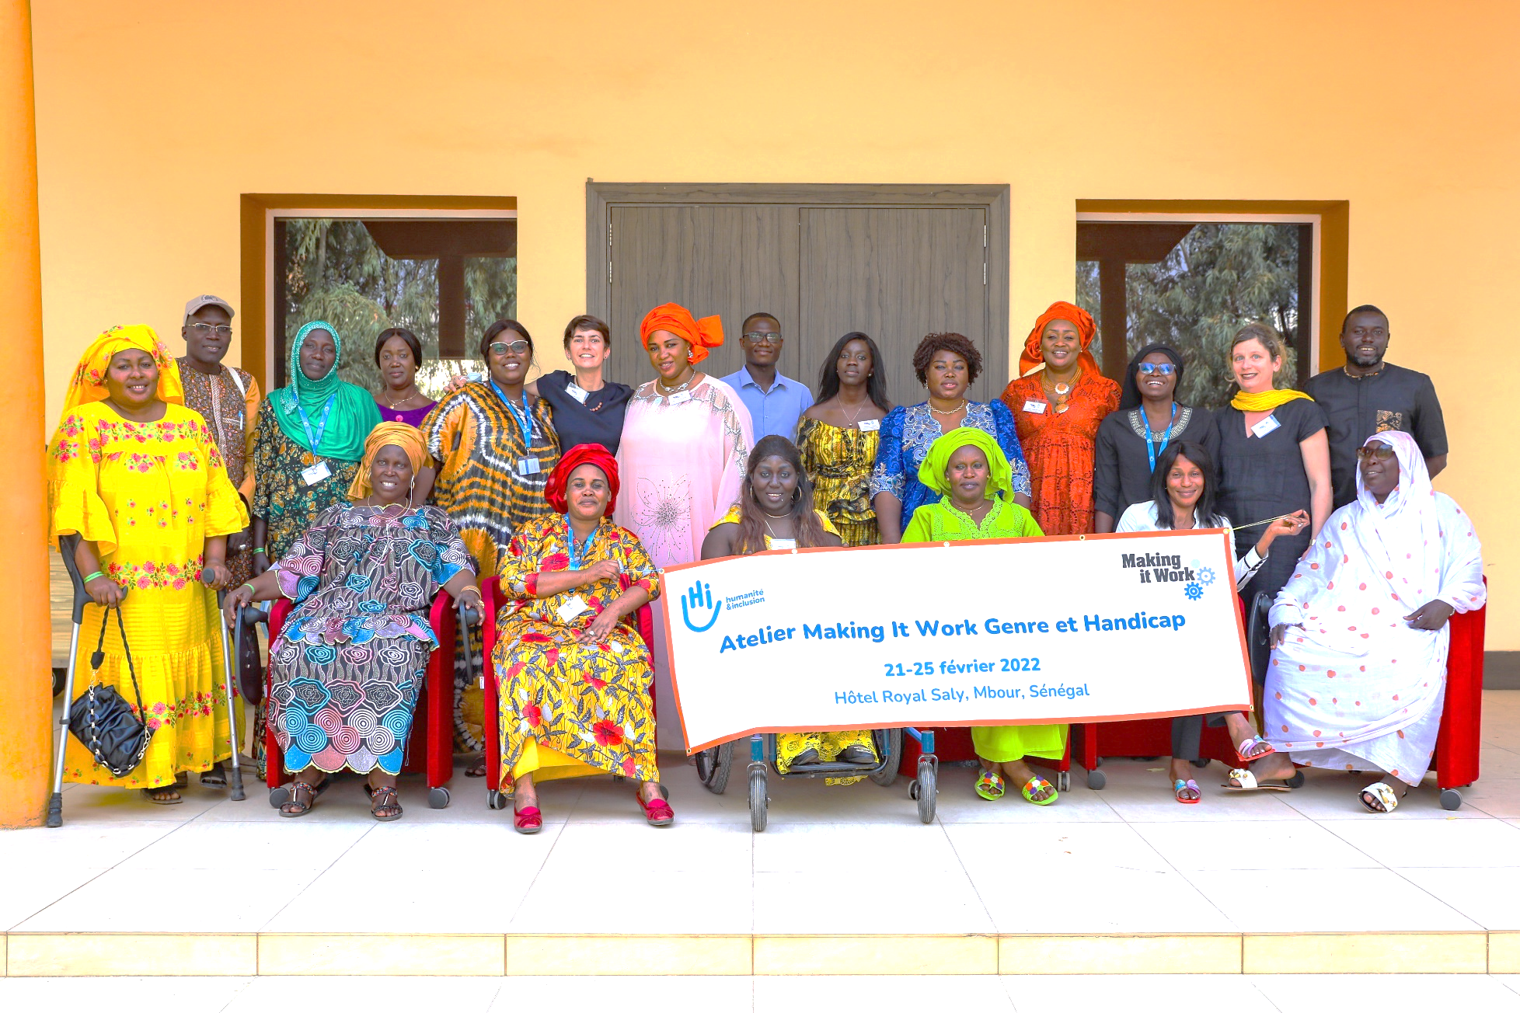

**Lessons Learned**

**Leadership of women with disabilities: strategies to combat violence in West Africa**

**Protection and Risk Reduction Division  
November 2022**



**LL I n**° 19





**Authors**

Sophie Pecourt

Anne-Constance Rossignol

(Making It Work)

**Contributors**

Sosthène Aguidissou

Couna Gueye

Faith Lemon

**A Humanity & Inclusion publication**

Protection and Risk Reduction division

**Editing & layout**

Stéphanie DEYGAS ‒ Innovation, Impact & Information Division

**Photo credits**

Cover: Group picture at the Making It Work workshop in Senegal © Fran6Concept, Senegal, 23 February 2022

Page inside : : Group picture at the Making It Work workshop in Benin © HI/A-C. Rossignol, Benin, 7 July 2022

**Rights and Licenses**

[Logo of the Creative Commons License which protects the content of this document](http://creativecommons.org/licenses/by-nc-nd/4.0/)

This work is available under the Creative Commons Attribution-NonCommercial-NoDerivatives 4.0 International license (CC BY-NC-ND 4.0). Under the Creative Commons-NonCommercial-NoDerivatives license, you are free to copy, distribute, and transmit this work, for noncommercial purposes only, under the following conditions:   
**Attribution-**Please cite the work as follows: Sophie Pecourt, Anne-Constance Rossignol (Making It Work). Leadership of women with disabilities: strategies to combat violence in West Africa. Lyon: Humanity & Inclusion, November 2022. License: Creative Commons Attribution-NonCommercial-NoDerivatives 4.0 International (CC BY-NC-ND 4.0). **Noncommercial-**You may not use this work for commercial purposes. **No Derivative Works-**You may not alter, transform, or build upon this work.

**Table of contents**

Foreword: “A place is up for grabs!” by Dieynaba Diallo 5

Introduction 7

The long way to inclusion 7

Engagement of women with disabilities in the post-covid era 7

Latest developments of MIW in 2022 8

At a glance : good practices 2022 9

Gender based violence against women and girls with disabilities 10

Define to better combat 10

A. Prevention of gender-based violence 11

A.1 Awareness 11

A.2 Eliminating Root Causes and Contributing Factors to Risk 12

A.3 Empowerment of women and girls 12

B. Response to gender-based violence 12

C. Involving all stakeholders: the ecological model 13

Good practices 2022 15

1. Active listening by peers at the Pikine Est Listening Center -Association des Handicapés de Pikine Est (AHPE) - Senegal 15

2. Improving access to sexual and reproductive health services (SRH) for women and girls with disabilities in Thiès - The Women’s Unit of Handicap FormEduc (HFE) - Senegal 18

3. Inclusive mechanisms to combat GBV and promote the rights of women and girls with disabilities - Community Brigade for the Awareness and Denunciation of Human Rights Violations – Ziguinchor, Senegal 21

4. Women's rights with a capital W: creation of a feminist and inclusive platform in Thiès - Platform for women leaders - Senegal 24

26

5. Girls’ Club: discussions and intergenerational transmission between women and girls with visual disabilities – The Organisation of Blind Women of Benin (OFAB) - Benin 27

Context 27

6. The empowerment of women with disabilities through access to microcredit, NGO Dédji, Benin 30

7. Women leaders with disabilities alongside women and girls with disabilities in rural areas, NGO Bartimée 33

8. Promising practice: Women with disabilities and mothers working together for the well-being of children with disabilities in the community, Parakou Centre for Social Advancement 1 and Madihatou Mohamed (a volunteer) - Benin 36_Toc120224701

Appendix: The Making It Work Methodology 39

What is the MIW methodology? 39

What is a good practice in MIW? 39

How did we use the MIW methodology in this project? 40

# Foreword: “A place is up for grabs!” by Dieynaba Diallo

Dieynaba DIALLO is a staunch advocate of the rights of women and girls with disabilities. She is the coordinator of the Regional Coalition of WiLDAF (Women in Law and Development in Africa), Communications Officer of the Fédération Sénégalaise des Associations de Personnes Handicapées (Senegalese Federation of Disabled Persons Associations) for the Thiès region, and was elected Regional President of RENAFES, the Réseau des Femmes Travailleuses du Sénégal (Network of Women Workers of Senegal) in 2022.

Today in West Africa, women with disabilities are fighting back and are increasingly present in feminist organisations and decision-making bodies; yet they are still subject to a huge amount of violence and discrimination, some of which is linked to harmful practices.

This report by the Making it Work project highlights these difficulties, the strategies that must be strengthened, and the actions that must be taken to improve the living conditions of women and girls with disabilities.

Despite all this, not enough action has been taken by women with disabilities in West African countries. Women with disabilities are grouped into committees or sections in umbrella organisations led by men, which keeps them away from the decision-making process. We must have independent women’s organisations in each country and must work on how we can network and connect our organisations.

What about leadership? This is still a major challenge. Women with disabilities often lack training: random access to the Internet, language barriers (e.g. poor knowledge of English), no access to sign-language interpretation, and the inaccessibility of some places mean that these women are effectively excluded in certain meetings or discussion spaces. There is a significant lack of representation because the choice is all too often focused on women without disabilities to the detriment of women with disabilities, particularly in regional and international forums.

The conditions are not in place for these African women to participate in the development of their country, let alone the development of Africa itself. Not all African countries have laws for people with disabilities such as the *Loi d’Orientation Sociale* (Social Guidance Act) in Senegal; furthermore, the harmonisation of the Convention on the Rights of Persons with Disabilities into national laws is not widespread.

According to a Senegalese proverb, it is better to shout for yourself than ask someone to shout for you. The fight by feminist organisations is necessary, but it will not be enough. Who can advocate for women and girls with disabilities better than a strong organisation representing them in West Africa?

A West African organisation for women with disabilities will allow women activists to meet up and learn from each other’s work. The report by Making it Work provides a first insight into the actions taken by women with disabilities in Senegal and Benin. They are showing us the way!

Women with disabilities do not have a strong organisation capable of advocating at Head of State and African Union level for the full implementation of regional and international laws and conventions. Incidentally, when was the Protocol to the African Charter on Human and Peoples’ Rights on the Rights of Persons with Disabilities in Africa, adopted on 29 January 2018, ratified and rolled out in all the countries of Africa? This Protocol establishes a more effective legal framework to protect women and girls with disabilities who are receiving unprecedented attention for the first time.

**We are increasingly embracing this challenge, so that women with disabilities can overcome barriers and exist in their own right, in every country of the sub-region and in West Africa. A place is up for grabs – let’s take it!**

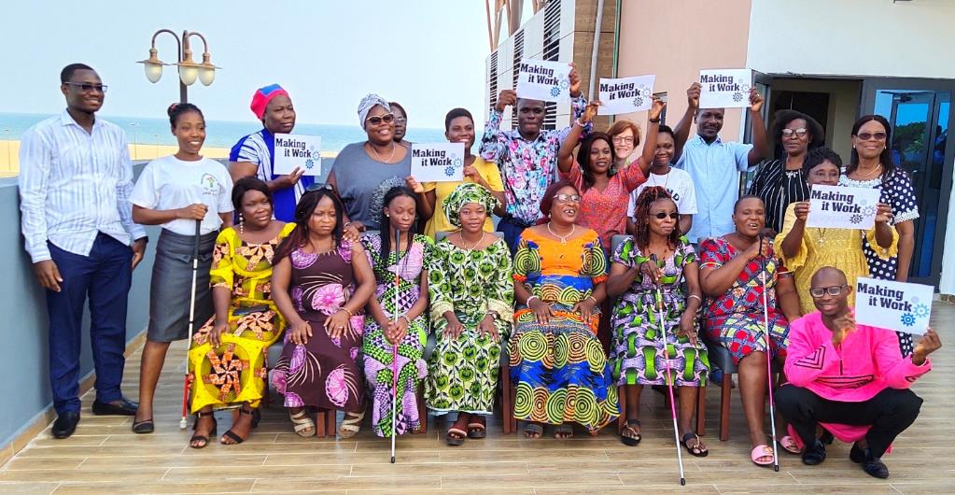

# Introduction

## The long way to inclusion

While the pandemic of gender-based violence continues to rage in the wake of the COVID one, women with disabilities remain disparately impacted while disproportionately underfunded[1]. It is against this backdrop that the Making It Work (MIW) gender and disability project is proud to present its new report, showcasing seven good practices and one promising practice from two west African countries, Senegal and Benin.

In reflecting on the two years that have passed since publishing our last report “Gender and disability: Inspiring practices from women and girls with disabilities addressing discrimination and violence in Africa”[2] we know the need remains urgent to highlight these practices aimed at combatting gender based violence, toward creating communities that are safer and more inclusive. We certainly hope that the innovative actions of the feminists with disabilities highlighted this year will inspire practitioners and decision makers to ensure that the rights of women and girls with disabilities are upheld in policies, budgets and programming. In our December 2020 study report titled “A long way to go: Inclusion of women with disabilities in African GBV policies”[3], 27 national GBV policies across the African continent were reviewed and found that women with disabilities are totally invisible in two thirds of the policies. Unfortunately, the landscape remains largely unchanged.

## Engagement of women with disabilities in the post-covid era

Still, women with disabilities persist and *keep* taking more and more space to claim their rights. During the Covid-era, also referred to as an epidemic of loneliness, the setback in progress on realizing the rights of women—in general, and especially those at the margins—has been widely acknowledged. Meanwhile, this period has shown an unprecedented engagement of women with disabilities, calling attention to inequities and supporting their peers. In this context, MIW country partners began implementing seven projects in Burundi, Cameroon, Kenya and Uganda. These interventions addressed **basic needs**, **GBV,** access to **sexual and reproductive health and rights**, as well as prevention of Covid-19 itself and the **economic recovery**. The active contributions by women with disabilities have grown more visible, even beautifully set to music in [Take Responsibility](https://youtu.be/6pUFMhPSknk) (by Grace Jerry, a MIW partner and director of Inclusive Friends Association-IFA Nigeria).

While intersectionality has emerged at the forefront of the feminist agenda as a powerful framework to reflect on women’s diverse identities, the crisis has reminded us that the inclusion of women with disabilities is fragile. We are reminded over and over again that when there is urgency, the specific needs of the underserved often go unheard.

## Latest developments of MIW in 2022

Acknowledging that disability remains overlooked amongst the discriminations considered in intersectional feminism, MIW partnered with IFA to develop practical guidance based on learning from and for our partners, feminists with disabilities driving change across Africa. This “[How-To Guide: Intersectionality in practice](https://www.makingitwork-crpd.org/miw-how-guide-intersectionality-practice)” was published in March 2022 and is progressively being used by country partners.

In this period, the West African countries of Senegal, Togo and Benin were selected for the current cohort. To ensure that our work best reflects the voices and perspectives of women with disabilities in Senegal, Benin and Togo, we went and met with formal and informal groups of women with disabilities. This report documents their activism and successes[4].

As we deepen this intersectional work and seek to advance de-colonial, anti-racist, anti-ableist feminism, we are heartened by the promise of cross-movement collaboration and the growing number of mainstream partners committing to inclusion. Still, the gaps remain many and wide. Thank you for making them a little less so by sharing this report available on MIW Website in English and French[5], and your feedback!

|  |  |
| --- | --- |
| Icone ordinateur et tablette | **Email**: [s.pecourt@hi.org](mailto:s.pecourt@hi.org)  **Web**: makingitwork.hi.org  **Twitter**: @MIW_CRPD  **Facebook**: @MakingItWorkCRPD  **LinkedIn**: https://www.linkedin.com/company/makingitwork-gender-disability |

## At a glance : good practices 2022

| GOOD PRACTICE | ORGANISATION | COUNTRY |
| --- | --- | --- |
| **Active listening by peers at the Pikine Est Listening Center** | **Association des Handicapés de Pikine Est (AHPE)** | **Senegal** |
| **Improving access to sexual and reproductive health services (SRH) for women and girls with disabilities in Thiès** | **The Women’s Unit of Handicap FormEduc (HFE)** | **Senegal** |
| **Inclusive mechanisms to combat GBV and promote the rights of women and girls with disabilities** | **Community Brigade for the Awareness and Denunciation of Human Rights Violations of Ziguinchor** | **Senegal** |
| **Women's rights with a capital W: creation of a feminist and inclusive platform in Thiès** | **Platform for women leaders** | **Senegal** |
| **Girls’ Club: discussions and intergenerational transmission between women and girls with visual disabilities** | **The Organisation of Blind Women of Benin (OFAB)** | **Benin** |
| **The empowerment of women with disabilities through access to microcredit** | **NGO Dedji** | **Benin** |
| **Women leaders with disabilities alongside women and girls with disabilities in rural areas** | **NGO Bartimée** | **Benin** |
| **Promising practice: Women with disabilities and mothers working together for the well-being of children with disabilities in the community** | **Parakou Centre for Social Advancement 1 and Madihatou Mohamed (a volunteer)** | **Benin** |

# Gender based violence against women and girls with disabilities

## Define to better combat

Gender-based violence, violence against women: the variety of terms should not dilute the extent of this violence. The Convention on the Elimination of All Forms of Discrimination against Women (CEDAW) monitoring committee wrote in 2019 that the definition of discrimination against women includes " includes gender-based violence, that is, violence that is directed against a woman because she is a woman or that affects women disproportionately. It includes acts that inflict physical, mental or sexual harm or suffering, threats of such acts, coercion and other deprivations of liberty[6]”. In 2017, it adopted the term “gender-based violence against women”, a term “ that makes explicit the gendered causes and impacts of the violence. The term further strengthens the understanding of the violence as a social rather than an individual problem […][7]”.

Gender-based violence (GBV) is a form of violence whose root causes are linked to gender inequalities. Women, but also non-binary and trans people are victims of GBV. The Making It Work project recognizes a feminist perspective of violence against women, as defined by COFEM, namely that any action against violence must "focus on inequality - and the resulting oppression of women and girls - as the root cause of violence[8]”.

However, some women are more at risk of GBV than others. Women with disabilities are twice as likely to experience domestic violence and other forms of sexual violence as women without disabilities[9],[10] . It is estimated that 83% of women with disabilities will experience sexual violence in their lifetime[11] .

GBV affects women and girls with disabilities more, and in unique ways. They suffer the same forms of violence as non-disabled women (psychological, verbal, physical, sexual, economic and administrative violence). They also experience specific forms of violence due to intersectional discrimination based on their gender and disability[12] . For example, sexual violence committed by caregivers, overmedication, forced abortions, forced contraception, deprivation of basic necessities, devaluation of the parental role due to the disability, confiscation of sensory devices and financial control are all manifestations of GBV affecting women and girls with disabilities.

As for all women, GBV has a greater impact on women and girls with disabilities with multiple identities. Women with disabilities are not a homogeneous group; the diversity of women with disabilities and intersectional discrimination must be taken into account.

Service providers must take into account the needs of women and girls with disabilities who have experienced GBV in order to adapt their care and develop programs that truly meet their needs. GBV prevention and response initiatives must include women with disabilities in their diversity. Organizations led by women with disabilities, such as some of the MIW partners featured in this report, play a critical role in this regard.

In order for women with disabilities to access GBV prevention and response mechanisms on an equal footing with others, it is essential to implement specific activities to ensure that prevention and response services are fully inclusive. This section describes the context of GBV prevention and response and explains the inclusive strategies used.

## Prevention of gender-based violence

The prevention of GBV relies mainly on :

* Outreach;
* Eliminating root causes and contributing factors to violence;
* Empowerment of women and girls.

### A.1 Awareness

Raising awareness about GBV and the rights of those who are exposed to it is an important step towards prevention. Informing people who were previously unaware of the prevalence of GBV and its negative effects contributes to social change, which allows for positive actions to be taken. In addition, informing women and girls with disabilities helps them to advocate for their rights within their communities.

Outreach strategies include:

* Discuss with community leaders to highlight specific aspects;
* Rely on communication campaigns to reach a significant portion of society;
* Engage women and girls with disabilities in group discussions to promote women's participation and leadership;
* Encourage men and boys to participate in trainings and workshops that encourage them to sensitize their peers and rethink their approach to power dynamics , as a leader, husband, brother, son, neighbor, etc.

### A.2 Eliminating Root Causes and Contributing Factors to Risk

Eliminating the root causes and risk factors involves changing the norms, attitudes and behaviors that perpetuate GBV.

The root causes of GBV include gender inequality, abuse of power, social norms that promote violence and disregard for human rights.

Poverty, lack of education, conflict, substance abuse, lack of police protection, impunity and harmful sexual, physical, emotional and economic practices are all factors that increase the risk of GBV. Both the root causes and the factors contributing to the risk of GBV may vary depending on the local context.

Strategies to address root causes and risk factors may include:

* The implementation of interventions within families and/or couples to encourage critical reflection on gender norms, roles and stereotypes, to promote the role of women and to advocate for parity between men and women.
* Creating programs specifically for men and boys to change gender norms, roles, and stereotypes in society. This strategy may involve introducing men and boys to the concepts of positive masculinity and nonviolent parenting in order to change the mindset of the community.

### A.3 Empowerment of women and girls

The empowerment of women and girls involves promoting their autonomy and self-determination. It allows them to advocate for their own interests and take action on their own initiative. Educational opportunities and group activities can help women understand that they have a major role to play in their communities and that they are entitled to the full range of their human rights. Empowering women should ideally address gender inequalities and ensure that they have the same rights as men.

## Response to gender-based violence

In addition to preventing GBV against women and girls with disabilities, it is essential to include people with disabilities in the response to GBV. Access to quality services in areas such as health (including sexual and reproductive health, mental health), justice, and education helps reduce GBV, protect individuals, and prevent the harmful consequences of such violence. Survivors of violence must have access to immediate protection and coordinated and integrated quality support, including medical care, police intervention, social, psychological and legal assistance, and safe housing. Relevant professionals (police, lawyers, social workers, and health workers) should be trained in inclusive practices. Service providers should receive systematic training to ensure compliance with quality standards and protocols such as informed consent, confidentiality and non-discrimination, active listening, safety, and referral procedures.

## Involving all stakeholders: the ecological model

The most effective GBV prevention and response strategies take a holistic view of the problem by considering different spheres of influence (the different levels that make up the individual's dynamic environment) and different factors, including the human factors that protect against violence and the factors that increase the likelihood of such violence[13] .

The ecological model is a tool for examining the **multiple factors** contributing to a complex problem at different levels: **individual, relational, community and societal.**

It proposes to explore the links, interactions, and relationships of influence and power between these levels.

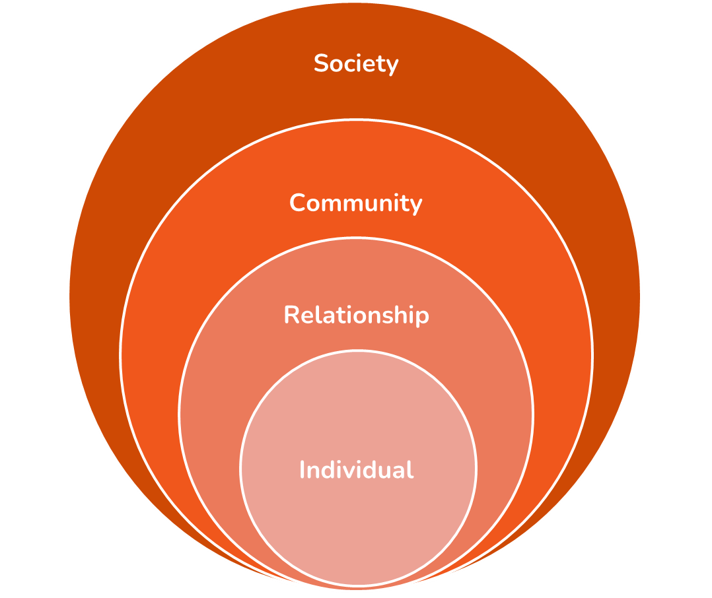

* Individual sphere: **personal identity factors** such as gender, age, disability, socioeconomic status, education level, geographic area, ethnicity, sexual orientation, etc.
* Relational sphere: **relations** between the individual and his family, his intimate partners, his friends.
* Community sphere: **characteristics of the different environments** in which an individual lives, the characteristics of a village/neighborhood/community in terms of opportunities, participation, poverty, social cohesion or tension, etc.
* Societal sphere: **the social, cultural and institutional context in which the individual lives**. Certain factors at the societal level contribute to reducing the inhibition to violence, for example poverty; economic, social and gender inequalities; a weak social security system; a weak legal system and judiciary (which influences the impunity of perpetrators, the absence of rights for victims); social and cultural norms favorable to violence; lack of information and social isolation of women; lack of appropriate care for survivors of violence, etc.

In order to better prevent GBV and to provide relevant response services, we need to understand these spheres as continuous and reciprocal interactions between the individual and her environment. **This approach makes it possible to realize that certain stakeholders and partners, who were not initially involved in the strategy, must participate in the prevention and response to violence against women and girls with disabilities**. The ecological model also provides an opportunity to address different risk factors (e.g., lack of autonomy, attitudes that support gender inequality and GBV, acceptance of violence) and factors associated with the risk of being a survivor of violence (that influence the experience of violence).

In concrete terms, an analysis of GBV prevention and response actions through the ecological model can help improve the coherence and coordination between actions. **An action implemented at one level** (e.g. raising awareness among girls with disabilities about their rights and the possible recourses in case of GBV) **should be reinforced by actions at other levels** (e.g. promoting non-violent and rights-based education among parents of girls with disabilities; training health or social service agents in inclusive, non-discriminatory and qualitative care for young survivors; or adopting and enforcing laws and policies protecting women and girls with disabilities from violence).

# Good practices 2022

## Active listening by peers at the Pikine Est Listening Center -Association des Handicapés de Pikine Est (AHPE) - Senegal

### Context

Founded in 2001, the Association des Handicapés de Pikine Est [Pikine Est Disabled People’s Association], located in the commune of the same name in the Dakar region, is composed of women and men with disabilities. It carries out actions that help boost the rights of people with disabilities and their empowerment.

It campaigns against gender-based violence and promotes the right to education for children with visual disabilities. The association draws on the dynamism of its member women with disabilities to carry out its missions. The AHPE is part of the Pikine Departmental Federation of Disabled People's Associations (FDAPH) and works in cooperation with grassroots community organisations (women, young people, development actors, etc.).

In 2015, a series of awareness-raising and information activities (talks, home visits) was carried out jointly between the AHPE and the Italian association “Oghogho Meye”. The high prevalence of violence and discrimination against women and girls with disabilities became apparent.

### What happened?

In 2019, the AHPE decided to strengthen the actions of its centre by setting up a listening centre to encourage women and girls with disabilities who are survivors of violence to speak out. The centre can be reached on a fixed line, two mobile telephone lines 24/7, and physically on the premises of the AHPE.

The objective of active listening is to provide psychosocial support to women with disabilities in order to strengthen their self-esteem and help them express their self-determination. The centre is a safe and accessible space where women with disabilities can be listened to so that they can gain or regain confidence in themselves.

An initial census had identified 180 women and girl survivors of violence who were invited to come to the listening centre for individual active listening sessions throughout 2020 and 2021.

Following the positive feedback from the first operational phase of the centre, it was decided to boost the capacities of the listening centre's two female disabled “operators’’ and to improve the visibility of the centre so as to increase the number of female users. Flyers were distributed within the communities, discussion groups were held to publicise the centre, and awareness-raising actions were carried out at public events.

Activists from the association have been trained to act as focal points in the communities, to support the actions implemented, and to identify girls and women with disabilities at risk of violence. Home visits are then organised to meet the women, especially those who have difficulty moving around or are afraid of coming to the centre.

Radio programmes and talks are organised regularly at the centre and within the communities to discuss themes relating to human rights; they also allow the listening centre and its added value to be publicised. In addition to promoting the participation (or not) of women with disabilities who use the centre, these discussion groups make it possible to improve the way their needs and expectations are taken into account in order to offer appropriate support. Women with disabilities who have benefited from the listening sessions are referred to legal-aid offices for legal support. They are encouraged to take part in the centre’s income-generating activities (sewing, food processing unit). Girls with a hearing impairment are referred to the Pikine-Ouest literacy centre for people who are deaf.

### What changed?

* For the first time in Senegal, a listening centre for women and girls with disabilities who are survivors of violence exists.
* The operators of the listening centre, trained in active listening, and themselves women with disabilities, respond effectively to the needs of each survivor.
* The varied activities of the listening centre have led to changes in behaviour and attitude within the families and community of the women and girls with disabilities who use the centre.
* The women and girls with disabilities who visit the centre have developed greater self-confidence – many are ambassadors for the centre’s actions.

### Notable successes

* The training of 30 focal points within the AHPE (28 women and 2 men) proved to be a success. These focal points have played a vital role in reaching out to women and girls with disabilities who are at risk of violence.
* The centre has gained a great deal of visibility thanks, on the one hand, to the feedback from women and girl beneficiaries and, on the other, to the numerous awareness-raising actions. This has allowed other women to find out more about the listening centre.
* Since 2020, over 350 women and girl survivors of violence have been listened to and supported by the listening centre, and 44 home visits have taken place.

### Key success factors

* **The leadership of women with disabilities**, a project for and driven by the women themselves;
* **The establishment of a focal-point group in the communities** to identify women and girls with disabilities who are experiencing violence in the community or are at risk of violence;
* **A differentiated approach** based on active listening, non-judgement and respect for confidentiality, which actively encourages them to speak out;
* **Psychosocial support** based on the specific needs of each woman;
* **The involvement of the men within the association who support and participate in** activities to prevent and respond to gender-based violence and in the fight against discrimination.

## Improving access to sexual and reproductive health services (SRH) for women and girls with disabilities in Thiès - The Women’s Unit of Handicap FormEduc (HFE) - Senegal

### Context

In Thiès, as in many other regions of Senegal, women and girls with disabilities face many barriers regarding access to basic social services – access to health care in particular. Lack of access to sexual and reproductive health services constitutes gender-based violence and undermines observance of the rights of women and girls with disabilities.

They also experience verbal violence (lack of consideration and sensitivity from medical staff) and gynaecological and obstetrical violence.

The lack of accessibility to services, the low level of education, the lack of resources, and the lack of awareness of their rights, as well as the lack of training for medical staff, all contribute to this situation.

Handicap FormEduc (HFE) is a national association of men, women and girls with disabilities which strives to promote the rights of people with disabilities through inclusive education, training, action research and communication for the purposes of development and advocacy.

The women of the Women’s Unit of the Handicap FormEduc (HFE) association in Thiès, who are witnesses to and survivors of this violence, decided to act and establish themselves as front-line actors in the fight against gender-based violence.

### What happened?

In 2016, members of Handicap FormEduc (HFE) attended a training course supported by Amnesty International on the sexual and reproductive health rights of women and girls with and without disabilities.

This enhancement of their SRH skills has generated a significant level of commitment from them. The knowledge gained has allowed them to boost the impact of the awareness-raising sessions they conduct with their peers, members of their communities, and health and political actors.

Women leaders with disabilities have mobilised to promote rights to access quality inclusive health care and services. Acting as community focal points, they act on several levers.

* **A better understanding of human rights, including SRH**: women and girls with disabilities have organised sessions to provide feedback to their peers and other community members on the training courses they attended.
* **Raising awareness among local healthcare actors** (midwives and health authorities) about gender-based violence against women and girls with disabilities in healthcare facilities. Women community focal points subsequently met with healthcare actors, local authorities and members of their communities to conduct community dialogue sessions. These sessions, led by women and girls with disabilities, mainly targeted midwives at Thiès Hospital and healthcare authorities at the regional hospital of the 10th *arrondissement* and four health centers: Sam Pathé, Randoulène, Pout, Grand Thiès. The hospital’s head midwife, who is also president of the Association of Midwives of the city of Thiès, took a leading role in the practical training of midwives, and demonstration sessions were organised.
* **Raising local authorities’ awareness of policies to improve accessibility** for women and girls with disabilities in the health sector so as to ensure fair and impartial access to healthcare and services for all women. Targeted meetings with local elected officials allowed the women focal points to submit registers of grievance to various structures regarding the inaccessibility of services and healthcare.

### What changed?

This practice has helped the women leaders with disabilities of the HFE Women's Committee to introduce the following positive changes:

* **Improved access to SRH services and care** for women and girls with disabilities with demonstration sessions on how women and girls with disabilities can access medical services and platforms.
* **Improved health care** and pregnancy monitoring for women with disabilities, in particular by circulating the telephone number of the head midwife of Thiès hospital. This has enabled better coordination and rapid treatment, particularly by mobilising several midwives within the medical structure with the support of the midwife.
* Raising the awareness of medical staff and local authorities about disability, and a **positive change in the behaviour** of healthcare providers.
* An advanced strategy by introducing **a mobile team offering home consultations** for women with disabilities who are unable to travel.

### Notable successes

* Improved mother-child health through improved access to quality sexual and reproductive health services and care for women and girls with disabilities;
* Accessibility work in some health facilities in the city of Thiès, involving the construction of ramps and corridors linking services;
* The development of a hospital unit adapted to the needs of women and girls with disabilities on the ground floor of Thiès regional hospital, and making the post-operative room accessible.
* Promoting the right to health for all, in accordance with Article 25 of the Convention on the Rights of Persons with Disabilities, by introducing regular home consultations for the purpose of monitoring women with disabilities who cannot get around.

### Key success factors

* **The mobilisation and commitment** of the association's women with and without disabilities who, for the first time, **came forward** to demand better access to care and to strive for practical solutions in cooperation with healthcare actors;
* **Collaboration between women and men with disabilities** within the association, with particular regard to violence against women and girls with disabilities;
* **The leadership of women with disabilities** in the development and implementation of activities: women with disabilities are stakeholders in these activities as **agents of change** and lead certain activities themselves (by and for women with and without disabilities);
* **The availability and commitment of the regional hospital’s head midwife** who has since been appointed supervisor of the hospital's maternity department.

## Inclusive mechanisms to combat GBV and promote the rights of women and girls with disabilities - Community Brigade for the Awareness and Denunciation of Human Rights Violations – Ziguinchor, Senegal

### Context

In a context heavily burdened by socio-cultural norms unfavourable to gender equality, and by the Casamance conflict that has been raging for nearly 40 years involving large numbers of combatants and troops, there is a high prevalence of gender-based violence in this region of southern Senegal.

Women and girls with disabilities are exposed to all kinds of violence that is very rarely reported and often mediated or hushed up by the family or the community. In addition to the impunity of the perpetrators of this violence, there is also poor access to justice, a lack of awareness of the rights of women and girls with or without disabilities, and no effective framework to combat gender-based violence in Casamance.

A group of women and men therefore decided to mobilise to denounce human rights violations and to boost the care of the victims of violence. This is how the Brigade for the Awareness and Denunciation of Human Rights Violations was set up in Ziguinchor in 2019 as part of a project called “Facilitating the effectiveness of human rights and access to justice for vulnerable people”. This project is backed by the African Network for Integrated Development (ANID) and the Senegalese Women’s Council (COSEF).

### What happened?

With its dual objective of awareness and denunciation, the Brigade has set itself the following essential tasks:

* **Raising awareness within communities** (parents, girls, boys, school staff, opinion leaders, customary and religious leaders, etc.) about human rights and gender-based violence;
* Identifying and collecting data about **violations** and particularly at-risk situations;
* Helping and **supporting survivors** to report the violation of the right to justice and to benefit from the multi-sectorial care provided by medical and social welfare structures;
* **Creating strategic alliances** with community actors for better results in the promotion of the effectiveness of human rights and access to justice for women and girl survivors of gender-based violence.

The Brigade has mobilised all community actors including the “Badiénou Gokh” (women community focal points), imams, priests, local delegates, school authorities, parents of pupils and representatives of youth associations involved in local life. All – both men and women – work together on the reporting, referral and care (psychosocial, legal, medical and economic) of survivors of gender-based violence.

The Brigade has therefore established a referral system in Ziguinchor with different structures each providing a specific response: the Reception Centre (CPA) and Action Education in an Open Environment (AEMO) care for victims who are minors; the Association of Senegalese Women Jurists (AJS) deals with legal matters; and the Kullimaro Centre is a reception centre dealing with emergency accommodation and medico-social care. In the medium term, the Brigade monitors women and girl survivors with or without disabilities to ensure that the necessary services to which they have been referred have been provided.

The Brigade aims to include women and girls with disabilities both in the leadership of the Brigade and in the actions carried out. Awareness-raising activities focus on the rights of women and girls with disabilities. The Brigade cooperates with the women’s section of the Zinguinchor Regional Organisation of People with Disabilities (UROPH).

The wide range of awareness-raising media (talks, radio programmes, forums, mobile stands at markets, and walkabouts) makes it possible to reach a broad spectrum of women and girls. Home visits, particularly to families with a woman or a girl with disabilities, are organised; they aim to improve the integration of these girls and women into the community, civil registration and enrolment at school, access to care, and the fight against stigmatisation.

Male involvement is a concern; the Brigade has male leaders and some activities involve young men, especially motorbike taxi-drivers.

Lastly, the financial empowerment of women and girl survivors of violence is sought via income-generating activities that also contribute to a resilience fund in cooperation with the African Network for Integrated Development (ANID).

### What changed?

#### More visible and better supported

* Previously invisible and silenced, **women and their entourage speak out about** and report cases of violence, and the number of victims cared for is increasing;
* **Boosting the confidence of women and girl survivors of violence** who consider the Brigade **a major ally in terms of assistance;**

#### Communities that are less complicit and have become actors of change

* **A major change in the perception of women and girls with disabilities by themselves and the community**: above all, the women and girls who have benefited from the Brigade’s interventions have found a new self-confidence and the conviction that their disability is in no way a reason to be subjected to violence;
* **Strong involvement of all community actors** in the fight against violence and impunity through awareness and denunciation within the community;
* **Community and legal recognition**: the Brigade is recognised in all administrative, religious and customary bodies and frameworks.

### Notable successes

Since the Brigade was founded, **over 100 survivors** of gender-based violence have been cared for, the majority of whom are cases of sexual violence against girls with or without disabilities.

**The Brigade is recognised as** **the armed wing of women’s associations** for providing support to survivors and facilitating access to response services.

### Key success factors

* **The expertise of women leaders** who are members of the Brigade and stem from the local associative milieu: women’s associations, associations of women and girls with disabilities, women para-legals, cultural and sports associations for young people, women community actors of all types;
* **The community anchorage** of the Brigade, the **mobilisation** and **involvement** of all actors at community level;
* **Medium-term follow-up of referred cases**, which allows the Brigade to guarantee quality action recognised by all – both men and women;
* **The inclusion and leadership of women with disabilities within the Brigade**, which was crucial for ushering in the end of a long tradition of exclusion and self-exclusion of women and girls with disabilities;
* The existence of **male champions** fighting alongside women with a strategy based on male involvement to eradicate gender-based violence against women and girls with disabilities.

## Women's rights with a capital W: creation of a feminist and inclusive platform in Thiès - Platform for women leaders - Senegal

### Context

In early 2020, the newly appointed female Head of the Departmental Community Development, Social and Territorial Equity Service (SDDC) of the department of Thiès (east of Dakar), and the department’s women’s organisations, launched a cooperation platform. As the health crisis and its restrictions have severely affected the activities and lives of women in the department, the activities of the Platform have been stepped up, particularly through the extensive use of social networks (WhatsApp and Facebook). The women leaders of Thiès have pooled their efforts to provide better care for women and the family, and to improve the well-being of children.

In Thiès, women and girls with disabilities are repeatedly subject to several forms of violence and discrimination. The members of the Platform therefore decided to work together to respond to these problems.

The Platform brings together more than 250 women’s organisations, groups and/or structures, including the Thiès departmental committee of women with disabilities and the Committee to Combat Violence against Women (CLVF). Several women company heads are also members of the Platform.

Its small technical committee comprises 25 organisations, and coordination is the responsibility of the head of the SDDC.

The departmental platform brings together women with and without disabilities from several sectors (healthcare, education, human rights, religion, culture, justice, etc.). The Platform is very diverse in terms of ethnicity, religion (with Christian and Muslim associations) and age (including youth associations and representatives of older women).

### What happened?

The Platform encourages and coordinates actions to promote human rights and access to social services. It encourages the fight against gender-based violence.

With the support of designated women focal points and community facilitators (“Badiénou Gokh”), the Platform organises weekly talks in the communities. These discussions are led by the women members of the Platform who are designated as advisors. They address topics such as sexual and reproductive health, women’s empowerment, gender-based violence and care mechanisms, land rights and the protection of personal data, education and child protection, in both formal and Koranic schools.

The mobilisation of women with disabilities who are members of the Platform has been a vital element in promoting their rights and providing knowledge to other members of the Platform. A deeper analysis of the national legal framework relating to fighting violence against women and girls with disabilities has been carried out, thus strengthening advocacy initiatives aimed at improving the integration of disability into local development policies.

The coordination and collaboration of the women on the Platform has also helped support the people in the community who are most affected by the health crisis (women and girls with or without disabilities, people at risk, etc.) by providing protective equipment and raising awareness of barrier measures.

### What changed?

Defending the rights of women and girls with disabilities, as well as combating gender-based violence, is not so much the individual struggle of a person or organisation as that of a group of women engaged in change because **“there is strength in unity”**.

These changes include:

* The women leaders of the Platform have better knowledge of the issues relating to disability and gender-based violence against women and girls with disabilities;
* The existence in Thiès of a network of committed women with a wide range of expertise who are able to influence decision-making at local level, with particular regard to the inclusion of the disability and gender perspective;
* The creation of strong synergies by pooling resources and skills in order to promote activities, particularly economic activities carried out by women or of benefit to women.

### Notable successes

* The grouping of 250 chairwomen and/or leaders of structures, groups and/or associations at departmental level, making the Platform a powerful lobby group serving women’s rights and championing the rights of women and girls with disabilities.
* The consolidation of links and exchanges between women leaders in the context of the Covid-19 health crisis (lockdown, isolation, absence of discussion forums) through a dynamic and sustainable virtual group (WhatsApp).
* The development of the expertise of women leaders in combating violence against women and girls with disabilities, with a view to the systematic integration of the issue of disability in the workshops and activities of the Platform.

### Key success factors

* **The mobilisation and commitment** of, and the solidarity among, women leaders **in all their diversity**.
* **The mutual trust** between members of the Platform, accompanied by consultation forums.
* The long-term involvement of **the female head of the SDDC.**
* **The pooling of the resources and skills** of women leaders, which promotes joint actions and the mobilisation of the resources needed to implement activities.

## Girls’ Club: discussions and intergenerational transmission between women and girls with visual disabilities – The Organisation of Blind Women of Benin (OFAB) - Benin

### Context

The Organisation of Blind Women of Benin (OFAB) was created in 1994 and officially recognised in 1995. Based in Cotonou, it advocates inclusion, the participation of women with disabilities, the fight against gender-based violence and gender equality. The seven members of OFAB’s Board of Directors are all blind or visually impaired women leaders. Chaired by Ms Olga Noélie ADJANOHOUN, OFAB is a member of national networks (including the Benin Federation of Associations of People with Disabilities), regional networks (including the West African Federation of People with Disabilities) and international networks (including the World Blind Union).

OFAB’s activities currently focus on three initiatives. The first is a microcredit project aimed at empowering women with disabilities. OFAB also receives funding from Global Affairs Canada (GAC) through a partnership with Oxfam-Benin, as part of the Women’s Voice and Leadership Program. OFAB is recognised as an emerging women’s rights organisation. It is the only organisation of women with disabilities involved in this project. Lastly, OFAB collaborates with Handicap International to implement an advocacy project on inclusive education.

### What happened?

The Girls’ Club was created in 2019. It brings together girls and young women aged 10 to 20 with visual disabilities. They are pupils at the special primary school of the Sègbèya Centre for the Social Advancement of Blind People (CPSA of Cotonou) or at mainstream secondary schools. All are boarders at the CPSA and continue to receive care there: the social centre (a public institution) offers rehabilitation, education and training services to people of all ages who are blind and visually impaired. The oldest members of the Club continue their education at the university or have already started work.

This Girls’ Club is a great first for Benin. It was created on the initiative of the Chairwoman of OFAB, who is also a teacher at the CPSA primary school. It addresses a double objective: firstly, it provides a supportive and stimulating space for discussion and awareness-raising among peers and by women specialists; and secondly, it helps to train the next generation of young women activists at OFAB.

Often the victims of exclusion or violence from pre-adolescence to adulthood, these young women with disabilities benefit from a unique safe space where they can ask questions with confidence and be listened to by their peers or by supportive adults. They develop their self-confidence and their power to act.

The themes discussed are rich and encouraging: women’s leadership, women’s rights, the autonomy of girls and women with disabilities, the fight against gender-based violence, and sexual and reproductive health.

The Club is organised and managed by its young members as a small association. It is a real crucible for training in associative life and a springboard to prepare young women to take over the running at OFAB.

The families of Club members find that it is a true crucible for the development and blossoming of their daughters’ leadership skills.

Club members meet at least once a month to hold discussions and/or information or training sessions. These meetings are complemented by formal or informal active-listening and coaching sessions for those who wish to attend, given by OFAB managers who also work at the CPSA. The Club also mobilises on special occasions, such as White Cane Safety Day, the 8th of March, and for festive or fun events.

### What changed?

The Girls’ Club began life with five 10-year-old girls that OFAB managers (who are also primary-school teachers and very involved in the life of the CPSA) had known and supported since they started school. The mobilisation has now borne fruit and the Club has more than twenty young girls and women.

They are comfortable discussing many important topics, including intimate subjects, and some that society at times considers taboo, such as menstruation, responsible sexuality, methods of preventing sexually transmitted infections and unwanted pregnancies.

They learn to recognise different forms of violence and know the institutions they can turn to in the event of gender-based violence, such as the police, social advancement centres and health centres.

Girls at the Club have increased their self-esteem and their ability to speak in public. They are doing well at school.

### Notable successes

* There is a place in Cotonou where girls and young women with visual disabilities can discuss intimate and social subjects, without taboo or embarrassment, and which contributes to their empowerment.
* A climate of trust is established between the adult women of OFAB and the young girls at the Club. These young girls now know who to contact in cases of personal or family difficulty and feel more comfortable asking for help. They feel listened to and understood.
* The instance of dropping out of school or leaving school among girls with disabilities who are members of the Club has fallen sharply.
* The Club allows its members, of different age groups and different academic levels, to meet up and benefit from this mixing. Older people serve as role models and inspire the younger ones, at an age when having role models in whom they can recognise themselves is decisive for building their own identity.
* The active engagement of men within OFAB makes it possible to promote positive models of masculinity.
* The Club helps to change gender and ableist stereotypes by promoting young girls who are active, who are learning, who are the seizing the initiative, who are fighting to overcome obstacles and who succeed.

### Key success factors

* The Girls’ Club has been designed and is being implemented by women with disabilities for women and girls with disabilities.
* The topics discussed combine the themes of gender and disability in order to take better account of the experiences of each member of the Club.
* The leadership and commitment of the women managers of OFAB and their strong pre-existing involvement at the Centre for the Social Advancement of Blind People in Cotonou have allowed an enabling environment for the establishment of the Club.
* The various stakeholders at the CPSA and the pupils’ parents support the initiative.

## The empowerment of women with disabilities through access to microcredit, NGO Dédji, Benin

### Context

The NGO Dédji was founded in 2012 by seven people representing a wide range of genders and disabilities (two women with visual disabilities, one woman with physically disabilities, one woman who is deaf, one man who is deaf, one man who is blind and one man who has no disabilities). It is based in Cotonou and chaired by Ms Kafilatou MAROUFOU, a woman leader who is blind. The NGO now has 38 members, including 23 women with disabilities.

Dédji, which means “be confident” in Fon, has set itself the mission of defending the rights of people with disabilities and enabling them to improve their living conditions.

It recently collaborated with the WiLDAF Benin network (Women in Law and Development in Africa) on the “Inside Out” project which supports the social and professional inclusion of prisoners and former prisoners, women and men with disabilities, funded by the European Union.

The NGO Dédji is particularly committed to empowering women with disabilities through access to microcredit. Initially, members gave each other microloans by pooling their savings. As the system was not enough in terms of volume for a real development of these activities, the use of microcredit and support from a financial institution was deemed necessary. In so doing, the members wanted to continue pursuing their goal of better social inclusion and financial independence, which in turn contributes to reducing economic violence and situations of exclusion.

### What happened?

The first attempts to partner with microfinance institutions were unsuccessful because of the impossibility of “lending to *ill* people” (the term used by one of the microfinance institutions approached to refer to people with disabilities). In 2019, however, the NGO Dédji managed to convince the financial institution called Micro-Enterprise Development Support Project (PADME) to support women with disabilities in their income-generating activities. The Chairwoman of Dédji, already a PADME client in a personal capacity, was able to make a successful case in favour of her peers and the members of her NGO. This work and success is exactly the kind of good practice we are talking about.

PADME has agreed to grant individual loans to women with disabilities of a minimum of 50,000 CFA francs (about €75) or more, depending on needs and repayment ability.

The managers of the NGO Dédji, who have stable economic activities and good credit-worthiness, act as the guarantors and borrow from PADME. They receive the funds and then pool them between the members, organised into cooperatives.

By pooling the funds, but also the risks, the cooperatives are more sustainable: repayment difficulties are shared among the members, thus overcoming individual repayment difficulties.

At the same time, the women with disabilities who submit a request and who have been selected by Dédji, receive training on one or more income-generating activities in the agri-food sector (e.g. the manufacture of maize-based flour that makes it possible to make aklui, a very popular dish in Benin) and the cosmetics sector (soap manufacture).

They also benefit from training in how to manage a commercial activity (book-keeping, savings, inventory management, bargaining techniques, etc.), technical support and a start-up fund to launch their activity.

These technical training courses are complemented by discussions and training sessions on self-confidence and leadership.

Furthermore, the NGO Dédji continues to advocate for better access to microfinance for women with disabilities, building on the successes it has achieved.

### What changed?

* For the first time, a microfinance institution is providing loans to women with disabilities.
* Fifteen women have been trained on how to create an agri-food sector-based activity and have been able to start their own income-generating activity. Some of them can now manage their activity independently. They produce aklui flour which they sell at markets, and at fairs organised by the NGO Dédji. Other women are still being supported by the NGO Dédji in order to overcome certain personal family-related objections.
* The relatives and entourage of women with disabilities have also changed their opinion of them, giving them more consideration and a more respectful place in the family and the community.

Logo for testimony insert**Testimony from Nelly L. ., a woman who is blind, a beneficiary of this project: *“Their entourage has found that women with disabilities have potential and can move the goalposts. I was introverted, I didn’t want to leave the house, I was ashamed of my disability. But with this project, I have met other women like me and I have got my confidence back. My parents have noticed that I have changed”.***

* Good practice has also introduced a significant change in the way women with disabilities are received and regarded at PADME. The manager, with whom the NGO Dédji deals, has in fact instructed PADME employees in contact with customers to welcome and support women clients with disabilities.

### Notable successes

* Diversity in terms of disability, age, social background, ethnicity and culture is also promoted. The fifteen women who have benefited directly from this good practice since 2019 have visual, physical and auditory disabilities and are based in the cities of Cotonou and Abomey-Calavi.
* They engage in income-generating activities that enable them to improve their living conditions and gain self-esteem and autonomy. Most are now able to contribute to household expenses and assume certain responsibilities in their respective families.
* The microfinance institution PADME has changed its opinion of the ability of people with disabilities to manage and develop an income-generating activity whilst properly reimbursing a microcredit.

### Key success factors

* The leadership and determination of women with disabilities at the NGO.
* The fact that this good practice is mainly driven by, for, and with women with disabilities, in close collaboration with men with/without disabilities who are against GBV and who raise awareness of positive masculinity among their peers.
* The diversity of backgrounds and types of disability and mutual support between members.
* Pooling resources between members for better risk-management, thus linking members around a common purpose and creating a spirit of solidarity.
* A successful partnership with the microfinance institution, and particularly the good collaboration between PADME and Dédji managers.

## Women leaders with disabilities alongside women and girls with disabilities in rural areas, NGO Bartimée

### Context

The NGO Bartimée, based in Cotonou, was founded in 2005. It is run by women and men with and without disabilities. The NGO Bartimée is a member of the Coastal Network of Associations of People with Disabilities and the Benin Federation of Associations of People with Disabilities via the network.

Building on a long-standing partnership with the Swiss organisation Mission Evangélique Braille, the NGO Bartimée works for the well-being and full development of people with visual disabilities in general, and women and girls who are blind in particular. To this end, it implements various activities that promote women’s leadership, economic empowerment and the fight against violence against women and girls with disabilities.

The NGO Bartimée is currently involved in the rural areas of the departments of Mono, Kouffo and Ouémé.

### What happened?

The “Women Leaders” project was launched in 2017. It aims to eliminate the social inequality and violence experienced by women and girls with disabilities. Non-enrolment at school or dropping out of school, forced marriage, cases of unwanted pregnancies and sexual violence are in fact very much present in the daily lives of women who live in the most remote areas of Benin.

First and foremost, “Women Leaders” allows women with visual disabilities to become leaders in their community through empowerment support. Future “women leaders” are identified by current women leaders or in collaboration with local organisations of people with disabilities. They receive training to help them develop their self-confidence, their ability to express themselves and their knowledge of human rights, including the rights of people with disabilities.

The “Women Leaders” project adopts an outreach approach whereby women leaders meet women and girls who are blind in rural Benin, particularly in the departments of Mono, Kouffo, Atlantique and Ouémé. They chat to them about their living conditions and the difficulties they face.

In a second phase, women leaders mobilise their skills to help women and girls with disabilities in rural areas.

The methodology has three main pillars: group discussions, meetings with families, and support for the economic empowerment of women and girls who are blind.

1. The group discussions take place through major mobilisation carried out in partnership with local structures (The Centre for Social Advancement, and local organisations of people with disabilities). Each discussion group brings together about a dozen women, all with visual disabilities, who discuss their difficulties and aspirations, with particular regard to gender-based violence.
2. The next stage after these group discussions is to raise awareness among the families of women with disabilities who encounter difficult situations in their homes. These home visits foster a family dialogue that improves the understanding and consideration of people with disabilities and the understanding of the personal experiences of their friends and families. Families are made aware of the rights of women with disabilities, the need to guide and support them and the value of so doing.
3. The final stage consists of promoting the economic empowerment of the women with disabilities they have met through income-generating activities, such as selling essential items, or weaving and selling mats.

### What changed?

* The “Women Leaders” project has provided a new perspective for women with visual disabilities from rural and some urban areas. Women leaders manage to build bonds of trust with them and represent a source of inspiration for them and their families.
* 12 women leaders with disabilities have developed their skills to facilitate group discussions and home visits. This training and their new role enable many of them to escape social exclusion, to be seen more favourably within their own families and to be more able to defend their own rights.
* Since then, some women leaders have also been involved in the associative life of other structures, such as the Benin Organisation of Women who are Blind (OFAB), the Benin Association of Students who are Disabled (ASEHB) and other associations of disabled people at departmental and communal level.
* So far, more than 60 families encountered during the awareness-raising sessions have changed their perception of women and girls with disabilities. For example, Flora, a young woman with a late-onset disability, was heavily overprotected by her parents and saw her autonomy extremely restricted. The women leaders met her family. Her parents then embraced a different perspective of disability and therefore considerably relaxed their behaviour. Flora has now regained her autonomy: she can choose her own clothes for example, or go out without the need to be accompanied by a member of her family.
* About twenty women have been trained to create and manage income-generating activities.

### Notable successes

* The women leaders of the project convey messages about combating violence against women and girls with visual disabilities, but also against women in general.
* The action of women leaders with disabilities helps to combat stereotypes about women with disabilities. They demonstrate that visual disability must not in itself be an obstacle to social and community involvement.
* Women with visual disabilities in rural areas are more aware of their rights and know that they can participate in a fair and impartial manner within their families and communities and assume responsibilities.
* Most families whose awareness has been raised by women leaders are receptive to the messages and recommendations made and show an intention to change.
* Some women with disabilities whose awareness has been raised by women leaders have in turn become women leaders who go out to meet with their peers.

### Key success factors

* The involvement of women leaders with disabilities trained in leadership is the main success factor of this project implemented by and for women with disabilities.
* Some women leaders are also members of the Benin Organisation of Women who are Blind (OFAB), which allows them to benefit from further training.
* The long-standing partnership with the Mission Evangélique Braille allows the NGO Bartimée to continue implementing and improving the Women Leaders project year after year.
* The synergy with organisations of people with disabilities in the districts visited by women leaders is important. These focal points are valuable resources for the Bartimée team in terms of introduction, acceptance and mobilisation.
* The fruitful cooperation between women leaders with disabilities and their volunteer guides, sighted women who are also very committed to gender-based violence issues, is one of the keys to success.

## Promising practice: Women with disabilities and mothers working together for the well-being of children with disabilities in the community, Parakou Centre for Social Advancement 1 and Madihatou Mohamed (a volunteer) - Benin

### Context

The Centre for Social Advancement is a public service under the authority of the Ministry of Social Affairs and Microfinance (MASM). Centres for Social Advancement [*centres de promotion sociale*] exist throughout Benin and ensure that the Ministry’s policies and strategies are implemented. The City of Parakou has two, including the Centre for Social Advancement 1 (CPS1), which has a community-based rehabilitation service (CBR).

CBR can be defined as a strategy adapted to any type of disability and which aims to improve the integration and quality of life of people with disabilities through a comprehensive approach (medical rehabilitation, training in the activities of daily living, schooling, vocational training, access to income-generating activities, etc.). CBR encourages people to take responsibility for themselves in and with their community, with the resources available, and helps to change society’s view of people with disabilities.

In Parakou, the largest city of the Borgou department (north-east Benin), the CPS1’s rehabilitation sessions involve around one hundred children with disabilities accompanied by their parents, usually their mothers.

### What happened?

Ms Madihatou MOHAMED, a young woman with a physical disability, is a member of a group of women with disabilities in the city of Parakou. Thanks to mediation by CPS1 managers, this volunteer’s family agreed that she take an active part in the CBR service’s activities. Since 2021 she has been working as a volunteer at this service. This collaboration and synergy has been chosen as a good practice to be aspired to.

Alongside the rehabilitation therapy sessions for children with disabilities, this volunteer also raises the mothers’ awareness of various topics such as nutrition and the importance of good personal, oral and clothing hygiene. This volunteer also encourages the mothers to repeat the rehabilitation exercises at home with their children.

This volunteer also addresses the issue of the discrimination experienced by the mothers because of their association with their child who has disabilities. By linking this discrimination to the gender-based violence that may ensue, she helps these mothers seek support.

This volunteer also accompanies the manager of the rehabilitation service during regular home visits to mothers and their children with disabilities in order to assess the extent to which the concepts introduced during the functional rehabilitation and awareness-raising sessions are applied.

### What changed?

* The awareness-raising activities for mothers of children with disabilities conducted by this volunteer, herself a woman with disabilities, change the way parents look at their child. Drawing on her personal experience as a strong and committed woman with disabilities, she gives hope to the families of children with disabilities by encouraging them to give them their full place [in society], regardless of their disability.
* All the activities change the attitude of families and the community: the mothers and fathers of children with disabilities are less stigmatised by those around them.
* This volunteer has acquired the skills required to facilitate awareness-raising activities with ease. She has also proven to be very talented at performing the techniques practised in rehabilitation sessions.
* Every week, nearly 25 children benefit from the functional rehabilitation sessions run by the CBR manager and this volunteer. Their aim is the progressive acquisition of motor function by children with disabilities.
* Families become aware of the practices that constitute violence, and have their awareness raised of the rights of children with disabilities.

### Notable Successes

* This volunteer developed her self-esteem, her self-confidence and her leadership. She is more comfortable in her community and with the families being monitored at CPS1. Madihatou MOHAMED is now an inspiring example for women with disabilities and for all women in her community.
* The mothers of children with disabilities who have had their awareness of care and non-violence against children with disabilities raised, are changing their practices. They closely adhere to personal and food hygiene rules.
* Some families have managed to overcome shame and stigma: children with disabilities who once were hidden in the backyards of houses and neglected or assaulted, are now benefiting from the services of CPS1.

### Key success factors

* This volunteer is readily available and committed to the full development of children with disabilities and their mothers.
* The manager of the rehabilitation service (a woman without disabilities) and this volunteer collaborate with good synergy.
* The CPS1 manager and CBR manager provide this volunteer with ongoing technical support.
* The Centre for Social Advancement is a state institution; its permanent nature therefore facilitates the success of emerging good practice and is a guarantee of sustainability.

# Appendix: The Making It Work Methodology

### What is the MIW methodology?

**The Making It Work (MIW) methodology is a participatory approach to generate change using well-documented evidence.** It guides organizations through the process of identifying, documenting and analyzing good practices that advance the rights of the persons concerned, enshrined in the United Nations Convention on the Rights of Persons with Disabilities (CRPD) and, depending on the project content, other international treaties such as the Convention on the Elimination of All Forms of Discrimination Against Women (CEDAW). Information is used to act for change. Actions for change include: advocacy, awareness-raising, sensitization, knowledge transfer, and **scaling of selected practices**.MIW encourages collaboration between key actors, in particular the concerned persons, the persons with disabilities if relevant, and their representative organizations that play a central and leading role.

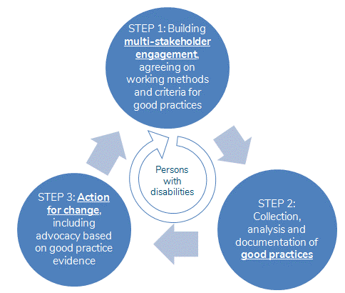

**The MIW methodology** can be used across all development and humanitarian sectors to explore the most significant changes, as experienced by persons with disabilities. It has been developed over the years by Humanity & Inclusion (formerly Handicap International), its partners and collaborators in projects using MIW.

### What is a good practice in MIW?

MIW defines a good practice as a set of activities that facilitate the “full and effective participation in society for people with disabilities on an equal basis with others” (CRPD, Preamble) and actions that concerned persons have confirmed as having a positive impact.

**We propose standard criteria**, providing a useful starting point which can then be adapted to each context:

1. **Demonstrable Impact:** the impact must be validated by partners and beneficiaries, for instance through interviews and testimony;
2. **Replicability:** a specific action, approach or technique that could feasibly be replicated, adapted, or scaled up in other contexts;
3. **Sustainability:** potential for local actors to be able to develop or sustain this action, approach or technique in the future;
4. **Efficiency:** a practice which is efficient in terms of time, finances, human resources;
5. **Person centered and leadership:** practices which respect the concept of individual users being actively involved in any decisions that concern them ; having concerned persons in leadership is strictly related to that criteria;
6. Conforming to the general principles of the CRPD, as stated in its article 3.

### How did we use the MIW methodology in this project?

**Step 1 ‒ Establishing multi-stakeholder engagement:** the Technical Advisory Committee was formed at the start of our project, bringing together international experts in gender and disability. Following the successful call for good practices in 2018 and 2020, a focus has been put on some countries in West Africa. This report highlights good practices from Senegal and Benin identified by MIW team members thanks to dedicated efforts to reach out to groups of women and organisations of women with disabilities involved in the fight against gender based violence. The good practices identified in Togo will be the subject of a future edition.

**Step 2 ‒ Documenting and analyzing good practices:** The pre-selected practices were reviewed. The Committee has been using the criteria as follows: **achieved positive changes, diversity, leadership of women and girls with disabilities, gender equality, collaboration with women and girls with disabilities and scalability**. Practices meeting all of the criteria were then thoroughly documented. Ultimately, four new good practices were selected in Senegal in 2021. Three new good practices as well as one promising practice were selected in Benin in 2022.

**Step 3 ‒ Actions for change:** The implementing organizations have joined previously selected organizations, partners in the MIW project. They are therefore receiving training and technical support on topics such as advocacy, communication, and scaling, in order to amplify the change generated by their practices. Their scaling action plans were developed during the MIW Forums that took place in February 2022 in Senegal and in July 2022 in Benin. Additionally, this present report is a precious advocacy tool for regional and international stakeholders.



**Leadership of women with disabilities: strategies to combat violence in West Africa**

The Making It Work 2022 report provides a better understanding of the violence and discrimination experienced by women and girls with disabilities in Senegal and Benin.

It highlights good practices in preventing and combating gender-based violence against women and girls with disabilities, which are being implemented by eight disability and women-led organizations.

Humanity & Inclusion   
138, avenue des Frères Lumière   
69371 Lyon cedex 08

France

  
[publications@hi.org](mailto:publications@hi.org)



1. See [article « Reversing the trend: The time is now to fund disability rights](https://www.hrfn.org/resources/reversing-the-trend-the-time-is-now-to-fund-disability-rights/)», By Lorraine Wapling, Arlene Wilson-Grant, and Aapurv Jain at the Disability Rights Fund
2. [Link to the last MIW Report](https://www.makingitwork-crpd.org/sites/default/files/2021-03/MIW_Gender_and_Disability_Report2020_LL11.docx) 2020, more versions [on this page](https://www.makingitwork-crpd.org/gender-and-disability-project)
3. [Link to the study report « A long way to go »](https://www.makingitwork-crpd.org/sites/default/files/2021-03/A%20long%20way%20to%20go-MIW%20GBV%20Policy%20Rev%20Accessible%20version-Dec%202020.docx), published December 2020, Word accessible and [link to PDF not accessible study report](https://www.makingitwork-crpd.org/sites/default/files/2021-03/A%20long%20way%20to%20go-MIW%20GBV%20Policy%20Rev-Dec2020_compressed.pdf)
4. Practices from Togo will be shared in a future edition.
5. Link to [MIW Report in English](http://bit.ly/MIWreport2022) and to [MIW Report in French](http://bit.ly/MIWrapport2022), see also the complete [MIW Website](http://makingitwork.hi.org).
6. CEDAW General Recommendation No. 19: Violence against Women, Adopted at the Eleventh Session of the Committee on the Elimination of Discrimination against Women, in 1992, (Contained in Document A/47/38)
7. Committee on the Elimination of Discrimination against Women, General recommendation No. 35 on gender-based violence against women, updating general recommendation No. 19, CEDAW/C/GC/35
8. COFEM TipSheet 1 [« Why does a feminist perspective matter in work to prevent and respond to violence against women and girls? »](https://cofemsocialchange.org/wp-content/uploads/2018/11/TS1-Why-does-a-feminist-perspective-matter.pdf)
9. This risk is even multiplied by 10 for people with intellectual disabilities according to Karen Hughes *et al* , Prevalence and risk of violence against adults with disabilities [...], *The Lancet*, 28 February 2012
10. S. Ortoleva and H. Lewis, Forgotten Sisters - A Report on Violence against Women with Disabilities, Northeastern University School of Law Research Paper No. 104-2012, 2012.
11. D Rajan, Violence Against Women with Disabilities, The Roeher Institute, Canada, 2004
12. Situation of women and girls with disabilities and the status of the Convention on the Rights of Persons with Disabilities and its Optional Protocol, Report of the Secretary-General, 72e session, July 28, 2017
13. [A framework to support action to prevent violence](https://www.unwomen.org/sites/default/files/Headquarters/Attachments/Sections/Library/Publications/2015/A-framework-to-underpin-action-to-prevent-violence-against-women-fr.pdf) against women, UN Women 2015, pp. 22-24.