Summary

Grace Jerry, Olawunmi Okupe and Tracy Onabis
Inclusive Friends association, Nigeria | inclusivefriends.org
How are discrimination factors affecting the lives of women with disabilities in Plateau State, Nigeria?
An intersectional analysis by Inclusive Friends Association
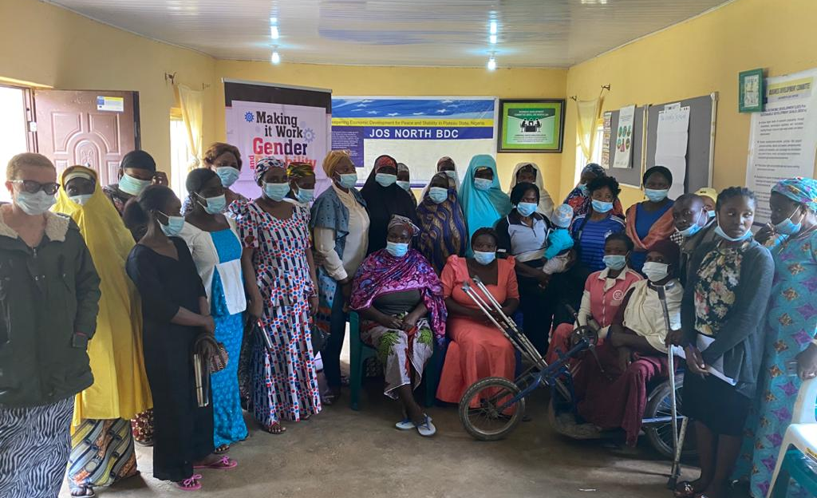
Jos and Riyom Local Government Areas, Plateau State, Nigeria,
September 2022
It is estimated that over 30 million Nigerians are Persons with at least one disability or the other; and more than 50% of them are women.
Nigeria’s ranking is 130 over 170 countries on the 2021 Women, Peace and Security (WPS) Index that captures the three dimensions of women’s inclusion (economic, social, political), justice (formal laws and informal discrimination), and security (at the individual, community, and societal levels).
Stigma and discrimination against persons with disabilities in Nigeria take place within interconnected power structures (e.g. religion, government, and politics) which lead persons with disabilities and especially women with disabilities to experience various forms of oppression. Therefore, it is important to understand the factors that combine to form a person’s identity, such as age, ethnicity, religion, educational level, social status, employment, and disability that make a person either enjoy access or face multiple and/or intersectional discriminations.
As civil rights activist, lawyer and professor Kimberlé Crenshaw stated: “where there is no name for a problem, you cannot see a problem; you pretty much cannot solve it”. Willing to name the discrimination factors that affect the lives of women with disabilities and better inform its programming, the Inclusive Friends Association (IFA) in partnership with the Making It Work (MIW) Gender and Disability project engaged in 2021 in an intersectional study. Focusing on Jos North and Riyom local government areas of Plateau State in Nigeria, it aimed at better understanding to what extent women with disabilities are facing discrimination resulting from intersections of various social determinants. Following the steps proposed in the co-developed IFA-MIW “How-To Guide: Intersectionality in practice”, IFA conducted this study using an intersectional approach; from an initial self-reflection on diversity within its own organization to field visits. Key informants interviews, Focus Group discussions were held with organizations, traditional rulers, and women with disabilities. They allowed the three IFA’s team members to hear about the women’s experiences relating to their livelihood, economic status and inclusion in their communities. Further analysis helped articulate how key intersecting discrimination factors actually affects the lives of women with disabilities living in Plateau State, Nigeria.
Age, place of living (whether in rural areas or in cities), marital status of mothers, religion as well as diversity of impairments showed to be key identity factors that impact differently the lives of those women. The report further illustrates their lived experiences using an intersectional lens.
We wish to thank all the women who accepted to share their personal experiences with us.
Grace Jerry, Olawunmi Okupe and Tracy Onabis, Inclusive Friends Association, Nigeria, April 2022
For further information, please contact Olawunmi Okupe
ookupe@inclusivefriends.org
or info@inclusivefriends.org

How are discrimination factors affecting the lives of women with disabilities in Jos and Riyom Local Government Areas, Plateau State, Nigeria?
An intersectional analysis by Inclusive Friends Association

Methodology: intersectional approach in practice 4
Key discrimination factors impacting the lives of women with disabilities in Jos North and Riyom: An analysis 7
How women with disabilities living in rural areas are disadvantaged 7
How single mothers with disabilities struggle extra to cater for themselves and their children 9
How religion impacts access to benefits and support mechanisms for women with disabilities 10
How age is intersecting with other discrimination factors to negatively impact the opportunities of women 10
How the different types of impairments play a role in the discrimination faced by women with disabilities 11

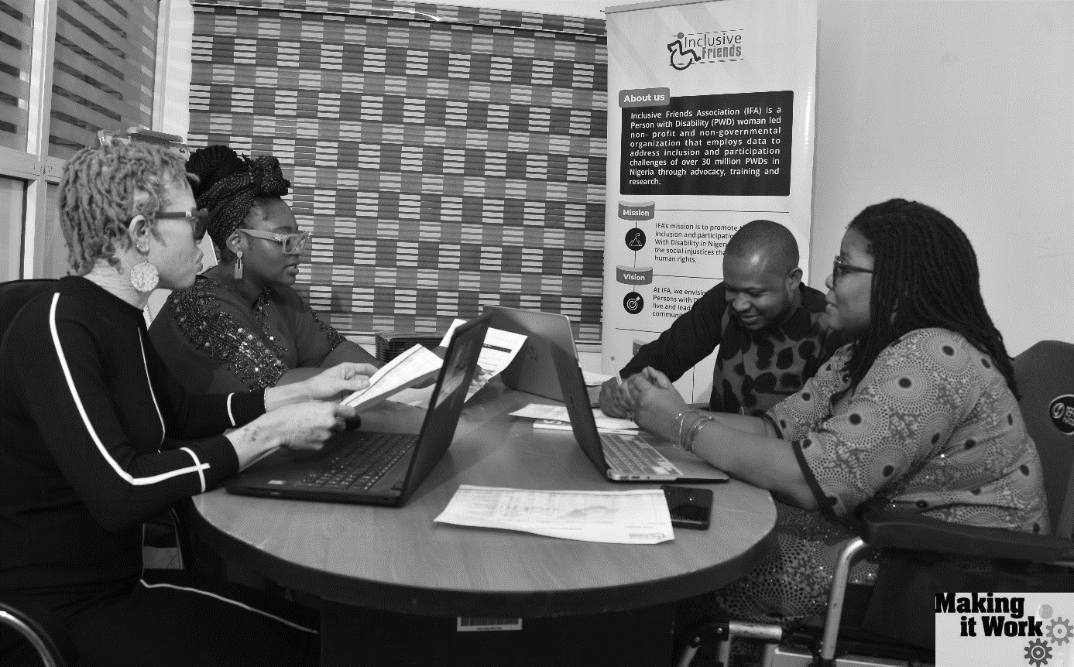
1 Left to right: Wunmi Okupe, Tracy Onabis, Molly Joshua, Grace Jerry

Methodology: intersectional approach in practice
The Plateau is one of the 37 States of Nigeria, located in the centre of the country. It is the twelfth largest state of the country. The state is divided into 17 local government areas containing different ethnical groups. Plateau State sub-national Women Peace and Security ranking is of 22 over the 37 Nigerian States.
We conducted a qualitative study in the Jos North and Riyom areas of Plateau state. These communities were selected because of their mixed population, showing diversity in terms of the various factors pre-identified as contributors to the discrimination faced by women with disabilities: rural and urban areas, diversity of religion with some villages being mostly inhabited by Christians and some others being mostly inhabited by Muslims, etc.
As a first step, a workshop whose content is displayed in the “How-To Guide: Intersectionality in practice” was organized to increase the internal capacity of team members with regards to intersectional approach. Participants were trained on what intersectionality is and what intersectional approach entails. Self-reflection on IFA team members diverse identities, on bias and privileges, as well as an analysis of diversity within the organization were instrumental in laying the foundation for an effective intersectional study.
We identified those who influence communities, such as traditional leaders, and they participated in key informant interviews. We also interviewed representative organizations such as Faith-based women’s organisations, among others.
We collected data and stories from women with disabilities through Focused Group Discussions (FGDs) and by conducting Key Informant Interviews (KII). Women with disabilities were selected through their membership in the Joint National Association of Persons with Disabilities (JONAPWD) chapters in Jos North and Riyom, as well as within Inclusive Friends support groups.
As a result of self-reflection, the team members understood the importance of the socio economic differences between us and the women with disabilities we were about to meet in the communities. We discussed how best to avoid making them feel like we are in any way discriminating them, or taking advantage of our power relation. Thus the team thought it was a good idea to dress in a traditional attire, which depicts the culture of the women with disabilities we were going to have an interface with. We needed them to understand that despite some differences we are all together, adopting the principle of “nothing about us without us”.
Having the IFA team dressed in that matter helped us reach out to these women in Jos North and Riyom: they felt more relaxed and made us feel at home as well. They were very receptive, which made our work easier. Also, before we left, the team learnt one of their local songs, and we all sang and danced together.

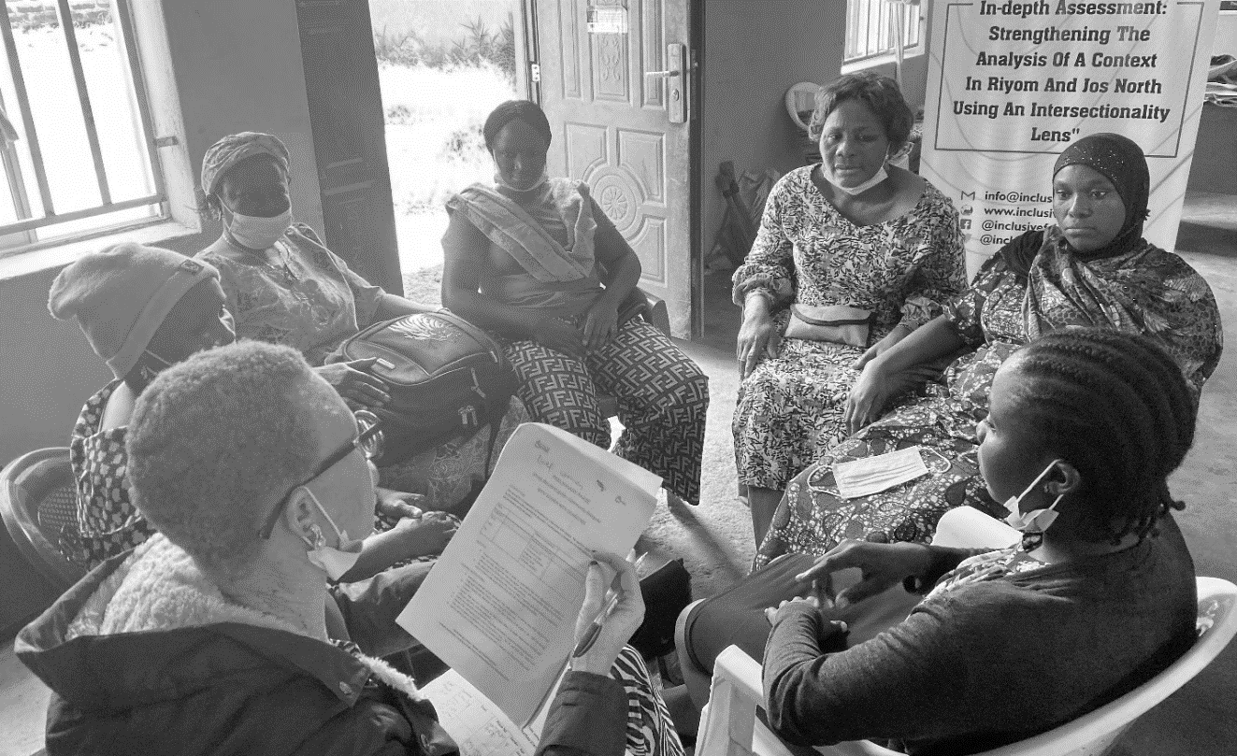
2 Focus Group Discussion with women with hearing impairments
As well, the questions discussed in the Focus Group Discussions were prepared, in the most accessible language for them. One group was made up of women with hearing impairments using Nigerian Sign. Participants took turns responding to each question raised. This allowed us to document and review the information gathered during those sessions to identify what was relevant to our intersectional analysis and should be included in our report.
The study and the analysis performed employed a qualitative intersectional approach. It allowed to identify the particular issues faced by women with disabilities, in particular linked with their intersecting identity factors, as well as reaching out to those the most at-risk. Steps followed are described in the “Tool n° 2: Working with and for the most at-risk women” of the How-To Guide, that was improved and finalized alongside our assessment and analysis conducted in a collaborative manner with the MIW team. As a result, this study was looking to come up with key findings that will inform future programming of Inclusive Friends Association.
More details on the key informants interviews and FGDs performed can be found in the table hereafter.

Individuals / organisations | Number | Details
Women with disabilities | 46 women with disabilities, 6 women per group | 24 women with disabilities in Riyom  22 women with disabilities in Jos North
Stakeholders/  Organizations | 4 organisations | FOMWAN (Federation of Muslim Women’s Associations in Nigeria)  CWEENS (Christian Women for Excellence and Empowerment in Nigerian Society)  JONAPWD (Joint National Association of Persons with Disabilities)  FIDA (International Federation of Women Lawyers)
Traditional leaders | 2 leaders | 1 chief in Riyom  1 chief in Jos North

Key discrimination factors impacting the lives of women with disabilities in Jos North and Riyom: An analysis
Our discussions with women and organizations helped identify five identity factors as key in understanding the various forms of discrimination and violence faced by women with disabilities. Those factors, whether called discrimination or identity factors, intersect with the disability status (and the type of impairment in particular) and with other factors to create unique lived experiences for the women we met.
These factors are presented below and are further analysed:
- Location (rural or urban)
- Marital status
- Religion
- Age
- Different impairments

How women with disabilities living in rural areas are disadvantaged
Women in rural areas have limited/no access to services from the Government, NGOs and CSOs unlike those in urban areas. This is explained by the fact that most of these organizations are located in urban centres. As a result, women with disabilities living in urban settings are more visible to the organisations, and thus their issues often form the basis of targeting and planning. Services are not available for or adapted to women living in rural settings; because their needs differ from those of women living in urban settings. For instance, what a woman with a disability in an urban area may see as a pressing need may be useless to a woman in a rural area.
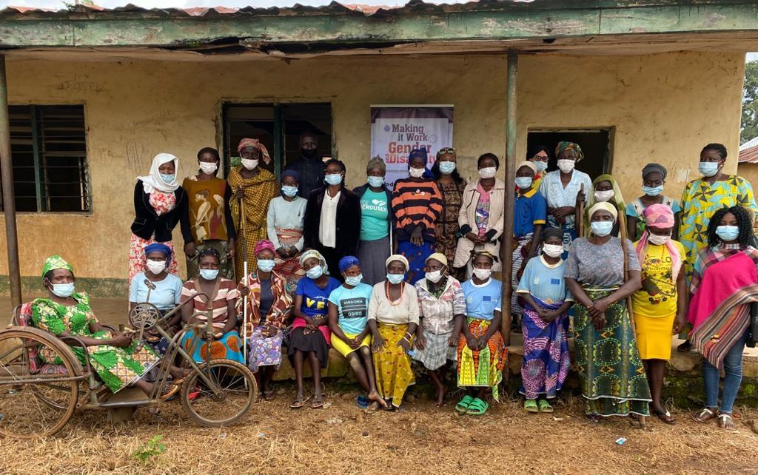
3 Women with disabilities in Riyom Local Government
The ability of women with disabilities living in urban settings to benefit from any support program that could exist is determined by better access to information. The support programs are often based on skills acquisition:
- Entrepreneurship training
- Soft grants
- Loans to start up
- Support to existing businesses
Most of these programs organized by civil society organizations target urban women because they are often time already acquainted with the basic knowledge needed.
The women in Jos North appeared more privileged than those in Riyom local government because of their proximity to the urban city centre and exposure. These women get opportunities for skilled empowerment compared to the women in Riyom because they already had the skill set.
Moreover, girls with disabilities living in urban areas have more access to education, as the schools in rural areas are not inclusive.
In addition, the quality of life and education of children of women with disabilities in urban areas shows a difference compared to women in rural areas. There is a huge gap because most of the facilities in the rural areas are under-maintained. Most women in rural areas cannot even afford to give their children quality education and other basic necessities, thus subjecting their children to child labour such as street hawking.
Access to health is also very restricted in rural areas where you only find primary health facilities that are underfunded and not properly equipped. Accessing some form of transportation is an additional barrier that hinder their access to well-equipped health facilities.
Finally, stigmas and negative stereotypes towards persons with disabilities are more visible in rural areas than in urban settings as there are more sensitization campaigns in urban areas aiming to change negative perceptions of persons with disabilities.
“A woman in Riyom who is visually impaired stated she often felt discriminated against by the people of her community, especially in the church and social gatherings, as she was forced to sit outside and most of the time did not receive help from any member of the community. Indeed, persons with disabilities are not seen as people who contribute meaningfully to the community. Unfortunately, rural inhabitants are not yet enlightened enough to understand that disability is neither a curse nor contagious. They should be more open to socializing with persons with disabilities like people in urban communities”
Stakeholders such as the non-governmental Christian network CWEENS also agree on the fact that women with disabilities in rural areas face more discrimination, as there are many social problems that overlap and create multiple levels of social injustice. Therefore, they highlight the need for these women to get more attention through community-based interventions.

How single mothers with disabilities struggle extra to cater for themselves and their children
The discrimination that single mothers face sterns from the societal perceptions of them. In a society like Nigeria where there is still high regard for the institution of marriage and having children within the confines of marriage, there is a lot of eyebrow-raising in regards to a single woman with a child.
Nigerian society tends to condemn and exclude single mothers from equal community participation as other women place them in a lower category. Despite the circumstances of single mothers with disabilities, they are discriminated against both within and outside the disability community. We regularly found that other women with disabilities often orchestrate their exclusion from programs and interventions meant to benefit them as a whole.
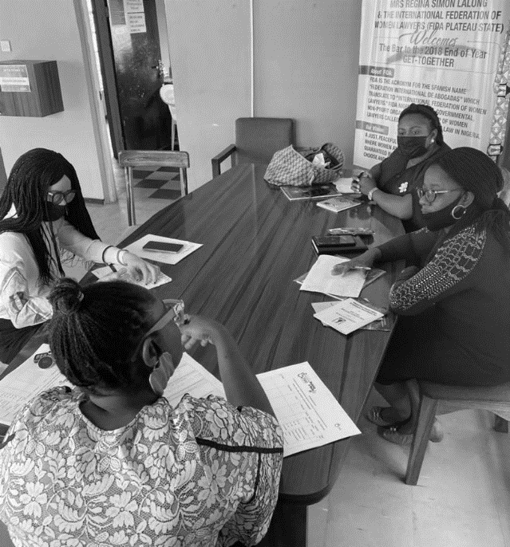
4 Interview of FIDA
Furthermore, single mothers are among the poorest within their communities. They often live on a day-to-day basis having to resort to odd jobs to be able to cater for themselves and their children. Also, when items or cash are distributed to all women with disabilities, single mothers may be the first to be out seeking more support because they easily exhaust their share on account of the absence of another breadwinner figure in the household.
On the other hand, children of single women with disabilities are among those that are mostly out of school because of the lack of financial means to cover the cost of their education. For instance, some of the children are exposed to hawking and doing menial jobs to support their mothers with disabilities, which is in itself a form of child labour and is unhealthy for the total wellbeing of the child.
“One lady in Riyom local government stated that she and her son constantly suffer from discrimination as the boy is labelled the child of the blind lady who was born out of marriage, thus no family or community member wants to extend their help to them, they rather prefer to take advantage”.

How religion impacts access to benefits and support mechanisms for women with disabilities
In Nigeria, the religion of each person impacts his or her life depending on the community where the person leaves. This statement was supported by the study we carried out as Riyom is largely a Christian community, whereas Jos North is divided in different sections majorly populated by Christians and some other sections majorly populated by Muslims. Because of two decades of religious crisis in Plateau Stage, Christians have been progressively relocating to settle in Christian populated area, and the Muslims have been settling in Muslim populated area. Although, this does not mean there are no areas where Christian and Muslims cohabite.
Discussions showed that a Christian woman cannot easily benefit from programs or interventions arranged by Muslims. The same goes for Muslim women living in a predominantly Christian area.
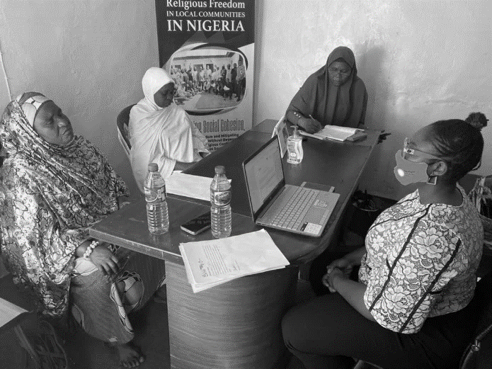
5 Discussion with FOMWAN
Women of different religions do not mingle on a regular basis because of the difference in their beliefs. There is no free exchange or dissemination of information between Christian and Muslim women even if they are mixed in equal proportion because most of the time, men -whether fathers, husbands, or brothers- prevent the women from mingling with women from the opposite faith.
Discussions with different local actors intervening in both Christian and Muslim populated areas confirm the fact that there are obstacles to overcome in order to achieve a truly inclusive intervention.
Christian Women for Excellence and Empowerment in Nigerian Society (CWEENS), a non-governmental organization that intervenes in mixed areas, stated that they do not apply any form of segregation when it comes to their intervention towards Muslim women with disabilities. The organisation provides all form of help to any women no matter the religious status. For instance, CWEENS run a safe house that accepts both Christian and Muslim women because one of their core values is the right of every woman to be free from violence. However, CWEENS member staff has noticed the resistance from the Muslim women because the safe house is being managed by a faith-based organisation. As a result, their intervention towards Muslim women is limited.

How age is intersecting with other discrimination factors to negatively impact the opportunities of women
Age is another important factor that also contributes to the vulnerability of women with disabilities. During the study, 10 to 15 of the total number of women whom we engaged with were above 50. From these interactions, we could deduce that most of them do not have a family to support and cater for their needs, in addition to their disability.
The study also revealed that often programs of Civil Society Organizations or individuals targeting women with disabilities do not take into consideration the needs of older women. In cases where a need assessment meeting was first held with the target beneficiaries, older women with disabilities were often not present to contribute their quota and raise specific issues relating to them as aging women with disabilities.
Indeed, women with disabilities above 50 are often not included in intervention programs; they therefore cannot partake in educational or livelihood intervention schemes that come to their communities.
Some women, due to their age, face abandonment from family members who see them as liabilities or witches (as one woman reported). This is partially caused by the absence of a legal framework or interventions tailored to support older women with disabilities in these communities.
Although Nigeria has signed the AU Protocol on the Rights of Older Persons and established a senior citizens centre at Federal level with States chapters, little has been done in regards to activities that can improve the welfare of older women with disabilities. There is also a need to increase sensitization and advocacy to the relevant stakeholders on the inclusion of older persons with or without disabilities in their activities. Women with disabilities who already have to struggle extra to live daily now become weaker and lose stamina because of age.
Most of the older women in the two local governments who participated in this study stated that if they had the opportunity of being educated, they would be more empowered and more independent.
One of the participants in Riyom lamented that her children abandoned her and that she has no skill to get by. She resorted to helping people weed their farms to earn a living. Unfortunately, this situation is similar to most aged people with disabilities in the Plateau state.

How the different types of impairments play a role in the discrimination faced by women with disabilities
The different types of impairments have different impact on the lives of women with disabilities because people are more receptive to certain types of disabilities than others, and because the barriers faced are different.
A woman with leprosy in Jos North complained about the lack of patronage in her petty business because people were afraid of her “contagiousness” and would rather patronize a woman with a physical disability, who sells near where she lives, and whose disability is not perceived in the same way. She ran into losses in her trade and had to eventually stop, not only because nobody wanted to buy from her, but also because the discrimination she endured discouraged her to continue.
The study highlighted the different levels of discrimination faced by women with disabilities.
For instance, a woman with albinism who is from the western part of Nigeria had to relocate to Jos because of fear of being killed for ritual purposes which were highly prevalent in her hometown.
This is not the case for women with visual impairment or deafness, who will not experience the same risk in the community as their disability is not culturally perceived as desirable for ritual purposes.
During our Focus Group Discussion, the story of a woman with mental disability in Riyom who was raped several times and now has three children without fathers was revealed. The perpetrators took advantage of her knowing that she will not be able to hold them liable as they can easily deny ever having anything to do with her. There were speculations that some of the men who sexually abused her do so for ritual purposes or spiritual fortification against their enemies.
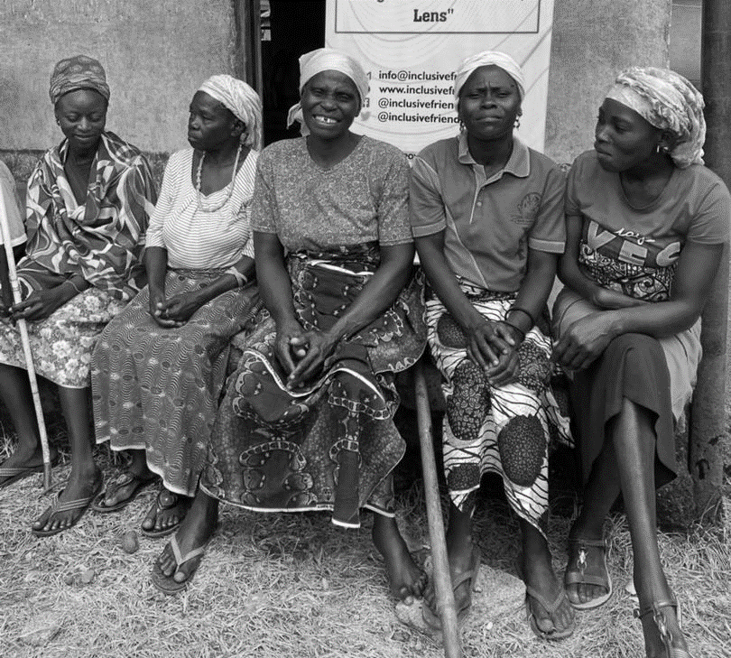
6 Women in Riyom Local Government

“The 2011 National Baseline Survey on PWDs put the national prevalence rate at 3.2%. The current approximate number of persons with disabilities in Nigeria is put at 28 million” in State Report, Federal Republic of Nigeria, CRPD/C/NGA/1
Georgetown Institute for Women, Peace and Security and Peace Research Institute Oslo. 2021. Women, Peace, and Security Index 2021/22: Tracking sustainable peace through inclusion, justice, and security for women. Washington, DC: GIWPS and PRIO. Last accessed at this link.
The “Making It Work How-To Guide : Intersectionality in practice” was published on the 8th of March 2022. It is available at this link.
See “Tool n° 1: Exploring who we are” in the “How-To Guide : Intersectionality in Practice”, MIW-IFA, March 2022, available at this link

