Making it Work “Gender and Disability” Project: contributing to a world free from violence for Women and Girls with disabilities

Project Brief – July 2022
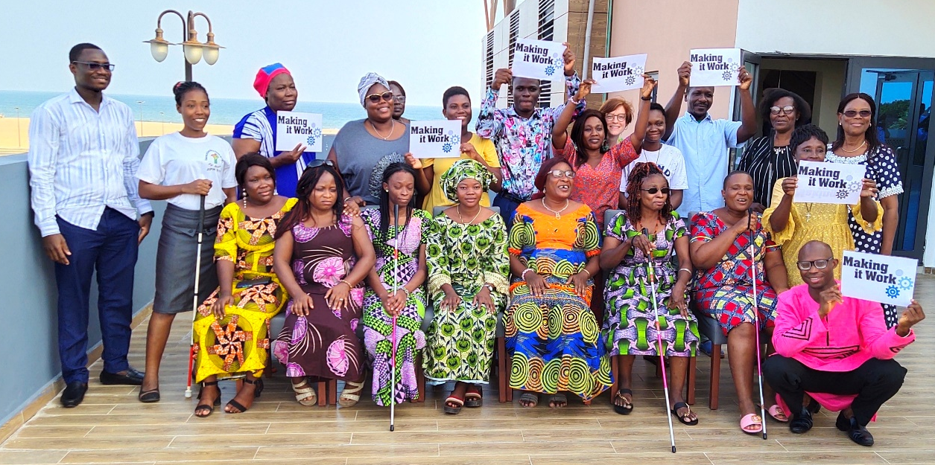
This picture was taken during our last workshop with four new partner organizations from July 4 to 7 in Cotonou, Benin. More information below!

MAJOR NEWS

On March the 8th 2022, Making It Work published its How-To Guide to put intersectionality in practice! Developed in collaboration with Inclusive Friends Association Nigeria. This guide helps you to implement the intersectional approach in your work.
Focusing on the inclusion of women and girls with disabilities, this practical guide can however be used to address any type of discrimination in any context to analyze the lived experiences of all individuals.
Available on our website, this tool to adopt an intersectional approach is ready to be used in French and English!
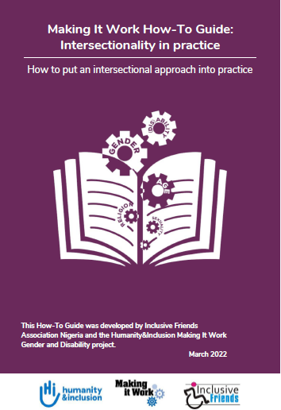

MIW WELCOMES 8 new Country Partners in Senegal and Benin

WORKSHOP IN SENEGAL, FEBRUARY 9th TO 13th 2022

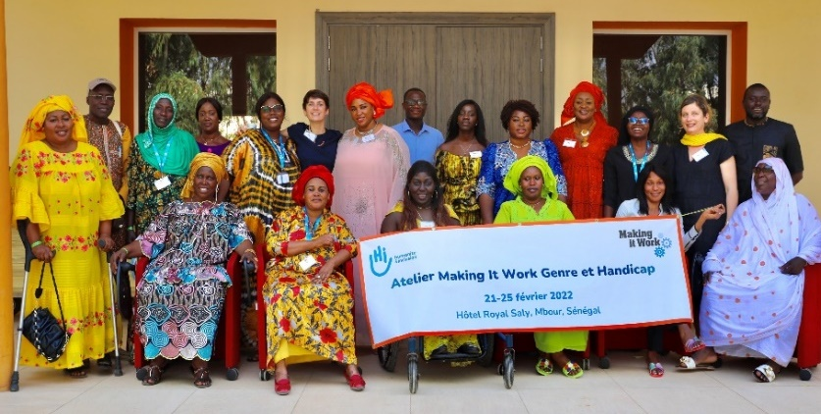
4 new partner organizations joined the Making It Work workshop in Senegal: L’AHPE, l’HFE, La Plateforme des femmes leaders de Thiès, et La Brigade de conscientisation et dénonciation de Zinguinchor. The analysis of their practices according to international standards for the prevention and the response to GBV allowed them to develop action plans for scaling action; with questionings on how to better take into account diversities.

WORKSHOP IN BENIN, JULY 4th TO 7th 2022

The MIW workshop in Benin also introduced 4 new partner organizations: l’OFAB, the NGO Bartimée, the NGO Dédji, and le Centre de Promotion Social 1 de Parakou. Maximizing the impact of practices was at stake, as always in MIW. However, the discussions focused on the leadership and economic empowerment of girls and women with disabilities, as well as on intergenerational transmission. 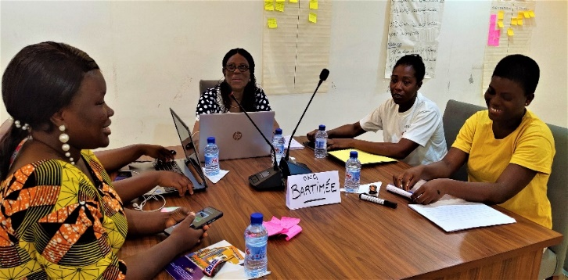

NOW IT IS YOUR TURN TO PUT INTERSECTIONALITY IN PRACTICE – We can help you!
Following the publication of our How-To Guide, the Making It Work team developed a workshop content on intersectionality and diversity. Filled with theoretical inputs and practical activities, the proposed content can be adapted to achieve the set objectives of every team or organization willing to engage on the journey of intersectional approach. By performing this workshop, we can help the teams to understand and to implement an intersectional approach in their works and projects.
It already has been performed with Humanity&Inclusion teams, with the advocacy and the inclusive education team in Senegal. The workshop was also presented to partner organizations like COVAW in Kenya and external structures like IWRAW Asia Pacific.
If you are ready to adopt an intersectional approach, and would like us to support you, like please contact us!

CONTACT
- Email: s.pecourt@hi.org
- Twitter: @MIW_CRPD
- Facebook: Making It Work - @MakingItWorkCRPD
- LinkedIn: https://www.linkedin.com/company/makingitwork-gender-disability

