Making It Work How-To Guide: Intersectionality in practice
How to put an intersectional approach into practice

This How-To Guide was developed by Inclusive Friends Association Nigeria and the Humanity&Inclusion Making It Work Gender and Disability project.
March 2022

Today, 8th of March 2022, we are celebrating the rights of women across the globe.
All women; all of their rights.
The Humanity&Inclusion Making It Work Gender and Disability Project and the Inclusive Friends Association Nigeria are proud to publish the How-To Guide: Intersectionality in practice. It was co-developed all along 2021 by our two organizations, as a practical guide to support organizations to actually implement intersectional approach in their work.
Because identities are diverse, discriminations are multiple and intersectional. Academics and policy-makers have been progressively bringing intersectionality at the agenda – giving space for the experiences of those facing discrimination based on age, (dis)ability, ethnicity, gender identities among other factors. Still, the effective use of intersectionality in projects implemented by women-led civil society organizations has shown to be challenging, due to the lack of practical guidance.
Women are not an homogeneous group. Neither are women with disabilities. Age, diversity of impairments, ethnicity, religion, socio-economic status, sexual orientation, gender identity, etc.: Bringing intersectionality in the design phase of projects implemented by women with disabilities will bring efficiency, accuracy and allow different lived experiences to be considered. Supporting women-led organizations to start with self-analyzing who they are and how their own diversity is impacting their projects is a must-do. Guiding them to actually analyze how discrimination factors impact the lives of individuals differently is crucial.
This Guide is providing with steps and tools to actually adopt an intersectional approach to design and initiate projects that will leave no woman behind. Although it was developed with a targeted intersectional approach where gender is at the center of the factors of discrimination, the How-To Guide can be used to approach any context and consider all the factors of discrimination to analyze the lived experiences of individuals of all genders and (dis)ability status.
"There is no such thing as a single-issue struggle
because we do not live single-issue lives." - Audre Lorde

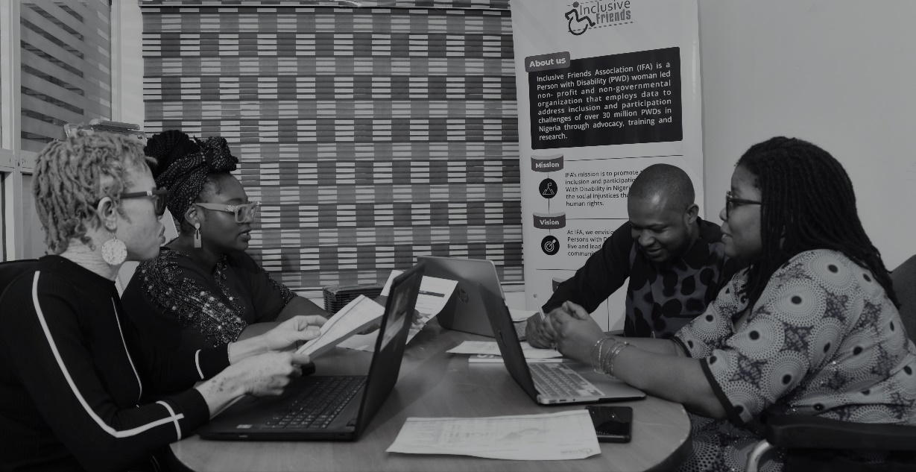
Credit: Nansel Samuel. Left to right: Wunmi Okupe, Tracy Onabis, Molly Joshua and Grace Jerry, IFA
CONTENT
Purpose and content of the guide 4
Composition of the How-To guide 4
In brief: What is intersectionality and why take an intersectional approach? 5
Tool n° 1: Exploring who we are 6
Part 1 - Self-Reflection: My identity factors 7
Activity 1.1: Define your own identity factors and multiple identities 7
Activity 1.2: Questioning bias and prejudices 8
Part 2 - About your organization 10
Activity 2.1: My vision of diversity in my organization 10
Activity 2.2: Analyzing diversity in my organization 12
Conclusion 14
Tool n° 2: Working with and for the most at-risk women 15
Part 1: Analyzing context with an intersectional lens 16
Objective 16
Steps 16
Part 2: Identifying and engaging with the women/persons you want to work with 20
Objective 20
Steps 21
APPENDICES 25
Annex 1. The ecological model 25
Annex 2. Key points to apply an intersectional approach (from GBA+) 25
Annex 3. The importance of talking with concerned the people 26
Annex 4. What do we mean by “context”? 26
Annex 5. Focus Group Discussion guide 27

Making It Work How-To Guide: Intersectionality in practice

How to put an intersectional approach into practice
Please Note
Taking an intersectional approach is needed to recognize the importance of individual's social identities within the broader context of power systems and structures which reflect macro systems of privilege and oppression. Keep in mind that recognizing areas of advantage, disadvantage, and oppression may bring up feelings of confusion, guilt, distress, among others and that is okay to feel uncomfortable.

Purpose and content of the guide
This guide to intersectionality proposes specific tools to provide organizations with the means and the opportunities to adopt an intersectional approach ; when designing, implementing or evaluating a project.
A number of steps must be followed in order to understand intersectionality and its practical use.
This guide provides insights and tools to support you throughout the process.
Although it was developed with a targeted intersectional approach where gender is at the center of the factors of discrimination, this practical guide can be used to approach any context and consider all the factors of discrimination to analyze the lived experiences of individuals of all genders.
This Guide was developed using a series of existing resources. We have tried to include reference to those resources as much as possible.

Composition of the How-To guide
- Tool n° 1: Exploring who we are
- Tool n° 2: Working with and for the most at-risk women

In brief: What is intersectionality and why take an intersectional approach?
Intersectionality is a concept used to understand and analyze how the multiple identity factors (for example gender, economic situation, ethnicity, religion, disability, sexual orientation etc.) for a given person combine and interact to create specific experiences and situations of discrimination or privilege, and confer advantages or disadvantages in a specific context. For example, a woman with a disability might face discrimination that is not only due to her gender or her disability, but due to a combination of the two factors which operate simultaneously and interact in an inseparable manner, producing distinct and unique forms of discrimination.
For a deeper understanding of what intersectionality is, see the additional resources below:
- Reading: “WomanKind Worldwide - Intersectionality 101: what is it and why is it important?”
- Reading: “Ten tips for putting intersectionality into practice’’
https://www.opportunityagenda.org/explore/resources-publications/ten-tips-putting-intersectionality-practice
- Video of Kimberlé Crenshaw who introduced the concept of intersectionality:
https://www.youtube.com/watch?v=akOe5-UsQ2o

Tool n° 1: Exploring who we are
We all have a situated standpoint linked to a number of individual factors. Who we are impacts the way we think and work. The aim of Tool n°1, “Exploring who we are”, is to question ourselves in order to raise awareness and thus think about who we are, what biases we have, where we are situated in the social space, what power dynamics we are involved in, and how these factors might impact our actions and our work.
These factors are part of our identity and make us who we are. We can call them ‘’identity factors’’. They can influence how we position ourselves, the way we behave, how we interact with others on different levels, as well as how we perceive and are perceived by others.

The ecological model is a good way to explore in more detail the different circles of influence and start thinking about the dynamics and interactions between them. It allows us to represent ourselves within different circles of interaction.
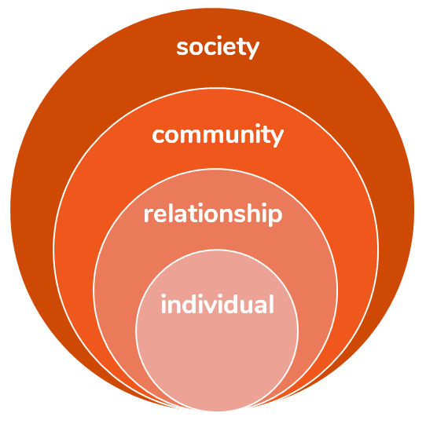

Tool n°1 is made up of two different but related parts. It is important to complete them one after the other in the right order.
CONTENT:
- Part I: Self-Reflection: My identity factors
  - Activity 1: Define your own identity factors and multiple identities
  - Activity 2: Questioning bias and prejudices
- Part II: About your organization
  - What are we talking about and who are we talking to?
  - Who am I and who are my colleagues?

Part 1 - Self-Reflection: My identity factors
Everybody has different aspects to their identity that make her or him unique. The first key step in the process is to think about your own beliefs and behaviors. Like the people you work with and the populations you support, your individual identity and perceptions are shaped by your intersecting factors and their interaction with systems and power structures.
Exploring who you are helps to understand the relationship you have with the people you want to help and to realize that these identity factors mean certain social realities stand out for your more than others, due to your own identity and experience.

Activity 1.1: Define your own identity factors and multiple identities
Objective
This activity will help you identify your own multiple and diverse identity factors that are part of who you are as a whole and impact your lived experiences and relationships with others.
The main objective is to situate yourself, to self-identify. It will help you decide what you want to share about yourself. It will increase your understanding of the power and unearned privilege you may have. Indeed, in any given situation and context, you may have power and privilege over others.
Our identity factors involve us in social relationships and power dynamics, consciously or unconsciously. Sometimes, we may find ourselves in a dominant position (with recognized advantages known as ‘’privileges’’), and sometimes in a position of being discriminated against or disempowered.
This balance of power and the resulting dynamics can be exercised at different levels, including organizational, individual, community, and societal. See the Ecological model diagram above.
Steps
In order to fill in the empty intersectionality flower below, take few minutes to look at the completed flower below. The flower does not indicate factors that you must include but examples of factors that may make up the individual identity of a person (for example man, woman, Christian, old/young etc.). When filling out your own flower, you can add personal identity factors even though they are not shown in this example.
To identify the intersecting categories that you think make up your identity:
- Ask yourself: “How do I identify myself?’’, ‘’What are my identity factors?’’ etc.
- Fill out the empty flower with the identity factors that are meaningful to you.
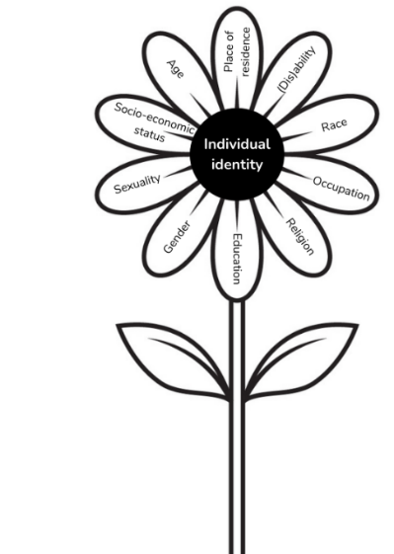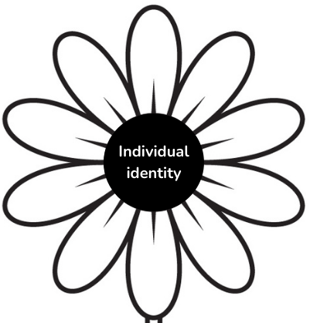
Keep in mind | The petals give the impression that each of the different factors forming social identity is separate from the others. In reality, all the factors interact with each other.  If you imagine replacing one factor with another, this can have a significant impact and consequences on the other listed factors that change your lived. For example: a man with disabilities will not experience discrimination in the same way as a woman with disabilities. The lived experiences of these two people are different and unique.  Some identity factors are context specific meaning they can advantage or disadvantage you depending the situation and the context. You may consider some factors (gender, age, religion, ethnicity, etc.) to be more important than others in a specific situation and context.

Activity 1.2: Questioning bias and prejudices
Objective
We all develop beliefs about the world and the people living in it ; we are influenced by our own perceptions shaped by our identity factors.
In this section, you will explore how the identity factors explored in the activity 1-1 actually impact the way you work, your relationships, and the people you work with, both colleagues and persons of interest in your projects.
Steps
Try to look at the flower you just completed with your own identity factors. See how your own experience can sometimes lead to bias and influence your work and perceptions of others that might lead to discrimination.
To do so, please answer the following questions:
- According to your own identity (religion, ethnicity, gender, age, ability, etc.), try to give an example of a situation in your life where one of your identity factors was an asset or a privilege and explain why (example: access to education, health, employment etc.)
………………………………………………………………………………………………………………………………………………………………………………………………………………………………………………………………………………………………………………………………………………………………………………………………………………………………………………
- According to your own identity, try to give an example of a situation in your life where one of your identity factors was a disadvantage (factor that may lead to discrimination)?
………………………………………………………………………………………………………………………………………………………………………………………………………………………………………………………………………………………………………………………………………………………………………………………………………………………………………………
- How do your identity factors and your place in the society or in your community impact your work on this project? (think about limitations, biases, assumptions, strengths, assets, how you choose the people you work with, etc.)
………………………………………………………………………………………………………………………………………………………………………………………………………………………………………………………………………………………………………………………………………………………………………………………………………………………………………………
- How do your identity factors relate to the focus of the project? Are you a member of the impacted group you want to work with? Are you directly impacted by the issues that your project is trying to tackle?
………………………………………………………………………………………………………………………………………………………………………………………………………………………………………………………………………………………………………………………………………………………………………………………………………………………………………………

Key findings
Below, write down the key points to keep in mind, your notes or thoughts:

Part 2 - About your organization
When you work on issues related to inequalities and discrimination, it is important to start by observing your own community, the team and organization you belong to, and to try and analyse the diversity or social resemblance within it. It will help you be aware of the bias it could produce in your work, and as well further inform your program design and implementation.

Activity 2.1: My vision of diversity in my organization
Objective
The objective of this activity is to start looking individually at diversity within your team or organization. It will help you start thinking who belongs to it and who is missing. It will help you to think about “who we are” and “where we speak from”.
Steps
Individually, think about the following questions and complete the table by ticking the box you think is most relevant (there is no right or wrong answer).
Questions | 1  (Strongly disagree) | 2  (Disagree) | 3  (Somewhat agree) | 4  (Agree) | 5  (Strongly agree)
A range of genders, religions, socioeconomics statuses, ethnic identity work in our organization
Gender, socioeconomic status, religion, racial and ethnic identity are regularly discussed and taken into consideration in our work
We have links with organizations doing work relating to gender, socioeconomic status, ethnic or community inequality
Are there any other (discriminated) identities or minority groups missing from your organization? Please list them below:
Key findings
Below, write down the key points to keep in mind, your notes and thoughts:

Activity 2.2: Analyzing diversity in my organization
Objective
The objective of this activity is to observe the diversity or social similarity within the team, the possible power relations exercised therein. It will help identify any possible preconceived ideas or prejudices you may have about your colleagues. You will question the impact the composition of your team has on the choices you make, and decisions about who you work with and for.
Steps
Prior to starting, make sure each team member feels comfortable with this activity. Take a few minutes to complete the following table. The table can be completed individually by project team members and individual results shared with the team.
- Write the name of each team member in the dedicated box in the first column
(1 name/line)
- Individually, complete the first line “I am”. Then, complete the line for each of your colleagues (fill out the line based on what you think your colleagues identity factors are, still individually)
- If everyone agrees, share and compare your results with the team
How to do it
Gender: indicate the gender of the person (man, woman, non-binary etc.)
Age: indicate the person’s age
Ethnicity: indicate the person’s origin, the ethnicity or ethnic group
Religion: indicate the person’s religion (Christian, Muslim etc.)
Ability: indicate if the person has a disability (mobility/physical, vision, hearing, mental, cognitive, invisible)
Level of education: indicate if the person has a degree and their level of education (primary, junior secondary, senior secondary, university etc.)
Social class: (lower class, working class, middle, upper middle, upper class etc.)
Sexual orientation: Heterosexual, LGBT+ etc.

In my organization | Gender | Age | Ethnicity | Religion | Ability | Level of education | Social class | Sexual orientation
I am
My co workers are…
First name
First name
First name

How might my own identity and experience of diversity influence my assumptions?
When I look at this exercise, I realize that I am almost always surrounded by people like me. I may forget about different types of experiences as a result. Or, I notice that I am accustomed to being a minority in some way or another. I may assume that everyone knows what it is like to be a minority. Maybe there are some types of diversity in my team, but not others. I may therefore consider some aspects of diversity, but make assumptions about or ignore others.
Key findings
Below, write down the key points to keep in mind, your notes and thoughts:
Let’s talk about it
What do you think about the results from these activities? Go back and look again at the first table with your individual answers and see with your team if you would tick the same boxes after discussing together.
If you want to go further, you can discuss the following questions together.

Is there diversity in our organization? Which people belong to our organization and which do not? Who is missing and who is not represented, in particular among the discriminated persons (and why)?
How does all of this impact the way we work and what you have to take into account to identify the persons you want to work with/target in your projects?

Conclusion

These activities allowed you to identify your factors, our biases, to look at your organization and who is part of it, and to reflect on how this might impact your way of working and reaching out to the people you want to support. It also helped to understand, regarding who you are, who you want to work with, and how. Activities gave you insights on what you need to consider to answer these two key questions - which will be looked at thoroughly in the Tool 2 - in order to start thinking about how you need to work to include all women with their diversities in your projects, using an intersectional approach.

Interesting resources to find out more about intersectionality
• Discover what Humanity & Inclusion means by intersectionality with this hand drawn video (1’59): https://www.youtube.com/watch?v=VHk7P-PW-1E
• A Newcastle University animation offering a short and clear explanation about what intersectionality is (2’49): https://www.youtube.com/watch?v=3pKx8bKJMsI&t=156s
• A short animation explaining the notion of unconscious bias by Simon Fraser University of Canada (2’54): https://www.youtube.com/watch?v=dphBC-Ff2X4
• A video explaining the Gender Based Analysis+ (GBA+) (28’47): https://www.youtube.com/watch?v=qjdI6G3RFDg

Tool n° 2: Working with and for the most
at-risk women
The tool 1 “Exploring who we are”, showed that your own identity factors as well as the team’s composition can lead to biases and influence how you work and the people you target within your project, even unconsciously.
Going through this first step was essential to allow you to apply an intersectional approach in your work.
This second tool will be used as a guide for the practical implementation of an intersectional approach; it will show you how to apply an intersectional lens at the initial phases of a project – the initial assessment including context analysis.
Applying an intersectional approach on your own projects is beneficial as it examines the different forms of discrimination experienced by women, including women with disabilities, taking into account additional factors that can create disadvantage, and how those factors affect them in specific ways.
If you do not take into account discrimination based on criteria intersecting with gender and disability, such as disability, age, social class, religion, ethnic origin, etc. you will not be in a position to effectively tackle inequalities for women in their diversity.
Keep in mind that although this How-To Guide has fixed gender as a central discrimination factor, it can be used to analyse the experiences of persons of different genders.
This tool will focus on the phase of the project where you define:
- Who to work with, using an intersectional approach
- How to reach the persons/ the group or groups you want to work with
Different steps should be leading you to identify which women, in a given geographic area, are the most at risk of violence/the most discriminated against in the sector you are considering. To achieve this, you will try and analyze which are the different factors of discrimination that are relevant to this topic.
You will answer to the following questions: Who are the women most-at-risk? Who are the women we want to work with? Who are the groups of persons the most affected by the issues we are addressing? How do we reach out to them?

CONTENT
- Part I: Analyzing context with an intersectional lens
- Objective
- Steps
- Part II: Identifying and engaging with the women/persons you want to work with
- Objective
- Steps
- Appendices

Part 1: Analyzing context with an intersectional lens

Objective
The objective of this part is to conduct an analysis of your context in order to identify the most pressing and serious issues people face. At the end of this part, you will have improved your understanding of the context in which individuals operate ; you will be ready to select the persons you want to work with.
- For the definition of “context”, please refer to Annex 4.

Steps
Analyze who are the people living in specific areas, their identities, the power relations in the different communities/amongst people/families, the laws and the institutional framework that can impact different groups, in relation to your sector of intervention.
This involves describing and understanding the general situation and the specific situation of each group by collecting and comparing data from several sources. It is important to go through the following steps:
- Data collection, part of the context analysis: looking at the environment (favorable/unfavorable geographic location, why; favorable/unfavorable legal framework, which ones, for whom, why, etc.; chronic crisis that occurred in the past and positive/negative consequences, etc.): in brief, to collect information on the environmental factors that may affect specific individuals.
- Consultation of the women themselves: make sure to take into account a variety of identity factors (age, ethnicity, disability, geographical location, religion, etc.) to better identify their needs, challenges, strengths and resources. It will guide you to identify who are the most marginalized, which discrimination factors seem to have the biggest impact, and also to identify which women are not or rarely represented and why.
- Analyzing the data from a variety of sources (‘’cross-checking data’’)
In order to guide you through the process, you will find below a list of suggested questions to conduct the context analysis. They are examples and the list is not exhaustive. It is up to you to add any additional questions you think are relevant to complete your context analysis.
As stated above, looking at different levels of the environment (political, laws, social, culture, economy, education, insecurity, etc.) can inform you about the different forms of discrimination that might exist in a particular context and who is particularly at-risk (individuals, specific groups, minorities, etc.).
Tips to go further:
At the end of the tool, you will find several appendices providing additional information and understanding:
- Annex 1 The ecological model
- Annex 2 Key points to apply an intersectional approach (from GBA+)
- Annex 3 The importance of talking with concerned the people concerned

- Looking at the environment: political (legal and policies), social, cultural, and economic (crisis, etc.):

Examples of questions | To answer your questions and proceed with the analysis/ “how to”
What laws or policies can restrict the rights of certain populations or specific groups, or impact them in some way? | - Start filling out this section with the knowledge you have of the location (from the office).  - Collect facts and data from various sources related to the context, the environment, changes and transformations due to specific event(s) etc.  - Collect information about the diversity of women with disabilities that might exist (including within legal frameworks, etc.) to look at how intersecting factors are taken into account.
What are the main causes of inequalities between women and why? Are there patterns of social exclusion of some women, young people and minority groups? Why?
Are any ethnic or identity groups mobilized around specific claims? Which ones? Why?
Are there historical inequalities as regards an issue (here disability) that affects certain categories of people?
What obstacles do people and women face in accessing services, jobs opportunities, etc.? Why? What options are available to people and what limits them (examples: laws, public transport access etc.)?

- Looking at the services and stakeholders:

Examples of questions | To answer your questions and proceed with the analysis/ “how to”
Which groups have the most and least public representation, and why?  Specify within which specific location/body/structure. | - Look at the representation of women with disabilities within structures and services at different levels: cities, districts, villages, etc.  - Identify key contact persons (with different profiles: gender, age, ethnicity, etc.) to discuss with in order to inform your analysis (community members, associations, community leaders, key actors and structures etc.) in order to obtain further data and resources.
What circumstances (laws, social context, policies, discrimination ...) impose limits on the rights or opportunities of different groups and are vectors of inequalities?
Which particular groups encounter difficulties or obstacles in terms of access to services?

- Looking at the individuals and groups of people:

Examples of questions | To answer your questions and proceed with the analysis/ “how to”
What power relations exist between the different communities, between family members, people etc.? | - Look at the issues women with disabilities face and mobilize as much data as possible from the existing documentation. It is important to have resources from a variety of sources.  - Observe and understand different forms of discrimination, how they intersect, discrimination factors which may advantage or disadvantage and influence the lived experiences of women with disabilities in their diversity. It is important to look at the different identity factors and understand how and why some of them create a specific situation and experience of discrimination.
Who are the most marginalized women, girls, men, boys and gender minorities in their communities and why?
What intersecting identity factors can make people vulnerable in a particular setting (example: low-income single mother, undocumented youth, transgender person with a disability, religious minorities in rural areas etc.)?
What kind of data disaggregated by gender and other factors of diversity do we already have on the issue? Which data are missing? Which segments of the population might be affected differently by this issue?
What key problems do the identified people face?

Now that you have collected information from various sources, list in the table below the main key points and/or considerations that you think are significant (what you learned, outcomes etc.) for your work:

Part 2: Identifying and engaging with the women/persons you want to work with

Objective
You can now make the connection between the different groups and the different factors and aspects that have or may have an impact on their lives.  The rest of the analysis involves more in-depth research work to determine who you will target. The objective of this second part is to identify the women most at risk (based on the work previously carried out and a deeper analysis of the main findings), and decide who you want to work with and how you will work with them.  To facilitate your work:  Keep in mind that you are using a targeted intersectional approach: You consider gender as the entry point and look at how other discrimination factors such as disability are intersecting to create unique experiences.  Your study will show how gender and disability may be combined with other factors you may identify as being relevant (age, socio-economic status, ethnicity for instance). | Key points to consider:  Some individuals and/or groups are more likely than others to be negatively affected by an event or an incident.  In our study, ‘risk of violence’ refers to the likelihood that threats (such as gender-based violence for example) will occur and negatively affect women in combination with vulnerabilities.  Risk results from the interaction of multiple personal characteristics with factors relating to the environment.

To guide you through the process of identifying the women you are going to work with and their specific needs and challenges, there is a method which can help you to structure your thinking following a specific logic and methodology: going from the general aspects (top of the funnel) to the more specific aspects (bottom of the funnel).  See figure on the right | 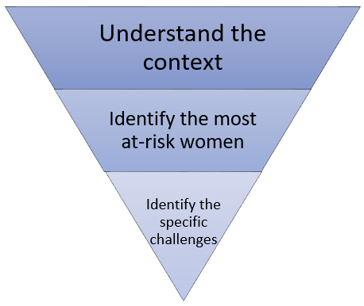

Steps
Taking into account the analysis conducted in the previous part, you will first take a step back and further question your findings. This will allow you to identify which are the most relevant discrimination factors for your sector of intervention, therefore which are the people most at risk, the groups of individuals that you will target with your project.
To do so, try and answer some additional questions.
- Are there any policies or programs that address the issues analyzed above?
- Which identities or groups are left behind?
- Who are the most marginalized and discriminated against groups?
- Who are the least autonomous individuals?
- Which individuals are most exposed to violence?
- Who are the most discriminated, excluded and isolated women?
- What are the specific challenges do they face?
- Which are the key discrimination factors to consider?
Who do we want to reach and work with? Based on the key discrimination factors, define who are the women we want to work with and why.
- What are their particular characteristics?
- What are their strengths and assets?
- What difficulties or obstacles may they face?
Summarize your findings below:

Last, you will deepen your knowledge of the groups you want to work with. To do so, you must meet with them directly. Involving women themselves and hearing their experiences and perspectives will contribute to valuing and empowering them in their diversity as main actors of change through their meaningful participation and leadership. The most at-risk and marginalized people are often isolated (socially or geographically), and do not necessarily have any links with associative or activist communities or any opportunities to meet them.
You can proceed by:
Conducting community discussion: Connect and communicate with your community allies - community partners, local organizations, schools and other local resources - and gather their perspectives on the needs and experiences of women in the community. Then directly consult the people concerned to ensure that you understand the issues and their own experiences, in which they are the experts. You can identify and list the organizations, associations and other stakeholders you think could be relevant to speak to in a “stakeholders identification mapping” document, with any additional points you wish to keep in mind at this stage of the process (contact details, what do they do, where are they located, information you want to collect etc.).
In order to prepare, you can create a discussion guide with the questions you want to ask the different stakeholders you will meet. It will help you to structure and facilitate the discussion. Discussion guides should be adapted to the different people you will speak with.

Organize Focus Group Discussions (see Annex 5): in a familiar and accessible place, find solutions to encourage participation. It is important to collaborate with associations and community partners, to make sure that the participants reflect the diversity of the population you wish to work with. It is all about creating a "safe place" to connect with the people and understand the challenges they face (admitting that you do not necessarily understand their reality, accepting and validating their experiences). Organize discussion and meetings/group discussions with the community members directly at field level, ensuring accessibility and representation (consultation and discussion with women from different social groups and backgrounds, going beyond the networks you are familiar with). The Annex 5 is an example of a discussion guide co-created with the organization IFA (Inclusive Friends Association) to conduct Focus Group Discussions with women with disabilities in Plateau State, Nigeria.
In this last part, you furthered your thinking on who you want to work with, how to reach them, and what challenges they are facing. To conclude and have a more organized view of these significant findings, please fill the table below:
Most at-risk people/women/groups | How to reach out to them (the key stakeholders, the representative organizations, identified leaders, etc.) | Key issues and challenges
Ex: single mothers living in rural areas

Now that you have analyzed the social issues more thoroughly, you have identified your targets/the persons and groups you want to work with, and have a thorough knowledge of their needs. You connected with representatives of those groups and the women/individuals themselves. You are ready to design an effective and relevant intervention that will take into account both the diversity of your team, and of the people you will support.
We welcome feedback on this How-To Guide ! Contact Sophie Pecourt, MIW Coordinator, at s.pecourt@hi.org

APPENDICES
- The ecological model
As seen in the first tool, the ecological model is a good way to explore in more detail the different circles of influence and start thinking about the dynamics and interactions between them. It allows us to represent ourselves within different circles of interaction.  Whereas the first tool focused on the ‘’individual’’ and organizational levels, we’re now branching out to explore other circles of influence such as “relationship” “community” and “society”. This provides us with in-depth knowledge and understanding of how external factors relative to a specific context and environment affect the lived experiences of individuals. | The Ecological Model
- Key points to apply an intersectional approach (from GBA+)
Understanding diverse perspectives: fundamentals for applying an intersectional approach. Taking multiple and diverse intersecting identity factors into consideration can be complex. It is important to remember that there is no one single – or “right” – way to apply an intersectional approach; however, there are some fundamentals to keep in mind:
- Identify the multiple and diverse identity factors that impact people's experiences
- Analyze your own position and perspective in relation to the issue or initiative that you are working on (i.e. how do your biases affect your perception and/or work on the issue?)
- Accept that there are various factors that contribute to an experience or an outcome (e.g. power relations intersecting with systematic factors intersecting with where we live – urban vs. rural, plains vs. mountains)
- Identify other factors, including external ones, that shape experiences
People can experience advantages and disadvantages simultaneously (e.g. a biological male may experience some of the advantages of being male but may also experience some disadvantages because of the intersection of his male identity and his racial identity. Specific stereotypes exist for men of different ethnicities and specific stereotypes exist for women of different ethnicities, because of the interplay between gender and race.) Women with disabilities are not a homogeneous group and other factors may come into play and therefore have to be included in the data collection and analysis.
- The importance of talking with concerned the people
During this analysis, the aspects seen in the previous tool should always be kept in mind: questioning assumptions, making sure to consult different sources, resources and points of view. Working with an intersectional approach also means taking into account and ensuring that power relations are reduced. If your objective is to empower women through economic activity, for example, it is essential that you reach out to all women and do everything possible to reach those who are most isolated. This will ensure that all people are included and their specific needs are identified. For example, reaching out to religious or community leaders for information is a good step but will be limited since you will only have access to their own perspective and knowledge, as person of power among the community. The people concerned must be consulted directly as they are the experts regarding their own experiences and therefore the best placed to provide you with the information you are looking for.
- What do we mean by “context”?
Context and environment refer to a set of elements, conditions, structures and circumstances in which individuals live and interact. Depending on the positions of different individuals in a given context or situation, the environment could be perceived differently from one person to another. In order to remain as objective as possible, information has to be collected from a variety of sources to produce a structured and evidence-based context analysis.
- Focus Group Discussion guide
This discussion guide was co-created by Making It Work and IFA (Inclusive Friends Association) as part of an in-depth assessment and context analysis through an intersectional lens, in the preliminary phase of the implementation of a project to fight against gender-based violence in Plateau State, Nigeria. This document was produced for a specific context and is presented only as an example.
PRELIMINARY PHASE
Focus Group discussion guide – Community dialogues
WITH WOMEN WITH DISABILITIES
INTRODUCTION:
This document is a proposed template for a discussion with women with disabilities. The question guide is used by IFA facilitator who is steering the discussion. A second person is needed to take notes and document the discussion.

Date: |  | Name of facilitator(s):
Location: |  | Name of note taker(s):
Time:  From:  To: |  | If presence of interpreters/sign language interpreter, specify name, surname, position:
OBJECTIVE:
- Collect information and data in order to understand the lived experience of women in their diversity, with their own perception of their own experience, taking into account different identity factors and individual characteristics
- The objective is to understand the point of view of women and girls without judgement, and to create a safe space where they feel free to express themselves.
GENERAL INSTRUCTIONS:
- Introduce yourself, as the facilitator, the note taker(s) as well as any other person (sign language interpreter, if any); clarify what your roles are;
- Explain the objective of the FGD clearly and mention that there are no ‘’right or wrong answers’’;
- Explain that you are interested to learn from them, to listen experience sharing and different opinions, without judgment;
- Clarify the intended use of the FGD outcomes and what is expected of the participants;
- Explain that participants will remain anonymous; (i.e. ‘’we do not write down your names and they will not appear anywhere in the information filed’’).
- Ask for permission to take notes and/or pictures and, if relevant, to record the discussion.

Focus group composition:
Note:
- No more than 7 to 8 members / group
- Attendance list (with data disaggregated) is required
Sex: | ☐ Male ☐ Female ☐ Mixed group
Total number of participants | Female | Male
Age groups | ☐ 15-17  ☐ 18-25  ☐ 26-49  ☐ Elders (50+) | ☐ 15-17  ☐ 18-25  ☐ 26-49  ☐ Elders (50+)
Disability | If FGD is conducted with women with disabilities, specify the types:  ☐ Physical impairment ☐ Sensorial impairment  ☐ Intellectual impairment ☐ Mental impairment
Location: | LGA: | District:
- Name of villages/ communities (if relevant):

QUESTIONNING GUIDE:
Questions:
- Could you tell us what you do in your daily life? What are your daily activities? What is your daily life like? And what about girls?
- What types of disabilities do people in your community have? (if needed give examples)
- In your opinion, do you think you have the same rights as everyone else? (in your family, community, society?)
Yes, absolutely ☐ Not all of them ☐ Not at all ☐ Not sure ☐

Please, explain your point of view (‘’self-perception’’): which ones, etc.:
- Do these rights give you access to the same services (health; education; job opportunities; etc.) as anyone else/on an equal basis with others (from your family? Community? Society?):
Yes, absolutely ☐ Not all of them ☐ Not at all ☐ Not sure ☐
Please, explain and share examples (if you have)
- How does the community treat women and girls with disabilities?
In your opinion, why is this the case?
- Do you ever feel discriminated against based on your appearance/disability?
Yes, always ☐ Yes, sometimes ☐ Never ☐ Not sure ☐

And based on other individual characteristics?
- Age: Yes, absolutely ☐ Yes, sometimes ☐ Not at all ☐ Not sure ☐
Gender (being a woman/girl): Yes, absolutely ☐ Yes, sometimes ☐ Not at all ☐ Not sure ☐
Ethnicity: Yes, absolutely ☐ Yes, sometimes ☐ Not at all ☐ Not sure ☐
Religion: Yes, absolutely ☐ Yes, sometimes ☐ Not at all ☐ Not sure ☐

Do you think other characteristics (than those listed above) can negatively impact the lived experience of women and girls? …………………………………………………………….
Please explain:
- What made you feel that you were discriminated against?
In which specific areas of life do you feel you are discriminated against?
What do you do when facing/experiencing discrimination? (reformulate if needed to ensure better understanding and adapt to the person you are speaking to)
- What violence and discrimination (experiences + challenges) do you experience in the community? in accessing services? Etc.

What forms of discrimination do you face (if any), as a result of one or several of your “identity characteristics/factors”? (reformulate if needed to ensure better understanding and adapt to the person you are speaking to)

What about girls with disabilities?
Do you think women and girls with disabilities in particular are more impacted by discrimination and violence due to their disability? Yes ☐ No ☐ Not sure ☐

Please explain;

How does it differ according to the type of disability, gender, and/or other factors?

How does this discrimination impact your daily life? Could you give examples?
- In which circumstances do you think you are more discriminated against? Less discriminated against?
- What do (you) women and girls with disabilities do to protect (yourself) themselves from violence?

What support/help systems do you have? What does the community do to protect women and girls with disabilities?
- Who is aware of services that help to respond to or reduce gender-based violence in this community?
- Do you feel safe (to explain: notion of safety/security: free from harm/danger/risks/violence) living in your family? community?

What makes you feel unsafe?
Or:
In this community, where do women with disabilities feel safe?...............................................................
Where do they feel unsafe or avoid going? ……………………………………………………………………………………..
What makes this place safe or unsafe? What could be done in this community to create a safe environment for women and girls with disabilities?
- Which girls or women are the most isolated in the community?
What difficulties do they face?
- Compared to other women in the community, do you think you are:
- More discriminated against?
Yes ☐ No ☐ Not sure ☐ + Explain: based on which factor: ………………………………………………..
- Less discriminated against?
Yes ☐ No ☐ Not sure ☐ + Explain:

Which characteristics/factors makes you feel more protected/powerful/valuable within the family/community)
(reformulate if needed to ensure better understanding)
Please explain:
- Do you hold any position of repute in your community? Are you a member of any group in your community? (e.g. age group, community leaders, political, etc.?)
- Do you think specific people/ groups of people have more power within the community?
Yes ☐ No ☐ Not sure ☐
Could you explain what (specific factors) give them power/make them powerful? (see if gender, age, religion, location, education background, resources, etc. are mentioned)

- Do you think you have power (are powerful) in the community?
Yes, always ☐ Yes, sometimes ☐ Not really ☐ Not at all ☐

Please explain:
- What limits your access to some forms of power? (to look at the impact of different identity factors and to see what comes up: cultural beliefs, traditional practices, and/or identity factors and individual characteristics; etc.)
- In what circumstances do you think you are more powerful? And less powerful?
- In your opinion what can be done to prevent violence against people with disabilities?
- What obstacles do people and women with disabilities face in accessing services, jobs opportunities, etc.? Why? What options are available to people and what limits them?
- How do you think the situation of women and girls with disabilities can be improved in term of accessibility to services, health, education, employment?
- What would you like to do if you could choose an activity, job or education?
ADDITIONAL TOPICS AND COMMENTS:
Are there any other issues relative to inequalities and discrimination concerning women and girls you think are important and would like to talk about?
Remarks and additional comments: (from the contact person; from IFA)

Disability project.
This How-To Guide was developed by Inclusive Friends Association Nigeria and the Humanity&Inclusion Making It Work Gender and Disability project.

Reference document used to develop the How-To-Guide: https://knowledgetranslation.net/wp-content/uploads/2020/08/Intersectionality_KT_Reflection_Workbook_20200317_FD.pdf
From Intersectionality & Knowledge Translation, Reflection workbook
Intersectionality & Knowledge Translation, Reflection workbook; Gender Based Analysis +; Canadian Centre for Diversity and Inclusion - Toolkit 3
Gender Based Analysis +; Intersectionality & Knowledge Translation, Reflection workbook; Intersectionality Toolkit (IGLYO)
Gender Based Analysis +
Lesbian, gay, bisexual, trans and other sexual orientation
Refer to the Tool.1 when exploring what diversity means, taking into account different identity factors, background, etc.
FAO. 2019. Guide to context analysis: Informing FAO decision-making – Approaches to working in fragile and conflict affected contexts. Rome
Comité québécois femmes et développement, fiche technique « L’intersectionnalité »
Toolkit Mentoring girls Canadian women’s foundation; Gender Based Analysis +
Gender Based Analysis +
Focus group discussion age groups: the FGD is composed either of one age group or a balanced mix of different age groups. Adults could be split up in three groups (18-25, 26-49, 50+) or merged in one. The below table is therefore only indicative.
Do not forget to seek consent if the group discussion is organized with young people (15 to 17 years old)

