A long way to go: Inclusion of women with disabilities in African Gender-Based Violence policies
  - Policy review across 27 countries
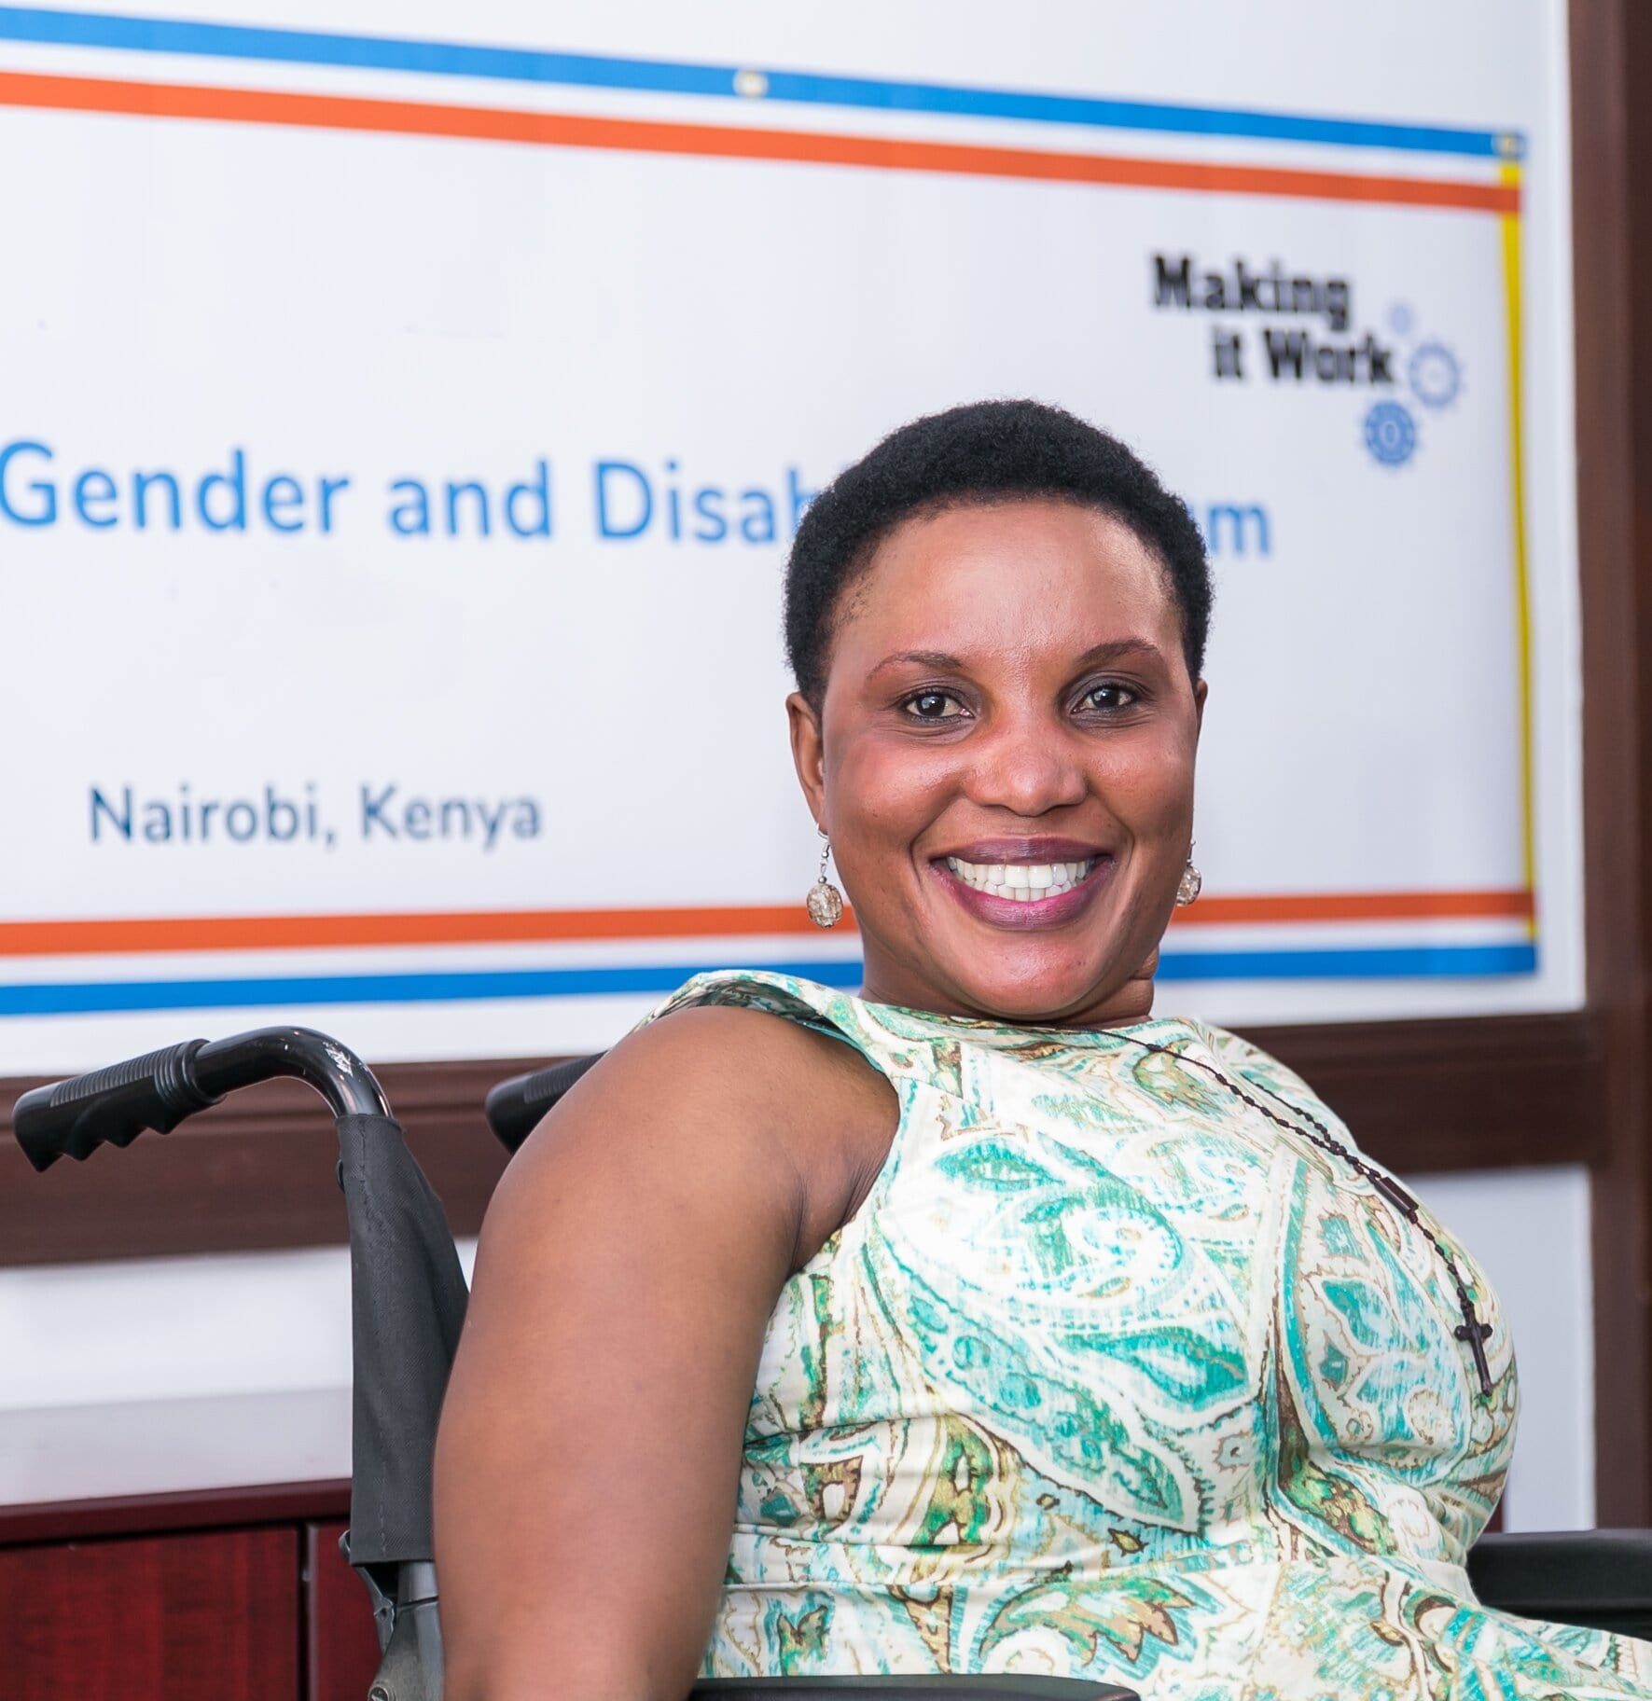
Inès Ayyadi, Sophie Pecourt, Humanity & Inclusion, Making It Work, Gender and Disability project.
December 2020.
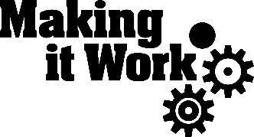
Time for effective inclusion
This policy review aims at measuring the level of inclusion of women with disabilities in the national policies addressing Gender-Based Violence (GBV) in African countries. Our analysis was conducted using a measuring tool, which is displayed at the end of the document.
One in five women is a woman living with a disability, yet very few policies are built to ensure and protect the rights of women with disabilities specifically. Although some policies entail inclusive measures, which deserve to be highlighted, this study sheds light on the huge lack of inclusion and equality of GBV policies.
Inclusion, intersectionality and diversity are at the centre of the conversation; policies should be inclusive, protecting those facing intersecting forms of discrimination. Women with disabilities are invisible in two-thirds of GBV policies: this review of 27 GBV policies across the African continent demonstrates that there is still a long way to go.
This document gathers elements to guide policy makers on building stronger and more inclusive policies. We also hope it can inspire women-led civil society organizations to review existing policies, because the better the assessment of exclusion, the more chances we get to fix it.
The measuring tool was built thanks to the contribution of Lucky Mahenzo Mbonani and Professor Arlene S Kanter from Syracuse University, College of Law, with guidance from the Making It Work Technical Advisory Committee members.
Contact Sophie Pecourt, Making It Work coordinator: s.pecourt@hi.org
MakingItWork.hi.org

Summary
About the tool 4
Five levels of inclusion 4
Categories of inclusion 4
Key findings 5
Best results: 5
Less inclusive areas: 6
There is hope 7
Conceptualisation: 7
Data and evidence: 7
Accessibility: 7
Participation: 8
Recommendations 8
Scoring tool 9
Global results 11
List of policies reviewed 13
Method to calculate the score of inclusion 14
Resources 14
Credits 14

About the tool

Five levels of inclusion
27 gender-based violence policies have been analysed. By the end of the analysis, each policy obtained a “score of inclusion”. This score shows to what extent the policy is inclusive of women with disabilities based on a "scale" divided in 5 levels of inclusion:
- Invisible: No or few mentions of women with disabilities.
- Awareness: Mention of women with disabilities, discrimination is seen as important to address but there are no adequate resources nor specific practices towards them.
- Intentional inclusion: Women with disabilities are not only mentioned but targeted by specific practices.
- Strategic inclusion: Long term, strategic measures are taken to ensure women with disabilities can enjoy their rights. Provisions for monitoring and accountability are made.
- Culture of inclusion: Women's multiple identities are considered and supported and systemic processes for maintaining inclusion are enforced.

Categories of inclusion
The tool was built around five categories of questions:
- Conceptualisation: Questions seek to analyse whether the policy refers to women with disabilities, acknowledges their vulnerability to GBV and prioritize their needs. The policy should adopt a twin track approach: ensuring that women with disabilities have access to their basic needs in all services on an equal basis with other women, while also addressing their specific needs.
- Data and evidence: Questions seek to analyse whether the policy requires data on GBV against women with disabilities and data about the accessibility of services.
- Accessibility and inclusive services: Questions seek to analyse whether the policy includes the concept of accessibility to all users and specific provision for vulnerable groups including women with disabilities. The policy should provide instructions on the provision of accessible services and information. It should also ensure that service providers are trained on working with women with disabilities who are victims/survivors of GBV.
- Participation and coordination: Questions seek to analyse whether the policy establishes partnerships with organizations of women with disabilities to develop, enforce and monitor the policy provisions. The policy should ensure monitoring of accessible service provision.
- Resource mobilization: Questions seek to analyse whether dedicated financial resources are mobilized to prevent and respond to GBV against women with disabilities.

Key findings
  - A long way to go
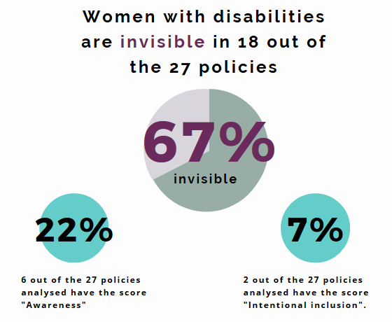
- Women with disabilities are invisible in 18 of the 27 policies analysed (67%).
- 6 out of the 27 policies analysed have the score “Awareness” (22%).
- 2 out of the 27 policies analysed have the score “Intentional inclusion” (7%).

Best results:
The most inclusive policies are:
- South Africa, National GBV and Femicide Strategic Plan 2020-2030: Strategic inclusion.
- Cabo Verde, National plan to combat GBV (PNVBG 2015-2018): Intentional inclusion.
- Zimbabwe, National Program on GBV Prevention and Response 2016-2020: Intentional inclusion.
- Rwanda, National Strategic Plan for Fighting Against Gender-based Violence 2011-2016: Awareness.
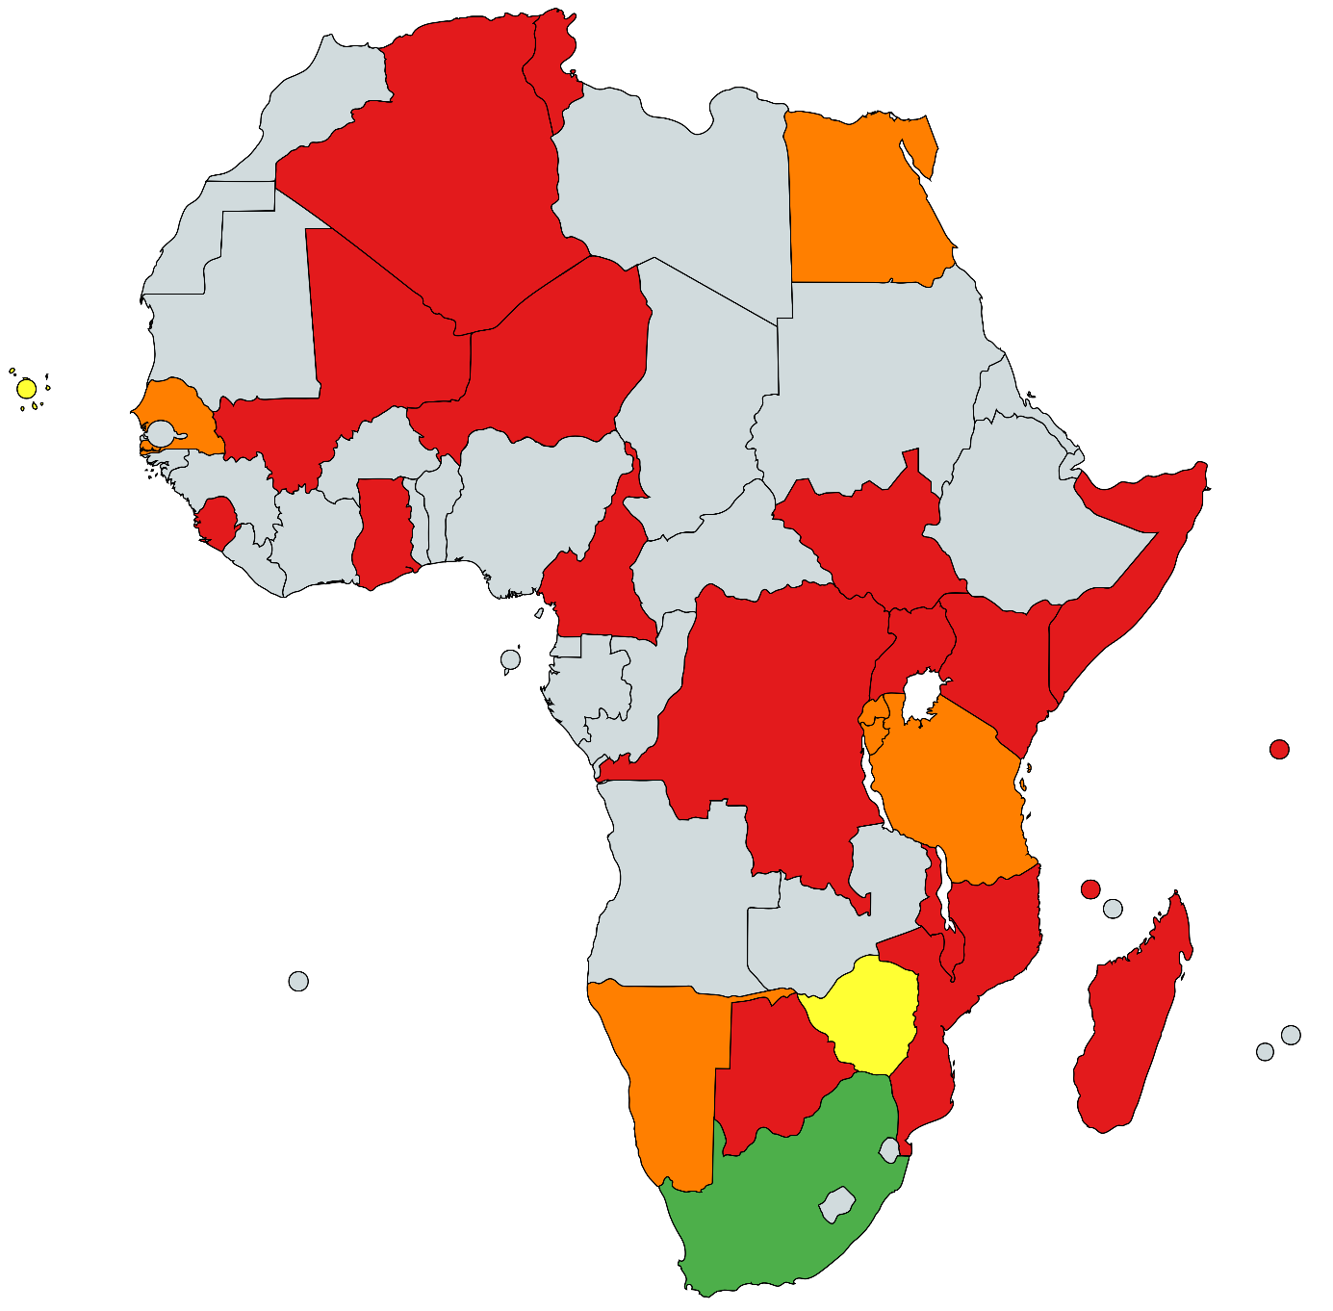

Less inclusive areas:
Conceptualisation: 93% of policies do not prohibit the use of forced sterilization, forced abortion and forced contraception on women with disabilities.
Accessibility and inclusive services: 89% of policies do not ensure the training and supervision of service providers (shelter staff, social workers, medical personnel) about the rights and needs of women with disabilities and how to provide respectful care; nor the training of police, judicial officials or other law enforcement personnel on responding to women with disabilities who are victims/survivors of GBV.
Participation: 83% of policies do not engage organizations of women with disabilities in the development of GBV programs and policies.

Score by category: from theoretical to effective inclusion
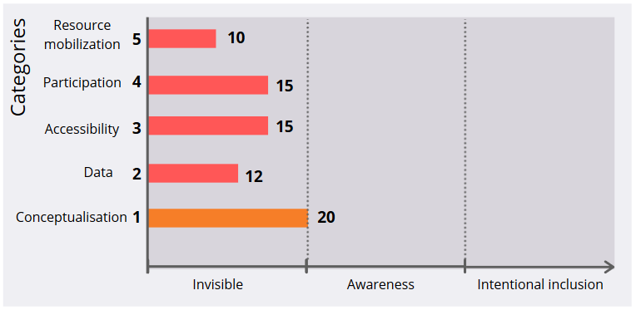
We have shown that among the 27 analysed policies, women with disabilities are visible in only 9 of them. Looking into the different categories of inclusion, as illustrated above, it appears that most of the inclusive provisions belong to the category called Conceptualisation. This category is looking at whether the policy refers to women with disabilities, acknowledges their vulnerability to GBV and prioritize their needs.
Our study shows that even when women with disabilities are mentioned in the introduction of a policy, there is very little translation into practical provisions dealing with data, accessibility, participation, or funding.
The inclusion of women with disabilities remains performative and does not translate into concrete measures.
There is an urgent need to shift from theoretical inclusion to effective inclusive policies.

There is hope
  - Focus on inclusive provisions
Some of the policies analysed presented a few innovative and inclusive provisions to tackle GBV. Here are a few ideas on how to conceive better policies, meaning policies that encompass the complexity and diversity of women’s identities, in order to leave no woman behind.

Conceptualisation:
- Egypt foresees that GBV affects "in particular women and girls with disabilities who, as a result of their disabilities, are more prone to become victims of violence."
- Senegal acknowledges the mental and physical harm caused by GBV: “Victims suffer serious physical and psychological consequences.”
- South Africa insists on the intersecting forms of discrimination “As such, it can be suggested that women with disabilities face multiple forms of oppression as gender, violence, and disability intersects and shapes the life experiences of a person already experiencing discrimination.”

Data and evidence:
- Tunisia reaffirms that “Data relating to the victim and the perpetrator should at a minimum be distinguished by sex, age, type of violence and relationship between victim and perpetrator, geographical location, as well as other factors considered relevant, such as disability.”
- South Africa, assesses the accessibility of services by ensuring that the “Mapping of services assists to […] determine the accessibility of services in terms of geo-location, language, age, disability and diverse needs of survivors.”

Accessibility:
- Tanzania recognizes the necessity of “Creating and sustaining safe and accessible spaces for women and children throughout our communities" p10 and that "efforts must be made to improve access to services for those groups that are marginalized, likely to be excluded, or face barriers to accessing services."
- Namibia guarantees that "Wherever possible the National Disability Council will also take responsibility for ensuring that information and messages generated by stakeholders are distributed to their constituent organizations. While specialized versions, such as braille and sign language remain the gold standard, the Plan encourages stakeholders to utilize simple appropriate technology (e.g. voice notes for visually impaired, text messages for hearing impaired) where the gold standard is not available or affordable."

Participation:
- Ghana includes in the policy making process “Associations of persons with disabilities.”
- South Africa commits on “Community Dialogues held in collaboration with civil society on critical GBV areas such as […] rights of womxn living with disability.”

Recommendations
  - Let’s build policies that leave no woman behind!
- Ensure the rights of women with disabilities are mainstreamed in all policies related to gender equality, GBV, Sexual and Reproductive Health and Rights, harmful practices.
- Ratify the Convention on the Rights of Persons with Disabilities (CRPD) and the Convention on the Elimination of all Forms of Discrimination Against Women (CEDAW) and translate it into national legislation.
- Ratify the Protocol to the African Charter on Human and Peoples' Rights on the rights of persons with disabilities in Africa, which explicitly tackles the different forms of violation that women and girls with disabilities in Africa are particularly at risk of.
- Refer to regional tools such as the Southern African Development Community (SADC) Gender Protocol Barometer and other inclusive documents when building policies.
- Include organizations of women with disabilities in the design, implementation, monitoring and evaluation of all policies related to gender equality, GBV, SHRH, harmful practices.
- Support organizations of women with disabilities to ensure representation.
- Always consider the intersection of gender, disability and age, among other factors (socio special inequalities, ethnicity, poverty, migrant women, sex workers, etc.) in policy-making.
- Establish governance bodies, which include ministries, civil society and women with disabilities to monitor the implementation of national policies and strategies.

Scoring tool
- Conceptualisation
  - Does the document mention women with disabilities? (yes/some/no; comments)
  - Does the document identify women with disabilities as a marginalized/most discriminated group? (yes/some/no; comments)
  - Does the document state the disproportionate risk of GBV women with disabilities face?
  - Does the document state the specific needs of women with disabilities?
  - Does the document recognize the compounding inequities resulting from discrimination on grounds of gender, disability, ethnicity, LGBTQI+ and diverse SOGIESC, socio-economic status?
  - Does the document promote the recognition of the diversity within women with disabilities?
  - Does the document establish the causal link between GBV and a physical impairment/serious psychological trauma?
  - Does the document include any strategies on prevention and elimination of gender-based violence against women and girls with disabilities?
  - Does the document prohibit the use of forced sterilization, forced abortion and forced contraception on women with disabilities?
  - Does the document encourage investigation, prosecution and punishment of perpetrators of gender-based violence against women with disabilities?
- Data and evidence
  - Does the document promote data collection on GBV that is disaggregated for women with disabilities / Have indicators with targets on GBV amongst women with disabilities?
  - Does the document collect data on the availability and accessibility of services and accommodations for women and girls with disabilities?
- Accessibility and inclusive services
  - Does the document ensure that all GBV response programs, complaint mechanisms and services for survivors (SRHR, shelters, psychosocial support, suitable medical equipment, etc.) are fully accessible?
  - Does the document ensure that information about GBV laws and policies and GBV prevention and response is provided in a variety of accessible formats?
  - Does the document ensure all phases of accessing justice for survivors of GBV are accessible (physically accessible police stations and courts, available Sign Language interpretation, etc.)?
  - Does the document ensure training and supervision of service providers (shelter staff, social workers, medical personnel) about the rights and needs of women with disabilities and how to provide respectful care; and the training of police, judicial officials or other law enforcement personnel on responding to women with disabilities who are victims/survivors of GBV?
- Participation and coordination
  - Does the document engage organizations of women with disabilities in the development of GBV programs and policies?
  - Does the document engage organizations of women with disabilities in the implementation and monitoring of GBV programs and policies?
- Resources mobilization
  - Does the document include separate budget line items for ensuring equal access to GBV prevention and response programming for women with disabilities?
  - Does the document allocate resources for organizations of women with disabilities to participate in the development, implementation and monitoring of GBV programs and policies?
  - Does the document allocate specific subsidies to women with disabilities who are survivors of GBV?

Global results
Country | Policy | Score of inclusion | Level of inclusion
Algeria | Stratégie Nationale de Lutte contre la Violence à l'égard des Femmes (2007-2011) | 5 | Invisible
Botswana | National Gender-Based Violence Strategy (2015-2020) | 0 | Invisible
Burundi | Plan Stratégique National de lutte contre les Violences Sexuelles Basées sur le Genre (2018-2022) | 26 | Awareness
Cabo Verde | Plano nacional de comate à Violência Baseada no Género (2015-2018) | 52 | Intentional inclusion
Cameroon | Stratégie Nationale de lutte contre les Violences Basées sur le Genre (2017-2020) | 5 | Invisible
Comoros | Stratégie Nationale de lutte contre les Violences Basées sur le Genre (2018-2030) | 7 | Invisible
Congo, Democratic Republic of the | Feuille de route nationale de l’appel à l’action pour la protection contre les violences basées sur le genre (VBG) en République Démocratique du Congo (2018-2020) | 18 | Invisible
Egypt | National Strategy for Combating Violence against Women (2015-2020) | 25 | Awareness
Ghana | National Domestic Violence Policy and the Plan of Action to Implement Domestic Violence Act, 2007 (2009-2019) | 10 | Invisible
Kenya | National policy for prevention and response to GBV (2014) | 5 | Invisible
Madagascar | Stratégie Nationale de Lutte contre les Violences Basées sur le Genre (2016-2020) | 5 | Invisible
Malawi | National Plan of Action to Combat Gender-Based Violence in Malawi (2014 – 2020) | 14 | Invisible
Mali | Programme National de Lutte contre les Violences Basées sur le Genre (2018) | 0 | Invisible
Mozambique | Plano Nacional de prevenção e combate à Violência Baseada no Género (2018-2021) | 3 | Invisible
Namibia | National Plan of Action on Gender-Based Violence (2019-2023) | 22 | Awareness
Niger | Stratégie Nationale de Prévention et de réponse aux Violences Basées sur le Genre au Niger (2017-2021) | 7 | Invisible
Rwanda | National Strategic Plan for Fighting Against Gender-based Violence (2011-2016) | 31 | Awareness
Senegal | Plan d'action national de lutte contre les Violences Basées sur le Genre et la promotion des droits humains du Sénégal (2015) | 24 | Awareness
Seychelles | Domestic Violence Act (2020) | 4 | Invisible
Sierra Leone | Sierra Leone National Action Plan on Gender-Based Violence (2012-2016) | 0 | Invisible
Somalia | Somalia National Gender-Based Violence Strategy (2018-2020) | 0 | Invisible
South Africa | National Gender-Based Violence and Femicide Strategic Plan (2020-2030) | 70 | Strategic inclusion
South Sudan | Standard Operating Procedures for Prevention and Response to Sexual and Gender-based Violence (2014) | 0 | Invisible
Tanzania | National Plan of Action to End Violence Against Women and Children 2017/18 –2021/22) | 24 | Awareness
Tunisia | Stratégie Nationale de lutte contre les Violences Faites aux Femmes (2016) | 18 | Invisible
Uganda | National Policy and Action Plan on Elimination of Gender -Based Violence (2016) | 8 | Invisible
Zimbabwe | Zero Tolerance for GBV 365, A National Programme on GBV Prevention and Response (2016-2020) | 36 | Intentional inclusion

List of policies reviewed
- Algeria, Stratégie Nationale de Lutte contre la Violence à l'égard des Femmes (2007-2011)
- Botswana, National Gender-Based Violence Strategy (2015-2020)
- Burundi, Plan Stratégique National de lutte contre les Violences Sexuelles Basées sur le Genre (2018-2022)
- Cabo Verde, Plano nacional de combate à Violência Baseada no Género (2015-2018)
- Cameroon, Stratégie nationale de lutte contre les violences basées sur le genre (2017-2020)
- Comoros, Stratégie Nationale de lutte contre les Violences Basées sur le Genre (2018-2030)
- Congo, Democratic Republic of the, Feuille de route nationale de l’appel à l’action pour la protection contre les violences basées sur le genre (VBG)en République Démocratique du Congo (2018-2020)
- Egypt, National Strategy for Combating Violence against Women (2015-2020)
- Ghana, National Domestic Violence Policy and the Plan of Action to Implement Domestic Violence Act, 2007 (2009-2019)
- Kenya, National policy for prevention and response to GBV (2014)
- Madagascar, Stratégie Nationale de Lutte contre les Violences Basées sur le Genre (2016-2020)
- Malawi, National Plan of Action to Combat Gender-Based Violence in Malawi (2014 – 2020)
- Mali,Programme National de Lutte contre les Violences Basées sur le Genre (2018)
- Mozambique, Plano Nacional de prevenção e combate à Violência Baseada no Género (2018-2021)
- Namibia, National Plan of Action on GBV (2019-2023)
- Niger, Stratégie Nationale de Prévention et de réponse aux Violences Basées sur le Genre (VBG) au Niger (2017-2021)
- Rwanda, National Strategic Plan for Fighting Against Gender-based Violence (2011-2016)
- Senegal, Plan d'action national de lutte contre les VBG et la promotion des droits humains du Sénégal (2015)
- Seychelles, Domestic Violence Act (2020)
- Sierra Leone, Sierre Leone National Action Plan on GBV (2012-2016)
- Somalia, Somalia National GBV Strategy (2018-2020)
- South Africa, National GBV and Femicide Strategic Plan (2020-2030)
- South Sudan, Standard Operating Procedures for Prevention and Response to Sexual and Gender-based Violence (SGBV) (2014)
- Tanzania, National Plan of Action to End Violence Against Women and Children 2017/18 –2021/22)
- Tunisia, Stratégie nationale de lutte contre les violences faites aux femmes (VFF) (2016)
- Uganda, National Policy and Action Plan on Elimination of Gender -Based Violence (2016)
- Zimbabwe, National Programme on GBV Prevention and Response (2016-2020)

Method to calculate the score of inclusion
The scoring tool has 21 questions to measure the inclusion of women with disabilities. In order to give a score to the GBV policy, we calculate the score built as follow:
- Each “yes” gets 1 point.
- Each “some” gets 0,5 point.
- Each “no” gets 0 point.
- If a question refers to a measure which was not conceived in the policy, the result is written as “Na”- non available, and the question is removed from the final calculation.
The score is the addition divided by the number of questions answered, which gives us a final percentage fitting in one the five levels of inclusion.
NB: The goal is not to establish what the perfect GBV policy would be, but rather to measure how women with disabilities are included in existing provisions.

Resources
The full database of results of the analysis is available here.
The main inspiration to build the scoring tool were the following documents.
- The right to access, Regional Strategic Guidance to increase access to SRHR for Young Persons with Disabilities in East and Southern Africa, SAMRC, UNFPA, KPMG, UKAid, 2017, page 95
- Young Persons with Disabilities: Global study on ending GBV and realising SRHR, Aecid, WeDecide, UNFPA, 2018
The scoring levels and their definition have been inspired by:
- The Alberta Urban Municipalities Association, Measuring inclusion tool, 2017, page 9.

Credits
Copyright Arnold Temple Visuals, Kenya, 2019.

The term « womxn » is used as a word welcoming trans and non-binary individuals, as well as each person who identifies as a woman regardless of assigned sex at birth.

