REPORT OVERVIEW | 2018
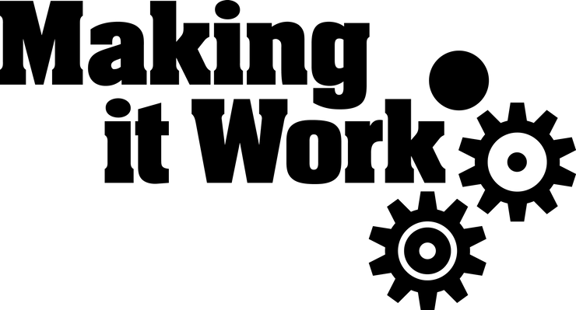 | GENDER AND DISABILITY INTERSECTIONALITY IN PRACTICE: WOMEN AND GIRLS WITH DISABILITIES ADDRESSING DISCRIMINATION AND VIOLENCE IN AFRICA

SUMMARY
The 2018 Making It Work report “Gender and disability intersectionality in practice Women and girls with disabilities addressing discrimination and violence in Africa” documents 9 good practices across 6 African countries. The practices are carried out by Disabled Persons’ Organizations (DPOs) and Women’s Organizations and are prime examples of concrete experience on how to address issues faced by women and girls with disabilities.
From those good practices emerged key recommendations targeting States, International Organizations, development actors and stakeholders working on disability and gender-related issues. Through this work, key actors from both the gender equality and the disability rights movements call for the effective prevention and response to the violence experienced by women and girls with disabilities at the national, regional and international level.
The Making It Work Gender and Disability report is available by following this link.

WHAT IS MAKING IT WORK?
The Making It Work Gender and Disability project aims at eliminating discrimination and violence against women and girls with disabilities, by advocating for their rights using well-documented good practices as evidence.
The MIW project involves:
- A project team located at HI headquarters,
- A Technical Advisory Committee made up of individual members and representatives from key organizations working on disability rights, women's rights and human rights,
- Regional and country partners including the Good Practice Holders.

KEY RECOMMENDATIONS:
The following recommendations are short extracts from the Making It Work report.
- Tackle stigma and discrimination harming women and girls with disabilities.
- Empower women and girls with disabilities to access economic opportunities and justice.
- Ensure that acts of violence against women and girls with disabilities are brought to justice through enhanced access to justice and fight against impunity.
- Include women and girls with disabilities in legal and policy frameworks.
- Collect inclusive evidence, and data disaggregated by gender and disability.
- Foster sustainable collaboration across gender and disability movements.
- Provide accessible safe spaces for women and girls with disabilities and led by women with disabilities.
- Allocate resources to the inclusion of women and girls with disabilities.
- Acknowledge and support the engagement and leadership of women with disabilities, in line with the “nothing about us without us” principle of the Convention on the Rights of Persons with Disabilities (CRPD).
- Ensure decision-making rights of women and girls with disabilities.

AFRICAN GOOD PRACTICES
Criteria used for the selection of the good practices
- Achieved positive changes.
- Diversity of persons involved in the practices.
- Leadership of women with disabilities.
- Aiming for gender equity.
- Collaboration with women and girls with disabilities.
- Potential for being scaled up.
The following content presents the key elements that make each practice successful and unique. For more information about the practices, please refer to the full MIW report.

Gender-Based Violence prevention through a grassroots initiative led by women with disabilities
Rwandan Organization of Women with Disabilities (UNABU), RWANDA
- Full leadership of women with disabilities within UNABU at managing level and community level.
- Community mobilizers trained on women’s rights issues and gender-based violence (GBV) provide training to the groups, reaching more than 680 women and girls with disabilities and mothers of girls with disabilities.
- Experience-sharing and peer support within community groups.
- Legal support for women with disabilities to access justice in cases of economic violence or sexual abuse, in partnership with legal actors.
- Joint submission to the Committee on the Elimination of all forms of Discrimination Against Women (CEDAW) highlighting the situation of women and girls with disabilities in the country, in partnership with Human Rights First Rwanda and Uwezo Youth Empowerment.

Protecting urban refugee women and girls with disabilities from abuse and discrimination in Kenya
Women Challenged to Challenge (WCC), KENYA
- Strategic partnerships with specialized regional and international organizations like the Network of African Women with Disabilities, HIAS and the Women’s Refugee Commission.
- Training of urban women refugees with disabilities on their rights.
- Facilitation to access services such as procurement of refugee cards or access to assistive devices when necessary.
- Advocacy in key international events such as the World Humanitarian Summit 2016, and the 9th Conference of States Parties to the Convention on the Rights of Persons with Disabilities.

Advancing the access of deafblind women and girls to Sexual and Reproductive Health
Visual Hearing Impairment Membership Association (VIHEMA), MALAWI
- Focusing on deafblind women and girls, recognized by the Committee on the Rights of Persons with Disabilities as women at a greater risk of facing abuse.
- Training deafblind women and their relatives on their rights and their Sexual and Reproductive Health and Rights (SRHR).
- Training health professionals on improving accessibility and preventing forced sterilization.
- Awareness-raising through media coverage with roundtables broadcasted on the radio, and reaching out to newspapers.

Enhancing access to justice for Gender-Based Violence survivors with intellectual challenges through integrated legal and psychosocial support service provision
Coalition On Violence Against Women (COVAW), KENYA
- A mainstream women’s rights organization partnering with a Disabled Persons’ Organization, the Kenya Association of the Intellectually Handicapped (KAIH).
- Sustained legal support for women and girls with intellectual disabilities, ensuring that their voice is taken into account and that perpetrators of GBV are brought to justice.
- Psychosocial support for the survivors of GBV.
- Inclusion of concerns of women with intellectual disabilities in the revision of the Kenyan Bench Book for criminal proceedings.
- Contribution to a submission to the CEDAW in 2017 calling for more protection of women and girls with disabilities.

Developing knowledge and empowerment through the Gender and Disability Inclusive Development Community of Practice
Cameroon Baptist Convention Health Services (CBCHS), CAMEROON
- Community of practice belonging to a wider network focusing on thematic issues faced by persons with disabilities.
- Bringing together 12 individuals actively involved in gender and disability-related projects.
- Aiming at generating evidence-based decision-making, and at enhancing knowledge by pooling resources.
- Creating Standard Operating Procedures (SOPs) to better organize the response to GBV experienced by women and girls with disabilities.
- Developing an avenue for women and girls with disabilities to speak out with the publication of 16 stories for the 16 days of activism against GBV campaign in 2017.

Promoting a safer, Gender-Based Violence free environment for women and girls with disabilities Lilongwe, Malawi
Disabled Women In Africa (DIWA), MALAWI
- 2014 baseline survey “Exploitation, Violence and Abuse among women and girls with disabilities”.
- Their approach cuts across Malawian society as a whole by targeting official and traditional structures.
- Community awareness-raising through poetry and theatre plays created by groups of women with disabilities to depict the violence they face.
- Cooperation with the Malawi police of the Central Region formalized in a Memorandum of Understanding to ensure prosecution of perpetrators of GBV, and effective collection of gender and disability disaggregated data.
- Development of by-laws with the community to ensure collective protection of women and girls with disabilities.

Restoring the dignity of women and girls with disabilities in the Plateau State of Nigeria
Inclusive Friends Association (IFA), NIGERIA
- Creation of a qualitative study, partly led by women with disabilities, highlighting issues of women with disabilities during and after conflicts in three local government authorities.
- Key findings include the poor accessibility of alert systems during conflicts and the need to include women with disabilities in post-conflict peace-building processes.
- Legal and psychosocial support provided to survivors in partnership with the Christian Women for Excellence and Empowerment in Nigeria Society (CWEENS).
- Advocacy efforts leading to women with disabilities being appointed in the Disability Rights Commission of the Plateau State.

Forging a district community where women and girls with disabilities live dignified and empowered lives
Lira District Disabled Women Association (LIDDWA), UGANDA
- Grassroots women with disabilities leading capacity building for other women with disabilities.
- Seeking to make health centers more accessible, especially for sexual and reproductive health services.
- Partnership with local media to publicly hold health centers accountable for providing reasonable accommodation.
- Training on GBV and SRHR in schools for girls with disabilities as well as community awareness-raising forums.
- Ensuring that cases of GBV against women with disabilities are not dropped with the help of a legal officer contracted in partnership with the National Union of Disabled Persons of Uganda (NUDIPU).

Emerging Practice: Fostering peace and respect by bringing women and girls with disabilities concerns into a women’s organization
Rural Women Peace Link (RWPL), KENYA
- A mainstream women’s organization working with GBV survivors and key institutions to identify the main areas of concern in their county.
- Sensitizing sessions for school children on the importance of reporting abuse with an initiative called “adopt a cop” and through the creation of safe spaces for children to talk about GBV in schools.
- Practice acting as an eye opener for RWPL on the need to take extra steps to be fully inclusive of women and girls with disabilities.
- Planned activities include training sign language interpreters on the laws and procedures linked to gender- based violence, and raising awareness on disabilities among the police.
- Inclusion of specific training provision for persons with disabilities on their rights in the local development plan.
Twitter: @MIW_CRPD
Facebook: @MakingItWork_CRPD
LinkedIn: Making It Work Gender and Disability Project @Humanity & Inclusion
www.makingitwork.hi.org
HI Operations Division – Making It Work Gender & Disability Project
June 2018

