Making it Work “Gender and Disability” Project: contributing to a world free from violence for Women and Girls with disabilities

Project Brief – April 2018

Latest news
MIW Gender and Disability Forum, Nairobi, 5-9 March 2018  The 9 MIW Good Practice Holders attended a 5-day workshop on capacity development, CRPD and CEDAW monitoring, Theory of Change and scaling.  They developed their scaling action plan for maximizing the impact of their practice. | 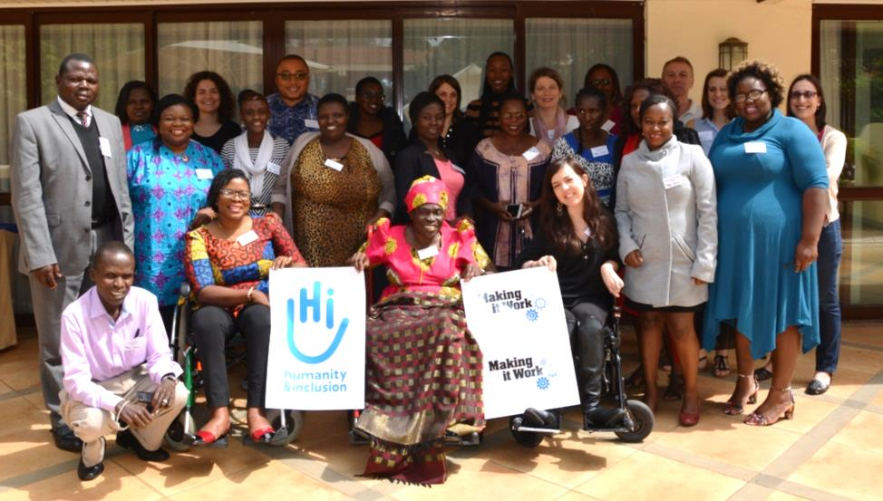  ©C.Masson/HI
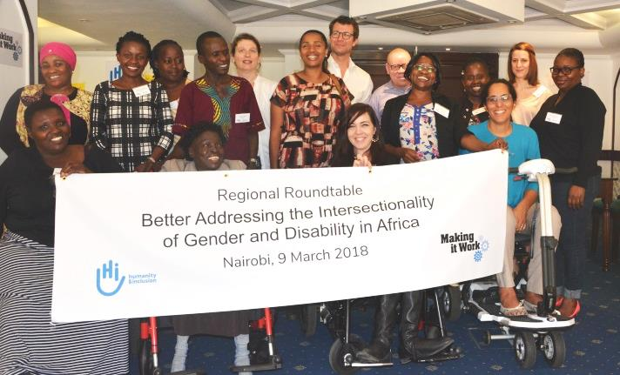  ©C.Masson/HI |  |  | Regional Roundtable “Better Addressing Intersectionality of Gender and Disability in Africa: regional opportunity”  Co-chaired by Fatma Wangare (ADF) and Yetnebersh Nigussie, the RoundTable welcomed IDA, Center for Reproductive Rights, CBM, HI, US Aid, UN Women, Sight Savers, COVAW, LIDDWA and Women Challenged to Challenge.
MIW Good Practice Holders at the Commission on the Status of Women in New-York 22 March 2018  Florence Edong-Ewoo from LIDDWA (Uganda), Gaudence Mushimiyimana from UNABU (Rwanda) and Robinah Alumbuya from World Network of Users and Survivors of Psychiatry (Uganda) were on the panel of the event titled ‘Advocacy on the margins: Women with disabilities addressing violence at the grassroots level’. |  | 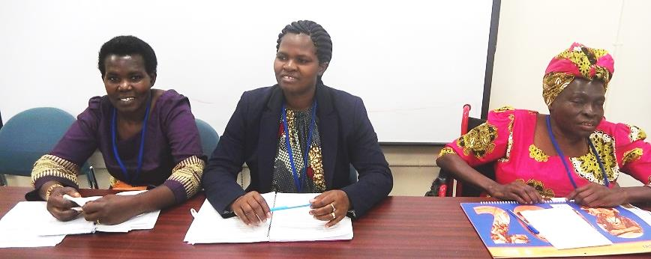  ©L. Adams /DRF  The event was a success with a full room. It was co-organized by MIW@HI, IDA, DRF and IWHC.

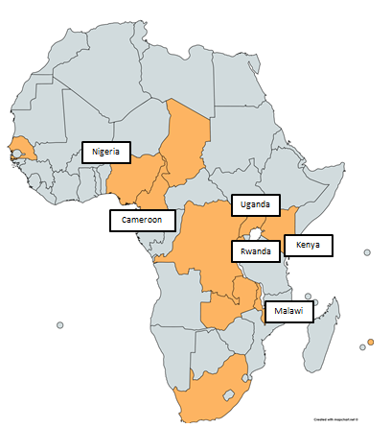
MIW Good Practices in Africa: Our Network of Country Partners
9 practices implemented by 7 DPOs and 2 Women’s Rights Organizations have been selected in October 2017 and further documented through field visits conducted by the MIW team, members of the Technical Advisory Committee and external consultants.
2017 Making Good Practice Holders are:
Cameroon | - Gender and Disability Inclusive Development (DID) group
Kenya | - Coalition on Violence Against Women (COVAW)
 | - Rural Women Peace Link (RWPL)
 | - Women Challenged to Challenge (WCC)
Malawi | - Disabled Women in Africa (DIWA)
 | - Visual Hearing Impairment Membership Association (VIHEMA Deafblind)
Nigeria | - Inclusive Friends Association (IFA)
Rwanda | - Umuryango Nyarwanda w’Abagore Bafite Ubumuga (UNABU)
Uganda | - Lira District Disabled Women Association
Our country partners work on preventing and responding to violence against women and girls with disabilities. With a strong leadership of women with disabilities, these practices address access to justice, to health services, as well as empowerment of women and girls. They tackle stigma and negative traditional beliefs. They push for women and girls with disabilities to be taken into account in GBV policies and programmes.
Discover more on our website www.makingitwork-crpd.org/gender-and-disability-project and soon in our new report.

What have we done before?
Using good practices for evidence based advocacy
In 2015, Making It Work documented 11 practices selected on their potential to raise awareness, inform international level advocacy, and build the capacities of women and girls with disabilities and their organizations from across the world. These good practices have since been used for various advocacy actions. The MIW good practices contributed in 2015 to shape the debate on gender-based violence at the Commission on the Status of Women, the Conference of State Parties to the CRPD and the 62nd session of the CEDAW (Committee on the Elimination of all forms of Discrimination Against Women). Further contributions were made to the report of the Secretary-General on the status of women and girls with disabilities (2017), the CEDAW Committee (68th session, Aug. 2017), etc. The 11 good practices can be downloaded on our website: www.makingitwork-crpd.org.

Contact Details
Email: s.pecourt@hi.org ; j.davodeau@hi.org
Website: www.makingitwork-crpd.org/gender-and-disability-project
Twitter: @MIW_CRPD / Facebook: https://www.facebook.com/MakingItWorkCRPD/
LinkedIn: www.linkedin.com/company/18451952

