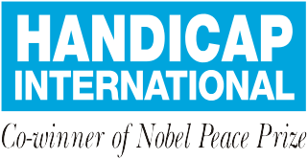
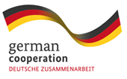

MAKING

IT WORK

Good Practices of Implementation of UNCRPD in Timor Leste

2015 - 2017

MAKING IT WORK

Good Practices of Implementation of UNCRPD in Timor Leste

FOREWORDS
Since 2012, Handicap International (HI) along with several disabled people's' organizations (DPOs),in partnership with various organizations has been working on Advocating for The Rights Of People with Disabilities. In the first phase of the project, HI supported the establishment of the National Action Plan on Disability (NAPD) which involved 10 Ministries. The NDAP continues to become a living document used by HI and its partners to advocate inclusion of disability to target groups at the national and municipal level.

Advocacy is a vital activity for civil society organizations who are promoting effective participation of people with disabilities. Elimination of discrimination against people with disabilities is a dream that should be promoted in this new nation. Despite the various challenges HI and partners face, we also achieved positive results to encourage the process of ratification of the International Convention on the rights of people with disabilities (UNCRPD).

Advocating for Change Project (AfC), a project funded by the German Federal Ministry for Economic Cooperation and Development (BMZ), aims to promote and advocate for rights of people with disabilities through the push for the ratification of the UNCRPD at the national level, improving quality decentralization process at the local level and promoting quality livelihood action for people with disabilities through improved and inclusive vocational training center (CNEFP) in Tibar.

One particular activity in this project is the collection and dissemination of best practices with the "Making it Work" methodology. This methodology aims to document and promote already existing best practices that adhere to the principles of UNCRPD. Making it Work utilizes a multi stakeholder approach and encourages members of DPOs and other organizations to identify best practices and effective action in and surrounding their localities. These best practices are then collected with the ultimate goal to serve as examples of embodiment of the UNCRPD for replication by organizations or institutions elsewhere.

Although Timor-Leste has not yet signed or ratified UNCRPD, but there have been a number of actions made to support the process of ratification of this Convention. The ratification of UNCRPD is a real testament of the Government's desire to support the issue of disability in Timor-Leste.

Handicap International would also express gratitude for the work done together and the good cooperation through Advocating for Change project activities, in particular efforts to promote the collection of and hopefully then, the replication of the best practices that we collected.

Viva Inklusivu!

The AfC Team

CONTENTS

FOREWORDS 3
INTRODUCTION 6
SUMMARY OF AFC PROJECT 6
WHAT IS MAKING IT WORK 7
MAKING IT WORK PROCESS IN TIMOR LESTE 10
THE MEMBERS OF THE COMMITTEE 12
WRITERS 13
OVERVIEW ON DISABILITY IN TIMOR LESTE 15
Legal framework in Timor Leste 16
Disability and Access to Justice 18
Disability and Political participation 19
Disability and Access to vocational training and employment 21
Disability and Psychosocial Rehabilitation 24
COLLECTED GOOD PRACTICES 27
Achieving justice for people with disabilities in Timor Leste 27
How People with Disabilities Can Access Vocational Training 31
Story of Leopoldino Mequita Correia 34
Marcelo da Conceiçao Silva 38
Jaco da conceição 41
Participation in Politics of Helio Pereira Lobato 44
GOOD PRACTICE STORY on Psychosocial Rehabilitation 47
GENERAL RECOMMENDATIONS 49
Government 49
Organization working on Disability Issue and DPOs 49
CBOs, NGOs, INGOs, and other Service Providers 49

ABREVIATIONS

ADTL Asosiasaun Defisiensia Timor Leste
PAND Plano Asaun Nasional ba Ema ho Defisiensia
KIDED Konvensaun Internasional Direito ba Ema ho Defisiensia
KNEED Konselho Nasional ba Ema ho Defisiensia
CNEEFP Centro Nasional do Emprego e Formasaun Profesional
MSS Ministerio Solidariedade Sosial
HI Handicap International
MiW Making it Work
DPOs/OED Disabled People Organizations/Organisasaun Ema ho Defisiensia
ONG Organisaun Naun Governamental
AfC Advocating for Change
KD Klibur Domin
AHDMTL Asosiasaun Halibur Defisiensia Matan Timor Leste
ETBU East Timor Blind Union
RDTL Republica Democratica de Timor Leste
UNCRPD United Nations Convention on the Right of Person with Disability

INTRODUCTION

SUMMARY OF AFC PROJECT

Handicap International (HI) in Timor-Leste started back in 2012 after the withdrawal in 2003. The main HI mission is to support and develop the initiatives affecting directly to people with disabilities and to prevent situations of disability through capacity building and participation of people with disabilities in society.

The project “Advocating for Change” (AfC) phase II is funded by BMZ-Germany and began in October 2015. This project is implemented through a regional initiative in India, Indonesia and Timor-Leste. Each country has its own goals. For Timor-Leste, its aims are to reinforce effective participation of people with disabilities in inclusive development efforts at the local and national levels.

The following are the results of project:

Result 1: The ministry of Social Solidarity is supported to establish, set-up and/or implemented relevant institutions, mechanism, policies and processes towards becoming a Party to the UNCRPD.
In this result, HI increasingly worked with civil society networks, particularly the members of the Association of Disability in Timor-Leste to advocate for the implementation of the national action plan on disability and the establishment the National Council on Disability, and support efforts to ratify and sign the UN Convention on the Rights of People with disabilities (UNCRPD)

Result 2: In 4sucos of Bazartete & Liquica sub-districts, models(s) of inclusive local governance are established in line with the National Disability Action Plan and the decentralization reform.

In this result, Handicap International works with partner organizations to establish support groups (Self Help group – SHG) composed of men and women with disabilities. HI and partners increase self-help groups' capacity to be actively involved in advocacy activities for various target groups from village level to municipality level.

Result 3: 4 In 4 Sucos of Bazartete & Liquica sub-districts young people with disabilities build capacities and increase livelihood opportunities.
In this result, HI with partners conducted employment potential assessment of people with disabilities who have potential and refer them to the vocational training center in Liquiça. HI also provided literacy and numeracy training for people with disabilities for those who cannot read, write and count before they access the training center. Through this activity, HI created a network between trading companies and small industries that could employ people with disabilities.

Notable achievements in this phase include:
- A mid term review of the National Disability Action Plan was done in 2016
- A timeline of the ratification process for UN CRPD is done and presented to the government
- At the local level in Liquica, initiatives to encourage inclusive governance –in relation with the decentralization process- was established
- Initiatives to increase the level of inclusion of CNEFP was taken, by involving more DPOs encouraging them to refer their beneficiaries to the Center.

WHAT IS MAKING IT WORK

MAKING IT WORK is a methodology for documenting good practices on inclusion of people with disabilities and analyzing how these positive changes can be replicated or sustained. It provides a set of tools and guidelines for empowering groups to work collectively on documenting good practices and use this evidence to in?uence positive changes to policies, systems and services, in accordance with the principles of the Convention on the Rights of People with disabilities (CRPD).

In 2014, during the first phase of Advocating for Change, the project has already used the Making it Work Methodology to collect information on good practices of inclusion of people with disabilities in Timor Leste. During this process, recommendations that were made by the committee and the writers of the good practices were:

For Government
To request to government, in this case is President of RDTL, to affirm and assure the acceleration of ratification of UNCRPD for Timor Leste.

For Society
To ask to society, intellectual persons, civil society organizations toconcern on people with disabilities in Timor Leste and together to recallthe government on the acceleration of ratification of UNCRPD.

This graph represents the MIW methodology:
- Step 1: Building multi-stakeholder engagement
- Step 2: Collecting, analysing and documenting good practice
- Step 3: Acting for change, including advocacy based on good practices evidence

People with disabilities are always at the center, co-leading or leading.

For DPOs
- To build capacities and comprehension on UNCRPD.
- To build capacities to advocate for the rights of people with disabilities.
- To ask DPOs in Timor Leste to improve their advocacy activities towards government in implementing immediately the National Action Plan, especially on how people with disabilities in Timor Leste can access education from elementary school until university levels.
- To ask DPOs in Timor Leste to improve their advocacy activities towards government in implementing immediately the National Action Plan, especially on how persons with mental disabilities in Timor Leste can access services and adequate facilities especially those living in remote areas.

Making it Work methodology draws attention on what has worked and how it could be replicated or scaled up by putting forth constructive practical recommendations. At the heart of the process, peoplewith disabilities analyze and validate cases that worked well. After which, they utilize evidence-based good practices to strengthen their advocacy and influence social changes. The methodology applies a multi-stakeholder approach and builds alliances and collaborations among stakeholders related to disability inclusion issues.

There are five key elements of the Making It Work methodology, as follows:
- To set up involvement of multi-stakeholders where different organizations work together to implement the Making It Work methodology
- To document evidences of existing good practices related to specific disability issues (for example, one particular article expressed in UNCRPD)
- To apply these evidences in order to make concrete and practical recommendation on how to replicate or scale-up the good practices
- To produce and disseminate the good practices and recommendation through publication
- To conduct publication and recommendation in order to develop evidence-based advocacy and trainings which will influence policies, system or services in line with UNCRPD.

MAKING IT WORK PROCESS IN TIMOR LESTE

Introduction about MiW
On November 30, 2015 – December 2, 2015 at Salao Sao Paulo Meeting Hall, HI invited the relevant partners including disabled people organizations, civil society and public institutions involved in this project to have meeting on MiW. The T meeting was designed to introduce MiW methodology to the members of the organizations, define topics of best practices to collect, the type of publication and dissemination of best practices, who writes the best practices, and the members of the Committee. This seminar was attended by 23 people (8 female and 15 male),

In this meeting topics for which good practices are going to be sought for, were agreed. The topics include:
  - Access to Justice
  - Political participation
  - Access to vocational training and employment
  - Psychosocial Rehabilitation.

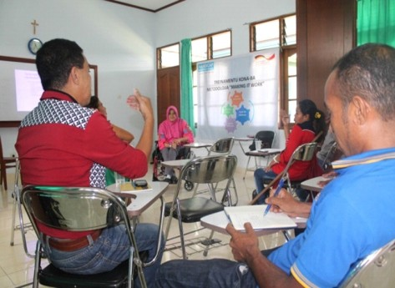
MiW meeting discussion

The collection of best practices
Based on the seminar and meeting, the members of these organizations who are responsible for the collection of best practices began to identify and collect best practices that have occurred in their organizations or close locations. The methods of collection of stories include direct interviews with people with disabilities who are beneficiaries to the project. These good practices were written according to MiW guidelines. Nine stories were collected during the identification process that took place between January and July 2016. Those stories consist of:
  - 2 stories came in on Access to the rehabilitation center
  - 5 stories came in on Access to vocational training and employment
  - 1 story came in on story Political participation
  - 1 story came in on Access to Justice

Capacity Building for Committee members and writers
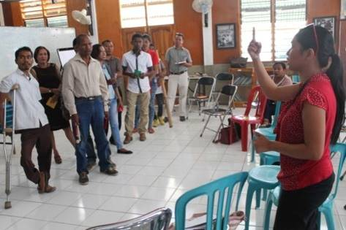
To reinforce the knowledge of committee members and writers, HI provided additional training on UNCRPD and Sustainable Development Goals (SDGs) and clarified again MiW issues during three days on 26-28 July 2016. This event was attended by 24 people and was held at Yayasan Hak Meeting Hall.

Capacity Building for committee members and MiW writers

Presentation of Good Practices Stories
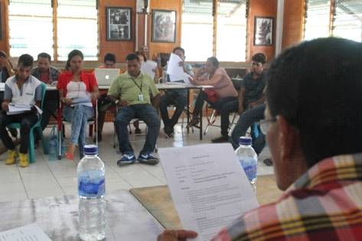
In this phase, the writers presented the identified and written good practices to MiW committee members and members of committee provided their comments and recommendations before the validation. This event was organized on 29 August 2016 and was attended by 12 people.

Presentation on
Good Practice draft of writers to MiW committee members

Validation of Good Practices Stories
On October 3, 2016, The committee members and writers once again met and reviewed the good practices stories which were collected and written. All 20 members of the committee gave their last recommendations and validated the stories. Out of 9 practices collected, 7 were validated as good practices to be disseminated for replication.

THE MEMBERS OF THE COMMITTEE

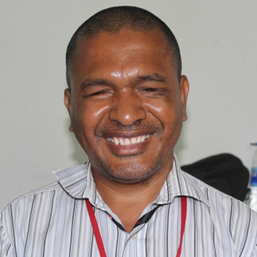 | 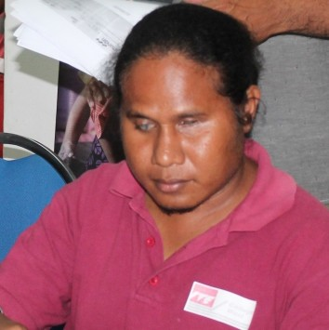 | 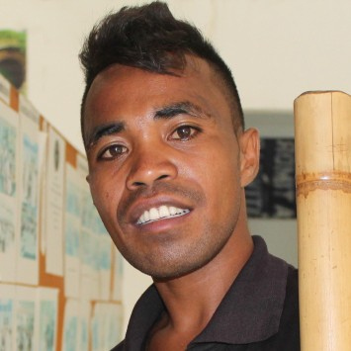
“As a committee member, collecting the good practices in Timor Leste, I feel very happy for those practices that happened in Liquica and other places. As what I witnessed all those validated stories were real and happened in reality. We need to value those stories because in the future we will produce more. The validated good practices stories will be as our guidelines or evidences to implement the advocacy to community, society, leaders, and public and private institutions to prove that people with disabilities have capacities to make a change for them, families, and communities and for the Nations of RDTL.”  Gaspar Afonso  General Secretary of ADTL (galfia2014@yahoo.co.id), HP +670 77338176 | “As a person with disability, I feel very happy with our contribution and promotion of the rights of people with disabilities. Why this is very important? Because with MIW we can show to everyone that people with disabilities are not just sitting at home, they can do anything better through good practices, these good practices will become a guide to change people perspectives on people with disabilities. With all these good practices we hope that n the future we can make a positive change.”  Martinho Guterres  Executive Director of ETBU  HP: +670 774 275 44 | “I feel proud, I had not experienced writing but I have the opportunity to provide my ideas and thoughts. Participating in the MIW was new to me, I learned from other fellow members of the Committee who are better experienced on advocacy and written stories relating to people with disabilities. In the future I hope that those stories and best practices which can be simulated in other areas and can be used as reference to advocate to various target of groups.”  Venancio  Advisory Official of AHISAUN
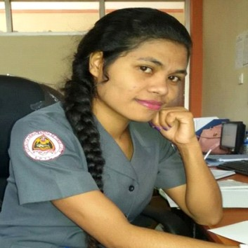 | 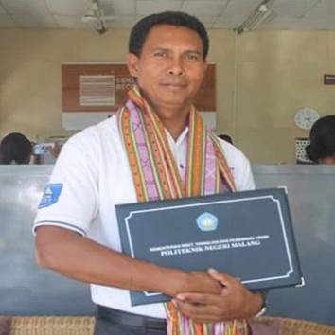
“My observation during participation as a member of Committee in MIW I was really admiring on those good practices that show the ability of people with disabilities. Those practices are not just like documents, in the future we will continue to use them in each one of our daily work.”  Matilda da Costa  DNAFOP – SEPFOPE Official | “Best practices stories are real examples for Government institutions and the private sector that can be used as a reference to open up and recognize that people with disabilities also have the capacity and skills. Therefore people with disabilities, government and private institutions need to replicate these good practices stories from this book. Here are some important points:  1. People with disabilities should be able to stand up and be independent.  2. Family and community should also provide support and encouragement to people with disabilities, value the importance of their capacity not their weaknesses  3. Local Authorities, government institutions, private sectors and civil society should involve people with disabilities in their programs from National to such levels.”  Mateus Aniceto  Funsionario CNEFP

WRITERS

- Domingos T.M. dos Santos (Fundasaun Ahisaun)
- Silvia Antonia (RHTO)
- Antonio Pereira (RESOMLIQ)
- Felipe G. Correia (RESOMLIQ)
- Gregorio Mendes (Klibur Domin)
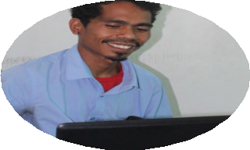
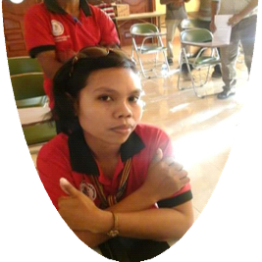
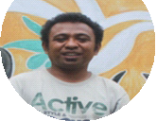
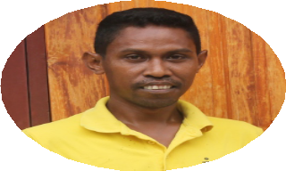
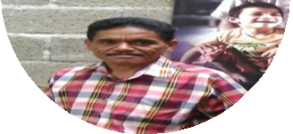
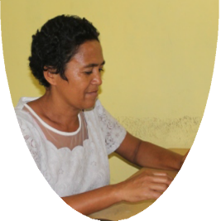
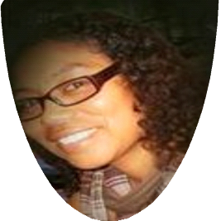
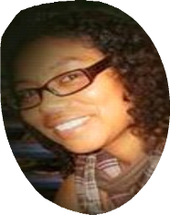
- Joana dos Santos (RESOMLIQ)
- Elda Cardoso (PRADET)

Writers

OVERVIEW ON DISABILITY IN TIMOR LESTE

According to the 2015 Census, published by the National Statistics Directorate of Ministry of Finance of Timor Leste, from a total of 1,179,654people, 38,118 people have some type of disability. This number, at 3,3% of the total of the current population paints a different picture from the census in 2010 which recorded the number at 48,243 which was approximately 4.6% of the population in 2010.

Comparison of the 2010 and the 2015 census of the breakdown of the numbers are as follows:

Type of disability Physical impairment Visual impairment Hearing impairment
Intellectual and mental impairment Disaggregation M - F (%)
2010 census

20,593

29,488

17,692

13,308

53 –- 47
2015 census

16,780

24,260

14,075

11,298

51 - 49

Legal framework in Timor Leste

The Constitution of the Democratic Republic of Timor Leste, hereinafter referred CRDTL, states that disabled citizens have equal rights and they are subjects to the same duties as other citizens, and that no citizen can be discriminated against on the grounds of physical or mental condition, as provided in paragraph 1 of article 21 and paragraph 2 of article 16.

The Government aims to implement public policy oriented towards the most vulnerable population within which to include persons with disabilities. Through Government Resolution No. 14/2012 of 9 May 2012, a National Policy for the inclusion and promotion on the rights of people with disabilities was adopted.

The National Policy defines each sector, laws and programs stipulating universal provision, adapted provision or specific provision of services; therefore people with disabilities can access their rights as other citizens.
The National Policy for the Inclusion and Promotion on the rights of persons with disabilities complies with following principles:
- Principle of Non-discrimination
People with disabilities cannot be discriminated against on the grounds of their physical and/or mental condition.
- Principle of Equality of opportunities
People with disabilities should be on equal terms with other citizens in exercising their basic rights.
- Principle of Non-institutionalization
People with disabilities must be maintained, whenever possible, within his family and his own social and professional environment, so the institutionalization should be a measure of last resort.
- Principle of Coordination
The implementation of programs and action plans should be defend, promoted, organized, supported and assessed in consultation amongst various sectors involved in order to ensure the achievement of specific rights set out in the policy
- Principle of Responsibility and Complementarities
The Government ensures the implementation of measures and programs aimed at ensuring the realization on basic rights of persons with disabilities, through an appropriate multi-sector and multidisciplinary coordination involving public and private entities, non-governmental organizations, governmental organizations and representatives of associations of people with disabilities.
- Principle of Participation
Participation calls for people with disabilities, individually or through their representative organizations, to have an active role in the definition, monitoring and evaluation of policies in order to oversee their rights.
- Principle of Information
The dissemination of information through various communication channels allows greater awareness from the community to the issues on disability and promotion on the rights of people with disabilities.

This Disability Policy is detailed by another document, the National Disability Action Plan (NDAP). The NDAP is a 'blue print' of how ministries and state secretaries can contribute to the full implementation of the Disability Policy. Established in 2014 and valid until 2018, the NDAP describes in more detailed manner what the involved ministries' and State Secretaries' priority actions are. Through the implementation of the AfC project, in 2016 a review of the NDAP was done, with results as follows:
  - The Government has already undertaken a number of actions to implement the NDAP, and there are examples of good practice, from which we can learn
  - Factors which have helped create success include: (1) ministries/ secretaries of state providing space to people with disabilities (2) organizations in the disability sector advocating for action
  - But barriers and difficulties to the full and effective implementation of the NDAP remain, including: (1) lack of information, (2) low level of awareness and understanding of the NDAP, (3) weak communication channels, (4) people with disabilities do not have opportunities to participate and (5) insufficient budgetary and human resources
  - Level of priority put on the NDAP is low
  - The impact for beneficiaries (people with disabilities) has not been significant, however people with disabilities continue to support the NDAP.

Disability and Access to Justice

Data and statistics:
1. Data obtained from Timor Leste Judicial System Monitoring Programme (JSMP) showed that in 2016, 238 cases were entered at the mobile tribunal which showed significant raise by 64% compared to the previous 2015 cases which recorded 145 cases. 62% of the total cases were gender based violence.

In the National regulation:

CRTDL in paragraph 1 article 16 stated All citizens are equal before the law, shall exercise the same rights and shall be subject to the same duties. Paragraph 1 and 2 article 26 access to court is granted to all for the defense of their legally protected rights and interests and Justice shall not be denied for insufficient economic means

In the UNCRPD, Access to Justice is mentioned in article 13:
- States Parties shall ensure effective access to justice for people with disabilities on an equal basis with others, including through the provision of procedural and age- appropriate accommodations, in order to facilitate their effective role as direct and indirect participants, including as witnesses, in all legal proceedings, including at investigative and other preliminary stages.
- In order to help to ensure effective access to justice for people with disabilities, States Parties shall promote appropriate training for those working in the field of administration of justice, including police and prison staff.

Priority Problems:
  - Many women with a disability are sexually abused and do not have access to justiceor information on how to report abuse or crime
  - There are no facilities or other accommodations made, for example, for a person with a hearing impairment. AGAPE has the only sign language interpreters, otherwise family members have to help interpret for a person who can not hear.
People with disabilities do not feel the affect of article 21 in the Constitution. There are no facilities and no access to justice

Strategies Proposed in the NDAP, spearheaded by the Ministry of Justice include:
- Quickly adapt the Convention of the Rights of People with Disabilities (Ref: Policy Strategy 3 – Create mechanisms for the ratification of the Convention on the Rights of People with Disabilities)
- Disseminate information and raise awareness among the community about the rights of people with disabilities and the legal means available to defend themselves

Disability and Political participation

Data and Statistics:
- INSIGHT research on 2016 shows that 1200 people, 53% received well the information, 75% still need the information how to register and 77% still need the information how to register and where to vote ( no specific data for people with disabilities)
- Data from RHTO about the General Election (Suco and President): 327 people with disability attended training (m:61%, f: 39%), Meaning that 35,025 of voters (data fo census) only 0.93% voted.

Priority Problems:
- There is less participation of women with disabilities in the community and their ideas and decisions are not considered
- Participation of women with disabilities in development programs is not the same as other women
- In terms of media and communication, people with disabilities still face discrimination
- Media is not accessible, for example, there are no sign language interpreters or captioning
- Inaccessible facilities for voting

In the UNCRPD, political participation is mentioned in article 29 about participation of political and public life:

States Parties shall guarantee to people with disabilities political rights and the opportunity to enjoy them on an equal basis with others, and shall undertake:
- To ensure that people with disabilities can effectively and fully participate in political and public life on an equal basis with others, directly or through freely chosen representatives, including the right and opportunity for people with disabilities to vote and be elected, inter alia, by:
  - Ensuring that voting procedures, facilities and materials are appropriate, accessible and easy to understand and use;
  - Protecting the right of people with disabilities to vote by secret ballot in elections and public referendums without intimidation, and to stand for elections, to effectively hold office and perform all public functions at all levels of government, facilitating the use of assistive and new technologies where appropriate;
  - Guaranteeing the free expression of the will of people with disabilities as electors and to this end, where necessary, at their request, allowing assistance in voting by a person of their own choice;

- To promote actively an environment in which people with disabilities can effectively and fully participate in the conduct of public affairs, without discrimination and on an equal basis with others, and encourage their participation in public affairs, including:
  - Participation in non-governmental organizations and associations concerned with the public and political life of the country, and in the activities and administration of political parties;
  - Forming and joining organizations of people with disabilities to represent people with disabilities at international, national, regional and local levels.

In the National regulation:
CRDTL article 46 paragraph 1 and 2; Every citizen has the right to participate in the political life and in the public affairs ofthe country, either directly or through democratically elected representatives; Every citizen has the right to establish and to participate in political parties.

Disability and Access to vocational training and employment

Data and Statistics:
- RHTO data shows that of 49 women with disabilities interviewed shows that 86% of women with disability did not have access to vocational trainings and 65% did not have to any income generating activities. The data were collected during the interview with 49 women with disabilities on the commemoration of international labour day conducted in Dili
- Data from INSIGHT, a Survey Research Center, which implemented a research in November 2016 to 1200 people in Timor Leste shows that 4% work full time, 5% work part-time, 9% are looking for jobs. Those who have income recive it from: 26% in housekeeping, <1% receive pensions, 11% are in training, 40% farmers, 1% fishermen, 3% other sectors
- In the 2015 census, 25,789 people with disabilities did not receive formal education, 11,121 have accessed formal education and 741 had accessed non formal education
- From the project's data, in the span of 2014-2017, only 7 people with disabilities were enrolled in CNEFP, a national vocational training center

Priority Problems:
- Employers do not understand the advantages of employing people with disabilities and how to do so; and the Government has not given business incentives to employ people with disabilities
- Data from INSIGHT, a Survey Research Center, which implemented a research in November 2016 to 1200 people in Timor Leste shows that 4% work full time, 5% work part-time, 9% are looking for jobs. Those who have income recive it from: 26% in housekeeping, <1% receive pensions, 11% are in training, 40% farmers, 1% fishermen, 3% other sectors
- In the 2015 census, 25,789 people with disabilities did not receive formal education, 11,121 have accessed formal education and 741 had accessed non formal education
- From the project's data, in the span of 2014-2017, only 7 people with disabilities were enrolled in CNEFP, a national vocational training center

Priority Problems:
- Employers do not understand the advantages of employing people with disabilities and how to do so; and the Government has not given business incentives to employ people with disabilities
- People with disabilities are not involved in self employment programs; vocational training programs; youth training programs.
- There is no reasonable accommodation so that people with disabilities have access to the workplace; are able to do their jobs; are able to study
- People with disabilities do not have the courage to apply for jobs
- Not many people with disabilities had access to formal education which leads to high rate of illiteracy among people with disabilities which later resulted in them not being able to access vocational training centers or apply for jobs, since most require them to be either be able to read, write or count

In the UNCRPD, access to employment is mentioned in article 27, which states:
- States Parties recognize the right of people with disabilities to work, on an equal basis with others; this includes the right to the opportunity to gain a living by work freely chosen or accepted in a labour market and work environment that is open, inclusive and accessible to people with disabilities. States Parties shall safeguard and promote the realization of the right to work, including for those who acquire a disability during the course of employment, by taking appropriate steps, including through legislation, to, inter alia:
  - Prohibit discrimination on the basis of disability with regard to all matters concerning all forms of employment, including conditions of recruitment, hiring and employment, continuance of employment, career advancement and safe and healthy working conditions;
  - Protect the rights of people with disabilities, on an equal basis with others, to just and favourable conditions of work, including equal opportunities and equal remuneration for work of equal value, safe and healthy working conditions, including protection from harassment, and the redress of grievances;
  - Ensure that people with disabilities are able to exercise their labour and trade union rights on an equal basis with others;
  - Enable people with disabilities to have effective access to general technical and vocational guidance programmes, placement services and vocational and continuing training;
  - Promote employment opportunities and career advancement for people with disabilities in the labour market, as well as assistance in finding, obtaining, maintaining and returning to employment;
  - Promote opportunities for self-employment, entrepreneurship, the development of cooperatives and starting one's own business;
  - Employ people with disabilities in the public sector;
  - Promote the employment of people with disabilities in the private sector through appropriate policies and measures, which may include affirmative action programmes, incentives and other measures;
  - Ensure that reasonable accommodation is provided to people with disabilities in the workplace;
  - Promote the acquisition by people with disabilities of work experience in the open labour market;
  - Promote vocational and professional rehabilitation, job retention and return-to- work programmes for people with disabilities.

- States Parties shall ensure that people with disabilities are not held in slavery or in servitude, and are protected, on an equal basis with others, from forced or compulsory labour.

In the National regulation

- Labour law No 04/2012 (labour Code) article 6 paragraph 1; All workers, men and women, have the right to equal opportunities and treatment in access to employment, vocational training and professional development, working conditions and remuneration.

- CRDTL, Article 50 paragraph 1; Every citizen, regardless of gender, has the right and the duty to work and to choose freely his or her profession and article 59 paragraph 2; Everyone has the right to equal opportunities for education and vocational training.
  - Lei No 04/2012-lei do trabalho (Employment Regulation)
  - Konstituisaun RDTL, Article 50- Right to employment
  - Konstituisaun RDTL, Article 59- Rights to education and culture

Strategies Proposed in the National Disability Action Plan Spearheaded by SEPFOPE, several actions include:
- Create a procedure for evaluating personal, social, educational and professional skills of people with disabilities in order to assess their interests, motivations and skills to attend a vocational training course and / or integration into the labor market.
- Provide access for people with disabilities on an equal basis to courses of vocational training
- Promote professional training in pedagogical, human and technical conditions adequate to the person with disability
- Promote the creation of alternative forms of employment for people with disabilities

Disability and Psychosocial Rehabilitation

Data and statistics:
- Data from PRADET annual report 2015. In 2015 there were 5 Fatin Hakmatek (quiet place) in Timor-Leste. Since opening the first service in Dili in October 2002 to the end of 2015 these services have received a total of 3,320 new referrals.
- A mobile rehabilitation team has identified about 100 children with disability who are receiving support from Klibur Domin in their village

Priority Problems in Health Sector in general:
- There are limited trained professionals, for example, only 1 specialist eye doctor in the country
- The Sisca mobile clinics are not yet inclusive and people with disabilities can not access them
- WHO standards should be applied (International Classification and Functioning – ICF) in assessing disability
- The referral system and coordination between rehabilitation services and the Ministry of Health needs to be improved.

In the UNCRPD, rehabilitation is mentioned in article 26:
- States Parties shall take effective and appropriate measures, including through peer support, to enable people with disabilities to attain and maintain maximum independence, full physical, mental, social and vocational ability, and full inclusion and participation in all aspects of life. To that end, States Parties shall organize, strengthen and extend comprehensive habilitation and rehabilitation services and programmes, particularly in the areas of health, employment, education and social services, in such a way that these services and programmes:
  - Begin at the earliest possible stage, and are based on the multidisciplinary assessment of individual needs and strengths;
  - Support participation and inclusion in the community and all aspects of society, are voluntary, and are available to people with disabilities as close as possible to their own communities, including in rural areas.
- States Parties shall promote the development of initial and continuing training for professionals and staff working in habilitation and rehabilitation services.
- States Parties shall promote the availability, knowledge and use of assistive devices and technologies, designed for people with disabilities, as they relate to habilitation and rehabilitation.

In the National regulation:

CDRTL article 57 paragraph 1 ensures that everyone has the right to health and medical care, and the duty to protect and promote them.

Law no.10/2004 of 11 November 2014 that approves the health system provide in subparagraph b) and c) of article 3. “The creation of universal national health service and general basic aim of enabling the access to health care to all citizens on an equal footing, whatever their physical or mental conditions and will take special measures for groups at increased risk such as people with disabilities”

Decree law no.1/2008 of 16 January 2008, approving the organic structure of ministry of health, provide in paragraph 1 article 2 that this government departments mission is to ensure the population access to health care through establishment, regulation and development of healt system based on real needs and compatible with available resources with particular relevant to the fairness of the system and prioritizing the most vulnerable groups and has the task according to b) of parabgraph 2 of article 2 guarantee access to health care for all citizens”

Strategies Proposed in the NDAP, spearheaded by the Ministry of Justice include

- To disseminate information on ways of prevention, care and special needs of people with disabilities in healthcare and education facilities, community centers and other relevant public spaces utilizing various communication channels.
- To create specific measures to ensure identification, diagnosis, treatment and medical rehabilitation of disability.
- To develop early intervention activities contributing to an immediate response to the needs of children with disabilities through strengthening community health programs that involve family and community.
- To develop technical and scientific studies in the areas of prevention, treatment and rehabilitation of people with disabilities.
- To ensure technical assistances provided for people with disabilities are standardized internationally.
- To ensure people with disabilities may obtain services provided by health professionals, technical support, medication and specialized treatment in an equitable manner regardless of place of residence (rural or urban).
- To promote health services of a specialized care for personswith disabilities.
- To ensure issuance of medical statements certifying temporary or permanent disability of people with disabilities.
- To increase the ability and to diversify the response of physical and mental rehabilitation centers in order to meet the needs of people with disabilities.
- To ensure the existence of health professionals with specialized training, including physiotherapists, orthopedists, occupational and speech therapists, psychiatrists, nurses, physiatrists, psychologists and social workers.
To promote transfer for people with disabilities to health services using special or adapted vehicles

COLLECTED GOOD PRACTICES

Case Study 1

Achieving justice for people with disabilities in Timor Leste
Writer: Silvia Antonia Da Costa Soares

The story
"S" is a 15 year old girl with disability, she is 4th child from 6 children. She has physical impairments and communications disabilities. With these impairments preventing her to move around and speak, she is mainly bound to her wheel chair. Her daily activities are normally assisted by her parents: providing food, bath and etc.

One early morning her parents went to field and she was left alone at home. Her brothers went to school and nobody was there to look after her. So, as she was alone someone from neighborhood came in and found her lying in the bed alone. He sexually assaulted the little girl. She screamed but nobody heard and he left her after. In the afternoon when her parents came home they found her crying and her mom began to ask what happened using sign language as they normally communicate.

She tried to explain what happened to her; unfortunately her mother did not believe her. Her parents believed that the man she accused was a good man and this is not their first time to left her alone at home. Sometime they have even asked him to keep eye on her as they go to farm.

RHTO (Raes Hadomi Timor Oan), one of local NGO working in this area, made a regular visit to Ms “S” house and had a conversation with her. This was a regular visit by RHTO and initially they asked routine questions, as “how is your condition” and so on. But somehow she did not reply to them at all. She was seated with her head down and one of RHTO staff approached Ms S to know what was happening. Due to RHTO's staffs inability to understand her sign language they asked her mother to translate it. After having heard to Ms “S” story they tried to ask the mother if the story was correct? This was, however, asked when her mother still did not believe her daughter, she told the RHTO staff that she was lying. Anyhow, the RHTO staff believed what the girl had told them and that she was not lying. Finally her mother and family members started to believe was had happened to their daughter.

Right after listening to Ms “S” story, RHTO considered this act is a crime and against the law, therefore staff of RHTO consulted with family to bring this case to the Police and ready to help by any means to support the family and M “S”. Finally her case was brought to the court through the help of Vulnerable Person Unit (VPU) PNTL, ALFELA, Fokupers, Rede Feto, Agape and RHTO.

As the first step, Ms S will need to present the evidences to the court. As she is a person with disability communicating through sign language, it was very difficult for the court members and judges to understand her. Besides, this was the first time that a case involving a person with disability as a victim was brought to their court and, as they were never oriented on the issue of disability, they also didn't know how to communicate with her. Court members then asked RHTO to facilitate in any way possible the provision of support to help the victim. RHTO cooperated with AGAPE as AGAPE provides training to people with communication and hearing impairments. RHTO and AGAPE attended the court trial with Ms “S” and assisted her along the process.The suspect was sentenced to 8 years in prison.

The Case Study
ENSURING ACCESS TO JUSTICE FOR PEOPLE WITH DISABILITIES

Summary: people with disabilities are at greater risk of violence and face difficulties in accessing justice. Organizations in the justice sector, including police, judges, and courts, should work together with disabled peoples' organizations to eliminate barriers to access to justice for people with disabilities.

Background
Many times people who are victims of crimes find it difficult to access Justice. They may face obstacles due to distances of court or police do not take them seriously and do not commence with the investigation due to weak evidences.

People with disabilities in East Timor face even more obstacles, as often people with physical, psychosocial, visual, hearing and communications impairments are discriminated by society. Girls and women with disabilities face even bigger risk of sexual violence. According to the UN, women with disabilities face more risk of sexual violence to non- disabled women4.
Rahaes Hadomi Timor Oan (RHTO) tries to change this situation. RHTO recognizes that access to justice is the fundamental right of people with disabilities under article 13 of the UNCRPD.

Process of Advocacy
In 2015, members of court asked RHTO to help them to support with communications problems for Ms. S that experienced sexual violence to be able to access justice. Her name is “S” she has physical and communication disabilities She uses a wheelchair and her daily activities is helped by her parents. For example; feeding, bathing, dressing, etc.

3http://www.unwomen.org/en/what-we-do/ending-violence-against-women/facts-and-figures

RHTO cooperated with Vunerable Person Unit (VPU) of PNTL and with Organizations that work for violence against women, ALFeLA, FOKUPERS, REDE FETO.

At first she was asked to come to the court to present the evidences, making a short report regarding her conditions as a person with disabilities. Due to her communications problems there was a serious problem to the members of the court to understand her. Sign language is not common for the members of the court because they never had any sign language training before.

So, members of court requested to RHTO to provide assistance to help her to facilitate translation to sign language that she speaks. RHTO contacted with AGAPE as Organizations that works for providing training regarding people with communication disabilities and hearing impairments.

RHTO and AGAPE staff along with Ms. S went to the court to take next step to find any solutions to that case. With the help from of AGAPE and RHTO finally members of the court understood the case and the suspect was sentenced to 8 years in prison.

Contributing factors to success of the practice:
To implement the process of Advocacy, RHTO used resources existing in Timor Leste including:
- Good comprehension of RHTO staffs regarding disabilities issues.
- Networking with various organizations that work for people with disabilities, relevant ministries , Municipality administrator, local authorities including head of village, sub head village, PNTL and Judges.
- Availability of sign language interpreter, in this case from AGAPE Organization
- Availability of fund provided by DFAT to support the advocacy process
- Willingness of the court to follow the process with an interpreter

Constraints Faced:
The difficulties that RHTO faced are:
- The members of the court lack of knowledge on the needs of people with disabilities, in this case, on the problems of people with communications disabilities.
- Still some stigma in the society's mindset that people with disabilities are not useful
- The lack of physical accessibilities to the court house making it hard for people with disabilities to access and utilize the facilities there.

The significant transformation
Through this advocacy organized by RHTO, members of the court are now aware of the need for special assistance during trial proceedings for people with certain types of

disabilities, especially for people with communication disabilities. The courts congratulated RHTO and its partners involved for a hard and well-coordinated work to support the victim, Ms “S”.

How to replicate the good practice
To replicate this good practice, the important thing is to increase the comprehension about the obstacles and barriers that people with disabilities face when they access the Justice system. Working with the community becomes essential as well as with PNTL (the police) and Judges to ensure that these obstacles and barriers can be overcome when people with disabilities access to Justice.

Recommendations
All the organizations in disability area need to socialize and promote to the community, local leaders, PNTL, organizations, and the family regarding the right of people with disabilities especially women with disabilities, especially on accessing the justice system. Ministry of Justice has to support and facilitate access justice for people with disabilities. The ministry of Justice needs to include in their action plan, specific actions to provide special assistance for people with disabilities such as sign language training or interpreters, adaptation to accessibility adaptations in courts to court house to ensure that people with disabilities can also access these facilities.

Contact Person
Mrs. Silva Soares
Email : silviadpo@gmail.com HP :+67077337637

Case Study 2

How People with Disabilities Can Access Vocational Training
Writer : Gregorio Mendes, CBR Program Manager

The Story
In 2015, along with other NGOs, Klibur Domin and Handicap International entered into partnership to implement Advocating for Change Project (AFC). This project is implemented in the Municipality of Liquica covering an area of 4 villages: Motauluno, Lauhata, Maumeta and Dato. This project aims to advocate for solutions to reduce the barriers and obstacles that people with disabilities are facing in their daily lives working alongside with them, their family members , local authorities and other institutions.

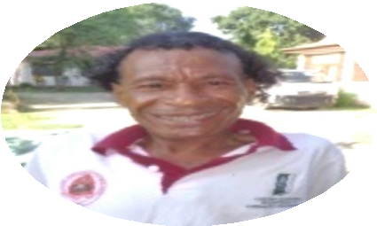
My name is Andre Jose dos Santos and I am 44 years old from Lauhata Village. During the Indonesian regime I went to primary school, I had been bullied a lot so I decided not continue my study”

• • •

“My name is Andre Jose dos Santos and I am 44 years old from Lauhata Village. DuringDu Indonesian regime I went to primary school, but I had been bullied a lot so I decided not continue my study. Every day I helped my parents with their daily activities. I never came out of the house to play with others due to my conditions that made me felt down.

I really appreciate HI and KD that already supported me to access vocational training in CNEEFP Tibar, I feel very happy now, and soon, I will finish my training and get back home then find a job to sustain my life. During my training, I majored in plumbing as this is the subject, which I like most. Therefore in this very moment I want to encourage all of people with disabilities to not be shy or feel down and come and attend this training to increase our capacity to compete in employment sectors. In the same time I would like to recommend to CNEEFP to create better accessibility for those using wheelchair so they can easily access””

Andre Jose dos Santos was born with this condition, and had faced many obstacles within his family who did not give him full support, faced stigmas and discrimination, which led him not to finish his study. He decided to stay at home because he was very uncomfortable with his friends, community members.

The result of this AFC project has given Andre a chance to access to Vocational Training in

The result of this AFC project has given Andre a chance to access to Vocational Training in CNEFP Tibar as he wished. Part from his willingness to access to training, family, local authorities and friends supported him. He attended diligently the training for six months and Andre said when he finished the course he will find job that relevant to his skills to sustain his life and family. Andre continued to share his experiences, motivating his fellows' disabilities, community to access to professional training in Tibar and other places.

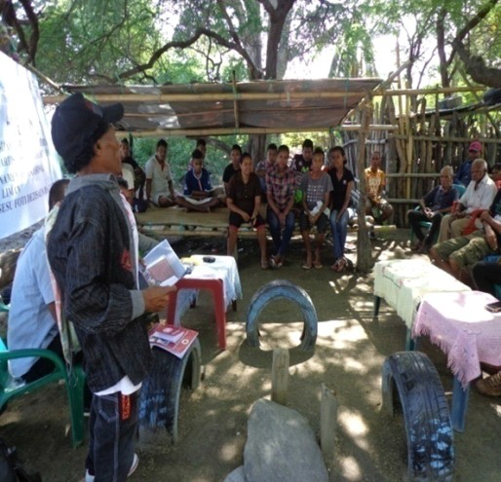
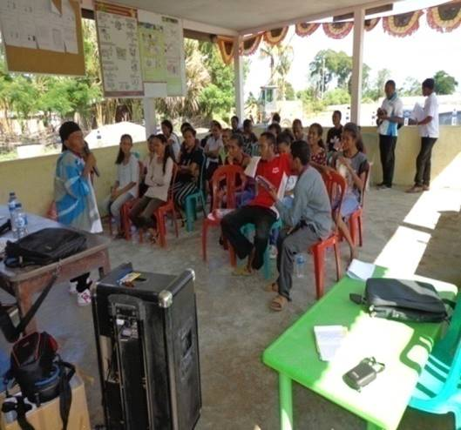

Andre is sharing his experiences and motivating other people with disabilities and the community.

The efforts that Andre did through this Advocacy action brought a very positive result to the community and people with disabilities who attended the advocacy meeting. They were happy with what Andre shared and wanted to join in the vocational training.

KD approached the family of Andre to explain CNEEFP is doing on vocational training and that it is ready to provide training to persons with disabilities. In addition KD also explained that the local authorities also encourage Andre to access to the training.

Andre wanted to share his experiences as he found out that so far people with disabilities have not yet received information regarding the training in CNEFP, Tibar. Therefore, he asked to develop a communication mechanism in order to provide access to information for people with disabilities.

The AFC project result was very satisfying and the number of people with disabilities who wanted to join the training increased, but still the lack of accessibilities in the training center can be considered as another obstacle for people with disabilities to access training services..

The Case Study
Topic :
Participation of people with disabilities in vocational training center (CNEFP) in Tibar

Introduction
In 2012, The Government of Timor Leste through its council minister approved a National disability policy. In the following year, HI and MSS made the National Disability Action Plan for 2014-2018. The action plan includes some actions in the sector of employment and this professional training. Employment rights for people with disabilities is recognized by UNCRPD in article 27 “States Parties recognize the right of people with disabilities to work, on an equal basis with others; this includes the right to the opportunity to gain a living by work freely chosen or accepted in a labor market and work environment that is open, inclusive and accessible to people with disabilities. States Parties shall safeguard and promote the realization of the right to work, including for those who acquire a disability during the course of employment, by taking appropriate steps, including through legislation”

In 2015 KD and Handicap International begun to cooperate as partners to work and implement the program which allow people with disabilities to access to professional training in the training center in Tibar (CNEFP). This program is implemented in four villages in the Municipality of Liquica.

The Advocacy Process
In 2015, Klibur Domin funded by Handicap International implemented activities on identifying people with disability in productive age to access vocational training in CNEFP- Tibar. We identified 40 people with disabilities from 4 villages which are from our target areas. The first person referred to CNEFP was Andre Jose dos Santos. At 44 years old, Andre had never attended any training from CNEFP. This was changed when KD and Handicap International worked alongside CNEFP so that he could access to this vocational training.

During 6 months of training, Andre attended the training diligently and he learnt new skills regarding Plumbing and now he is ready to work as a plumber.

Required resources on the good practices are:
The resources that Klibur Domin used for this Advocacy;
- Funding for advocacy action and accessibility adaptation
- Technical support on inclusion in the vocational training centers
- Means for traveling to and from training centers
- On-site facilitators acommodating questions and needs of Andre

Factors causing the good practices were successful:
Factors positively affecting the success of this practice are:
- Availability of accompaniment from Klibur Domin to the client
- Accessibility of venue in CNEFP and willingnes of CNEFP to open up to people with disabilities
- Trainings and awareness raising provided by HI on disability issue to CNEFP trainers and trainee
- Information sessions on need of employment and independence

The difficulties
- The lack of information to people with disabilities regarding opportunities to access to this professional training, people with disabilities were not knowing that this opportunity exist and also include them to access to training center.
- The quality of accessibility in training center also poses as a barrier. There is no sufficient space for a wheel chair to move around in CNEFP compound, and the toilets are not equipped with handrail.
- Lack of technical expertise on teaching students with certain impairments such as visual and hearing impairments and lack of adapted tools to allow for a people with certain types of physical disabilities to learn certain skills. CNEFP does not have dorms yet this is very difficult for some of disabilities to travel everyday with some distances and mobility problems.
- When the participants finish the training they need to make work group or work in some company. The students still need the assistance of Klibur Domin and Handicap International to help them in creating job opportunities.
- There is a lack of life skills and job readiness for people with disabilities who graduated from CNEFP. This is a service not yet provided by the center
- Most people with disabilities, due to their lack of education cannot read or write, which is still keeping them from being enrolled at CNEFP

Significant Changes
Based on the result of the project, many people with disabilities wanted to join in this training in CNEFP-Tibar. Klibur Domin and CNRFP directly give the information to people with disabilities and encouraged them to attending this training. People with disabilities who attended the experiences sharing of Andre were very happy and motivated by his experiences and wanted to attend this training.

Advocacy also can be implemented to the community, to show them that people with disabilities have the same right to access training like others and can work and be independent to sustain their own needs.

How to replicate this Practice
To replicate this good practice is to open the opportunity for people with disabilities to access to vocational training. This requires willingness from the training center to become inclusive, to adapt its training methodologies and the behavior of its whole team. On the other hand, advocacy is also very important to change perspectives of other stakeholders to ensure the most support for people with disabilities wanting to enter a vocational training center. This includes support and advocacy to the family members, closest relatives, and other governmental agencies.

Recommendations
To ensure that people with disabilities can access to training center, training centers need to be physically accessible and provide necessities such as like ramp, wide door and accessible toilets.
To improve and develop more the communications mechanism that is easier for people with disabilities to understand especially on the opportunities to access for these kinds of vocational training and participate in employment

Contact Person
For more information please contact; Mr. Gregorio Mendes
Email : g.mendeskd@gmail.com HP :+670 77322543

Case Study 3

Story of Leopoldino Mequita Correia
Writer: Domingos Talo Mau dos Santos, Fundasaun AHISAUN

The story
I am Leopoldino Mesquita Correia, born in 12-12-1983 in Dili Municipality and I am 33 years old. I was born with disability in leg (left side) and as I grew up my situation became worst because I did not get vaccinations properly so now I am moving around with wheelchair.

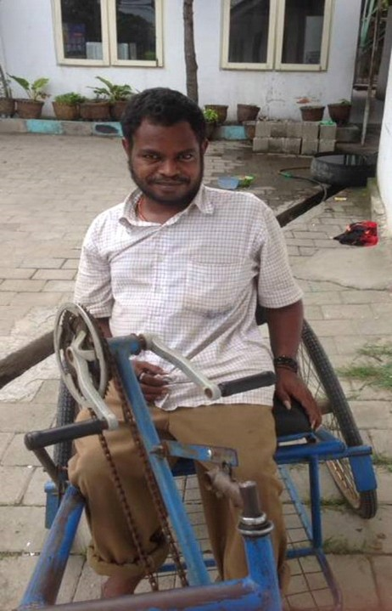
When I was a little boy, I did not benefit so much from the good care of my parents due my condition as a person with disability, they had thought I would not be somebody that one day could support and contribute to family needs. Still, I have the spirit to learn and find out how I could be a smart man in the future.

We all know that “Disability Issues” was not understandable to the community at that time. This happened to me as well. I was bullied a lot by my friends they made fun of me, and this hurt my feelings. They called me “Hey, limp where are you going?” That was very hard for me to get along with them so I found other people with disabilities to become my friends and finally I found one. His name is “Angelino Benevides” our friendship continued until now

In 2000 I started living in AHISAUN and by 2004 I started learning and work there, I produced vases and bracelets and took computer course. That was not easy for me as it takes a lot of energy to produce a vase. I was focused on producing vases and bracelets I did that activities only in nighttime or when I was free. In this capacity building program, we were thought how to make hand made products like shoe soles, vases and bracelets. These are things new to me and although trainings like these are common even in my village but as we know that those programs do not involved people with disabilities. With this opportunity I asked the Director of AHISAUN FAUNDATION to give me more opportunity to participate more and learn.

They put us in groups of five people, One day we produce 5 vases made of cement and tali metan (black rope) each. This means my group produces 25 vases per day. However, the main problem is after producing we need to move them to a selling place, which need special equipment.

In 2007 I went to UNTL university but only stayed until 5th Semester. I could not continue due to my economic condition and family support was not good. Therefore, I decided to look for a job in 2009. I would like to be able to escape my poverty and felt that I need to find a job, even though I am a person with disability. This thought motivated me and helped me have a more positive outlook on life.

In 2014 I was invited to attend a program organized by AHISAUN FOUNDATION. It was a capacity building program for people with disabilities. Through that program I came to know what is disability and the rights of people with disabilities. I also exposed to the UNCRPD and the Making it Work Process.

The most valuable things in my life is now I can produce vases and sell them in AHISAUN and get profit to sustain my life and support my family and pay for my brother's school fee in Jogya-Indonesia. My family is very happy with things, I am doing alright now and I am no longer dependent on them.

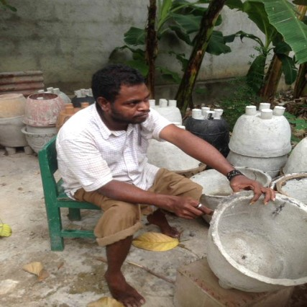
Last of all, I would like to say to all my fellow people with disabilities, that being a person with disabilityy is not the end of the world and that we can look for more opportunities to learn and sustain our lives to be more independent. As a human being, we also need to show to others (non-disabilities) that we also can do things like they can. We need to change ourselves not to wait others to do it for us. Show them that “don't focus on our disabilities but to our abilities” if we can do that, I guarantee that one day people with disabilities in Timor Leste will live free with dignity as other citizens.

Case Study
ACCESS TO VOCATIONAL TRAINING: OPEN OPPORTUNITY TO PEOPLE WITH DISABILITIES TO HAVE THEIR OWN INCOME AND LIVE INDEPENDENTLY

Writer: Domingos Talo Mau dos Santos, Fundasaun AHISAUN

Summary
Empowerment to people with disabilities through vocational training giving impact to their lives and change the perceptions of community

Introduction
In Timor Leste, people with disabilities faces lots of discriminations and stigmas, to access to education and vocational training is very difficult because there is no support from families, teachers due to non accessibile environment and their economic conditions also

as one of the reasons. From data collected there were 49 people with disabilities that attended our training in 2015 and most of them said that they have never accessed any vocational training andare unemployed

AHISAUN FOUNDATION is a Non-Governmental Organization that was established 1999. Its mission is to work with young people with disabilities to develop their capacities through informal education in order to support them to be independent and contribute to society and Nation.

Advocacy Process
AHISAUN Foundation works with the community to identify people with disabilities who want and willing to build their capacities through training.

Leopoldino Mesquita Correia was one of student that attended the training in AHISAUN. He receives a range of training including vase producing, soft skills on computer, etc.

The resources that are needed
In order to replicate this practice, resources needed include:
- Accessible training facilities (no stairs, ramp, wide doors for wheelchair to enter and exit)
- Funds to provide and perpetuate the training
- Staff and trainers who are also people with disabilities thus creating a sense of career development for trainees
- cooperation between training center with organizations who support accessible equipments for people with disabilities to continue their study

Factors for success
- Provide literacy and numeracy training so that people with disabilities can understand the training
- Understand and aswer other gaps presented by the people with disabilities
- Train practical subjects that matched the need of the market.
- Inclusive training methods is a must to ensure that the trainees can understand the training

Constraints Faced
- Market research to ensure marketing of the products
- Job placement is a problem
- Mobility is still an issue – for people with disabilities to mobilize outside of Ahisaun (for instance to the selling points, etc)

Significant transformations
Leopoldino said “when people with disabilities can have the same opportunities as I do from AHISAUN, they will understand that being a person with disability not an obstacle for them to learn and be independent. As human being we need to show to the others that we also can things by our own. We need to change ourselves no to wait others to do it for us. Show to them that “don't focus on our disabilities but to our capacities” if we can do that, I guarantee that one day people with disabilities in Timor Leste live free with dignity as other citizens.

How to replicate this good practice
To replicate this good practice, it is important to encourage people with disabilities to participate in any training, but especially vocational training. It is also important to work with people with disabilities to create/provide training that relate/ matches their interest and help them to find job in the future. Make sure that the training accommodates their needs and methods of learning.

Recommendations
Ensure that people with disabilities can access vocational training and the facilities. This means that need to provide training program tailored for people with disabilities to face their barriers and encourage them to participate.
Train them how to learn the new vocational ability that they can use to get job or any business opportunities, train them how to relate between people with disabilities with company's owners to sell their products.

Contact Person
More Information please contacts; Mr. Domingos Talo Mau dos Santos
Email :ahisaun.tl_disability@yahoo.com HP :+670 77427544

Case Study 4

Marcelo da Conceiçao Silva
Writer: Antonio Pereira da Costa

The Story

To access employment is to create opportunity for people with disabilities to change their lives to live as all human should in a society. Marcelo da Concecao Silva came from
Agriculture background family; he was born with disability and have mobility issues due to his legs. Regardless of all this he still wants to find his own way and not depend on others and support himself.

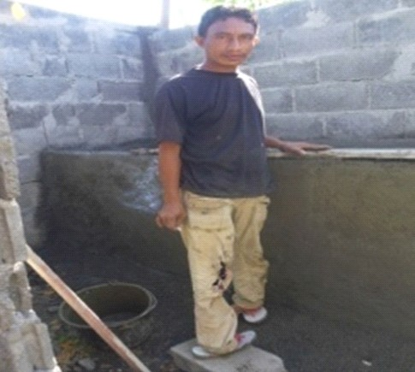
Ever since he was in high school, Marcelo had a hard time with friends bullying and making fun of him. He started moving from school to school.
Finally when he graduated he moved in with his sister and her husband. His brother in law is a driver and mechanic. He also did odd jobs around the house, like doing the plumbing and fixing the bathroom. He started helping out and in the end for three years, he learned the skill and became good at it.

“As a person with disability, I know that to being a builder and a mechanic is not easy and sometimes I need my brother's to help” Marcelo said

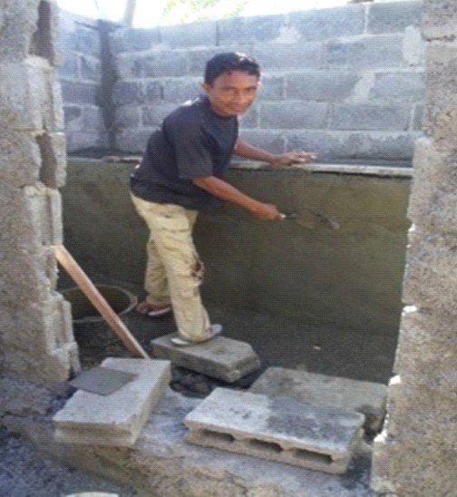
I am happy with my life because I never trouble anyone to look after me, I have capacity to support myself, to improve more. My routine activities are building small and simple constructions that can give me some income to help myself and not depend on others.

With courage and self-confidence and help from his family and other organizations such as Red NGO, Marcelo has access to employment that matches to his ability. He also tries to access jobs from family and friends. Currently Marcelo got a contract to build a house in Loes-subdistrict Maubara that will increase more his income.

Case Study
PARTICIPATION OF PEOPLE WITH DISABILITIES IN EMPLOYMENT TO SHOW TO THE COMMUNITY THAT PEOPLE WITH DISABILITY ALSO CAN CONTRIBUTE.

Summary: People with disabilities can be employed and contribute to community and Nation.

Advocacy Process
RESOMLIQ (REDE NGO) is working in some villages in Likisa Municipality to promote inclusive participation of people with disabilities to protect their equal right in sub-villages level, Villages level and Municipality level. So, now RESOMLIQ work with people disabilities organizations to increase their capacities through advocacy to help them to succeed their lives in the future. Marcelo is one of the participants. Marcelo da Conceiçao Silva came from Agriculture background family; he was born with impairment on both legs.

The resources needed for advocacy
- Funds for advocacy, targeting strategic people in the government
- Awareness raising and basic training on disability to local staff of NGOs on disability
- Collaboration with disability oriented organization

Factors that made this practice a success
- Willingness of Marcelo to learn and not give up
- Support from family is essential to boost confidence of people with disabilities
- Availability of family on job gigs possibilities

The difficulties
- People stigma. People still think people with disabilities are incapable
- Funds for expanding business is not too easy
- Adapted work tools and technology to improve quality of work is not common

Significant Changes.
Marcelo can now work as any person without disability would. He is proud to be able to not depend on his family for income.

How to replicate this good practice
- Support from family or support group is essential to ensure confidence and willingness of people with disabilities to learn and excel
- Accompaniment from a disbaility oriented organization on to people with

disabilities and their families/caretaker is essential to open horizons and change perspectives
- Good transfer of knowledge / networking between disability oriented organization (or DPO) to local organziation on how to perpetuate work on disability inclusion is important to ensure that the client is not 'left behind'
Ensure coordination with local government offices to advocacte for inclusion into services or even to connect between people with disabilities and the services provide. Often, services are available but information outreach s not enough.

Recommendations
All organizations that work for people with disabilities continue to fight and socialize and promote the right of people with disabilities
Organizations, civil societies have to consider and prioritize people with disabilities advocacy process activities.

Contact Person
Mr. Antonio Pereira da Costa: resomliq2009@yahoo.com

Case Study 5

Jaco da conceição
Writer: Joana dos Santos, Rede Sociedade Sivil Munispiu Liquica (RESOMLIQ)

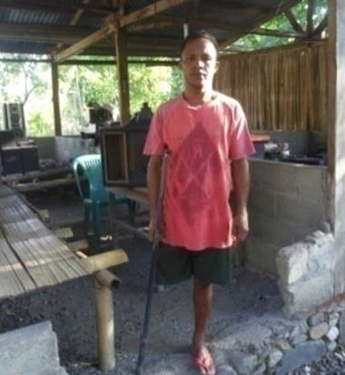
My name is Jaco da Conceicao, I live in Municipality of Liquica, Suco Dato and sub village of Kamalelara. I am a father of 6 children. 3 of them are primary students. I did not go secondary school. I was hit by a car and totally broke my right leg and it was amputated. I was in pre-secondary school and now I am a person with disabilities . It was hard for me to accept the reality; I thought my life will be useless with one leg. I went to Klibur Domin, back then it was called Knar Domin in 1996. I accessed KD training center and I thought it was a very new opportunity for me as back then I was hopeless.
Even as a person with disability, I still need to go forward with courage to learn something to sustain and support my needs and family needs.
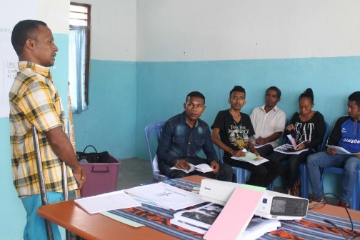
I attended an electronic training in Klibur Domin to learn to fix broken TVs, radios and sound systems. With the experiences I have, today, I run my own business Electronic Service in municipality of Liquica.
I don't feel bad or down about what people say or tell about my conditions this is the reality I need to move on and show them this is not end of my life. I need to show them that person with disability like me can do something and succeed something to support my life and family. So far I use my own income to support and to run my business, nobody fund me to run my business.

The problems with my business is, things change a lot and electronics change along with the technology. I can only fix outdated electronics so it is very difficult for me to fix newer electronics so maybe I need to upgrade my capacities by attending extra training regarding electronics. This can easily be overcome if you really want to fight for it.

As a person with disability, I would like to encourage my friends with disabilities to continue to learn encourage our own self not to dependable to others. Show to others we can do something better to ourselves families and Nation.

TO DEFEND THE RIGHT OF PEOPLE WITH DISABILITIES ACCESS TO SELF HELP ACTIVITY IN EVERYDAY LIVES.

Summary:
People with disabilities can help their own to develop and improve their lives and participate actively in community activities

Introduction
In Timor Leste, according to article 43 constitution of RDTL “Everyone guarantee freedom in associations and expressed through organizations and civil society” therefore, the general assembly of 12 organizations and civil societies in municipality of Liquica declared and established RESOMLIQ in September 9 in 2009 as an important pillar and role to control any development in in Municipality of Liquica.
Eventhough many times the participations of people with disabilities in Municipality Liquica not involved maximum. Therefore, RESOMLIQ considered disabilities as important issue and wanting to involve people with disabilities civil society process. In 2016 advocacy for change program which was implemented by Handicap International in Municipality of Liquica, RESOMLIQ understood disabilities issues as something new to organizations, but with all the decisions from executive team finally RESOMLIQ taken part on promoting the right of people with disabilities. This is as important opportunity to develop advocacy in every levels regarding disabilities issues because so far no maximum participations from people with disabilities in Municipality of Liquica.

This year, RESOMLIQ began to support Mr Jaco da Conceicao as a person with disability to help him to participate in more income generating activities that can support his life

Advocacy Process
RESOMLIQ/Rede NGO Liquica work with Jaco to explain and promote activities advocating the rights of people with disabilities to participate in community activities. Advocacy as a way to solve and promote the right of people with disabilities to participate in the inclusive development process began from sub village level to municipality level
The that we did in good practice, very efective to develop municipality inclusive change. With these process people with disabilities actively make a external changed through socializations to all partners to work more in networking because the proactive people with disabilities can make a change to good practices.

The Resources needed to make advocacy
To implement this advocacy Rede NGO of Liquica used these resources:
- Funds for advocacy, targeting strategic people in the government
- Awareness raising and basic training on disability to local staff of NGOs on disability
- Collaboration with disability oriented organization
- Self-help Groups of people with disabilities are present in Liquica, allowing for people with disabilities to arrange their voices from larger groups

Factors that support making good practice success
Factors that made Jaco success:
- support from family and friends is essential to ensure confidence of Jaco
- Training from Klibur Domin, a training center in Liquica
- Support from local authorities also helps to expand his business

Difficulties are:
These are the difficulties:
- Not too much clear information on options for employment or business expansion
- Community and including leaders not familiar with disabilities issues, resulting in perpetuating negative stigma
- Limited global factors to advocacy: no information regarding the participations people of disabilities in program activities
- Not too many organizations working on disability at the local level
- Trainings on his craft needs updating but inclusive training cenetrs are far
- Access to loans for expanding business and purchasing tools is limited

Significant Change
Jaco's activities as motivations for all of us to see the efforts he does as part of his contributions for development process in the same time to show to everyone that people with disabilities also can do and have capacity.

How to replicate this Practice
To replicate this good practice points that can promote a better good practice are:
- Dissemination of the ability of people with disabilities is essential, instead of focusing on their limitations.
- There need to be massive promotion of rights of people with disabilities to people at the local level
- There isn't too many organizations focused in disability inclusion at the local level so there need to be one at the local level that encourages people with disabilities to be involved and voice their needs
- Involvement of local authorities is key to ensuring a more inclusive service especially for people with disabilities

Recommendations
When implementing actions for the advocacy of the rights of people with disabilities, begin from the local level, this is where service provision should be done and the quality of inclusion can be seen and felt. Working at the local level will ensure tangible improvement of quality of life for people with disabilities.
Sustainability is key: ensure that there is contributions and participation from local organizations (or groups) to develop participation from more people with disabilities at the municipality level.
Do evidence based advocacy: people –and the government- need to know what works and how, as an example that people with disabilities can also take part in participating in various lines of social and public life.

Contact Person
Mrs. Joana dos Santos: resomliq2009@yahoo.com

Case Study 6

Participation in Politics of Helio Pereira Lobato
Writer: Pascoal da Cruz Gomes

Biography
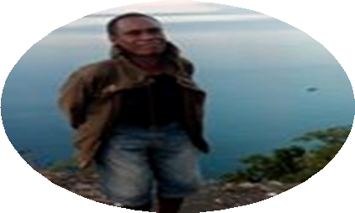
Helio Pereira Lobato is a person with physical disability. He was born in Dato on March 3, 1974 son of David de Jesus Lobato and Filomena Rodrigues Pereira. He finished his primary school in 1992 in St Jhon de Brito Primary school in Liquica. He finished his pre secondary in 1995 and finished his secondary in Secondary Cristal Liquica in 1998.
Helio Lobato was born in 1974 and became a person with disability due to an accident in the jungle when they were fleeing from the persecution of the Indonesian government.

• • •

Participation in Politic
In 1979 we moved back to our hometown in the mountain, this is around the time I had the accident that caused my disability. My parents tried to have me treated, but it didn't really work. I experienced great pain and after three years we gave up.

Back then, everyone called me “Mautuku” (Hunchback). In 1984 my elder sister her name is Manuela Pereira Lobato said to me “Atuku, you need to go to school sooner or later” so, I went to public primary school but I did not stay long in that school because they bullied me a lot. Then I moved to catholic primary school until I graduated. Then I went to pre public school then to Secondary school until I finished. I participated in school organizations called 'OSIS”, writing contest, speech contest and participating school gym and playing football, volley ball and Basketball.

Many people thought that the life of a person with disability is a burden for their surroundings; they thought I will be very dependent on my family. During the Indonesian invasion I went with my family to the mountains, moved from one place to another.We could see bullets flying everywhere, terrifying sounds of machines but still my father carried me along until we came back to town to surrender. It was in 1990 that Helio joined with one ICRC member and started working in the humanitarian sector. It was hard but he wanted to participate and support the movement. In 1995, with a friend, they established an organization called MAUN ALIN REZISTENCIA (MAR/ brothers of resistence) to make underground connection with rebels in the mountains until December 1993. This

Helio Lobato was also nominated to organize the important event to hoist the National Flag of Timor Leste in July 16, 1993 in Liquica. He took this responsibilities and became one of the propaganda members involved in the underground structure in military level until April 1999 in Municipality of Liquica. Now Helio works in Liquica.

Case Study
THE RIGHT OF PEOPLE WITH DISABILITY TO PARTCIPATE IN POLITIC
Writer: Filipe Goncalves Correia

Summary:
People with disabilities are not merely sitting at home and doing nothing. People with disabilities also can participate in politic in Timor Leste including fighting for the independence of Timor Leste

Introduction
Disabilities is part of human kind and is part of Timor Leste diversity. Participations and contribution of everyone including people with disabilities is very important to the development of Timor Leste

According to article 29 of the Convention on the rights of people with disabilities (CRPD), people with disabilities have rights to participate in the Organization of Governmental and this also include public and political life in the country, and in the activities and administration of political parties.

Resources that is needed for the practice
- Good understanding regarding disabilities issues
- Networking between Rede NGO and other organizations, relevant ministers, Municipality administrator, head villages, head sub villages, families

Factors that support this good practice
- The Government of Timor Leste recognized Helio's contributions for independence
- Helio Lobato has courage to learn, confidence
- The family support and encouraged him to study.

Constraints Faced
Barriers that Helio Labato was facing
- Negative stigma that people with disabilities should just stay at home
- Limited physical accessibility
- Low commitment from government to take disability as an important issue

Significant Changed
Helio Lobato currently works and no longer depends to other people. His story can be as an example and inspirational to show that people with disabilities can participate in politic, and to contribute for Timor Leste independence process. People with disabilities are not meant to stay at home, they need to take part in the community life.

How to replicate this good practice
- Good promotion of disability issue.
- Promoting participation people with disabilities in community, including political participation.
- Providing reasonable accommodation, including accessibility and reducing other barriers.

Recommendations
For all of us, we need to disseminate disability issue and advocate for disability inclusion to government, organizations, leaders, communities and to all of families of people with disabilities

Contact
Mr Filipe Goncalves Correia: resomliq2009@yahoo.com

Case Study 7

GOOD PRACTICE STORY on Psychosocial Rehabilitation

The Story
Client's name is AP, was born on March 1st 1973, 34 years old female from sub municipality of Nain Feto, Municipality Dili.
AP's father was killed during civil war in 1975, and her mom was also a person living with psychosocial disability since AP's father died. AP lives with her 8 brothers. AP is the first in the family. Among them, nobody went to school, including AP, who only went half way through pre-secondary, due to economic condition of the family. In 1992 AP decided not to continue and got married. In 1993, she had her first baby. After four months, she developed symptoms of mental health problems endangering herself and her newborn. Her family decided to tie her up with chains and they let her sleep in the balcony for almost one month. Her family did try some traditional treatment, using leaves to drink and bathing and for a while, it seemed to have worked.

For a while, things were under control and then she had her second baby. However, the symptoms returned and again this cycle continued again for the third baby. Her condition heavily depends on her psychology condition. When everything is all right, she is loveable person, caring to her children, able to perform daily tasks and can perform income generating activities, which includes selling vegetables. However, in 2007 her husband abandoned her and the children. There was no money to support basic needs of the family. She began to depress with economic conditions and her psychology was affected again.

In July 2007, AP went to PRADET office to obtain support and to share about her domestic problems . She started getting treatment and support from PRADET. From 2011 to 2013 AP routinely goes to PRADET to report her children had left her and went with their father so she lived alone with her mother who happened to also be a person with psychosocial disabilities, so they both lived in terrible economic situations and nobody was around which worsens AP's condition. They received terrible stigma, pressure, sometimes they have no food and were generally ignored by relatives. The culmination of this was AP being thrown out of the house. She went to PRADET to ask for soaps and other necessities. But most the time she sleeps by the beach, and was living in the streets.In 2011, funded by UNFPA, PRADET built a small house for her and her mother to stay. They also support basic needs like bed covers, beds and kitchen tools and food.

AP always went to PRADET to ask for job. Finally she got a job to help PRADET as a cleaner and she uses that money to buy basic necessities and gave some to her children. AP was very happy with what she got at least this can help her needs and could send her children back to school. PRADET observed that she worked diligently and so dedicated.

Nevertheless, AP is prone to relapses. PRADET observes that her relapses always occurs around the time of great depression for her, whenever she had fights with the family and

whenever her family pressure her, bullied her. Families and community believe that people with psychosocial disabilities are “crazy” so no need to waste time to look for any medical treatment.

Difficulties which were faced by PRADET in field work to make this good practice was the conditions of AP who was really desperate and poor, living with her mother who is also a person with psychosocial disabilities. The community participations was not good and there is a real lack of considerations or respect to AP from the family. AP's family rarely will take them to rehabilitation centers such as PRADET which leads to relapses hence preventing them to independent people.

Recommendations
To all readers, to respect our fellow human who have psychosocial disability, love and care for them like us. They have the same rights like to access to medical treatment, information, business, and education. We have no differences between us everyone is the same in the eyes of God. Please do not tie them up, spit on them or ignore them.
I ask, The Government of Timor Leste to continue to support the rehabilitations center and its programs, support people with psychosocial disabilities to provide assistances in order for them to be independent people in the future

Contact
Writer Elda J. Cardoso, staff PRADET – Asistensia ba Programá Moras Mental (PAMM). Work for Psycosocial Disabilities and incharge in Municipality of Baucau
Contact +67077298970.
Office: Hospital Nasional Guido Valadares-PRADET

GENERAL RECOMMENDATIONS

Government
- Ratify quickly the UN CRPD in Timor Leste
- Ensure inclusion for people with disabilities in all government's programs across the country.
- Provide specific programs tailored for people with disabilities, focusing on reducing barriers for people with disabilities
- Provide information outreach to people in the municipalities on available services
- Collect more comprehensive data on people with disabilities to allow for more precise programs
- Raise awareness and understanding on the National Disability Action Plan.
- Strengthen and monitor the implementation of the National Disability Action Plan
- Provide training on etiquette for interacting with people with disabilities for minitries and district level offices.
- Ensure there is opportunity for people with disabilities to take part in political proceses. Ensure that voting centers are accessible for their use.

Organization working on Disability Issue and DPOs
- Raise awareness on the National Disability Action Plan – what it is and how it should be done through the various ministries
- There is a great need for a more robust disability movement at the local level. DPOs should encourage people with disabilities to form groups to support each other in their localities. This will also enable them to better voice their needs.
- DPOs have to start networking with other organizations – either at the national or local NGOs at the municipality level.
- There is a great need for DPOs to disseminate and promote disability issue at the municipalities to governmental offices and local leaders. There is also great need of emphasizing the rights of people with disabilities to their families and caretakers.

CBOs, NGOs, INGOs, and other Service Providers
- Include people with disabilities in existing programs and services. This can start as them being beneficiaries to you project or service.
- When planning for new projects, budget for inclusion for people with disabilities, this may include accessibility adaptations, information adaptation, or other tailored approaches to ensure that people with disabilities can also benefit from your projects.
- Giving spaces including opportunities for capacity building activities and employment for people with disabilities
- Reinforce advocacy for disabilities issues in National and Local levels.

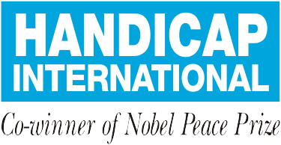

Handicap International Indonesia & Timor Leste Programme
Avenida Luro Mata/Pantai Kelapa (in front of Dili International School), Dili-Timor Leste Phone : +670 3311174
Mobile : +670 77161754

Jl. Mantrigawen Kidul No. 24A RT 21 RW 07 Kelurahan Panembahan, Kecamatan Kraton Kota Yogyakarta, Indonesia 55131.
Telp: +62 (0)274 414 574
Mobile: +62 (0)811 25 89 22

www.handicap-international-id.org FB: www.facebook.com/HIIDTL Twitter: @hi_idtl
Youtube: Handicap International Indonesia Timor Leste

http://dpt-rhto.wixsite.com/timor/single-post/2016/05/03/Servisu-Hamutuk-Oins%C3%A1-atu –ajuda- Ema-ho-Defisi%C3%A9nsia-Hetan-Suseu-iha-Neg%C3%B3siu
http://www.iri.org/sites/default/files/english_timor-leste_2016_public_opinion_poll_for_public_release.pdf
www.kliburdomin.org/p/programs.html

