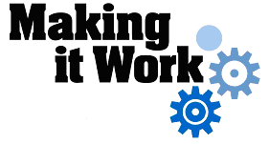

Good Practice case study

How can a Disabled People’s Organisation ensure that hearing impaired students are included in mainstream education?

Relevant articles of the CRPD: 24, 29
Country: Togo
Region: West Africa
Languages available: English, French

Advocacy for the Inclusion of Hearing Impaired Students in Mainstream Secondary Education

Description of the practice and the process involved

People with hearing impairments are often victims of discrimination and exclusion, particularly in terms of education. In Togo, there are few education opportunities for deaf or hearing impaired children – whether in specialized or mainstream schools. Those that exist are only at primary school level – there is nothing at the level of secondary or higher education.
In an attempt to address this situation, the Togolese Association for Deaf and Hearing-Impaired Children undertook advocacy activities aimed at the Togolese education authorities. The aim was to create the conditions for the inclusion of hearing-impaired children in mainstream colleges and high schools.

The process began with raising the awareness of stakeholders involved in the education of deaf children, namely parents, teachers, colleges and high schools, authorities in charge of education and networks of disability organisations.
Awareness-raising tours aimed at the heads of secondary schools in Lomé got underway. These tours were designed to negotiate the inclusion of students with hearing impairments in secondary schools.
Ultimately, three secondary schools in Lomé agreed in principle and decided to embark on the inclusion project. The three schools in question had no skills in terms of the education of hearing-impaired children. The DPO therefore contacted a specialist to conduct specific training for the teachers.
Following this awareness-raising campaign, a coalition of stakeholders was established to conduct lobbying of school authorities and define a strategy for action.
The coalition consisted of the following stakeholders: ATAIDEMES, the network of parents of hearing-impaired children, the three principals of the schools that joined the inclusion project, the Inspector of Education of the Maritime Region, and the teachers involved in the training in sign language.

Now that the primary stakeholders had agreed to the basic principle, the next step was to obtain the approval of the Ministry of Primary and Secondary Education for the inclusion of people with disabilities in secondary education.
After long negotiations, the Ministry gave its approval and permission was granted to the teachers of the three institutions to be trained in sign language.
For the training, an international NGO provided technical support and monitored the process.
To institutionalize this initiative and encourage its sustainability, a coalition of members lobbied the relevant authorities to integrate sign language into the training modules of the Teacher Training Colleges.

The factors that made this practice possible

- The ready and effective involvement of school officials and teachers was instrumental in achieving this result.
- The creation of the coalition of stakeholders for the advocacy and the dynamism of ATAIDEMES were also fundamental.

Some of the difficulties encountered

- The process was long and complex.
- The major difficulty was the lack of financial resources to organize the training sessions for teachers. This problem was solved through the mobilization of the DPO in the search for funding.

The effects / impact of the practice

- Parents of children with disabilities are now increasingly aware of the possibility that their hearing-impaired children can go to secondary school. As a result, they are increasingly committed to the concept of inclusive education.
- At school the children are included effectively and their fellow students have also taken steps to learn sign language.
- ATAIDEMES is now known for its expertise in the educational support of hearing-impaired children.
- Stakeholders at the local and national levels are more aware of the issue of inclusive education for hearing impaired children.

- “My inclusion in this school was initially very difficult. I felt like I did not belong here. But over time and with the help of the Director and my teachers, who are very caring, I am now integrated and I like going to school. I am determined to go very far in my studies if I can always have the support I get here” said Bertin, a hearing impaired student.

An example of disability Inclusion
The fact of adapting the mainstream education system to take into account the specific needs of people with disabilities is a concrete example of disability inclusion.

Related articles of the CRPD

This practice of including children with disabilities in mainstream secondary schools shows the participation of people with disabilities in public life (Article 29) as the DPO conducted, in collaboration with other stakeholders, advocacy in relation to local authorities on the right to education. This fundamental right for people with disabilities is stated in Article 24 of the Convention.

For more information, contact:

Mrs Amivi KOMLAN,President of ATAIDEMES
Tel: 00 228 234 92 80.

Background and context
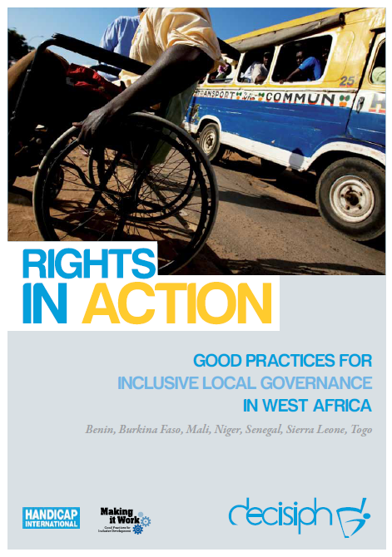
Full project report: Rights in Action - Good Practices for Local Inclusive Governance in West Africa (Handicap International 2010)

Criteria for the good practices: see pages 96 – 97 of the full report.

Recommendations from the good practices: see pages 98 – 111 of the full report.

Links to further resources:
Full text on CRPD article 24 – Education
Full text on CRPD article 29 – Participation in political and public life

