

Good Practice case study

How can a Disabled People’s Organisation ensure people with disabilities participate to prefecture councils and disability issues are taken into account in decision-making processes?

Relevant articles of the CRPD: 29
Country: Togo
Region: West Africa
Languages available: English, French

Participation of People with Disabilities in the Prefectural Council of Mandouri and Creation of a Specific Budget Line

Description of the practice and the process involved

Mandouri is the administrative centre of the Prefecture of Kpendjal, located in the Savannah region in the North East of Togo. This city, which has about 11,000 inhabitants, is one of the poorest and most isolated communities of Togo. People with disabilities are particularly vulnerable.
To contribute to improving their living conditions, the association ASPHAK was created in 2004. As a result of the advocacy undertaken by ASPHAK, the population of Mandouri has become increasingly aware of the rights of persons with disabilities. For example, this advocacy has supported parents of children with disabilities in considering the schooling and social integration of their children.
In 2004, the President of ASPHAK, who is a tax collector at the Prefecture, drew the attention of local authorities, and particularly of the Prefectural Council, to the situation of people with disabilities in the locality. An advocacy strategy was developed with the support of other DPOs in the region, such as the Organization of Committed Persons with Disabilities of Tone (APHMOTO), based in Dapaong.
These advocacy activities were aimed at supporting local authorities in more effectively addressing the needs of people with disabilities. After this process, dialogue was initiated between authorities and disability activists, which enabled ASPHAK to be acknowledged as a key local stakeholder.

These links between ASPHAK and the authorities of the Prefecture, initiated in 2006, created a climate of trust and enabled the DPO to make regular reports on its activities to the local authorities (which was not a common practice at the time). This led to improved understanding by the authorities of the socio-economic difficulties facing local people with disabilities. Building on this trust, the Prefectural Council began to provide financial support to ASPHAK in order to address some of the most pressing needs.
In 2007, the Prefecture of Mandouri sent an invitation to ASPHAK to attend the budget session of the council. At this meeting, the DPO called for the inclusion of a specific budget line for people with disabilities. As a result, a minimum allocation of 150,000 CFA was granted. Since then, the Prefectural Council has allocated a budget for people with disabilities every year. It was 150,000 CFA in 2007, rising to 300,000 CFA in 2009.
This amount may seem insignificant when compared to the scale of the needs to be addressed. However, according to ASPHAK, the willingness of the local authority to include a DPO in the discussions and decisions of the Board and to make an annual grant demonstrates a significant shift, and a new commitment to promoting inclusive local governance and the rights of people with disabilities. This practice is considered very innovative in Togo, where local government rarely has a specific budget line for people with disabilities.

The factors that made this practice possible
- Many of the advocacy actions undertaken by the DPO and their allies in the Prefectural Council helped prepare the ground and influence government decisions.
- The awareness-raising meetings on disability issues conducted with the support of the Togolese Federation of DPOs (FETAPH) and an INGO were also decisive.
- The visits of FETAPH and that INGO to the local authorities facilitated the positive reception and the legitimacy of the work done by ASPHAK.
- The regular reports of ASPHAK showed transparency in the management of the resources allocated, and this strengthened the trust of the local authorities.
- Another decisive factor was that the President of ASPHAK was also a financial adviser to the prefecture. His personal influence and his close links with the authorities have played a significant role.

Some of the difficulties encountered
Initially, there was reluctance on the part of some members of the Prefectural Council to accept the principle of a budget line for people with disabilities.
These difficulties were overcome by the arguments developed in the advocacy actions of the DPO with the authorities, which helped reach a consensus.

The effects / impact of the practice
- To date, this practice is well established and is now part of the budget of the Prefectural Council. According to the President of the Prefectural Council, the budget will increase in the coming years.
- The grants received were used to pay for the design of micro-projects that have been submitted to funding partners. These have all received funding.
- The grants were also used to finance some of the income-generating activities initiated by DPOs (mills, farm machinery) and to cover part of the operating expenses of the organisation.
- The many awareness-raising actions at the local level helped improve the way the community perceives people with disabilities, who are now regularly invited to political and social events.
“Thanks to the money that the authorities have given us, we were able to buy the necessary equipment to cultivate our fields with animal-drawn ploughs. Our group has also set up a mill that generates a little money for us, enabling us to avoid begging and to meet our daily needs... We could create a micro-business if the local authorities give us more support” said the secretary of ASPHAK.

Related articles of the CRPD
This practice is an example of the application of Article 29 of the CRPD in the sense that it promotes the involvement of people with disabilities in public life, notably through their participation in the sessions of the Prefectural Council.

What are the main points that require attention? How could it be improved?
Planning, prioritizing needs, transparency and the rigorous management of the funds granted to DPOs must precede the promotion of such practices.

For more information, contact:
M. Emmanuel TCHIANKA, President of ASPHAK
Tel: 00 228 998 23 85 or 00 228 974 00 17.

Background and context
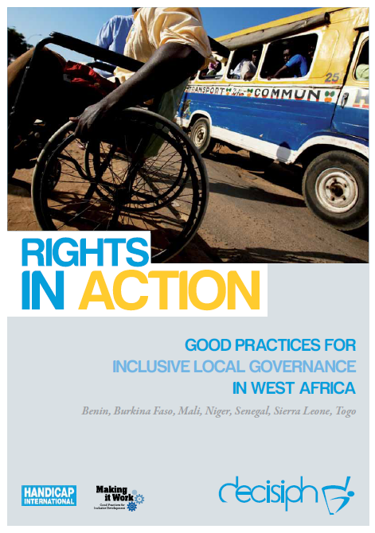
Full project report: Rights in Action - Good Practices for Local Inclusive Governance in West Africa (Handicap International 2010)

Criteria for the good practices: see pages 94 – 95 of the full report.
Recommendations from the good practices: see pages 98 – 111 of the full report.

Links to further resources: Full text on CRPD article 29 – Participation in political and public life

