

Good Practice case study

How can a Disabled People’s Organisation ensure that people with disabilities are included in local development projects and decision making processes?

Relevant articles of the CRPD: 29
Country: Togo
Region: West Africa
Languages available: English, French

Inclusion of People with Disabilities in the Village Development Committee of the Village of Mission-Tové

Description of the practice and the process involved

Mission -Tové is a village of the Prefecture of Zio, located about 30km northwest of Lomé. With a population of about 15,000 residents, the village has six communities and is headed by a village chief, a traditional authority who manages all local affairs. The chief is assisted in his mission by a Village Development Committee (CVD).
In this village, people with disabilities are often discriminated against and marginalized. Sometimes they were considered as «voduns» or «Tohossou» and, therefore concealed by their families.

In 2001 in Lomé, during the Games of the Future for People with Disabilities in Francophone Africa (JAPHAF), the Director of the Association of Parents and Friends of People with Encephalopathy (APAPE), an organisation of people with disabilities in the Prefecture of Zio, met with the Mawuko Group of people with disabilities of Mission-Tové. This meeting marked the beginning of the intervention of different stakeholders specialized in the field of disability in the Village of Mission-Tové.
In 2003, an awareness campaign conducted in Mission-Tové by APAPE found that disability rights were violated at all levels and generally not acknowledged by local communities. An extensive awareness-raising and capacity building programme was developed and implemented by the Mawuko Group until 2007.
In 2008, on the proposal of APAPE, a participatory local assessment of the situation of persons with disabilities in Mission-Tové was conducted by an INGO in cooperation with the local group of people with disabilities. This diagnosis aimed to identify the main problems experienced by people with disabilities and the priority areas for action to address them. The diagnosis, finalized in November 2008, led to the development of a three-year inclusive Village Action Plan.
In order to promote people with disabilities in the locality, the board of the Village Development Committee (CVD) was renewed and made more inclusive through a vote. Of the nine members of the board, two people with disabilities were elected as Vice-President and Secretary General. There was a strong presence of people with disabilities on the Health, Education, Welfare, Environment, Culture, and Solidarity committees.

The factors that made this practice possible

- This practice was made possible thanks to the intervention of APAPE, particularly its awareness-raising activities between 2003 and 2007.
- The local diagnosis, carried out with the participation of all stakeholders in the area, led to the design of an inclusive action plan.
- Open and positive dialogue with local authorities made clear the need for the participation of people with disabilities in the affairs of the village.
- The determination of people with disabilities themselves to prove their capacity to contribute to community development certainly accelerated the process.

Some of the difficulties encountered

The main difficulties were the initial reluctance of the Village Head and the indifference of the population.
Awareness-raising carried out by the APAPE and the Togolese Federation of DPOs (FETAPH) helped overcome these difficulties.

The effects / impact of the practice

- People with disabilities were directly involved in developing the new Action Plan of the Village Development Committee of Mission-Tové. Their role was to ensure that the plan was inclusive.
- A concrete result of the new Action Plan was the improved accessibility of primary schools in Mission-Tové. In 2009, ramps and accessible toilets were built. This had a significant impact on children with disabilities and the whole community. The Village Development Committee envisages, among other things, the physical accessibility of all the schools by 2011.
- Members of the Village Development Committee say the have more knowledge and greater awareness of disability issues: «We had never considered this before because of our lack of expertise on the needs of persons with disabilities».

- “Before, in this locality, people with disabilities were really suffering. We were excluded from everything that happened in the village and even our own parents mistreated us because of our situation and their inability to take care of us. Personally, I struggled in vain to make it at school, because of the lack of consideration for me despite my intellectual capacity... But since the intervention of APAPE and Handicap International in our community and our integration into the CVD, the living conditions of people with disabilities have changed. Now we can move freely and with dignity in the village streets without being ashamed. We participate fully in the community work organized in the village and we positively influence decision making in the Village Development Committee and other bodies...” said the Secretary General of the Village Development Committee of Mission Tové.

An example of disability inclusion
This practice is an example of taking into account the needs of people with disabilities in local planning. This resulted in the development and implementation of a three-year Inclusive Action Plan.

Related articles of the CRPD

The inclusion of persons with disabilities in the Village Development Committee is related to Article 29 of the CRPD on the participation of persons with disabilities in public life and politics.

For more information, contact:

M. AZIAYE Améfete, President of the Village Development Committee of Mission-Tové
Tel: 00 228 920 84 06.

Background and context
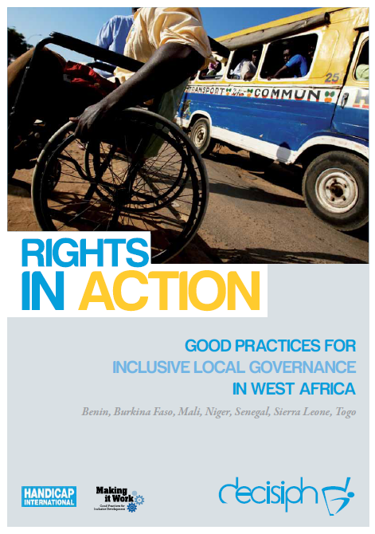
Full project report: Rights in Action - Good Practices for Local Inclusive Governance in West Africa (Handicap International 2010)

Criteria for the good practices: see pages 92 – 93 of the full report.

Recommendations from the good practices: see pages 98 – 111 of the full report.

Links to further resources:
Full text on CRPD article 29 – Participation in political and public life

