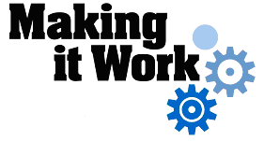

Good Practice case study

How can a Disabled People’s Organisation be represented in a regional committee and ensure gender and child issues are included in decision-making processes?

Relevant articles of the CRPD: 29
Country: Sierra Leone
Region: West Africa
Languages available: English, French

Representation of People with Disabilities on the Southern Region Gender and Child Protection Committee – Bo City

Description of the practice and the process involved

Bo city lies in the south of Sierra Leone, about 260 Km from Freetown, the capital city. It is the district headquarters of Bo District and the second largest city in Sierra Leone with a population of about 80,000.
The main DPO operational in Bo city is the Disabled Rights Movement (DRIM) founded in 1998. There is also a branch of Sierra Leone Association for the Blind (SLAB).

The traditional mission of Ministry of Social Welfare, Gender & Children’s Affairs (MSWGCA) is to ensure the provision of social services at community level to socially marginalized or disadvantaged groups (particularly children, whether living with their families or in the street), those affected by conflict, women, the elderly and people with disabilities, as groups, individuals or family units, who require these services. In this regard, the Ministry strives to promote and advocate the needs and rights of all these groups, mainly in the area of resource mobilization and allocation (without gender discrimination) and to identify policies and law reforms that enhance the work of the Ministry.
However, the current process of decentralization has occasioned a slight change in this mission statement. The ministry’s role shall now be focused on coordinating, monitoring, evaluating, formulating and developing policies; it will also help new local councils to fulfill their role in the delivery of services to vulnerable groups.

The regional gender and child protection committee was established as a coordination structure to help fulfill the current responsibility of the Ministry. Key objectives include:
- Ensuring the rights of children in accordance with the government’s current policies based on the United Nations Convention on the Rights of the Child (CRC) and the African Charter on the Rights and Welfare of the Child (ACRWC);
- Monitoring and coordinating the activities of all voluntary/community-based organisations and non-governmental organisations in this sector in order to provide effective welfare services to the population.
The committee comprises representatives from child protection NGOs (World Vision, HANCI…), the Ministries of Social Affairs (MSWGCA), of Education, Youth & Sports (MEYS)and of Health (MOH), DPOs (DRIMSL), local councils (Bo City Council & Bo District Council), Youth & Women’s Organizations.
The representation of people with disabilities in this committee started in 1998 when the Disabled Rights Movement - Sierra Leone (DRIM-SL) was established. The Executive Director of DRIMSL represents people with disabilities on this committee. This representation has helped tremendously to raise the profile of people with disabilities within Bo City. The DPO representative has provided technical advice and recommendations on disability issues and has also submitted requests to the Ministry of Social Welfare, Gender & Children’s Affairs, to local councils and other humanitarian organizations that have the required capacity and resources to meet the needs of people with disabilities.

The gender and child protection committee carried out a survey on the needs of people with disabilities. The survey led to an inclusive action plan that provided development support to people with disabilities, which included:
- Professional training (sewing, metal-working, workshops on repairing electronic devices) for disabled street beggars, with the support of the NGO Cause Canada;
- Refurbishment (2003) and perimeter fencing (2005) for the Paul School for the Blind, with funding and support from the Ministry of Education and Bo City Council.

The factors that made this practice possible

- Advocacy / awareness–raising campaigns by DPOs, especially DRIM-SL, on the radio as well as workshops on the rights and participation of people with disabilities in social life.
- Willingness of the Ministry of Social Affairs to have people with disabilities represented by a DPO on the committee.
- Regular representation/attendance at the monthly committee meetings held at the Ministry in Bo city.

Some of the difficulties encountered

- The committee members knew nothing about the situation of people with disabilities. This problem was resolved by preparing awareness-raising materials on disability issues and sharing them amongst members of the committee.
- The lack of funds for DRIM-SL to disseminate information to members. Support for this was solicited from other NGO partners.
- The environment and the committee meeting rooms are not accessible. No solution has yet been found to this problem.

The effects / impact of the practice

- The DPO (DRIM-SL) representative on the committee makes observations and provides technical advice on disability issues to forum members. Participation in this committee has helped to highlight the problems and needs of vulnerable groups, including people with disabilities.
- The representation has increased government awareness of their moral and constitutional obligations to people with disabilities.
- The DPO representative on the committee has positively influenced decisions / recommendations made for the provision of basic social and economic welfare services to vulnerable persons, including people with disabilities, by government, donor NGOs and local government councils.

An example of disability inclusion
This practice involved the inclusion of a DPO representative in a public forum that influences decisions / recommendations for the provision of development support services to vulnerable people, especially children, women and people with disabilities.

Related articles of the CRPD
This practice relates directly to article 29 of the CRPD. This practice enabled people with disabilities to participate in public affairs through their representation in the committee.

For more information, contact:
Vandy Konneh, Chairman, DRIMS, Bo
Tél: 00 232 076 641 368
E-mail: ndc@yahoo.ca,

Background and context
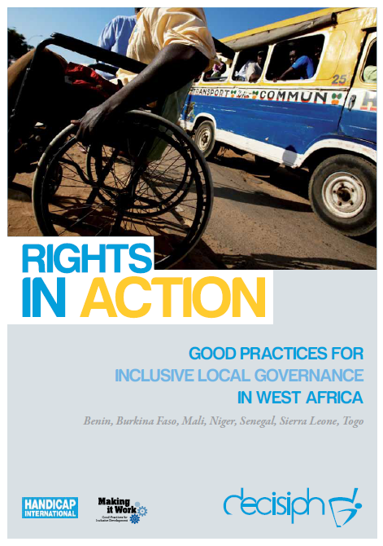
Full project report: Rights in Action - Good Practices for Local Inclusive Governance in West Africa (Handicap International 2010)

Criteria for the good practices: see pages of the full report.

Recommendations from the good practices: see pages 98 – 111 of the full report.

Links to further resources:
Full text on CRPD article 29 – Participation in political and public life

