
Good Practice case study

How can a Disabled People’s Organisation ensure that disabled people have the same access to university as other students?

Relevant articles of the CRPD: 24, 29
Country: Senegal
Region: West Africa
Languages available: English, French

Mechanisms for Taking into Account the Needs of Students with Disabilities at the Cheikh Anta Diop University of Dakar

Description of the practice and the process involved

The Cheikh Anta Diop University of Dakar (UCAD) is one of the oldest universities in Africa. It has about 50,000 students of 44 different nationalities, including students with disabilities.
UCAD is an autonomous community space for living and study. The academic community is composed of teachers, scholars, students and technical and administrative staff. It is a sort of a local authority.
The Association of Students with Disabilities (AEH/UCAD) brings together people with disabilities studying at the university. Founded in 1997, it has more than one hundred members (including people with motor, visual and hearing impairments). Its main mission is to ensure the improvement of the living conditions and education of its members. It has submitted a number of specific disability issues to the university authorities which, if neglected, can adversely affect the success of students. These include access to infrastructure and university exams, and financial and material support.
In 2003, the University created the Department of Student Life in Relation to the City (DVERC) to ensure, among other things, the reception of students and the development of the capacities of student organizations.
This department has a division in charge of students with disabilities. This division is headed by a former disabled student of UCAD and works for the better integration of the needs of disabled students. DVERC ensures the proper functioning of the Association of Students with Disabilities (general meetings, renewal of members, etc.) and supports its actions with government and other stakeholders outside the University. It presents grievances to the Assembly of the University and follows them up. The combined actions of AEH/UCAD and DVERC have significantly improved the lives of people with disabilities on campus. The new facilities of the university (classrooms, toilets, bedrooms, etc.) have begun to integrate accessibility concerns. Scholarships are awarded to all students with disabilities. They have priority for university residence.
They also have improved access to the technical and administrative services of the university (collecting scholarships, obtaining the student card, access to medical services, to the restaurant, etc.). The Board of Education and the Social Service Centre of the University provides support for the purchase of technical aids to facilitate mobility and access to the campus and to its knowledge resources. Deserving students with disabilities have access to scholarships to go and study in foreign universities and are prepared for their professional inclusion.

The factors that made this practice possible

- The mobilization of students with disabilities has been mainly driven by the university crisis in Senegal. Faced with the loss of social benefits and the increasing number of students, they came together in order to become a strong lobbying force.
- The foresights of the authorities, their awareness of disability issues and their willingness to make the university accessible to all citizens have been decisive in the establishment of this practice.

Some of the difficulties encountered

- The mobility of students with disabilities on the campus is not always easy. The campus is very large, larger than some of the municipalities.
- Students with disabilities have made great efforts to organize meetings and be heard.
- The solidarity between students with and without disabilities as well as the close relations with teachers resulted in the establishment of the association and its smooth functioning.
- The relatively short period of time students take to complete their studies can lead to mismanagement in the operation of the association and its bodies. For this reason, DVERC has a section which is responsible for students with disabilities and which ensures that disability issues are taken into account at all decision-making levels.

The effects / impact of the practice

- The number of students with disabilities has increased significantly since 1997 (the year of the establishment of the Association of Students with Disabilities). In 1997, AEH/UCAD had only seven members; at its last meeting in 2008, it had more than 100.
- The success rate of students with disabilities stands out clearly.
- The UCAD library is accessible to students with disabilities and is preparing to open a Braille section. The new buildings built in 2000 are all accessible. Each year AEH/ UCAD organizes, in conjunction with DVERC, open days aimed at the general public to raise awareness about issues relating to the social integration of people with disabilities.
- It also offers its expertise for free to DPOs present in the country.
- Two years ago, in conjunction with teachers, researchers and students of the university, it initiated an annual forum as part of the International Cultural Festival of People with Disabilities of Dakar (www.handifestival.com).
- “The conditions at the university are not always favourable for students with disabilities. The work of the association and DVERC solves some of our problems of accessibility, housing and access to scholarships. These actions have a real impact on our conditions of study and on our success” said a student of English, member of AEH/UCAD.

An example of disability inclusion
By trying to make room for students with disabilities, the university opens itself
up to all categories of the population. It becomes an inclusive place that guarantees access to education for all.

Related articles of the CRPD
The actions of AEH/UCAD and those of DVERC are related to articles 29 and 24 of the CRPD on the participation of persons with disabilities in public life and on education.

What are the main points that require attention? How could it be improved?
- The sustainability of the Association of Students with Disabilities is crucial.
- One of the weaknesses of the association is that it is run by dynamic young people who leave when they start to acquire leadership experience.
- The support and monitoring provided by the Disability Division of the Department of Student Life in Relation to the City is therefore fundamental.

For more information, contact:
Amadou Moustapha DIOP, Director of DVERC
Tel: 00 221 33 869.27.66 or 00 221 77 643 31 64 E-mail: taphadiop@ucad.sn.

Background and context
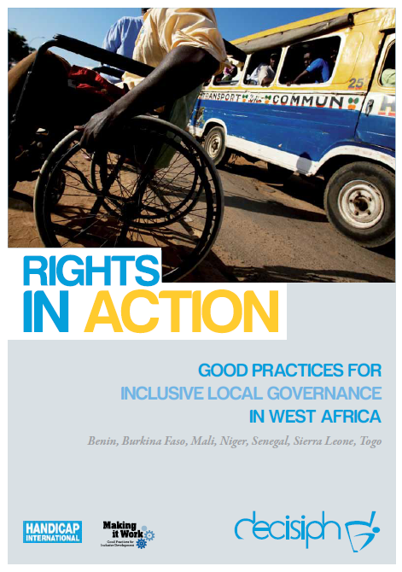
Full project report: Rights in Action - Good Practices for Local Inclusive Governance in West Africa (Handicap International 2010)
Criteria for the good practices: see pages of the full report.
Recommendations from the good practices: see pages 98 – 111 of the full report.
Links to further resources:
Full text on CRPD article 24 – Education
artcle 29 – Participation in political and public life

