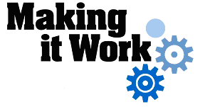

Good Practice case study

How can Disabled Women’s Organisations participate in decision-making processes?

Relevant articles of the CRPD: 6, 29
Country: Niger
Region: West Africa
Languages available: English, French

Participation of Women with Disabilities in Public Life in Municipalities III and V of Niamey

Description of the practice and the process involved

The Urban Community of Niamey is composed of five municipalities.
Municipality III is the most populated (226,886 inhabitants in 2009) and has comparatively more resources than the other municipalities. Municipality V is located on the right bank of the River Niger and is semi-rural.

In Niger, women with disabilities are very vulnerable. Indeed they often face a double discrimination, as women and also as people with disabilities.
To find solutions to their common problems, some women with disabilities have organized into groups. These groups are community-based organizations that have around 12 members each.
Through these groups, they have developed strategies to enhance their participation in the public life of the urban community of Niamey.

- In Municipality III, the groups of women with disabilities observed that they were not sufficiently considered and listened to at the local level. So four groups of women with disabilities came together to create the Jiki Kama Union («Let us mobilize» in the local language) in order to have a greater impact on life in the municipality.

- In Municipality V, the group of women with disabilities «Sourou Kanou Ka» has decided to integrate with other women’s organizations. This group had previously successfully implemented micro-projects in partnership with the municipal services of the Population and Social Reforms Unit. Through this collaboration and the visibility they acquired, the Department for the Advancement of Women and Child Protection has included the group in the activities of Women’s Day in Niger, alongside other women’s organizations.

The factors that made this practice possible

- The existence of a legal framework for the creation of groups of women with disabilities as well as unions;
- The will of women with disabilities to improve their living conditions, which has led them to unite and join women’s groups;
- The ability of women with disabilities to analyse stakeholders in the municipality of Niamey III and understand that, without a union, they would not have enough influence, because other stakeholders were also struggling to influence local policies;
- The success of the Ka Kanou Sourou group in implementing income-generating micro-projects in partnership with the municipal Population and Social Reform Unit;
- Good cooperation and synergy between the technical services of the municipality, including the Population and Social Reform Unit and the department for the Advancement of Women and Child Protection.

Some of the difficulties encountered

Because of illiteracy, women with disabilities have encountered difficulties in undertaking administrative procedures for the creation of groups. To overcome this obstacle, they resorted to external expertise that helped them fill out the necessary documentation.

Besides this difficulty, women with disabilities face a situation of high social and economic vulnerability every day because of the discrimination they still face in terms of employment, education and social and political participation.

The effects / impact of the practice

- The Union of Women with Disabilities has become a privileged partner of the Municipality of Niamey III and participates in meetings and decision-making;
- Women with disabilities, by integrating women’s movements, have been able to seize existing opportunities for funding and partnership in the Municipality of Niamey III, especially microcredit programmes for women;
- Women with disabilities that are members of the Union have had their capacity for action strengthened. They acknowledge that they have more power: «We have become important».

- “The creation of the Union, which has nearly 40 members, has been very beneficial for us women with disabilities. We are more visible and united in the municipality. Things are improving gradually and we have opened an account with a micro-finance institution in which we deposit the 1,000 Francs that the members of the Union contribute monthly. All the stakeholders present in the Municipality of Niamey III praise the creation of the Jiki Kama Union” said the President of the JIKI KAMA Union of groups of women with disabilities.
An example of disability inclusion
This process has enabled the Union of groups of women with disabilities of the Municipality of Niamey III to become a key development stakeholder in the public arena; previously, women with disabilities were more in a situation of dependency.
The participation of the group of women with disabilities of the Municipality of Niamey V in the activities of Women’s Day in Niger has enabled them to join the general movement for the promotion of women’s rights.

Related articles of the CRPD
This practice is in line with Article 6 on women with disabilities and Article 29 on the participation of people with disabilities in political and public life.

What are the main points that require attention? How could it be improved?

- Avoid internal conflicts related to the management of opportunities and power by ensuring quality internal governance of the union of groups of women with disabilities;
- Ensure that the collaboration of women with disabilities with the women’s movement goes beyond organizing the events for International Women’s Day. Women with disabilities should be fully integrated into the struggle for equality for the women of Niger in order to bring out the specific problems and demands related to their disabilities.

For more information, contact:
Mrs Aïssa Seyni, President of the Union of Groups of Women with Disabilities of Municipality IV.
Tel: 00 227 90 34 09 46.

Background and context

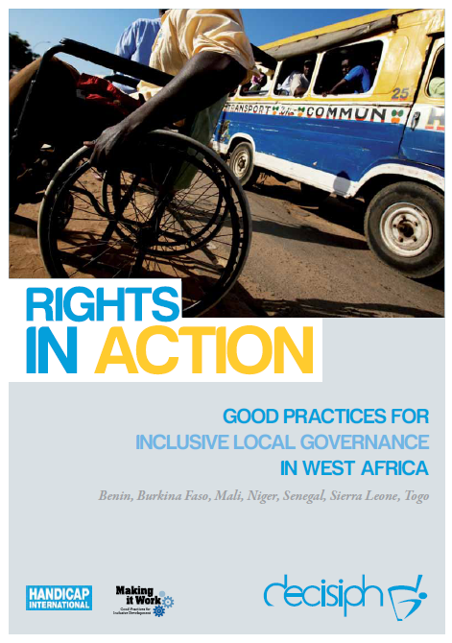
Full project report: Rights in Action - Good Practices for Local Inclusive Governance in West Africa (Handicap International 2010)

Criteria for the good practices: see pages 67 – 68 of the full report.

Recommendations from the good practices: see pages 98 – 111 of the full report.

Links to further resources:
Full text on CRPD article 6 – Women with disabilities
Full text on CRPD article 29 – Participation in political and public life

