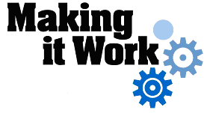

Good Practice case study

How can Disabled People’s organizations build a network in order to improve their visibility at the community level?

Relevant articles of the CRPD: 29
Country: Niger
Region: West Africa
Languages available: English, French

Advocacy by DPOs for the Waiving of the Administrative Fees related to the Formation of Groups in the 5 Municipalities of Niamey

Description of the practice and the process involved

According to the UNDP, 63% of Niger’s population lives below the poverty line. Several studies and field research have shown that people with disabilities are the poorest of the poor in the community.
Very aware of this situation, people with disabilities have organized advocacy actions in the municipalities of Niamey on the issue of exemption from the payment of administrative expenses for the forming of groups. A ‘group’ is a community-based organization that brings together 12 people around income-generating activities on the basis of solidarity.

In Niger, the administrative costs for the creation of a group amount to 15,000 CFA (about 23 euros) - an amount which is beyond the reach of most people with disabilities.
Faced with this difficulty, people with disabilities and their traditional chiefs have called upon the municipality for exemption from these fees.
This request was first accepted by the municipality of Niamey III, and then subsequently by the other municipalities.

Since the positive outcome of this collective advocacy led by people with disabilities, more than forty groups have been created free of charge. People with disabilities are the only groups that benefit from this exceptional measure.

The factors that made this practice possible

- The realization of people with disabilities that they need to unite in order to stake their claims more effectively;
- The political will of local political authorities in the 5 municipalities;
- Support from municipal technical services;
- Support from resource persons for preparing the applications of the groups.

Some of the difficulties encountered

Most people with disabilities were not aware of how the municipality functioned or what the procedures were for obtaining the formal organization of a group.

To overcome these difficulties, people with disabilities appealed to resource persons to prepare the applications for the creation of the groups; they also approached traditional chiefs to obtain the necessary information.

The effects / impact of the practice

- This practice has given groups of people with disabilities a higher profile at the municipal level. These groups have begun to use services in the municipality more than before, and they also visit the Mayor.
- It has improved the access of people with disabilities to funding opportunities and partnerships with development stakeholders involved at the local level.
- It has also led to the introduction of other support measures by the municipalities, such as exemption from municipal taxes for artisans and merchants with disabilities, or the granting of public plots for the economic activities of the groups.

- Zunmuntchi is a group of women with disabilities. All women members of the group are married to men with disabilities. Most of these women lived in slums on the outskirts of Niamey. In 2007, all the residents of these neighbourhoods considered as "dangerous" by the authorities were driven off. The majority of the women with disabilities found refuge in the industrial municipality of the capital, with all the risks associated with living near chemical waste. The group has a multiyear plan to help its members out of begging through the creation, among other things, of a sewing workshop. Now the group can submit issues to the authorities and propose solutions to improve the living conditions of its members. The president of the group said: “With the creation of this group, we are now treated with respect. When I go to Municipality IV, the head of the social service department receives me in person because she knows I'm not here in order to beg. Better still, I have her phone number and whenever we ask her to, she comes and listens to what we have to say.”

An example of disability inclusion
This practice has enabled people with disabilities who are members of groups to find their place alongside municipal authorities, NGOs and other development stakeholders in the fight against poverty.

Related articles of the CRPD

This practice is related to Article 29 of the Convention on the participation of persons with disabilities in political and public life.

What are the main points that require attention? How could it be improved?

It is important to ensure the viability and operational capability of the newly formed groups. To this end, capacity building measures and technical support are needed.
The creation of unions of groups in each municipality could be promoted to enable the development of a single channel of communication between people with disabilities, local authorities and other development partners.

For more information, contact:

Habou Rahamou, Head of the Population and Social Reform Unit.
Tel: 00 227 96 96 33 87.

Background and context
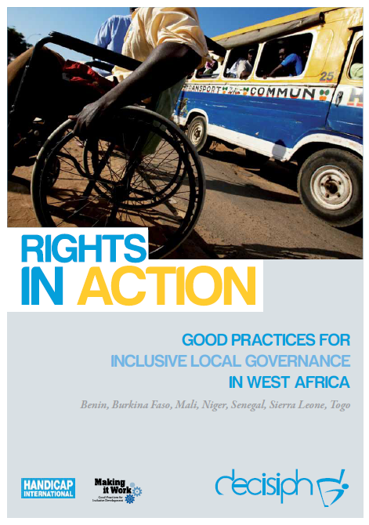
Full project report: Rights in Action - Good Practices for Local Inclusive Governance in West Africa (Handicap International 2010)

Criteria for the good practices: see pages 69 – 70 of the full report.

Recommendations from the good practices: see pages 98 – 111 of the full report.

Links to further resources:
Full text on CRPD article 29 – Participation in political and public life

