

Good Practice case study

How can Disabled People’s Organisations participate in decision-making processes?

Relevant articles of the CRPD: 29
Country: Niger
Region: West Africa
Languages available: English, French

Inclusions of Proposals from DPOs in the Budget of the Municipality of Niamei III

Description of the practice and the process involved

The municipality of Niamey III is the most heavily populated of the 5 municipalities of the Urban Community of Niamey. It had 226,886 inhabitants in 2009. The Population and Social Reform Unit of the municipality is in charge of implementing the social policy of the municipality. This department is the main contact point with the DPOs; it records their needs and submits them to the local authorities.

The authorities have decided to involve DPOs in the process of developing, implementing and monitoring the social policy of the municipality through the following consultation process:

- disability groups prepare proposals for micro-projects and submit a written request for support to the Population and Social Reform Unit of the municipality;
- the proposals of the DPOs are reviewed by the Population and Social Reform unit;
- discussions are initiated between the unit and DPOs to refine the proposals and identify actions that can be supported by the municipality;
- the micro-projects are approved by the unit, presented in the form of operational data sheets and transmitted to the municipal council;
- the financial support for the proposals of the DPOs is included in the budget voted by the council;
- the Population and Social Reform Unit and the recipients (DPOs) monitor and support the implementation.

The factors that made this practice possible

- The desire of the Population and Social Reform Unit of the municipality of Niamey III and DPOs to work together to improve the living conditions of people with disabilities;
- The good knowledge of disability within the services of the municipality of Niamey III due to the many awareness-raising sessions carried out on citizenship issues and the functioning of the municipality organized by INGOs and DPOs;
- Following the Act on municipal budgets, a new section called «social fund» has been incorporated into the operational budget of the municipality. Support for DPOs has been included in the «investment» section of the social fund (by law, it should represent at least 45% of the municipal budget);
- The gathering of people with disabilities into groups and unions (such as the Union of Groupings of Women with Disabilities) has made them more visible and more listened to at the local level.

Some of the difficulties encountered

The limited financial resources meant the municipality of Niamey III had limited capacity to support the projects of the DPOs. The search for financial partners is a constant concern for the authorities and DPOs.

The effects / impact of the practice

- The institution of a culture of dialogue and inclusion of the needs of DPOs in the public policies of the municipality of Niamey III in order to take into account these needs in the municipal budget;
- Developing a sense of citizenship among people with disabilities who are proud to receive support from the municipality;
- Reduced economic exclusion of DPOs (they have great difficulties accessing microfinance institutions), which receive direct grants to develop their income-generating activities;
- Better organization of DPOs by taking charge of some of their operating expenses.

- “We work with groups of people with disabilities who write directly to the Mayor to submit applications for group or individual support. Group support (purchase of equipment and materials) is financed from the «investment» section of the municipal budget, while individual support to people with disabilities is financed by the social fund. However, the limited resources available for our community and the high demand from disadvantaged people severely limit our ability to provide support” said the head of the Population and Social Reform Unit in the Municipality of Niamey III.

An example of disability inclusion
This practice shows the taking into account of the needs and proposals of DPOs in the development of policies and the allocation of public resources at the municipal level.

Related articles of the CRPD

This experience is in line with Article 29 of the CRPD on the participation of people with disabilities in political and public life.

For more information, contact:

Amadou Adamou, Head of the Population and Social Reform Unit, Municipality of Niamey III.
Tel: 00 227 96 49 48 12

Background and context
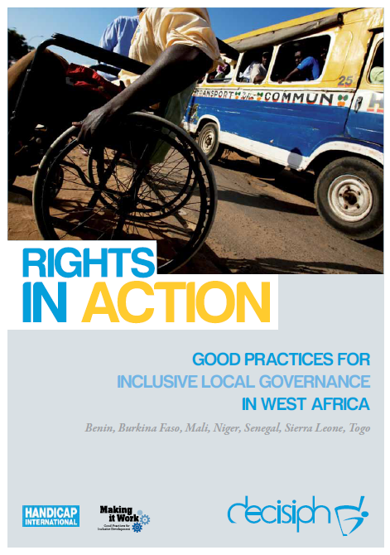
Full project report: Rights in Action - Good Practices for Local Inclusive Governance in West Africa (Handicap International 2010)

Criteria for the good practices: see pages 65 – 66 of the full report.

Recommendations from the good practices: see pages 98 – 111 of the full report.

Links to further resources:
Full text on CRPD article 29 – Participation in political and public life

