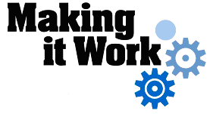

Good Practice case study

How can cooperation with their families improve people with disabilities’ economic inclusion?

Relevant articles of the CRPD: 27
Country: Nicaragua
Region: Central America
Languages available: English, French (full report available in Spanish and Arabic)

Economic Activities by People with Disabilities and Their Families: Maricela Toledo Nacional, Nicaragua

Description of the practice and the process involved

Assessing the needs of people with disabilities should include a study of their entourage: many economic inclusion programmes for people with disabilities also assist the parents of children with disabilities or other family members. Persons with disabilities are likely to gain more in terms of social inclusion or empowerment if they participate directly in the economic activities. Even if it might be difficult for them to run an economic activity independently, due consideration should always be given to how people with disabilities can participate.

Maricela Toledo Nicaragua is an association of blind persons that has a grant programme as part of its activities to support the development of its members.

Last year, a couple of visually-impaired persons applied for a grant with the idea of making tamales, a local speciality consisting of corn dough, meat and sauce wrapped in corn or banana leaf.

The cooking part was not easy for this visually-impaired couple, since they needed to produce a significant number of tamales per day to cover their costs.
They solved this problem by partnering with an unemployed aunt who had long experience cooking tamales for her large family. While their aunt carries out most of the cooking, the blind couple buys the ingredients, cleans the corn or banana leaves, wraps the tamales in those leaves, and sells them in the street.

The effects / impact of the practice

They are no longer dependent on their families for a living; indeed they have provided their aunt with employment, and in one month their business made profits of over US$700 – seven times the initial grant they received.

- The most important impact for them? “Before, we used to eat two times a day. Now, we manage to eat three times a day and provide for the rest of the family too!”

Background and context
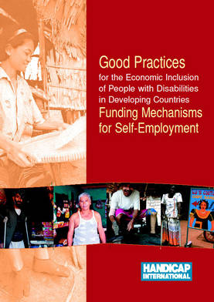
Full project report: Good Practices for the Economic Inclusion of People with Disabilities in Developing Countries: Funding Mechanisms for Self-Employment (Handicap International, 2006)

Criteria for the good practices: see p. 41 of the full report.

Recommendations from the good practices: see full report pp 87 – 90 of the full report.

Links to further resources:
Full text on article 27 – Work and employment

