

Good Practice case study

How can cooperation between an organisation for people with disabilities and a microfinance partner institution improve the management of loans?

Relevant articles of the CRPD: 27
Country: Nicaragua
Region: Central America
Languages available: English, French (full report available in Spanish and Arabic)

Financing Credit Line. FURWUS – Espino Blanco, Nicaragua

Description of the practice and the process involved

Fundación para la Rehabilitación Walking Unidos (FURWUS) provides physical rehabilitation, orthoses and prostheses, and employment opportunities for people with disabilities.
One-and-a-half years ago, FURWUS started a micro-credit programme through a partnership with the local microfinance institution, Espino Blanco, which specialised in working with vulnerable populations.
FURWUS received a grant from the Inter-American Foundation and got the socially minded Espino Blanco to manage it.
The loan terms were decided by FURWUS with some adjusted requirements: the interest rate is lower than market rates and there is a two-month grace period.

Some of the difficulties encountered

After a period of low on-time repayments, a strong follow-up system was put in place and financial indicators are improving.
For the moment, only 30 persons have used these services; FURWUS’ goal is to reach 200 users. There is currently a campaign under way to let people with disabilities in nearby communities know about this fund.

The effects / impact of the practice

Rosa María Pérez is an accountant. When she received a loan from FURWUS to start a small business she thought she may not need further training, but she attended anyway, since it was a requirement for all borrowers.
Now she realises the training is a great asset for her: “I learnt about marketing and client service; but the training also helped me select the best products for me to sell according to demand, offer and to my personal skills and constraints. I decided on selling basic grains, because they are not perishable, and because there are not too many people selling grains in this market. Combining my new skills with my accounting training really help me build a successful and sustainable business”.
“The loan opened a new life of opportunities for me and my children” she affirms. In spite of her degree in Accounting, she had never been able to find employment. “When people realised I had trouble walking, they would not hire me. I thought I had gone to school for nothing”. Thanks to the loan this is no longer true. Rosa María used her loan to start her small shop, which has been a success.

“Before I received the loan, my life was sad. My husband passed away a few years ago and I could not find any job, so my 14-year-old son had to beg and sell candies on the street to provide for both of us and for my smaller son”, she says. “Now that I have my shop, I can take care of the three of us myself; both my children go to school; and I will make sure they go all the way to university!” Rosa María spends three hours daily on public transport travelling to and from the market.

What are the main points that require attention? How could it be improved?

It is useful if the beneficiaries learn to calculate their income and expenses, to give them an idea of the real net revenue of their business activities.
Doing a business plan is equally important, since this means the entrepreneur plans for the future. This can help them in making rational business decisions.
Also an understanding of some basic marketing principles, such as the importance of product differentiation and behaviour towards customers, can be helpful.

Background and context

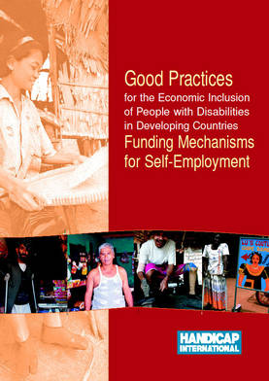
Full project report: Good Practices for the Economic Inclusion of People with Disabilities in Developing Countries: Funding Mechanisms for Self-Employment (Handicap International, 2006)
Criteria for the good practices: see p. 35 of the full report. Recommendations from the good practices: see full report pp 87 – 90 of the full report.
Links to further resources:
Full text on article 27 – Work and employment

