

Good Practice case study

How can a Disabled People’s Organisation improve people with disabilities’ access to loans and economic inclusion?

Relevant articles of the CRPD: 27
Country: Nicaragua
Region: Central America
Languages available: English, French (full report available in Spanish and Arabic)

Revolving Funds: ADRN, Nicaragua

Description of the practice and the process involved

Asociación de Discapacitados de la Resistancia Nicaragüense (ADRN), Nicaragua
ADRN decided to provide credit to its members since people with disabilities are not covered by any financial institution in Nicaragua, since most of them have very few economic resources. ADRN’s goal is to inject the capital that is needed to expand or create a business.

The rotating fund started with the fees of the members (US$7 per year). After a few years, the programme was so successful that it received a grant from the Danish Association of People with Disabilities and Oxfam Québec to expand its operations and receive technical assistance. The programme was quickly replicated in other regions of the country.
ADRN aims to achieve self-sustainability – so it charges interest and application fees – and even though ‘portfolio at risk’ is still high (seven per cent) it has been decreasing, particular after the technical assistance received.

The factors that made this practice possible

According to Eduardo Díaz from ADRN, the keys to success have been:

- Conducting a strict evaluation of the business plans before disbursement of the loans;
- Making sure borrowers understand the fund’s rules;
- Enforcing those rules as required;
- And providing training and follow-up for the users.

The effects / impact of the practice

Ciriaco González received a loan a year ago and used it to diversify the candy he sells on the streets. He was also able to venture into the lottery business. His family now has a higher income.
“Right now, I buy the lottery from an intermediary. With the next loan, I will be able to buy the lottery directly from the main office, so that I will be able to make more profits. In addition, if I sell a winning ticket, the commission will be for me, not for the intermediary!” says Ciriaco.

Background and context

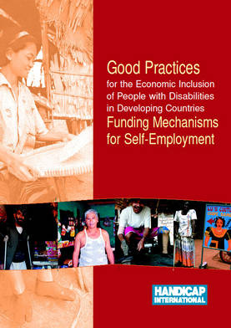
Full project report: Good Practices for the Economic Inclusion of People with Disabilities in Developing Countries: Funding Mechanisms for Self-Employment (Handicap International, 2006)

Criteria for the good practices: see p. 41 of the full report.

Recommendations from the good practices: see full report pp 87 – 90 of the full report.

Links to further resources:
Full text on article 27 – Work and employment

