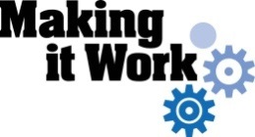 | 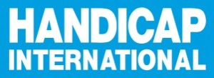

Towards Enhanced Inclusion of Women and Girls with Disabilities through Evidence-Based Advocacy and Strengthened Accountability
Project Brief – August 2017

Project Background: The Making It Work Methodology
The Making it Work (MIW) methodology is a set of tools to identify, document and analyze good practices that advance the rights enshrined in the United Nations Convention on the Rights of Persons with Disabilities (CRPD) and other key human rights instruments such as the Convention on the Elimination of All Forms of Discrimination against Women (CEDAW). Documenting good practices on the inclusion of people with disabilities allows key actors to analyze how these positive changes can be replicated, sustained or scaled. This methodology is usable across sectors in development and humanitarian action.
The MIW methodology is primarily intended for people with disabilities and their representative organisations. This refers notably to Disabled People’s Organisations, non-disability and disability-focused NGOs. However, the concept of identifying, documenting and building on existing good practices can be applied to almost any setting or organizational strategy.
Learn more here: https://www.makingitwork-crpd.org

Why focus on gender and disability? The MIW Global Project
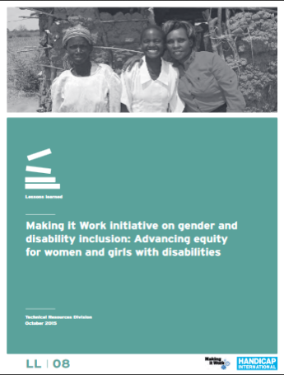
At least 1 billion women and men, girls and boys in the world have a disability. Women and girls with disabilities endure violence, abuse and exploitation twice as often as non-disabled women, and experience more serious injuries as a result of violence.
The goal of this project is to increase the visibility of women and girls with disabilities within international development, human rights, gender and humanitarian action both at the national and international level. This project acknowledges the vulnerability of women and girls with disabilities to gender and disability-based violence and the lack of documented good practices around inclusive responses. This is a participatory project which gathers various ideas, works and opinions from different people and regions. It seeks in particular to voice the concerns and experiences of women and girls with disabilities through their empowerment and meaningful participation in international and national initiatives, concerning all women and girls.

What did we do so far?

A global call for good practices to feed evidence based advocacy
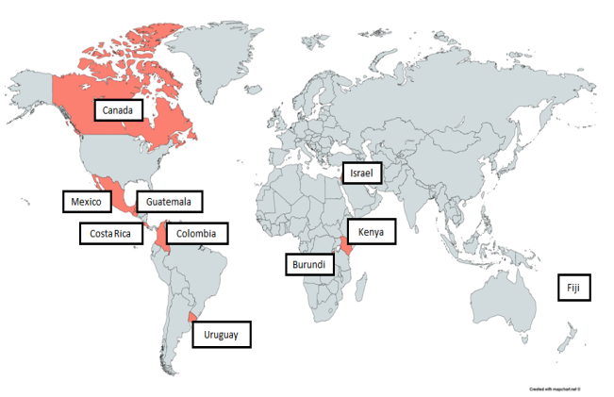
30 proposals submitted in response to an International Call for Good Practices were reviewed in 2014-2015. 10 good practices and one emerging practice have been selected based on their potential to raise awareness, inform international level advocacy, and build the capacity of women and girls with disabilities and their organizations from across South, Central, and North America as well as Asia, the Middle East and Africa. These good practices have since been used for various advocacy actions in order to improve the lives of women and girls with disabilities, within a wide range of topics such as social and economic inclusion, violence prevention, or human rights promotion. The MIW good practices contributed in 2015 to shape the debate on gender-based violence at the Commission on the Status of Women, the Conference of State Parties to the CRPD and the 62nd session of the CEDAW (Committee on the Elimination of Discrimination against Women). Further contributions were made to the report of the Secretary-General on the status of women and girls with disabilities (Apr. 2017), the CEDAW Committee (68th session, Aug. 2017), etc. The 10 good practices can be downloaded on our website: www.makingitwork-crpd.org.

Amplifying the Impact: Scaling Good Practices in Latin America
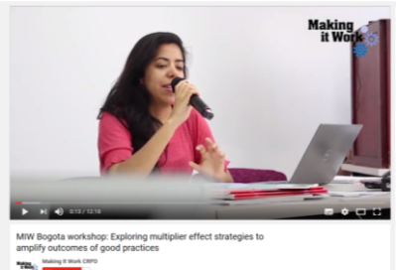
A regional workshop has been organized in Latin America (April 2017) dedicated to identifying scaling strategies (aiming at amplifying the impact of good practices) and advocacy opportunities, using the concept of Theory of Change and the ExpandNet scaling manual. The participants are now finalizing their action plans to increase the impact of their work nationally. Watch our video presenting the workshop on Youtube: www.youtube.com/watch?v=-UbjvaZx8GU

What’s Coming Up? Good Practices in Africa
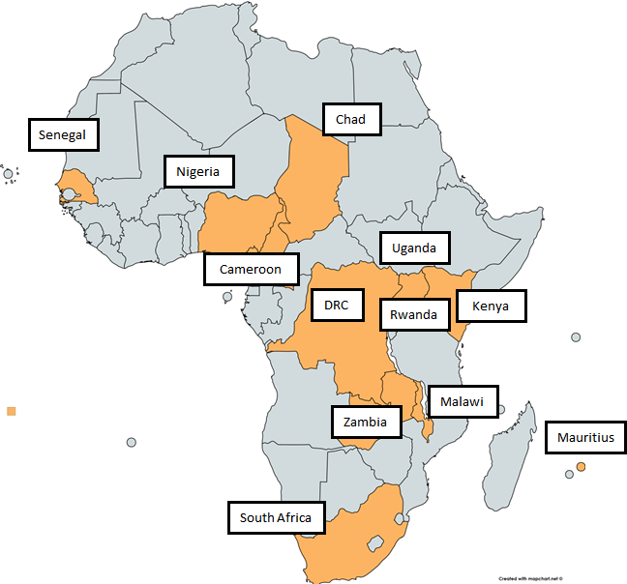
A “Call for Good Practices in Africa” has been launched in 2016. This call is an outstanding opportunity to once again identify activities throughout Africa that have generated some success in raising awareness about violence against women and girls with disabilities, but also preventing it by challenging local and State policies and practices that allow such violence to continue. The selected good practices will be used as a starting point to develop new advocacy strategies, which will focus on improving the rights and inclusion of women and girls with disabilities.
- As of August 2017, 28 applications have been received.
A regional forum will take place in Africa in March 2018, gathering local and country level advocates identified through the African Call for Good Practices. It will be the opportunity to identify scaling strategies, and to exchange on the most relevant tools and processes in order to increase the impact of each practice.

The Technical Advisory Committee (TAC)
An international Gender and Disability Technical Advisory Committee (TAC) was set up in January 2014. It gathers experts from the fields of Disability and Gender, and works closely with the MIW team to provide technical expertise on the key steps of the project.

Contact Details

Email: specourt@handicap-international.org ; jdavodeau@handicap-international.org
Website: www.makingitwork-crpd.org
Twitter: @MIW_CRPD / Facebook: https://www.facebook.com/MakingItWorkCRPD/

