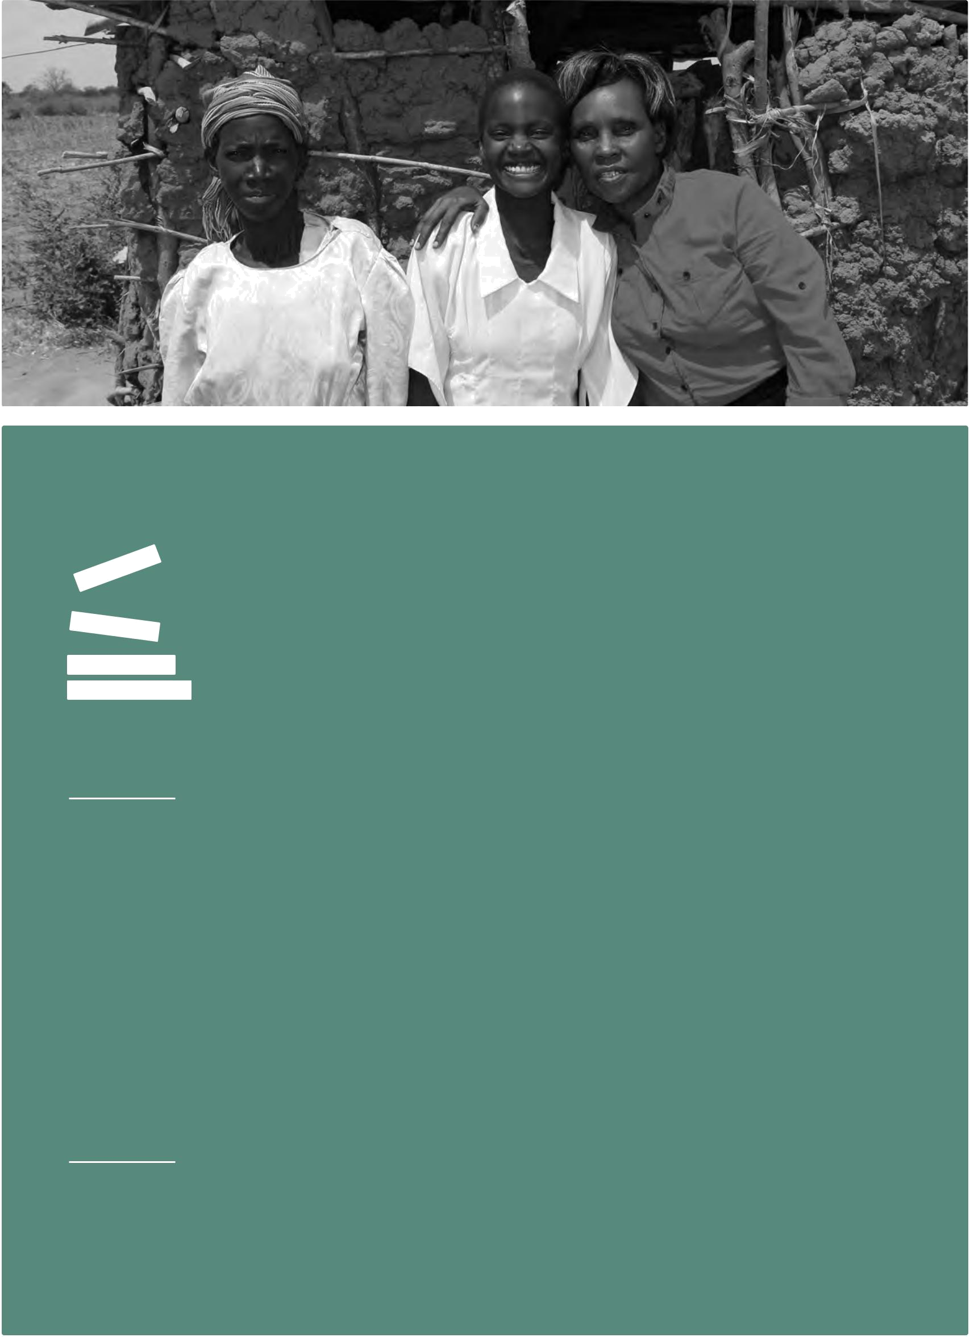

Lessons learned

Making it Work initiative on gender and disability inclusion: Advancing equity for women and girls with disabilities

Technical Resources Division

October 2015

LL 08


Project piloted by:

Handicap International

Technical Resources Division

Support to Civil Society Unit

Luisa Fenu

Ulrike Last

A Handicap International Publication Operations and Technical Resources Division Knowledge Management Unit

Editor

Operations and Technical Resources Division

Knowledge Management Unit

Stéphanie Deygas

Graphic Design

IC&K, Frédérick Dubouchet

Maude Cucinotta

Layout

IC&K, Frédérick Dubouchet

Rights and Permissions

This work is available under the Creative Commons

Attribution—NonCommercial—NoDerivatives 4.0 International license (CC BY–NC–ND 4.0). Under the Creative Commons—NonCommercial— NoDerivatives license, you are free to copy, distribute, and transmit this work, for non commercial purposes only, under the following conditions:

Attribution: Please cite the work as follows: Handicap International. Making it Work initiative on gender and disability inclusion: Advancing equity for women and girls with disabilities. Lyon: Handicap International, 2015. License: Creative Commons Attribution— NonCommercial—NoDerivatives 4.0 International (CC BY–NC–ND 4.0).

Non Commercial: You may not use this work for commercial purposes.
No Derivative Works: You may not alter, transform, or build upon this work.




Lessons learned

Making it Work initiative on gender and disability inclusion: Advancing equity for women and girls with disabilities

Foreword | 4
At a glance | 6
Introduction | 9
Key findings of the Making it Work initiative on gender and disability inclusion | 13
Good practices | 16
A. Legal advocacy and policy change: what worked | 16
Protecting the lives and integrity of women with disabilities detained at the National
Mental Health Hospital, Guatemala, through the Inter-American Human Rights System | 17
The anti-violence project: Addressing gender-based violence against vulnerable
members of the Bedouin community, Israel | 19
InFocus: Bringing people with disabilities into the picture—A National Pan-Canadian
Community Leadership Initiative | 22
B. Awareness raising: what worked | 26
Mainstreaming disability in the governmental programs addressing violence against
women in Uruguay | 27
Justice for survivors of sexual abuse through multi-sector community responsibility
in Kenya | 30
Women with disabilities advocating towards Costa Rican institutions to make
changes at national level and in different regions of the country | 33
Toolkit on eliminating violence against women with disabilities in Fiji | 35
C. Empowerment: what worked | 38
Breaking the silence around sexual- and gender-based violence against boys
and girls, women and men with intellectual disabilities in Kenya | 39
Capacity development for empowerment in Mexico City: Women with psychosocial
disabilities managing peer support, advocacy and self-representation | 42
Advocacy for legal education in Colombia | 44
Towards inclusion of refugee women with disabilities and care-givers of persons
with disabilities in existing women’s protection and empowerment programming
provided by IRC in Burundi | 47
Conclusions | 51
Annex—The Making it Work methodology in a nutshell | 54
Notes | 57

Foreword

 By Catalina Devandas Aguillar, UN Special Rapporteur on the Rights of Persons with Disabilities

Gender-based violence is a global concern. The international community has just agreed to work towards the elimination of all forms of violence against all women and girls in the public and private spheres, including trafficking and sexual and other types of exploitation. That commitment adopted by the UN in the new Sustainable Development Goals, would not be achieved unless the situation of violence against women and girls with disabilities are taking into account. Leaving no one behind means looking at the specific forms of violence that these women face and at how to design—with them–the best solutions to prevent and eradicate such violence and abuse.

Unfortunately, in the world, little

⁴ attention is giving to the situation of more than a half billion women and girls with disabilities, this despite evidence indicating that they are more likely to experience violence than their peers without disabilities.

Lack of awareness within policy makers, but also within the disability and mainstream women’s movement, results in their invisibility; their concerns remain underrepresented and the intersecting discriminations and multiple rights’ violations they experience are insufficiently addressed through inclusive programs and policies.

In that context, I am honored to have the opportunity to highlight the importance

of this report; containing ten good practices and one emerging practice on preventing, eliminating and responding to gender-based violence against women and girls with disabilities. As a woman with a disability from a developing country, I fully appreciate the impact and relevance of this initiative: by sharing the efforts of grassroots groups of women with disabilities and showing that success is possible, the report give us a great opportunity to engage in concrete actions to move forward.

Success is possible, yes, but for that it is urgent to build strategic alliances, and to active engage and consult with women and girls with disabilities. The report shows that little investment in building the capacity of these women and supporting their initiatives and organizations could truly transform their lives. It builds on the need to inform the national and international human rights and development agendas to be more inclusive and responsible to the needs of all women, including those that face the several challenges. We need to build upon these women’s initiatives, to learn about the challenges they have faced in their work and the lessons they have learned.

I see the urgency for state and non-state actors, disability and gender-focused organisations, and for the broader human rights community, to take up the issue of violence against women and girls with disabilities and address the intersecting factors leading to discriminatory practices and attitudes. I hope that these good practices show that it is possible to act effectively and that those actions need to be replicated and scaled up to reach far more women and girls.

In my capacity as Special Rapporteur on the Rights of Persons with Disabilities, I am strongly
committed to promote gender equality, and to support efforts to eliminate gender-based violence
in all its forms. Substantial efforts are needed to advance in the design and implementation of | Foreword
policies and practices that are fully inclusive of women and girls with disabilities; so that their
concerns are heard and that redress is sought when their rights are violated. These practices | 5
present concrete solutions to the problems faced by women and girls with disabilities specifically.
They also contain policy-making imperatives, and invite us to cross the border of our thematic
areas of work.
The process of implementation of the Convention on the Rights of Persons with Disabilities,
the Convention on the elimination of all forms of discrimination against Women and the
Sustainable Development Goals offer a great opportunity to ensuring that national efforts
are inclusive of women and girls with disabilities so that gender equity and empowerment
can be achieved for all. We have to make sure that those three instruments are mutually
reinforced as the most effective way to guarantee success.
Finally, I would like to thank all these women who work tirelessly for their rights and for those
of other women, and I invite them to keep up their fight and remind us about our responsibilities
towards a more inclusive, respectful and equal communities. Special thanks goes to the global
Making It Work Technical Advisory Committee and Handicap International whose work allowed
local and grassroots experts, who were isolated, to bridge the gap with global experts, and join
their advocacy efforts at the international level.

At a glance

At least 1 billion women and men, girls and boys in the world have a disability. Women and girls with disabilities endure violence, abuse and exploitation twice as often as non-disabled women, over a longer period of time, and experience more serious injuries as a result of violence.

Violence against women and girls is one of the most pervasive and harmful manifestations of gender inequality.

Worldwide, women and girls with disabilities experience higher rates of gender-based violence, sexual abuse, neglect, maltreatment and exploitation than women without disabilities including: forced sterilization, rape, being denied the right to a family, physical and sexual violence from a wide range of actors1. In addition, women and girls with disabilities face extreme/significant barriers in escaping violence, reporting crimes and accessing justice. The extensive physical, attitudinal and communication barriers women and girls with disabilities face including: social stigma and isolation, discriminatory practices based on gender and disability, inaccessible physical environments, lack of accessible communication, myths about perceived asexuality, lack of access to education and reproductive health services all reduce their options for a


6 just and compassionate response to prevent and eliminate violence, abuse and exploitation of women and girls with disabilities. Violations occur in homes and institutions, perpetrated by family members, neighbors, teachers, and caretakers. In some settings, it may even include state-sanctioned reproductive rights violations such as forced sterilization2.

Handicap International started the Making It Work Initiative (hereinafter the MIW Initiative)

in 2014, bringing together local and global experts on disability and gender. This MIW initiative builds on the broader Making it Work initiative, started by Handicap International in 2008 to propose a methodology aimed at capturing good practices to make the rights of persons with disabilities work in practice. A Gender and Disability Technical Advisory Committee (TAC) was set up in January 2014. During its first meeting it decided to focus its work on ending violence against women and girls with disabilities, jointly with Handicap International.

This initiative acknowledges the vulnerability of women and girls with disabilities to gender and disability-based violence and the lack of documented good practices on inclusive responses and their strengths to address it. On this ground, the MIW Initiative seeks to increase the visibility of women and girls with disabilities within international development, human rights, gender and humanitarian action to ensure that their voices and concerns are heard on how to respond to violence, abuse and exploitation throughout the world.

International call for good practices

In May 2014, the TAC launched an international call for good practices that have successfully addressed or shown progress in preventing, eliminating or responding to violence, exploitation and abuse against women and girls with disabilities.
Selection process

The TAC reviewed 30 proposals submitted in response to the international call. Ten good practices and one emerging practice were selected based on their potential to raise awareness, inform global advocacy initiatives, and build the capacity of women and girls with and without disabilities, their organizations and womens’ rights organisations across the globe. The key findings of the documented good practices were further used to inform key international advocacy initiatives. For instance, the project organised and participated in the 59th session of the Commission on the Status of Women where members of the TAC and some of the good practice holders presented their issues and shared their experience. Furthermore, in June 2015 the project hosted in New York the first global Gender and Disability Forum, which allowed the participants to the MIW Initiative to exchange on their experiences and identify common challenges, which were translated into key recommendations targetting States, UN agencies, women’s rights organisations, as well as Disabled People's Organisations. The side event, organised by the MIW Initiative at the Conference of States Parties to the Convention on the Rights of Persons with Disabilities (CRPD), allowed the speakers to share those key messages by illustrating the experience of all the good practices.

According to the main issues addressed by the local and grassroots organizations, the TAC grouped the practices around three broad themes: Legal advocacy and policy change

Awareness raising

Empowerment.

This report presents the key findings of this initiative according to those three themes.

Making it Work Methodology

Handicap International developed Making it Work in collaboration with partners over the last seven years. Making it Work is a methodology for documenting good practices on inclusion of people with disabilities and analyzing how these positive changes could be replicated or sustained. This methodology has been used to implement projects in over 25 countries by more than

60 different organizations on many of the topics covered by the CRPD, including legal capacity, accessibility, inclusive governance, and access to health, education, employment and water and sanitation.

You can read more about the various initiatives at: www.makingitwork-crpd.org

At a glance

7
At a glance

Selected good and emerging practices from the international call for good practices

on preventing, eliminating, and responding to violence, abuse and exploitation of women and girls with disabilities

Title of initiative


Preventing violence against women and girls with disabilities in Fiji


Advocacy for legal education


 |  | Women with disabilities advocating towards
8 |  | Women with disabilities advocating towards
8 |  | Costa Rican institutions to make changes
 |  | Protecting the lives and integrity of women with
 |  | disabilities detained at the National Mental Health
 |  | Hospital, Guatemala, through the Inter-American
 |  | Human Rights System


Submitting Organization(s)

Pacific Disability Forum (PDF)

Profamilia Colombia with Fundamental Colombia, A SDOWN, Programa de Acción para la Igualdad e Inclusión Social & University of Los Andes

Women with Disabilities Movement

Disability Rights International

Country3

Fiji


Colombia

Costa Rica Guatemala


Empowering women with psychosocial disabilities |  | Disability Rights |  | Mexico
to in Mexico to become advocates of their rights |  | International with
 |  | Colectivo Chuhcan
Raising awareness and mainstreaming disability |  | Gender Unit, Social |  | Uruguay
in the governmental programs addressing violence |  | Development Ministry
against women
Gender and disability rights in Bedouin society: |  | Ma’an |  | Israel
Addressing gender-based violence against
vulnerable members of the Bedouin community
Justice for survivors of sexual abuse through |  | Advantage Africa and
multi-sector community responsibility |  | Kibwezi Disabled Persons’
 |  | Organization |  | Kenya
Breaking the silence around sexual and gender- |  | KAIH and COVAW |  | Kenya
based violence against boys & girls, women & men
with intellectual disabilities
InFocus: Bringing people with disabilities into the |  | DAWN |  | Canada
picture—A National Pan-Canadian Community
Leadership Initiative
Towards inclusion of refugee women with disabilities |  | WRC/IRC |  | USA/
& care-givers of persons with disabilities in existing |  |  |  | Burundi
women’s protection & empowerment programming
provided by IRC4


Introduction

 By Professor Arlene S. Kanter, Syracuse University College of Law, Disability Law and Policy Program, and on behalf of the Technical Advisory Committee

This report on the Making it Work Initiative, entitled, Gender and Disability Inclusion:

Advancing Equity for Women and Girls with Disabilities, is the first report of its kind.

It identifies and describes eleven good practices in ten countries which were developed by women to eliminate violence against women and girls with disabilities. This report documents the Making it Work Methodology developed by Handicap International5. As explained more fully in the report, Handicap International brought together a Gender and Disability Global Technical Advisory Committee (TAC), consisting mostly of women with disabilities, to identify programs and activities throughout the world that have enjoyed some success in not only raising awareness about violence against girls and women with disabilities but also preventing it by challenging local and State policies and practices that allow such violence to continue.

Following an international call for good practices the TAC selected a diverse group of practices
from ten countries. These practices were selected based on several criteria. Those included key | Introduction
indicators such as the leadership by women and women with disabilities, practices that succeed
in eliminating violence against women and girls with disabilities, and show potential for serving | 9
as a model for other initiatives. Once the TAC had done the first selection of good practices, the
TAC members visited them to document the various programs. Those of us who visited these
programs were generally impressed not only by the accomplishments of these organizations,
and often against all odds, but also and especially by the women themselves. Each of the
practices we have selected are coordinated or directed by women. Some of them are victims of
violence themselves, but all have taken risks to pursue their goal of eliminating violence against
girls and women in their communities. Such risks include challenging well-established cultural
norms or demanding changes to policies, practices and even laws which support the perpetrators
rather than the victims of violence. Yet what all of these good practices have in common is the
important issue they are addressing: the inadequate response of the international community
to end violence against women and girls with disabilities throughout the world.
Following the TACs selection of ten good practices and one emerging practice from ten
countries, the Initiative organized a session at the Commission on the Status of Women (CSW)
at the United Nations (UN) in March 2015. The goal of this session was to inform the attendees
of the CSW of the continuing neglect of violence against women and girls with disabilities by
the international women’s community6 and to show ways of ending the neglect. The session
included presentations by Stephanie Ortoleva, Director of Women Enabled International
and member of the TAC, and representatives of two of the good practices: Milanoi Koiyiet,
on behalf of the Kenyan Association for the Intellectually Handicap (KAIH) and the Kenyan
Coalition on Violence Against Women (COVAW); Priscila Rodriguez, on behalf of Disability
Rights International (DRI) and Natalia Santos ESTRADA, representing the Collectivo Chucan,
an organization of self-advocates for the rights of women and men with psychosocial disabilities
from Mexico City. The Session also included Catalina Devandas, UN Special Rapporteur on the
Rights of Persons with Disabilities (via video) and Jeong Shim Lee, of UN Women, who reported
on plans of UN Women to address the gap in their work regarding disability inclusion. The session
was moderated by Professor Arlene S. Kanter of Syracuse University Disability Law and Policy
Program and Ulrike Last, Handicap International. The purpose of this session was to highlight
major concerns as well as the good practices on how to end abuse and violence against women
and girls with disabilities from Mexico and Kenya, and to advocate and inspire more action on
ending violence.

Introduction

Although the CSW has begun to address violence against women, generally, the unique issues affecting women and girls with disabilities have not been adequately addressed. Women and girls with disabilities constitute at least 15% of the world’s female population and many of them experience violence. Research has shown that women with disabilities are more likely to be affected by violence, exploitation and abuse than their peers without disabilities. This may be further heightened in situations of crisis or conflict where community and state mechanisms are often weakened or destroyed.

Thus in addition to raising awareness about violence against women and girls with disabilities within the international women’s rights community, the Project also hosted the first Gender and Disability Forum in New York in June 2015. The Gender and Disability Forum allowed the good practice holders, including members of the TAC, to gather and share their experiences, common challenges and formulate key recommendations targeting international stakeholders to address violence against women and girls with disabilities. In particular, the good practice holders had the opportunity to raise their issues and share key messages during the Side Event at the Conference of States Parties (COSP) to the CRPD at the UN in June 2015. The
10 goal of this event was to support the local practices and to call attention to the inadequacy of responses to violence against women and girls with disabilities within the international disability rights community itself, by highlighting the issues and promoting existing solutions in need of upscaling and replication. Members of the TAC, as well as the local grassroots experts from the good practices presented their concerns, the documented successes in addressing violence and launched a call for action to States Parties to the CRPD, UN agencies, Disabled People’s Organisations (DPOs), and mainstream development and gender organisations.

Readers of this report may wonder why a separate initiative aimed at eliminating violence against women and girls with disabilities is needed on the international level, given the attention that is being paid to violence against women, generally and to people with disabilities. Indeed, State parties to the CRPD, the Convention on the Elimination of all Forms of Discrimination against Women (CEDAW), the Convention on the Rights of the Child (CRC), as well as other international human rights treaties, are all obligated to protect and promote the equal rights of women and girls with disabilities, including their right to be protected from violence, abuse and torture. The Beijing Platform of Action (1995) also recognizes the obligations of States parties to address the rights of women. But neither the Beijing Platform nor subsequent international and regional reports adequately promote the empowerment of women and girls with disabilities and programs to eliminate violence, nor do they call for monitoring incidents of violence, exploitation or abuse against women and girls with disabilities.

Thus while it is also true that the international community has begun to address the issue of violence against women, generally, the specific issue of violence against women and girls with disabilities, in particular, needs more responses and specific attention. This is also because women and girls with disabilities experience more discrimination and exclusion, compared both to men with disabilities and women and girls without disabilities. Women and girls with disabilities are more than twice as likely to live in poverty as non-disabled persons in most countries of the world7. Further, women with disabilities are even less likely than men to be employed and when they do work, they receive lower wages than men8. Women with disabilities also are denied an education more often than are women without disabilities, and are less likely to receive a high school diploma or university degree than their non-disabled peers9. Thus not only do women with disabilities have lower incomes, fewer employment opportunities, and are denied access to education in most countries of the world today, they also are two to three times more likely than non-disabled women to experience violence, including sexual and domestic violence10.
For these reasons Handicap International decided to document good practices on ending, eliminating and responding to gender-based violence against women and girls with disabilities, and is today spreading their wealth of information by publishing this report. In fact, this publication would like to provide States, UN agencies, gender and development actors,

and Disabled People’s Organisations with concrete and practical examples of how all women and girls, including those with disabilities, can be protected and freed from violence through the design and implementation of inclusive policies and programming. This report would also like to be an eye opener on the continuing neglect by the international community of women and girls with disabilities who are subjected to violence in their homes, their communities, in institutions, and by States themselves who refuse to prosecute perpetrators or enact or enforce domestic and sexual abuse laws. Unless and until the international women’s rights movement and the international disability rights movement both recognize their respective and joint role in eliminating violence against women and girls with disabilities, it will continue in most, if not all, countries of the world.

We, the Technical Advisory Committee members and staff of the Gender and Disability
Inclusion Project hope that this report will be an important step in raising awareness about | Introduction
violence against girls and women with disabilities as well as providing concrete examples of
women’s organizations throughout the world that are working effectively to address violence | 11
against women and girls with disabilities in their home communities. By presenting a summary
of the eleven organizations from ten countries that demonstrate good or emerging good
practices, we are encouraging the national actors and the international community to do more
to support dedicated women and programs to end violence.
All that is needed is the long overdue support for these and other organizations of women
with and without disabilities that are working to eliminate violence against women and girls
with disabilities once and for all.
Gender and Disability Global Technical Advisory Committee
Arlene S. Kanter, USA
Lisa Adams, USA
Lorraine Wapling, UK
Michael Szporluk, USA
Silvia Quan, Guatemala
Stephanie Ortoleva Esq., USA
Ulrike Last, Germany
Yetnebersh Nigussie, Ethiopia

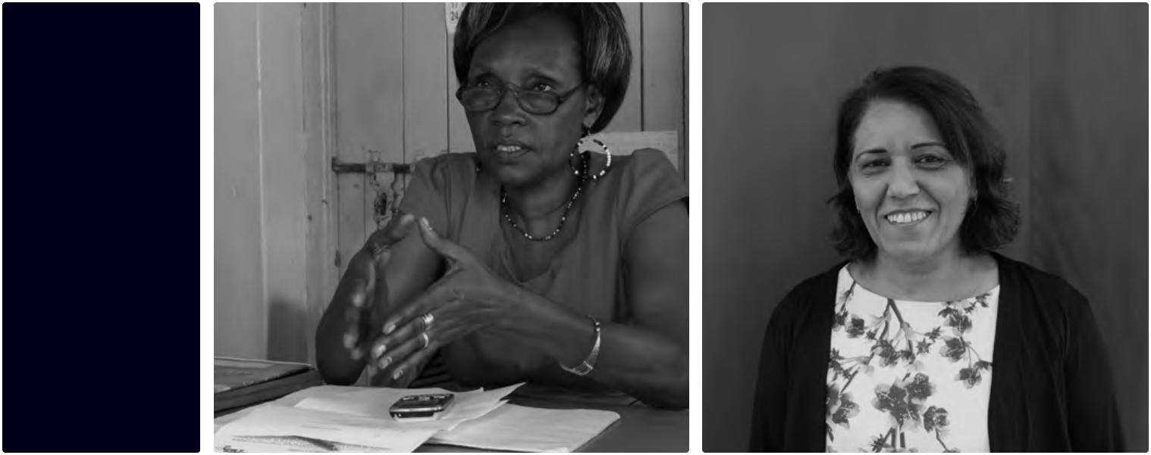
1 2
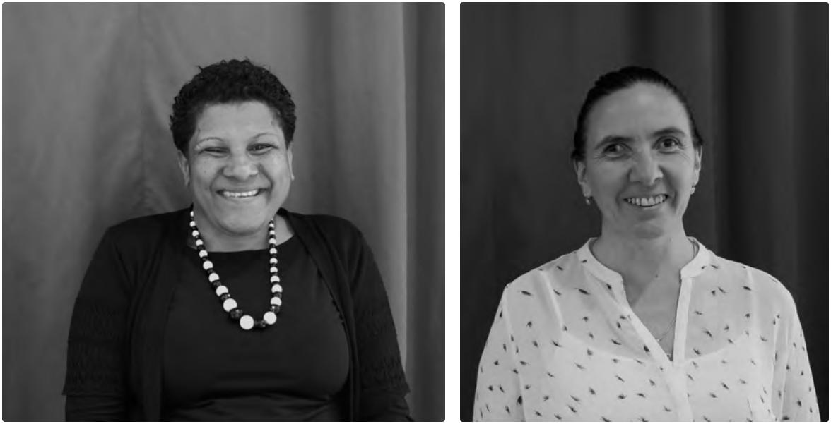

3 4

12
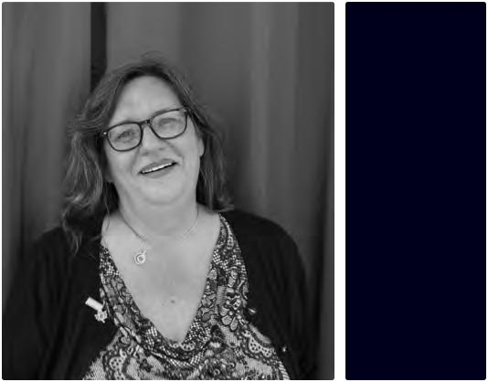

1. Agnes Mutuku, Kibwezi, Kenya | 5

- Safa Shehada Zalha, Ma'an, Israel
- Naomi Navoce, Pacific Disability Forum, Fiji
- Maria Antonia Irazabal Quintero, Social Development Ministry, Uruguay
- Bonny Brayton, DAWN, Canada

- Priscilla Rodriguez, Disability Rights Initiative, Mexico

- Natialia Santos Estrada, Collectivo Chucan, Mexico
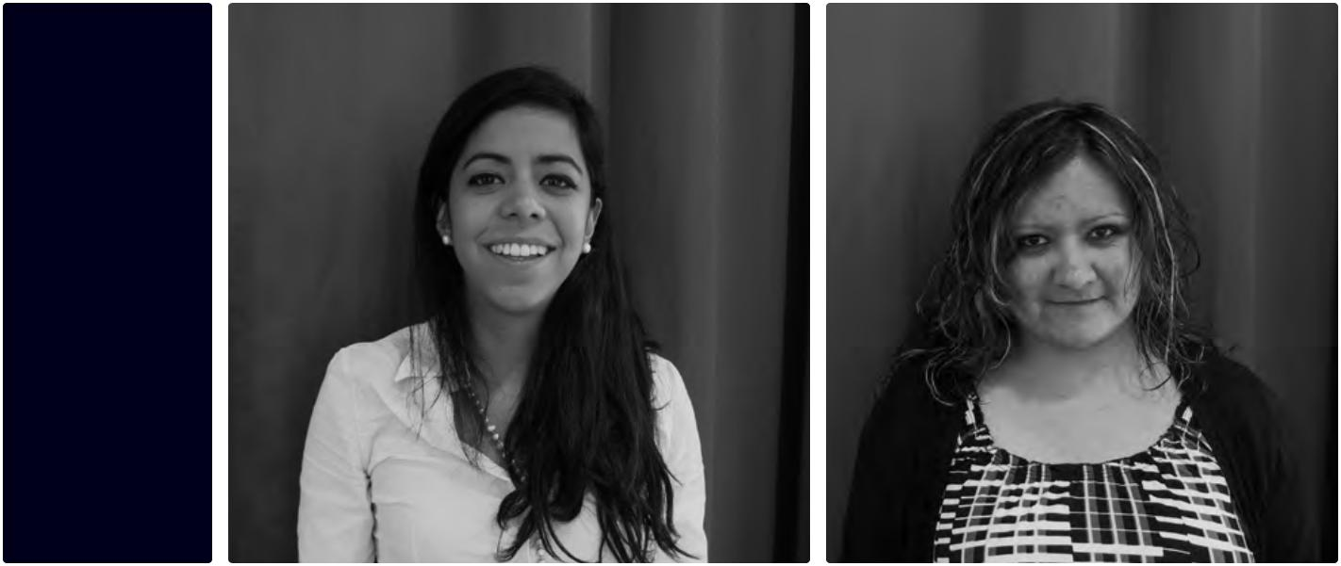

6 7
Key findings of the Making it Work initiative on gender and disability inclusion

The TAC and good practice holders elaborated many of the findings during the Gender and Disability Forum (GDF) which was held in June 2015 at the United Nations at the 8th Conference of States Parties to the CRPD. The GDF brought together good practice holders, TAC members, donors, human rights actors, bilateral agencies and development organizations to share good practice findings, develop recommendations for change based on the practices and elaborate collaborative advocacy strategies to implement Articles 6 and 16 of the CRPD. The first overarching finding of the TAC was that despite the diverse cultural background, languages, socio-economic status, and political systems of the ten countries in which the practices are located, the good practice holders are united by their experiences, challenges and successes. Namely, there was consensus on the need to address gender-based violence, and the need to join together to demand changes in policies and practices to end violence against women, generally, and women and girls with disabilities, in particular.

Policy—Key issues

Women with disabilities across the globe who report cases of violence and abuse to the police face multiple barriers in accessing justice, seeking violence prevention and response services and exercising their legal capacity. Frequently, violence against women with disabilities is not reported, and if a woman tries to report it, the justice system is inaccessible or officials, including police, do not believe her, do not believe she can viably identify her perpetrator, or do not find her case worthy of investigation11.

Without adequate information on services or legal aid, women with disabilities facing violence may not know where to turn to claim their rights. Inaccessible shelters, health facilities and courthouses compound the situation with limited to no accessible forms of communication such as sign language interpretation or information printed in Braille. Usually these barriers are a result
of ignorance and discriminatory attitudes of society and individuals, including health care professionals, police and other service providers. Barriers are due not to the persons’ impairments but often due to inaccessible and disempowering environments. In addition, violence prevention and response programs are largely found to be inaccessible to and not inclusive of women and girls with disabilities. Protection agencies and service providers are not addressing or responding to the specific needs of women and girls with disabilities. Often times, gender-based violence and/

or gender equity policies do not have specific provisions on women and girls with disabilities.

Too many women with disabilities do not have access to information on their civil and political rights and are forced to live in institutions or other residential settings against their will or are marginalized within their own communities and families. This status of disempowerment and isolation is often the precondition for acts of violence perpetrated against them.


Recommendations

Governance and justice reform programs

and human rights institutions need to do

more to enforce the realization of articles 4 and 12 of the CRPD. One of the priorities should be the development and review of the national, federal and regional legislative frameworks to abolish guardianship and ensure legal capacity of persons with disabilites as well as to make the transition from substitute decision-making to systems

Key findings. 


13
Key findings


for supported decision-making. It is of utmost importance for States to reinstate the legal capacity of men and women with disabilities in order to ensure women with disabilities, in particular, can enjoy and claim their rights, make their own decisions and prevent decisions made against their will.

States must take further steps to fulfill their obligations under articles 6, 13 and 32 of the CRPD to guarantee equity and equal opportunities to women and girls with disabilities to access justice. Without access to the police, the courts and systems of justice, there are no opportunities for legal redress of wrongs and enforcement of rights.

States should ensure data that is desaggregated by gender and disability as an urgent matter to look into if
14 the newly adopted 2030 Agenda for Sustainable Development (https:// sustainabledevelopment.un.org/post2015/ transformingourworld) and Beijing +20 (http://beijing20.unwomen.org/en/ step-it-up) are to succeed. Efforts to support self-advocacy of women and girls with disabilities will succeed only if gender programs involve and engage men for gender and disability programs to end violence.

Awareness raising—Key issues

Women with disabilities lack visibility because of the multiple intersections of discrimination they face on the basis of gender, disability and other identity markers such as sexual orientation or ethnic background. Moreover, violence experienced by women with disabilities remains undocumented in most countries in the world, especially as so many cases of violence go unreported or do not reach court.

There are insufficient links between disability-focused civil society organizations and States and/or multilateral actors. Too often, civil society is responsible for ensuring disability inclusion when such action is the responsibility of the State, as required by

international and national law. As a result, existing gender programs and gender-based violence case management systems, policies, and shelters are not inclusive of all women, such as those with disabilities. The active participation of women and men with disabilities, as well as the development of new tools, highly contribute to creating inclusive gender programming and gender-based violence responses.

Recommendations

According to article 4.3 of the CRPD, States, Disabled People’s Organisations, mainstream civil society organizations, and UN agencies should give greater room to the voices of women and girls with disabilities in global and local conversations on gender equity, and recognize their decision-making power to negotiate their position and guide their action. Such action will generate meaningful participation, and foster communication between civil and State actors.

Outreach programs to women (and men) with disabilities, including research and documentation of factors contributing to their exclusion and discrimination, the situation of marginalized women and girls with disabilities, and the scope of violence they experience are needed to break the circles of isolation. Media and researchers are essential vehicles to generate quality information, denounce abuse and rights’ violations, and recall States of their duties to respect, protect and fulfill individuals’ rights under international and national law. Additional systematic consultation between State actors and gender focused civil society organizations of women with and without disabilities and their organizations are needed during policy making and tools development, such as action plans.

Empowerment—Key issues

Empowerment is a pre-cursor to preventing violence, abuse and exploitation. Knowing one’s rights to a life free of violence exploitation and abuse and having access to key services including: sexual and reproductive health, violence prevention as well as education helps to stem vulnerability to violence and abuse. The disempowerment of women and girls with disabilities is widespread. It is rooted in the lack of inclusion of women and girls with disabilities in education, poverty eradication programs, women’s health and reproductive health programs and gender-based violence services. In addition, the rights of women and girls with disabilites are seldom prioritized by women’s rights organizations as well as overall human rights movements. Furthermore, national and local policies on gender equity and prevention of violence rarely include provisions on women and girls with disabilities. It also results from insufficient community based support services, lack of data, gender and cultural practices which all contribute to the lack of empowerment. The disempowerment

of women with disabilities can also affect families. It is equally important to ensure that service providers, Disabled People’s Organisations, gender-based management case systems, and other relevant actors are empowered through capacity-building and the development of their skills to adequately address the needs of women and girls with disabilities, who experience violence and abuse, and prevent situations that could further expose them to neglect, abuse or exploitation.

Recommendations


Increase and upscale capacity development programming for Disabled People’s Organisations, States, UN agencies, and service providers engaged in the protection and redress of gender-based violence. States must allocate sufficient resources on capacity development in these areas, including through funds dedicated to international cooperation and emergency situations, in realization of articles 11 and 32 of CRPD. This includes inter alia investments to develop the capacities of DPOs, women’s rights and gender organisations to engage more effectively in the defense of the rights of women and girls with disabilities. Following the provisions of CRPD’s articles 14.1, 15.1 and 16, it is imperative that measures are taken to guarantee that services, which support women who experience violence and abuse, offer them legal aid and safe shelters, can be accessed by women and girls with disabilities on an equal footing with other women and girls.

Based on these observations and findings, the TAC, together with the good practice holders, would like to recommend States, civil society, development partners, gender actors and UN agencies to identify inclusive mechanisms for the development and implementation of disability inclusive action plans, as well as inclusive tools for monitoring and evaluating the collection of data on progress in the Agenda 2030. Data needs to be disaggregated by gender, age, disability and support needs. Only by taking proactive steps to analyze the potential for replication and engage in effective scaling up of existing good practices on inclusive gender policy processes, programs ending violence against women, and empowerment initiatives will it be possible to use resources effectively so that the needs of the most marginalized women and girls, including those with disabilities are reached, monitored and fulfilled.

Key findings.

15

Good practices

A

Legal advocacy and policy change:

What worked

The briefs contained in this section summarize the actions undertaken by the good practice holders to advocate for change and influence policies at either local or national level.

While the practices cover a wide range of different activities, the following common components have been identified by the local and global experts:

 | With regard to outreach to women who are marginalized and isolated within their families,
 | homes or communities it's essential that self-advocates and their allies are allowed to go to
 | institutions and homes, and visit refugee camps, settlements, and far rural areas. The work of
 | self-advocates is of utmost importance to build the trust of women and girls and to provide
 | support to them as they advocate for themselves and their rights. In addition to support for
 | self-advocacy, alliances with women’s rights, human rights and other non-disability actors
 | are critical.
16 | are critical.

It is important to enforce legal protection, including representation in courts, to gather evidence of violations, protect witnesses and support parties. Such work has been done by organizations in Canada, Israel, Mexico, Kenya and Guatemala. Working with communities and national judicial systems is also a priority, as it supports the removal of barriers to access justice, and ensures the right to reasonable accommodation and adequate support for those women and girls whose legal capacity is denied. Such actions may result in positive change through the transformation of laws and policies, and court decisions.

Work with the media is also extremely relevant. This helps to raise the public's awareness of cases regarding women and girls with disabilities. To this end, it is essential that media are educated on, and engaged in, how to cover cases concerning women and girls with disabilities. The example of Guatemala shows for instance how media have collaborated to document violence faced by women and men in institutions.

Protecting the lives and integrity of women with disabilities detained at the National Mental Health Hospital, Guatemala, through the Inter-American Human Rights System

 By Disability Rights International (DRI)—Guatemala


Topic area: Legal protection of women with psychosocial disabilities against violence, abuse and exploitation.

Background

DRI is a US based organisation that campaigns for the promotion of human rights and full participation of people with mental disabilities across the world. Using the experience of legal professionals, mental health professionals, human rights advocates, people with disabilities and their families they investigate and document human rights abuses. Their work is helping to improve legal and service systems, assisting governments to develop laws and policies that promote community integration and human rights enforcement for people with disabilities (www.driadvocacy.org/about).

The Federico Mora hospital is Guatemala’s only national psychiatric hospital and was recently described by campaigners as “the world’s most dangerous mental institution”

(http://www.bbc.co.uk/news/magazine-30293880). It houses 334 child and adult patients including 70 violent and mentally-disturbed criminals. Serious concerns were raised about the conditions and treatment (both physical and medical) of patients commited to Federico Mora. In 2008 the hospital was visited by the UN Special Rapporteur on the Right to Health, but neither the government nor the health authorities acted to significantly change conditions.
As a result, in 2012 after an eighteen month investigation, DRI filed a precautionary measure petition to the Inter-American Commission on Human Rights (IACHR) with the aim of protecting the physical and sexual integrity of those housed within the hospital. A precautionary measure petition is an approach used to protect human rights when people are at very high risk of their lives or personal integrity. It can only be made when there is sufficient and compelling evidence which includes information that State institutions are either the source of these violations or have failed to stop them happening. If accepted the IACHR will then order the State to adopt urgent measures to protect the people at risk.

In this case the petition outlined abuses ranging from arbitrary detention; lack of appropriate supervision; routine physical, sexual abuse and the use of forced contraception; dangerous use of isolation rooms; inadequate and dangerous medical treatment; inhuman and degrading conditions; and a general lack of food and water.

What happened?

From their office in Mexico, DRI began an eighteen-month documentation process to gather firsthand evidence of the abuses taking place within the hospital. They carried out site vists, interviewed staff and patients, met with local advocates and mental health experts and had discussions with government officials. The resulting petition was submitted to the IACHR and the precautionary measures were granted. Since then DRI has held meetings with the IACHR, hospital authorities and

Good.  practices.


17
Legal advocacy and policy change

government officials seeking to implement the urgent changes requested by the Commission, with a special focus on actions to protect women from further abuses.

The measures that have been discussed include: no new patients admitted to the hospital; the violent and mentally-disturbed criminals to be physically separated

from the main hospital; a plan for the deinstitutionalisation of current patients into small group homes to be drafted; and criminal investigations launched into the alleged cases of sexual violence, abuse and exploitation within the hospital.

What worked?

Using precautionary measures was a highly effective way of generating public attention to the abuses being carried out within an otherwise very hidden institution. In particular
18 it has helped create open dialogue with the government of Guatemala over the possibility of stopping the segregation of people

with disabilities in institutions in favour of community based services. It also highlighted the widespread presence of violence against women held in the hospital. Women with psychosocial disabilities were found to be at very high risk of sexual abuse and exploitation which made this hospital especially dangerous for women. This is an aspect of violence against women that is rarely investigated and it has helped raise the profile of the vulnerability of women and girls with disabilities in institutions around the region. Although done at considerable personal risk, collecting first hand testimonials from patients and ex-patients ensured the petition was a credible and powerful document.

What changed?

There has been a significant increase in public mass media awareness of the ongoing human rights violations being carried out within the hospital. Bringing the petition to the IACHR also ensured hightened awareness at national, regional and international level. This has

made it more difficult for the government of Guatemala to continue to ignore the issues. Guatemala’s government has created an inter-institutional working group to look into how it can comply with the precautionary measures and is now working with the Pan-American Health Organisation (PAHO) to draft a new mental health law.

The IAHRC itself has also created a working group on disability and is now willing to visit Guatemala to supervise the implementation of the precautionary measures.

What did we learn?

To have a real influence on changing the way people with mental disabilities are treated by government and society you need to challenge the system. For that to be successful you have to have solid, reliable documentation and to build up your case with lots of evidence. Challenging this level takes a lot of time—using legal processes, although very effective is time consuming and will not necessarily result in immediate change.

During the negotiation process they learned that to be most effective you have to be open to talk with anyone. Although they sometimes found it difficult to talk with the government they never closed themselves to this opportunity.

There are serious, personal risks from taking up issues like this. Once the hospital became aware of the petition they became quite hostile to visits from DRI. Because of this hostility advocates, medical staff, residents and patients became a lot more wary of providing information and testimonies. Strict levels

of confidentiality are now in place. This level of risk needs to be identified from the start. DRI has found it very difficult to partner with DPOs in Guatemala because of their weak capacity, especially in regards to psychosocial disabilities and human rights awareness. This highlights particular areas of need that remain in terms of capacity building of the DPO movement.

For more information, please contact Priscila Rodriguez at: prodriguez@driadvocacy.org

The anti-violence project: Addressing gender-based violence against vulnerable members of the Bedouin community, Israel

By Ma’an, The Forum for Arab Women’s Organizations in the Negev, Beersheba, Israel


Topic area: Empowerment of Bedouin women with and without disabilities and prevention of violence against Bedouin girls and women with and without disabilities.

Background

Today, Arabs comprise approximately 20% of Israel’s 6 million people. Within that 20%, approximately 3.5% or 190,000 people are Bedouin. Considered semi-nomadic people, Bedouins are located throughout Israel, with the highest concentration in the Negev, or the southern desert of Israel. Among Bedouins, their fertility rate is about 5.5% per year, which is one of the highest in the world.

Bedouins are citizens of Israel with full rights of citizenship. But in practice, great disparities exist between Bedouins and the rest of Israeli society, including among other Arab and Palestinian Israelis. In recent years, most Bedouins have moved away from their homes (tents) in the desert to live in towns that were established by the government. But many Bedouins continue to live in the dozens of villages throughout Southern Israel that

have no official status. These “unrecognized” villages have no roads, infrastructure, or public services. As a result, the vast majority of Bedouins live in extreme poverty.

They also continue to practice polygamy and consanguity. The U.S. Department of State’s Bureau of Democracy, Human Rights and Labor’s 2010 Country Report on Israel found that the Bedouin segment of the Arab population is “the most disadvantaged group within Israeli society”.

Within the Bedouin population, Bedouin women face even greater discrimination as well as high levels of violence. Many Bedouin women live in dire conditions and face marginalization in all aspects of life within their own communty and and by the State of Israel. For example, once a woman’s husband takes his second or third wife, as is common, the woman is further cut off from her own community, both finanically and socially. Bedouin girls and women with disabilities suffer additional discrimination and exclusion because of their disability. Although disability within the Bedouin community is typically caused by consanguinity, poor prenatal health or poverty, people with disabilities are still “shunned” and “feared”. Bedouin girls with disabilities typically never marry and are often kept hidden for fear of stigmatizing the entire family, especially siblings of marrying age.

As citizens of Israel, Bedouins with disabilities are entitled to disability benefits in the amount of approximately $1000/month. Disability benefits are based on a medical model, with the amount per person adjusted for the type and severity of disability. Few Bedouin women and girls with disabilities are able to avail themselves of benefits because either they can’t leave their homes due to the rules set down by their fathers, husbands or sons or because they lack. Of those who can arrange to go to the local office to apply for benefits, they will continue to live in poverty because the cost of living in Israel is so high.

Good. practices.

19
Legal advocacy and policy change

What happened?

Ma’an was founded to address discrimination faced by Bedouin women within their own as well as within Israeli society. It distinguishes itself among other Bedouin women’s organizations by its firm stance against polygamy. Ma’an developed its anti-violence project to specifically address violence in its various forms.

The Ma’an anti-violence project has three main components:
The Women’s Empowerment Groups/ Workshops: These are groups for Bedouin women with and without disabilities, which take place regularly in the homes of Bedouin women, often in the “unrecognized villages”. These groups provide support to women so they learn how to support each other, and to talk about their lives, inclluding the violence

20 which they experience.

Hotline: The hotline started in 2012, and is staffed by 35 volunteers all of whom undergo intensive training. The volunteers refer the callers to local services or to Ma’amn’s two lawyers. Ma’an lawyers represent individual women and provide trainings to women in their villages. The lawyers help clients apply for government benefits, seek orders of protection to stop violence, or connect them to other Ma’an services, including temporary shelters. Prior to this project, no free legal aid for Bedouin women with or without disabilities was available, nor were there any organizations that assisted Bedouin women in their homes. Today, the lawyers from Ma’an go to the villages to meet with women in their homes, to instruct them about their rights to government benefits, as well as the right to a reduction in taxes and water and electricity bills for families with a person with a disability. In 2014,

12 women with disabilities and 13 mothers of children with disabilities contacted the hotline for assistance.

Groups for youth, students and young professionals: Ma’an believes that in order to eliminate violence against girls

and women with and without disabilities, it must work to re-educate Bedouin youth, particularly young boys. Ma’an recently hired a young man who had previously worked with a deaf-blind theatre group, and who is currently studying to become certified a sign language interpreter at an Israeli univesity. He works with boys ages 12–14 to teach them how to show respect girls and women with and without disabilities and how to address issues of violence. This young man is now forming a youth club for Bedouin boys who are Deaf to help build their self-esteem and to provide them with an opportunity for socializing. There are also girls’ groups, but to date no girls with disabilities have joined these groups.

What worked?

The anti-violence program was developed in 2012. By 2013, there were about 80 calls to the hotline, while in 2014 the number of callers increased to 114. Most women who call the hotline report that they heard about Ma’an after participating in one of Ma’an empowerment groups or workshops. To Ma’an, every call that comes into the hotline is viewed as a “success”. According to the director of Ma’an, “that call can literally break the cycle of violence because it means that the woman has decided to reach out, to outside of her family, for assistance”.

The most significant changes resulting from the anti-violence program are:
Increase in the number of women participating in the empowerment groups/ workshops;

Referrals from the Ministry of Social Welfare and other organizations to Ma’an for assistance for women with and without disabilities who are subjected to violence;

Successful outcome of court cases on behalf of women with disabilities who were subjected to family violence; and Successful outcome of applications by girls and women with disabilities for government benefits.

Dissemination of Ma’an publications, including a booklet that describes their program and practices. Their materials provide guidance on disability and gender rights in traditional societies in a frank and honest manner, taking culturally sensitive issues into account, while including practical advice for developing human rights awareness to enhance equality for Bedouin women.

What changed?

Ma’an’s record of appeals of denial of benefits for women with disabilities is impressive, winning 4 out of 5 of their recent cases.

One divorce case, filed on grounds of domestic abuse, concerned the loss of residency status for a woman who had entered Israel, illegally. Ma’an won and now in Israel, women (often from Gaza) who gain residency status through their husbands will not lose their status if they separate or divorce due to abuse or violence. Within the past year, Ma’an also has been successful in including women with disabilities and mothers of children with disabilities in their workshops and other activities. Part of the reason for their success is the assistance of a board member, Miriam Alamour, a Bedouin woman, who had polio as a young girl, and who is helping Ma’an staff connect with a group for women with disabilities which she runs at a local community center. Ma’an’s model of including women with disabilities into ongoing programs rather than developing separate programs or them is a valuable and empowering example of mainstreaming disability into a gender agenda. The challenge remains, however, for women and girls with disabilities to become more involved in the planning and implementation of such programs.

What did we learn?

Since Ma’an is so controversial within the Bedouin community due to its stance on polygamy, many Bedouin women are deterred or even prohibited by members of their own families from contacting Ma’an for assistance. Ma’an’s reputation for speaking out against polygamy also makes it difficult for the organization to find the volunteers needed to staff the hotline and to participate in the women’s empowerment groups, and other activities.

Ma’an brings together women, most of whom routinely experience violence, but by their own admission, it is difficult to talk for them to talk about violence, even one on one. Perhaps additional specialized training for Ma’an staff on how to support women in sharing information about violence in order to develop strategies to facilitate a more open discussion with victims of violence would be helpful. Additional funding to enable Ma’an to hire staff rather than rely on volunteers also would have a great impact on the effectiveness of the organization.

For more information, please contact Safa Shehada Zalha at: safa.maan@gmail.com

Good.

practices.

21
Legal advocacy and policy change

InFocus: Bringing people with disabilities into the picture—A National Pan-Canadian Community Leadership Initiative

By DisAbled Women’s Network/Réseau

d'action des femmes handicapées

(DAWN—RAFH), Montreal, Canada


22

Topic area: Issues of ACCESS for girls and women with disabilities in order to prevent or eliminate violence, exploitation and abuse.

Background

DAWN Canada is now celebrating its 30th Anniversary and it was founded in 1985 following a meeting between seventeen women from across Canada who came together to discuss issues of mutual concern. DAWN brought together a diverse community of deaf women and women with disabilities (hereinafter “women with disabilities” for brevity, recognizing that DAWN prefers to use the terms “deaf women” and “women with disabilities” in tandem), including aboriginal women, lesbians, older women

or women of color. DAWN’s comprehensive mission includes, among other things, to be a resource for and about women with disabilities and our concerns; to be a bridge between women with disabilities and the women’s movement; and to work together with the women’s movement on issues which affect all women and to help the movement become more accessible to women with disabilities.

Canada is the second largest country in the world, smaller only to Russia. The population of 28 million comprises great ethnic and linguistic diversity. According to a study by the Government of Canada, an estimated 3.8 million adult Canadians reported being limited in their daily activities due to a disability in 2012. This represents
13.7% of the adult population. At least 53% of all people with disabilities in Canada are women. In Canada today, sexual assault of women with disabilities takes place at a rate twice that of the general population of women. For women with intellectual disabilities and deaf women the rate is higher than that for other women with disabilities. Almost 80% of women with disabilities have experienced physical violence by their intimate partners compared to 29% of women without disabilities; and sexual offences are the most common type of abuse against women with disabilities. Furthermore, to compound the problems, the unemployment rate among women with disabilities is up

to 75%, 58% of women with disabilities live on less than $10,000 per year; of those, 23% live on less than $5,000 per year.

What happened?

DAWN developed an assessment tool, the “National Accessibility and Accommodation Survey” (NAAS), and undertook an accessibility assessment of domestic and gender-based violence shelters and programs. They found that across Canada, few rape crisis centres and transition houses are accessible to women with various disabilities.

DAWN produced a video “We Can Tell and We Will Tell”, which presented the thoughts and experiences of various people with disabilities with respect to violence, including gender-based and sexual violence. The video has been shown at workshops conducted by DAWN’s partners.

The implementation of the InFocus project was a collaboration between DAWN Canada and the Canadian Association for Community Living (CACL), with DAWN taking the lead on the development of the tool kit, training

materials and other resources and CACL assisting with the identification of community partners in the 10 provinces and 3 territories in Canada. This approach ensured that the project reflected the needs and input of their specific target communities and also fostered the greater capacity of local Disabled People’s Organizations (DPOs) throughout Canada. Each community partner was provided

with workshop tool kits in advance of the workshops and each partner was encouraged to adapt the training materials to the cultural and other specific needs of their communities. The InFocus project organized roundtables of women with disabilities throughout Canada to gain a better understanding of the specific violence issues they faced, and to increase understanding of their needs and experiences. This sharing helped women to understand that they were not alone in experiencing gender-based violence and abuse. The facilitators/local organizers received an initial training and were provided with a comprehensive guide on facilitating focus groups of survivors and their local advisory committees. Evaluations of the trainings were brought back to the national team, which in turn informed the final design of the roundtables.

The InFocus project held numerous workshops throughout Canada. One group of workshops focused on disability sensitivity training for healthcare providers, violence prevention workers, teachers, police and other front-line workers. In addition, information sessions were held to understand challenges and barriers, as well as practical things that can be done to make their workplaces more inclusive.

A second group of workshops raised awareness amongst women and girls with disabilities on risk factors for gender-based and sexual violence, explored proactive steps women could take in such situations, and enhanced the understanding of women with disabilities with respect to addressing violence and obtaining services.

What worked?

Lead organizations to implement the project were identified in each community, ensuring that learnings and outcomes were integrated into the local communities and lead organizations. In some communities disability rights organizations were the lead organization while in others more broadly focused human rights organizations led the effort. This approach enhanced the integration of disability issues into the disability rights community and broader human rights community. The project helped to build the capacities of the lead organizations; identifying and securing commitments from key local partners, forming a local cross-sectoral steering committee and securing institutional backing through the lead organizations.

Women with disabilities who participated in the workshops were especially grateful for the availability of counselors during the sessions as these workshops raised many very emotional and tramatic personal issues. The support of counselors was vital for the maintenance of a “safe space” for them. Participants in both types of workshops appreciated the very comprehensive and useful handbooks that were distributed at the workshops.

What changed?

Service providers, including front-line workers and management representatives, provided feedback demonstrating a greater awareness of the nature and scope of the barriers faced by women with disabilities in accessing services, and expressed a significant desire for additional practical and locally-relevant resources and tools to aid them in making the changes necessary in their own practices and within their organizations to make their communities more accessible and inclusive for women with disabilities.

Law enforcement officials and police indicated they had a greater understanding of the violence issues facing women with

Good.

practices.

23
Legal advocacy and policy change

disabilities and recognized that their agencies needed to address these issues in their training and work.

Some DPOs previously had not been informed about nor engaged in addressing issues concerning gender-based violence and women with disabilities. Their involvement with the InFocus project facilitated their engagement on these issues.

Disabled women came to understand their experiences were shared and respected by others. They also learned of the availability of community resources to address these important issues. A unique feature of this project is that it provides participants the opportunity to reflect on and understand their experience of violence in a systemic way, leading to discussions on how to make positive changes.

In those communities where the lead organization was a human rights organization or a women’s rights organization, issues of
24 violence against women with disabilities have been increasingly incorporated into their work.

What did we learn?

DAWN’s unique expertise, its reputation and engagement with diverse partners and its national reach make it uniquely positioned to influence change and increase awareness among the women’s rights community, the anti-violence and victim’s rights community, government officials and women with disabilities and deaf women ourselves. Dawn’s reputation and the respect for its work in the communities was helpful in obtaining collaboration of implementing partners and also in developing tools and strategies that were comprehensive and easy-to-use.

Some of the organizations with which DAWN collaborated were well-established in their communities while others were more recently formed. In those communities with less established DPOs, implementation of the project was slower but the project served as a catalyst for the advancement of the local organizations. For example, in the indigenous Nunavut Community in rural western

Canada, the DPO partner is newly formed and discussion of issues of violence against women with disabilities was a somewhat taboo subject. The project created a powerful catalyst for change, but implementation proceded more slowly there, in part due to the limited funds the partner has to continue the work. On the other hand, the more established DPO in Vancouver was better equiped to implement more aspects of the project and has been successful in obtaining additional funding to continue the work. This learning demonstrates that implementation of a nationwide project is complex and must be flexible to respond to the specific community and organizational context. Additional specialized training for staff in local communities to develop their organizational capacity and ability to conduct outreach activities in the diverse and widely dispersed rural communities would be helpful. Additional funding to enable DAWN to assist the less developed local DPOs to hire more staff rather than rely on volunteers also would have a great impact on the effectiveness of the organization and its implementation of the project.

Service providers expressed a strong intention to make their facilities and programs more accessible to women with disabilities. It would be very useful to re-assess the specific changes implemented in such programs, perhaps by again using the “National Accessibility and Accommodation Survey”. Many of the women with disabilities participating in the workshops used the space to express their own emotions and personal issues. Because of this there was not sufficient time to develop their personal plans for coping with violence. Given the strong personal emotions that were expressed, it would have been appropriate to have some follow-up sessions, but the scope of the project did not permit additional sessions. Some participants found that the videos, which presented other disabled people’s experiences with violence, were a trigger for their raw emotions.

The consultant who evaluated DAWN’s

project noted that in some communities,

the timing between the focus groups and

the workshops was too long and the energy

around the issues dissipated. The timing of

the delivery of the facilitators’ tool kit was

not sufficient to allow some organizations to

prepare and adopt the tool kit to the specific

needs of their communities.

For more information, please contact Bonny

Brayton at: admin@dawncanada.net

Good.

practices.

25

Good practices

B

Awareness raising:

What worked

The briefs contained in this section describe the actions undertaken by the good practice holders to raise awareness among local and national authorities, traditional and community leaders, communities and families, service providers, DPOs and other mainstream organisations.

While the practices cover a wide range of different activities, the following common components have been identified by the local and global experts:

To address the invisibility of women and girls with disabilities, it is important to collect data on where women with disabilities live, what barriers they face, and what supports they need. More and better quantitative and qualitative data would support governments to allocate adequate resources for disability and gender inclusive budgeting, as well as

26 policy development for women and girls with disabilities. In Uruguay, for instance, the Gender Unit of the Disability Program within the Ministry for Social Development has taken the lead in raising awareness on gender and disability-based violence, and has also initiated trainings with other departments within the government. As a result, the Women’s Institute began to track gender and disability violence as well.

To address barriers faced by women and girls with disabilities who have experienced violence, consultations are necessary between State actors and civil society. In Costa Rica, Fiji and Uruguay, women with disabilities joined hands with State actors, and provided advices on how to become more inclusive through the development of tools on disability inclusion and gender-based violence. In other countries, like Kenya and Mexico, women with disabilities were involved in policy-making and were able to contribute to the decision-making process, and ensure that policies were in line with the CRPD. Toolkits on how to address gender-based violence against women and girls with disabilities were successfully developed through inclusive and participatory processes in Fiji and Uruguay, and have been introduced into national programs.

Mainstreaming disability in the governmental programs addressing violence against women in Uruguay

By Ministry for Social Development— Gender Unit of the Disability Program (PRONADIS—MIDES12)


Topic area: Education and mainstreaming disability in governmental programs addressing violence against women.

Background

Prior to this intervention there were governmental programs aimed at women victims of gender-based violence, including legal aid and security measures. However, when the programs received information or a complaint regarding women or girls with disabilities, the institutions had no response and many women with disabilities received no support.

This practice was initiated due to a local inter-institutional initiative [Inter-American Institute on Disability and Inclusive Development (IIDI)] in response to demands from civil society regarding the need to improve sexual and reproductive health services for women and girls with disabilities. The focus of the demands centred on the lack of response and measures to support women and girls with disabilities who were subjected to violence. Bearing in mind these demands, an agreement was reached to design a research study about the following intersections: women with disabilities, access to sexual and

reproductive health services, and the exercise of these human rights. UN Women agreed to finance the study and it was designed with the support of the University Republica, the Disability Secretariat, and civil society representatives. That study was published and disseminated, and led to several main outcomes:
A guide for sexual and reproductive rights of persons with disabilities (with involvement from the Pan American Health Organization, the Health Ministry, and the Ministry for Social Development) that was distributed as support material to all medical practitioners in all health centers nationwide;

Accessible brochures about sexual and reproductive rights of women with disabilities;

Academic events on this topic that involved the academic units of gynecology, nurse schools, and executive chief officers for public policies on health. During these academic events, the need for awareness raising and for capacity building was evident, and thus the program “Sweeping barriers”, (Barriendo barreras) in the modality of seminars was designed and implemented.

What happened?

The program “Sweeping Barriers”, as a capacity building program that was implemented through seminars, was divided in two sectors: one aimed at civil society and the other one aimed at staff from health sector, both were implemented at local level. The seminars for DPOs and civil society organizations included the rights of persons with disabilities emphasizing in sexual and reproductive rights and the right to have a life free of gender-based violence. The civil society organizations were consulted to promote the direct participation of women and girls with disabilities.

The seminars aimed at health professionals and Ministry staff, included topics such

as the social model of disability, the legal framework protecting the rights of persons with disabilities, violence against persons

Good. practices.

27
Awareness raising

with disabilities, the proposed modifications of protocols to assist persons with disabilities who are victims of violence. A strategic alliance with the Health Services’ State Management was developed, and these seminars were organized with the coordination of the local MIDES offices. Under the scope of the Convention on the Rights of Persons with Disabilities (CRPD), this action has the double effect of making visible the issue of the rights of women with disabilities, facilitating their gender identification and the multiple oppressions to which they are exposed, and at the same time this action has the effect of questioning the hegemonic medical model with its vertical and polarizing vision, forcing it to move into the intersectional multi-dimensional perspective of human rights.

This practice has also generated rights awareness in persons with disabilities, promoting the exercise of their human rights;
28 and within the health sector it generates capacity for timely and adequate care of the specific demands of this population.

What worked?

Support for and facilitation of the organization of the first national seminar on gender, disability and violence was provided by the Spanish expert Dr. Isabel Caballero, and she continues to serve as advisor to the practice. A key factor that can be replicated is the alliance between governmental institutions and DPOs, especially organizations that represent women with disabilities. A very positive aspect of this practice was that the main official responsible for promoting this practice is a woman with a disability herself, showing a strong commitment and passion to advance these issues.

The guide to sexual and reproductive rights of persons with disabilities is a very good educational and awareness raising material, aimed at a wide scope of actors, including women and men with disabilities, medical practitioners, educators, social workers, and others. It would be important to disseminate it widely.

The head of the health services administration (Dr. Silvia Melgar) was instrumental in making this practice a success, directed guidelines to the Social Development Ministry and

all programs relating to prevention and elimination of violence against women, in order to be collaborative with the gender unit to organize and develop the seminars to train staff on disability rights and sexual and reproductive rights of women and girls with disabilities. As examples of her leadership, during her time in office, abortion was legalized and machines distributing condoms were placed in all public institutions.

What changed?

The program (with more funding and human resources) was adopted as part of the structure of the Ministry for Social Development.

After raising awareness among public officials and staff of these programs, measures have been adopted to provide these supports to women and girls with disabilities who are victims of gender-based violence (GBV), including legal aid and perimetral security measures.

Medical practitioners nationwide have demanded training on issues relating to the specific needs of women with disabilities, and thus awareness about the topic has been raised.

Forms that people use to receive social benefits now take into account gender, and now include questions about sexual and reproductive health as well as GBV. The data gathered from these forms are analyzed through a gender lens.

An initiative to track gender and disability-based violence was taken, for the first time, as a line of action by the Women’s Institute (IMujeres/MIDES, also within the Ministry for Social Development).

There is an interest in eliminating barriers in health services. In some premises, accessible toilets have been built, ramps have been placed to facilitate access, accessible parking areas have been

designated, and other adaptations have been undertaken.
A guide has been published on sexual and reproductive rights of persons with disabilities, with a gender focus. It is compulsory reading for university students pursuing careers in medicine, nursing and gynecology.

Once data on gender-based violence began to be collected, women and girls with disabilities who were legally incapacitated and also were victims of violence started being assisted with no need for their legal representative to speak for them. Although this practice did not challenge denial of legal capacity, this change in practice is an advancement in the protection against gender-based violence.

The first organization of women with disabilities with a rights perspective was created “Association of Uruguayan women with disabilities in diversity” (Asociación de mujeres uruguayas con discapacidad en la diversidad). It was constituted by the women with disabilities who participated in the study. Their main goals are aimed at the empowerment of their members, training in topics such as self-esteem, gender and disability, gender identities and violence.

What did we learn?

The difficulties faced in the implementation of this practice are related to scarce economic and human resources. The Gender Unit, for instance, has only two staff members, one of them is a full time official while the other one is hired only half time. This limits the scope of their efforts, although the program “Sweeping Barriers” has been implemented at the national level, this has taken a few years and there is still a challenge to include all staff into the trainings.

Even though this practice has been considered as good because it has been promoted by

a governmental institution, the “practice holders” have expressed their concern that with a change in the government, their work and efforts could be interrupted. Funding for the program “Sweeping Barriers” could be cut, so there needs to be an effort to ensure that it is fully institutionalized.

While some barriers have been eliminated as per above section on what changes, a policy to eliminate barriers in health services has not been developed.

For more information, please contact

Maria Antonia Irazabal Quintero at:

psirazabal@gmail.com

Good.

practices.

29
Awareness raising

Justice for survivors of sexual abuse through multi-sector community responsibility in Kenya

By Advantage Africa and Kibwezi

Disabled Persons’ Organisation

Topic area: Access to justice for women
with disabilities in the incidence of sexual
violence and abuse.
30


Background

Advantage Africa is a UK based NGO that works to support people affected by poverty, disability and HIV/AIDS to improve their education, health and incomes. Advantage Africa have developed a close relationship with Kibwezi Disabled Persons’ Organisation (KDPO) since they began a partnership

in 2004. KDPO is a community based organisation of persons with disabilities, with 12 self-help groups focused on looking for practical ways to improve the living standards of children and adults with disabilities and to raise awareness over their rights. It has over 1,500 registered members with disabilities and two of its most senior staff are disabled. Advantage Africa has been helping KDPO

to grow as an organisation and especially to develop its advocacy skills.
Kenya has ratified both the CEDAW and the CRPD which provide the framework for the legal promotion and protection of the rights for Kenyans with disabilities within both its Constitution (2010) and its Disability Act (2003). The latter is currently under review

for compliance with the CRPD. Formal legal and judicial processes co-exist with systems of traditional justice. These traditional processes take many forms and are practiced in more than fifty different ethnic groups across Kenya.
Kibwezi is a district in eastern Kenya where most families rely on agriculture for their livelihoods. Here, violence against women in general is not uncommon. They are considered to have a lower status than men leaving them more vulnerable to gender-based violence, such as rape and domestic violence. In Kibwezi, the community elders are frequently expected to deal with reported incidences of violence by facilitating a traditional reconcilliation method known as “cleansing”. The family of the perpetrator is required to give a number of goats as “compensation” to the family of the victim after negotiations between the male heads of the two families. Women are not engaged in the process and are not the recipients of this “compensation”.

However, this system has rarely included cases involving women and girls with disabilities. This is partially due to the fact that many families, whose one or more members are women or girls with disabilities, are headed by women who are not entitled to take part in the “cleansing” negotiations. Nevertheless, this is mostly due to the widespread belief that abuse and violence against people with disabilities is not a reportable issue. Very few women and girls with disabilities report crimes of violence to the police, and where they do, they are easily intimidated and convinced to drop the case. It is precisely because of these negative attitudes that women and girls with disabilities are at high risk of violence and abuse.

KDPO developed this project after becoming increasingly aware of the lack of support for women and girls with disabilities, who had become victims of abuse, including raping of girls with disabilities as they made their way to school. Advantage Africa agreed to support them in applying for a joint participatory research project to better understand how to improve the sexual and gender-based violence response system in Kibwezi.

What happened?

Over a period of six months, KDPO facilitated a big awareness raising campaign targeting key groups of people involved in providing support to those experiencing violence and abuse. At the same time they worked with Advantage Africa to implement their participatory research.

To build their own skills and confidence,

they worked with two experienced civil society organisations—Cradle and Women Challenge to Challenge—to develop appropriate methods to sensitise communities on issues concerning violence against people with disabilities, in general, and women and girls with disabilities, in particular.

The project focused primarily on the communities’ elders, decision-makers, law enforcement bodies, as well as people with disabilities. The aim was to inform them about the types and prevalence of sexual violence against women and girls with disabilities.

A workshop was organised. Stakeholders came together to work on creating an inclusive response system to support women and girls with disabilities experiencing violence. A diverse range of stakeholders came, including community elders, people with disabilities, family members, teachers, nurses from the hospital engaged in medical response to violent attacks, religious leaders, police officers involved in the reporting

of cases, local authorities, State social workers engaged in coordinating support for survivors, and other NGOs engaged in gender-based violence in Kenya.

What worked?

After learning about how to raise awareness with communities, schools, service providers and local authorities, members of KDPO have been attending weekly community meetings (called Barazas) across the district to talk openly about these issues. This became a very effective way of bringing this issue to the attention of communities and decision-makers.

The involvement of communities and the village elders was the most effective strategy in developing ways to minimize and progressively eliminate violence against people with disabilities. Since they became aware of this issue, and the existence of protection clauses under legal agreements, communities have been much more willing to support people with disabilities in reporting abuse, and bringing the abusers to the police. The engagement of KDPO in research,
with Advantage Africa, helped them to develop as an organisation. Not only did they learn new research skills, but they also established links with a much wider range of stakeholders, which contributed to establish new relationships with people working in the field of gender-based violence such as police officers, nurses and community elders.

In fact, the participatory nature of the research contributed to the establishment of an improved community response system for people who experienced by abuse.

What changed?

This is a relatively new initiative, and as such the work which is still early in the process to generate change.

However, there have already been some significant examples of changes in attitudes and practices. For the first time there

has been recognition that violence against anyone with a disability is a crime. The Deputy District Chief spoke publicly about this issue and declared that he would personally confront anyone accused of sexual abuse against women and girls with disabilities. Some key groups of people, including pastors and village elders, have immediately taken up this issue and have started to talk to their communities about how violence against women and girls with disabilities can be managed and prevented. Church services are now used to inform people on how to report abuse.

A recent case involving a woman with an intellectual disability was brought to the criminal justice system by the community itself, and has been adequately investigated.

Good.

practices.

31
Awareness raising

For the first time the community has expressed its shock in exposing this case and its support for justice for the victim.

What did we learn?

Although awareness raising and community sensitisation are already making a significant difference, beliefs and understanding of disability remain deep-rooted. It will take time to work with communities to understand, guarantee and realize that women and girls with disabilities are important and valued community members, who have the same rights as any other women. For this reason, women and girls with disabilities still remain critically vulnerable to sexual abuse. Moreover, the fact that people with disabilities also lack awareness and understanding of their rights. This means that often they don’t seek medical support
32 and/or don’t report crimes committed against them. This translates in significant delay in seeking justice, but also in getting medical help and preserving evidence. As a result women and girls with disabilities, who have experienced sexual abuse, are at an increased risk of sexually transmitted diseases like HIV/AIDS.

Women and girls with disabilities in Kibwezi face not just attitude barriers, but also significant environmental barriers when dealing with the consequences of abuse. Police and hospital services are located in towns and it prevents those living in rural areas with the difficult task of making the journey. Local transport is expensive and people with disabilities are often charged higher prices if local transportation is accessible to them. For some, such as those with intellectual disabilities or those who are deaf, the communication with service providers, such as medical staff or police, can be overwhelmingly difficult.

Their needs therefore often go unmet exposing them to a higher risk of abuse. Poverty is also a key factor in the vulnerability of women and girls with disabilities. Thus, one important strategy in the prevention of further abuse is to

empower women to be economically active and independent. As the KDPO coordinator described: “The more (economically) empowered a woman with a disability is, the stronger she would advocate for her wellbeing.”

For more information, please contact

Agnes Mutuku at: kibwezidisabled@gmail.com

Women with disabilities advocating towards Costa Rican institutions to make changes at national level and in different regions of the country

By Ileana Chacón and Shirley Angulo


Topic area: Awareness-raising.

Background

Women’s rights have been advancing in the country, placing Costa Rica in a leading position in relation to the Latin American region. However, women with disabilities had not been involved in the movement to advance women’s rights, and women’s rights were not addressed by disabled persons’ organizations. Women with disabilities themselves lacked knowledge and information about their rights, thus, many of them were being frequently subjected to violence. Their lack of knowledge about their rights made them more vulnerable and unaware of what institutions to seek help from.

Costa Rica’s government institutions include the National Institute for Women (Instituto Nacional de la Mujer—INAMU), the social security institution (Caja Costarricense de Seguridad Social—CCSS) which provides sexual and reproductive health services and disability specific health services, and the

National Council for the Disabled (Consejo Nacional de Rehabilitación y Educación Especial—CNREE), among others. None of them considered the rights of women with disabilities as part of their work. Costa Rica ratified the Convention on the Rights of Persons with Disabilities (CRPD)

in 2008. When considering its articles about women with disabilities (mainly articles 6, 16 and 25), two women with disabilities, Ileana and Shirley saw ratification as a good opportunity to raise awareness in the governmental institutions.

What happened?

In 2009, a group of women with visual disabilities attended a training on CRPD and disability rights, and after the training decided to constitute a working group or commission. They began to replicate that training with other women with visual disabilities. At this early stage, they sought support from the National Institute for Women. The working group of women with visual disabilities gave a list of demands to the Minister for Women’s Issues, the list included requests to include women with disabilities in policies about violence, and even more importantly, to be included in discussions on the those policies.

The trainings for women with disabilities on women’s rights and violence against women used innovative materials and methodologies.

In 2010, the women with visual disabilities decided they had to include women with other disabilities. As a wider group, they approached the National Council for the Disabled to seek support, using the argument that women with disabilities’ issues were human rights issues that had not been included in the disability policies being implemented by the Council. As a result, the Council agreed to provide the financial and technical support to develop capacity building activities in most regions of the country, implementing a total of 11 trainings in the capital city and the country’s provinces from 2011 to 2013. Besides the geographic

Good.

practices.

33
Awareness raising

diversity, women and girls with diverse disabilities and diverse ethnic background, including women of African ancestry. Additionally, the officers of the National Council for the Disabled also became involved in this process and within their own institution, in particular, several of the women officers. The trainings included gender and disability, gender and legislation, violence against women, and other related topics. The National Institute for Women (INAMU) had previously defined, as an institutional policy, affirmative action toward several women’s groups, such as indigenous women, girls, and victims of violence, but had not defined any policy for women with disabilities. Many of the trainings implemented during this practice were facilitated by the National Institute for Women.

Meanwhile the National Council for the Disabled (CNREE) had started to draft a national policy for persons with disabilities
34 (Politica Nacional en discapacidad or PONADIS), but in 2010 it had not yet considered the inclusion of women with disabilities as a specific group with specific rights. The PONADIS was adopted in 2011 and an achievement was that women with disabilities were included, the policy was adopted in 2011.

In September 2012, the first national meeting of women with disabilities took place, with the participation of 60 women with diverse disabilities and from diverse geographic and ethnic background, and the financial and political support from the CNREE. The contents and methodology of this first national meeting was jointly designed and organized by the women with disabilities and the Council’s officers, putting into practice CRPD article 4.3. The National Institute also provided technical support. As an outcome document the group drafted 22 recommendations. One of the recommendations was that the Council’s staff needed to be trained in these issues. The group also demanded the involvement of more governmental institutions such as the Labour Ministry, and greater involvement of the National Institute for Women.

In 2013, the council created a Gender and Disability unit. In September 2013, the second national meeting of women with disabilities took place, and a forum was organized on

25 November to address issues on violence against women with disabilities, involving INAMU and CNREE. In November 2014, the third national meeting took place. In addition to the public institutions already mentioned, this meeting also included the participation and involvement of Costa Rica’s national human rights institution (NHRI).

What worked?

Women with disabilities have greater awareness about the CRPD.

Mainstream women’s organizations that are part of the governing body of INAMU have learned about the rights of women with disabilities and have begun to involve them in programs.

The National Institute for Women includes a training module on women with disabilities’ issues.

A study on women with disabilities, funded by the National Council for the Disabled, was completed.

INAMU considers that the most important impact is that women with disabilities are now included as a specific group of women, and are taken into account in all its actions.

Within the CNREE, women with disabilities are included in their plans, budget and policies.

In the NHRI, the work unit responsible for women’s rights has monitored health service facilities and has identified lack of accessibility and non accessible equipment as a barrier. As a result of the follow

up, new equipment has been acquired in some of the services and accessible gynaecological beds have been purchased. The National Rehabilitation Center (CENARE) will provide specific sexual and reproductive health professionals for persons with disabilities attending their services.

What changed?

The women with disabilities movement also drafted an alternative report for the UN Committee on the Rights of Persons with Disabilities. So far, this is the only alternative report drafted exclusively by women with disabilities that the UN Committee on Rights of Persons with Disabilities has received. INAMU now has an affirmative action policy for women with disabilities.

What did we learn?

Women with disabilities were unaware of their rights as women and as persons with disabilities, but most importantly, that the rights of women with disabilities were basically rendered invisible, and thus, those women lacked protections. Neither DPOs nor institutions working for women’s rights paid attention to them.

Many of the women reside far from the capital city or in remote areas far from the centers where the regional meetings took place. Transport is not fully accessible, limiting the women’s possibilities to travel far distances. Additionally, it wasn’t always easy to hire a sign language interpreter, due to the hiring conditions required by the CNREE, institution that was funding the activities.

There is still a big challenge in letting women and girls with intellectual disabilities speak for themselves. Parents still believe their daughters they are not capable of doing so. Officials in the public institutions are often set in their ways of work, and this was an important obstacle when trying to convince them to get involved.

Hiring sign language interpreters was also an obstacle, in the sense that due to institutional policies of CNREE, some sign language interpreters could not qualify to be hired.

For more information, please contact Ileana Lucia Chacon at: ileanachacon@gmail.com

Toolkit on eliminating violence against women with disabilities in Fiji

By Pacific Disability Forum


Topic area: Education and employment.

Background

Pacific Disability Forum (PDF) is a Fiji based federation of Disabled People’s Organisations (DPOs) that represents people with disabilities across the Pacific. They run programs for women and youth with disabilities; conduct research; carry out advocacy on disability rights; support capacity building programs for national DPOs; and help public sector institutions and mainstream development organisations include people with disabilities into their programs.

PDF has hosted a Pacific Regional Forum for Women with Disabilities since 2007 in recognition of the fact women and girls face particular challenges. Over the past two years they have been running a program specifically focused on ending violence and abuse against women and girls with disabilities in the region. Fiji has ratified the Convention on Rights

of the Child (CRC) and the Convention on Elimination of Discrimination Against Women (CEDAW) and are signatories to the Convention on the Rights of Persons with Disabilities (CRPD). In their 2008 CEDAW report the Government of Fiji mentioned that women with disabilities are one of the ‘most marginalised groups in society’ (Report to CEDAW Committee, 2008, page 40) although they did not provide any further information about violence against women with disabilities.

Good.

practices.

35
Awareness raising

What happened?

In order to address the gap in awareness and support for issues around violence against women and girls with disabilities, PDF created a project (funded by the Australian Department of Foreign Affairs and Trade through the UN Women’s ‘basket fund’ on ending violence against women) to develop a toolkit for use by DPOs, service providers, government agents and communities.

The project had three distinct phases. During the first phase PDF worked to build the capacity and knowledge of a selection of DPO representatives, family members, care givers, and community workers from across Fiji on issues around violence against women and girls with disabilities. In a two week training program, 22 people were introduced to issues and concepts around gender-based violence and the techniques, legal services,
36 policies and programs focused on violence prevention. The DPO representatives learned techniques to gather and analyze data

on violence against women and girls with disabilities in their communities.
During phase two PDF and FDPF members analyzed the data that had been gathered as part of phase one, and then drafted a toolkit which was shared with 40 participants at a four-day workshop designed to review and improve the document. This workshop was primarily aimed at organisations and service providers, the potential users of the toolkit, the majority of who were non-disabled.

The DPO members at the workshop were tasked with putting together action plans to help their communities to prevent violence against women with disabilities.

Phase three involved a round of consultations to raise awareness amongst key interested groups about the toolkit. In addition a workshop was held with a variety of stakeholders in government to field test the toolkit.

What worked?

One of the key features of this program was the consultation process. Although it took time to develop the toolkit in this way, it provided PDF with the opportunity to raise awareness, gather and share experiences and collaborate with a whole variety of different groups of people. PDF were very strategic in their choice of partners including the Fiji Disabled Persons’ Federation; Fijian Women’s Crisis Centre; House of Sarah (Association of Anglican Women); the Ministry of Women, Children and Poverty Alleviation; and the Regional Rights Resource Team from the Secretariat of the Pacific Community. The varied nature of the partners meant that

a broad base of support for issues around violence against women and girls with disabilities has been created.

Ensuring women with disabilities had a leading role in the research and development of the toolkit was also important. During the first phase of the project, PDF identified a number of women with disabilities who were highly vocal about the issues. The women became important role models during subsequent workshops.

Awareness raising using case studies involving violence against women and girls with disabilities collected during the first two phases of the project worked particularly well. As an example, during an unrelated meeting organised by the Regional Rights Resource Team (RRRT), lawyers from across the region were given firsthand accounts of the types of abuse experienced by women with disabilities. It inspired several of them to return to their own countries to put plans in place for addressing the issues. As RRRT representatives explained: “There was little resistance to considering disability. There was recognition of challenges, but a

real desire expressed by participants to understand what they need to do, what guidance would help them.”

What changed?

PDF and the Fiji Disabled Persons’ Federation (FDPF) believe the most significant change so far has been in the knowledge and attitudes of non-disabled people. As an FDPF representative recalled: “Non-disabled people had not thought about violence against women and girls with disabilities, so this was a new learning for them.”

At government level there are early indications that the issue has gained some attention. The National Task Force on Ending Violence Against Women in Fiji has now agreed to include a representative from the disability movement in its committee discussions. The Ministry of Health is also in the process of drafting a new guide on responding to intimate partner and sexual violence against women which includes

a number of references to women with disabilities and some specific suggestions for working with women with disabilities. At international level this project has also had an influence through its key donor, UN Women. Following a presentation on the findings from the project at a learning exchange supported by UN Women other grantees were motivated to think more about how they could include people with disabilities in their own work. A UN Women representative noted: “A grantee in Tonga, for example, that focuses on empowerment of girls, started to look at how they could include girls with disabilities in the camps they organize. Now they do outreach even to include girls with disabilities who are pregnant (in another program for teens).”

What did we learn?

Women and girls with disabilities experience violence and abuse in ways not encountered by non-disabled women. This makes it extremely important to ensure that any program focused on violence against women makes specific space for connecting with and engaging women and girls with disabilities. There is need to keep in mind that close family members or carers may

be the perpetrators of abuse which makes women and girls with disabilities especially vulnerable. And it can be very difficult for women and girls with disabilities to report abuse because of the barriers and challenges they face in trying to access health, legal and judicial services.
This is a very difficult subject to talk about—both with the women themselves and with the general public. Women who had experienced violence explained that there were very few people who would actually listen to or understand what they had gone through. This made women much more reluctant to talk openly in public about their experiences. As a result there is very little data on the levels of violence and abuse against women and girls with disabilities and very low levels of awareness about its existence.

Women who experience psychosocial disabilities, intellectual disabilities or who are deaf have particular communication and support needs which have to be taken into consideration. Service providers need to develop specific guidelines in order to effectively support women and girls in these circumstances, otherwise they risk continued marginalisation.

Having a common understanding of rights amongst key groups, especially in regard to disability and women was very important.

For more information, please contact Naomi Navoce at: gender@pacificdisability.org

Good.

practices.

37
Good practices

C

Empowerment:

What worked

The briefs contained in this section describe the actions undertaken by the good practice holders to build the capacity of women and girls with disabilities, and their families,

on their rights and, in parallel, to train and develop tools to inform local and national authorities, traditional and community leaders, service providers, DPOs, and women’s rights organisations on how to prevent and respond to gender-based violence against women and girls with disabilities.

While the practices cover a wide range of different activities, the following common components have been identified by the local and global experts:

Comprehensive programs that address the intersection of gender and disability have shown some promise. Developing and supporting partnerships between women’s organizations, the

38 courts, judges and the police; and alliances with other actors, especially from the education or economic programs and authorities has worked in Kenya, Mexico, and Colombia.

Another important factor contributing to the empowerment of women with disabilities in Colombia, Mexico and Kenya, is the role of self-advocacy.

While women and girls are necessary participants in all gender and disability programming, it is important to include and engage men as a strategy to reduce violence against women and girls with disabilities, as evidenced by programs in Kenya, Mexico and Israel.

Families of persons with disabilities, service providers and authorities also need to be empowered in disability and gender equality, and inclusion.

Breaking the silence around sexual-and gender-based violence against boys and girls, women and men with intellectual disabilities in Kenya

By Kenya Association of the Intellectually Handicapped together with Colition of Violence against Women (COVAW)


AIDS: “The longer we had worked on it, the more we understood that many of the people with intellectual disabilities had suffered and experienced gender-based violence.” (Fatma Haji, Director, KAIH).
The poor treatment experienced by families trying to take cases of suspected abuse to the police or law-courts encouraged KAIH to begin an intensive community level program of rights-awareness. There

was a lot of negative attitudes from health service providers and the police. People believed it was not possible for a person with an intellectual disability to report sexual abuse and therefore did not take the cases seriously, offer any kind of support or preserve the necessary evidence for later use in court. KAIH determined that this situation had to change.

What happened?

Good.


Topic area: Research and data gathering on violence against women and girls with disabilities.

Background

Kenya Association of the Intellectually Handicapped (KAIH) is an organisation set up and run by parents and family members of people with intellectual disabilities. It was the first organisation across East Africa to establish self-advocacy groups of people with intellectual disabilities back in 2004 and it now has 100 parents support groups and 5 self-advocates groups across Kenya. Kenya has ratified both the CEDAW and the CRPD which provide the framework for the legal promotion and protection of the rights for Kenyans with disabilities within both its Constitution (2010) and its Disability Act (2003).

KAIH became aware of the seriousness and extent of gender-based violence amongst youth, and other people with intellectual disabilities, during the research for a program on disability inclusive HIV and

The program began with a period of sensitisation. People with intellectual disabilities and their families were counselled around their rights. At the same time, local authorities dealing with gender-based violence, were sensitised to the rights and needs of people with intellectual disabilities. Through their network of self-advocacy groups, KAIH was able to reach out to people with intellectual disabilities and educate them on how to communicate and make decisions around their reproductive health, and what to do in case of abuse. This took a lot of time because people with intellectual disabilities needed to fully understand what kind of behaviour is appropriate and what is not. “We used pictures to teach what is a bad touch, a good touch, a private touch… etc. They might be very helpful; if this happens who do you tell?; and how do you tell?;

why should you share with somebody?...” (Fatma Haji, Director, KAIH).

Following this sensitisation KAIH launched a small research activity. When they started to uncover stories of repeated sexual abuse of vulnerable people, KAIH decided to get support from more specialist legal partners and to start a research project. This led to a

practices.


39

Empowerment

partnership with the Coalition of Violence against Women (COVAW), who has legal and gender experience but had not previously worked with people with disabilities. Together, they conducted a baseline survey to identify the extent and nature of gender-based violence against people with intellectual disabilities in two counties of Kenya.

The research was powerful in helping to identify some of the most significant barriers people with intellectual disabilities face

in accessing justice, and gave KAIH and COVAW the basis on which to plan more targetted activities. For example, developing specific training and advice for the Judiciary Training Institute supported by the National Council for People with Disabilities, or the Consultation with the National Commission on Human Rights to adopt the issue as part of their work.

40 What worked?

The involvement of parents of people with intellectual disabilities in developing and implementing the awareness raising and counselling sessions was very effective. They have firsthand experience of the challenges and are aware of the kind of language needed to communicate the issues to others. They have been highly supportive of other parents and active in helping them to take cases to the police and law-courts. Dialogue sessions and training with the wider community helped to inform chiefs who became much more engaged and supportive. Specific training of health, police and judiciary on the rights and needs of people with intellectual disabilities by the self-advocacy groups and KAIH staff has been very powerful in informing service providers on their role in supporting alleged abuse. They are now more familiar with what accomodations are needed to enable people with intellectual disabilities to access their services and with the laws that protect their rights.

The donor, in this case the Open Society Foundation (OSF), played a significant role in helping KAIH to engage with a range of different partners who had experience in the field of gender-based violence. They supported KAIH to run their awareness raising program, but also facilitated the link with COVAW which brought about the possibility for taking legal action. This had a beneficial impact on both organisations who were able to bring their relative strengths to the partnership.

What changed?

Within the program people with intellectual disabilities, their families and communities have become far more aware of their sexual and reproductive rights. This means that people with intellectual disabilities have started to get married and sexuality is a topic that is more openly discussed. Gender-based violence and the vulnerability of people with intellectual disabilities is gaining attention. There have already been some successful prosecutions for gender-based violence against people with intellectual disabilities and more willingness from the police and judiciary to investigate reported abuse.

At the same time, people with intellectual disabilities are becoming more confident to bring such cases to the police.

KAIH are getting a lot more requests from families wanting help. Before the program started, it was rare for KAIH to be directly contacted by families because of the feelings of shame and stigma from both the disability and the abuse. Families are now less likely to accept informal settlements negotiated by village chiefs.

KAIH have forged new partnerships with a wider range of stakeholders including those in the legal system as well as gender activists.

What did we learn?

The fact of bringing of cases to court has really had an impact on changing the way people with intellectual disabilities are treated by the authorities, but it also highlighted the huge challenges that remain: Training and awareness raising of health

and legal professionals work well, but they are only able to engage relatively few at a time. It would be more effective to build disability rights into initial professional training.

The discriminatory terminology, which still exists in legal and policy documents, is holding back progress. Supportive lawyers need to be engaged to undertake a policy review to help update negative language.

The poverty of families has an impact on their access to justice. Many of the cases were being held-up in the court system or being settled through traditional village-based means because the alleged perpetrators were from more wealthy backgrounds and could afford to make informal financial arrangements. In addition, families were often struggling to be able to afford even the smallest payments for hospital visits or consultations, which made it hard for them to bring cases forward. The impact of poverty needs to be factored in to programs like this.

Involving the local media was sometimes the only way to prevent cases from getting ‘stuck’ in the system by officials who were unconvinced by the seriousness of the issue.

KAIH also learned that they need a wide range of partners and connections in order to be able to support families. When they began to offer legal support for cases of alleged abuse, people started to come to them expecting support for other legal issues (such as land disputes or home ownership). It was important for KAIH to clearly and repeatedly communicate the area of legal support they could provide and, at the same time, build up knowledge of other organisations for referal. Poverty was also an important factor they were forced to address

because many families could not afford to go through the legal process for lack of money. To help alleviate some of this, they have been working hard to put families in touch with other income generating programs that are operating in their areas. At the start though, KAIH had to do a lot of local fundraising which it had not anticipated.
Finally, KAIH learned that working with men and boys was equally important. Their initial work focused on supporting girls and young women in the self-advocacy groups, but it soon became clear that young men were also vulnerable to sexual abuse. KAIH realised that gender-based violence is not just a matter for women but involves the whole community. That means the support to, and engagement of, men and women in all program activities is essential.

For more information, please contact

Fatma Haji at: fatma@kaihid.org

Good.

practices.

41
Empowerment

Capacity development for empowerment in Mexico City: Women with psychosocial disabilities managing peer support, advocacy and self-representation

By Disability Rights International together with Collectivo Chuhcan


42

Topic area: Enhancing the empowerment of women with psychosocial disabilities.

Background

DRI is a US based organisation that campaigns for the promotion of human rights and full participation of people with mental disabilities across the world. Using the experience of legal professionals, mental health professionals, human rights advocates, people with disabilities and their families they investigate and document human rights abuses. Their work is helping to improve legal and service systems, assisting governments to develop laws and policies that promote community integration and human rights enforcement for people with disabilities (http://www.driadvocacy.org/about/).

Mexico has ratified both the Convention on Elimination of Discrimination Against Women (CEDAW) and the Convention on Rights of Persons with Disabilities (CRPD) and in 2011 adopted a Law for the Inclusion of Persons with Disabilities. However, DRI has been collecting evidence since 2000 to show

that women with psychosocial disabilities continue to be segregated against their will in poorly administered mental hospitals, deprived of their right to make their own decisions and at high risk of sexual and gender-based violence (DRI, 2010 Abandoned and Disappeared: Mexico’s segregation and abuse of children and adults with disabilities). Women in particular were disempowered, unaware of their rights and isolated either within their own families or through segregation in psychiatric institutions. Women (and men) with psychosocial disabilities were experiencing overly frequent hospitalization in psychiatric institutions and general marginalization with health staff frequently treating them as objects rather than respecting them as equal citizens.

In response to the realisation that there was no representative group of people with psychosocial disabilities in Mexico, Collectivo Chucan was established in Mexico City.

What happened?

DRI have been supporting Collectivo Chucan for the past three years to develop their skills and capacity as self-advocates but they realised that Collectivo Chucan’s ability to effectively advocate for the rights of women with psychosocial disabilities was still limited. And until women are able to speak out for themselves they remain at risk of abuse and gender-based violence. The lack of effective advocacy was rooted in the fact few women were visible in Collectivo’s discussions so this project was set up in order to develop an approach to improve the self-representation of women.

The aim of the project was to establish a women’s group within Collectivo Chucan and in order to achieve this they focused on building the capacity of one woman in particular who had shown an interest in taking on a leadership position to champion the rights of women with psychosocial disabilities. On becoming a gender officer in Collectivo she was given intensive training running groups, leadership,
disability and human rights and mentored by some of the male leaders within Collectivo. Having gained the necessary skills and confidence herself, she was then supported to work with other women, teaching them the same skills and knowledge she had gained. Before long a new group of women with psychosocial disabilities had been established with Collectivo and was beginning to offer peer support to even more women.

The original leader is now highly respected, presents a radio show, and recently reported at the Inter-American Human Rights Commission. All members of the women’s group are now engaged in visiting institutions to research the situation regarding the reproductive health of women with psychosocial disabilities, and continue to raise awareness about Collectivo.

What worked?

Focusing intense levels of capacity building support to develop the skills of one leader proved particularly effective in that she was quickly able to apply her knowledge to motivate and skill others. Supported by the project and mentored by other Collectivo leaders and DRI she became a very important role model which motivated other women. Even when she had to step down as leader for a while, there were enough skilled people to continue leading the group.

As a group they developed a particular mix of support including peer counselling and mutual support, and most importantly assistance during mental crises. The shared experiences of the women ensured that they were able to develop highly appropriate mechanisms for support which actually contributed to a stabilization of members pyschosocial situation and a general reduction in the need for hospitalization.

What changed?

The most significant changes have occurred amongst the women with psychosocial disabilities. There has been a real sense of

empowerment with the women regaining their capacity to take key decisions affecting their lives (including linked to reproductive health); seeking peer support during times of crisis, rather than relying entirely on medical professionals; and speaking out as self-advocates for the rights of people with psychosocial disabilities. This has affected families too, many of which are now more accepting of the need for members with pyschosocial disabilities to make their own decisions.

Although Collectivo Chucan had always provided mentoring and peer support to women with psychosocial disabilities it wasn’t until this project started that they realised the need for women themselves to be represented in leadership and decision-making positions. Male members of the collective now recognise the unique and diverse contribution that women members bring to the organisation are committed to ensuring they are able to participate equally in the group’s decision making. All members now support gender equity as a key principle of the Collective. More broadly, health staff in the hospitals they visit on a regular basis have started to treat them with more respect and generally the Human Rights Movement has begun to accept the need to understand pyschosocial disabilities and access to justice as a rights based issue.

What did we learn?

Human rights training was key to empowering the women during the early stages of the project. Understanding that their individual impairment was not the most disabling factor in their lives but that they could change the way they were treated by using rights as a tool was highly effective. Once they understood what kinds of discrimination they were facing they could do something about it; especially by working together with others in similar situations.

There is still a need to broaden out the groups’ knowledge and understanding of relevant rights documents. So far they have focused mainly on disability rights and the

Good. practices.

43
Empowerment

CRPD. In fact CEDAW offers a lot of additional opportunities for this womens group so in the future it will be important to learn more about this rights treaty.

So far the group is still only active in Mexico City so although it does carry out advocacy at national level, it is not yet representative of Mexico. It will be important in the coming years to expand the women’s group into new states around Mexico. That’s so that more women with psychosocial disabilities can benefit from the groups support and to ensure a more truly representative voice. Longer term funding to support the development of groups like this are needed for sustainability. It does take time to develop the confidence, skills and capacity to maintain groups like this and they cannot expand without additional resources.

For more information, please contact

Natalia Santos Estrada at:

44 nataliasantosestrada@gmail.com

Advocacy for legal education in Colombia

By Profamilia, Fundamental Colombia, ASDOWN, and University Los Andes' Action Program for Equality and Social Inclusion (PAIIS), Colombia


Topic area: Protecting women and girls with disabilities from forced sterilization.

Background

Although Colombia ratified the Convention on the Rights of Persons with Disabilities (CRPD), it has not complied with CRPD article 12. Many persons with intellectual or psychosocial disabilities have been declared legally incapable through a judge’s decision, and thus have been appointed a legal representative or legal guardian. Before this practice began the legal representatives or guardians had the right to decide to sterilize the person whom she or he represented. Sterilization was often performed as a form of “protecting” the person with disabilities against sexual abuse, or this was the argument often used for this type of intervention.

Once Colombia ratified the CRPD and became a State party, the practice promoting organizations started questioning the legality of forced sterilization. The coalition decided to legally challenge forced sterilization, using CRPD article 12 and 17 as legal framework and arguments.
What happened?

PROFAMILIA, as a nationally acknowledged organization providing sexual and reproductive health services, received requests from the guardians of women and girls with intellectual or psychosocial disabilities to sterilize them, arguing that the serilization would “protect” them from sexual abuse or violence. PROFAMILIA sought the advice from the University Los Andes’ Action Program for Equality and social Inclusion (PAIIS is the Spanish acronym) legal clinic, and together liased with two organizations of persons with disabilities—ASDOWN (Colombian association of persons with Down syndrome) and Fundamental Colombia (an organization of persons with psychosocial disabilities). The coalition designed an advocacy strategy which included: awareness raising activities aimed at health professionals

and practitioners, judges and judicial staff, families of persons with disabilities and persons with disabilities themselves; a legal strategy aimed at challenging denial of legal capacity and forced sterilization based on this criteria; promoting the autonomy and respect of the will and preferences of persons with disabilities; and promoting choices in sexual and reproductive health services.

The legal strategy including discussions with judges who had declared persons with disabilities as legally incapable, informing them about the CRPD, particularly the scope of article 12 (Equal recognition before the law), and article 17 (Protecting the integrity of the person). The outcome of these actions, in addition to legally challenging all legal provisions allowing for the restriction of legal capacity in persons with disabilities, was a decision of the court to allow forced sterilization only in cases when this medical intervention had been authorized by a judge’s order.

In addition, health professionals and practitioners were informed of this decision, consequently the protocols for the sterilization of persons with disabilities was modified. When inquiring about any changes in the number of sterilizations undertaken in persons with disabilities, the practice

“holders” were unable to provide these figures, due to the fact that sterilizations to persons with disabilities had not registered as such. However, they acknowledge the numbers of sterilizations have decreased. The project team realized that it is important to teach young women and girls with intellectual or psychosocial disabilities about sexual and reproductive rights. Trainings were also aimed at the families

of persons with disabilities, many of whom still believed that sterilization, particularly of women and girls with disabilities, would “protect” them from sexual abuse and violence. Awareness raising, not only about sexual and reproductive rights and prevention of sexual violence, but also about autonomy and supported decision making is fundamental for long term change.

What worked?

The leadership of the coalition was instrumental: PAIIS’ Director, the Colombian lawyer Andrea Parra, has been an intense activist for the rights of persons with disabilities, advocating at the highest judicial levels, including Colombia’s Constitutional Court. Andrea Parra is not a person with

a disability, but she has become part of the disability movement in the country, getting involved in many of the legal and political advocacy actions promoted by organizations of persons with disabilities, at national and regional level with a case at the Inter-American Human Rights Commission. Another key factor was the leadership of the two organizations of persons with disabilities involved in this practice. ASDOWN and Fundamental Colombia have played key roles in many advocacy efforts, especially since they represent persons with disabilities who are among the most marginalised.

As a health service provider, PROFAMILIA became fully involved in protecting the rights of persons with disabilities, shifting from the medical model of disability to the human rights model of disability. With 33 offices nationwide and widespread acknowledgement from Colombian society as a leader in

Good.

practices.

45
Empowerment

providing sexual and reproductive health services, its scope and outreach capacity enabled it to lead this practice.

What changed?

Now forced sterilization of women and girls with disabilities who have been declared legally incapable can only be undertaken with a judge’s order.

There is an advancement in prohibiting forced sterilization of women and girls with disabilities, although not banned completely.

There is more awareness amongst judges and professionals in the judicial system that CRPD harmonization requires the restoration of full legal capacity for

all persons with disabilities, including those with intellectual and psychosocial disabilities, and the elimination of all legal
46 regimes that allow for substituted decision making and gaurdianship.
Health professionals and practitioners, in particular those providing sexual and reproductive health services, have increased their awareness that sterilization is not the solution to prevent sexual abuse and violence against women and girls with disabilities. On the contrary, women and girls who have been sterilized are at a higher risk of being sexually abused.

What did we learn?

CRPD compliance has not been achieved, legal harmonization is still pending in relation to the articles involved in this practice, in particular, articles 12, 13, 16, 17 and 23.

There is still a big challenge in achieving full recognition of legal capacity in all persons with disabilities, but particularly for persons with intellectual or psychosocial disabilities. Forced sterilization (through a judge’s order) may still happen as long as cases concerning legal capacity are still pending.

It is an enormous challenge to achieve a change in attitudes toward fully respecting the autonomy, will and preferences of persons

with disabilities and their right to decide for themselves. Another challenge is addressing the huge misconception that sterilization may “protect” women and girls with disabilities from sexual abuse and violence.

Data should be disaggregated by type of impairment to understand if particular groups are being targeted or discriminated against. It is important to know how many persons with disabilities have been declared legally incapable, and whether they were sterilized following declarations of their legal incapacity. There is a need for more DPOs to get involved in the legal harmonization of CRPD (especially article 12), specially challenging the legal regimes that allow for substituted decision making of persons with disabilities. There needs to be more awareness among judges, health professionals and the families of persons with disabilities, that forced sterilization is a human rights violation under CRPD article 17 and the Convention Against Torture. People need to understand that sterilization does not protect persons with disabilities from sexual abuse or violence.

“I was never heard and never taken into account. Nobody asked me what I thought. But now, I know I can say what I think and if I don’t like something that’s happening, I can say it.” Sonia Restrepo, young woman with intellectual disability.

“I am aware that women and girls with disabilities must lead these processes.” Monica Cortes, President of ASDOWN.

For more information, please contact Monica Cortes at: monica.cortes@asdown.org

Towards inclusion of refugee women with disabilities and care-givers of persons with disabilities in existing women’s protection and empowerment programming provided by IRC in Burundi13

By International Rescue Committee (IRC) and Women’s Refugee Commission (WRC)


Topic area: Practices that address violence, abuse and exploitation of women and girls with disabilities in situations of risks and humanitarian emergencies.

Background

Burundi is one of the least developed countries in the Great Lake region. Burundi is a host country to roughly 150,000 refugees 14 and at the same time is resurfacing from decades of devastating civil war and genocide. It is struggling to regain socio-economic security, with a population of internal displaced people in some regions. Agriculture via small scale and/or subsistence farming is the main source of income.

The current refugees are predominantly from the Democratic Republic of Congo,

most living in camps, with a minority living alongside Burundians in the capital Bujumbura. While basic needs are mostly, though not completely, met through international humanitarian action in the camps, this isn’t the case in the urban context. While urban refugees receive support for accessing limited health care services, all other needs (shelter, safety, education, food and so forth) have to be met by the refugees themselves. Many of the urban refugees are exploited as basic and cheap labor; for women and girls, there is also a high exposure to sexual exploitation and abuse. Their isolation and social exclusion also mean they are more exposed to domestic violence, sexual harassment and other forms of gender-based violence. The IRC in Burundi implements Women’s Protection and Empowerment (WPE) programming with refugees living in both camp and urban settings. This programming focuses on response services for survivors of gender-based violence (case management, access to health care, counselling, safety planning), and on social and economic empowerment programmes designed to reduce the exposure of women and girls

to further violence through increasing their protective networks and social assets, and enhancing their access to income and economic resources. Women with disabilities face situations of financial and sexual exploitation, coercive sex when not able to pay back loans, and/or gender-based violence at home. Due to bigger distances between the homes of the women, the cost of transportation, and less community cohesion in the urban setting, the majority of women hadn’t had contact with other women with disabilities. In the camp context many faced challenges in accessing basic humanitarian and/or specific humanitarian services for themselves or their family members, such as rehabilitation services.

Yet IRC field staff indicated they’d been hesitant to work with women with disabilities. They had assumed they needed specialist skills to be able to work effectively with this group and include them in program activities. At the same time, they hadn’t had

Good. practices.

47
Empowerment

discussions with women with disabilities about thier needs. Existing interventions, such as economic and peer support groups, rarely included women with disabilities or their care-givers. IRC’s assessment tools and the annual safety audit weren’t inclusive of disability related components. Moreover, the gender-based violence information management system only tracked people according to physical or mental disability; and were not used to support program design and planning. Lastly, recruitment of refugee incentive staff to work on the community mobilisation and outreach components of the programme did not target women with disabilities or women caring for those with disabilities.

What happened?

IRC Burundi was identified as a pilot country

48 for the IRC and WRC project, Building Capacity for Disability Inclusion in gender-based violence (GBV) Programming in Humanitarian Settings, which included three phases of work: Group discussions with women and girls

with disabilities and female care-givers to identify GBV needs and capacities, as well as barriers and facilitators to access and inclusion in activities;

Implementation of pilot actions to promote disability inclusion in existing GBV activities;
A participatory evaluation to identify effective strategies and positive practices.

The collaboration between WRC and IRC started with a process of consulting refugee women and girls with disabilities, and women with care-giving responsibilities to better understand their situation, and to create space for them to share their ideas for how to strengthen programs. This was the first time that IRC staff in Burundi had met with refugee women and girls with disabilities in a structured way to hear about their lives, their concerns and their priorities.

The women with disabilities brought forward priorities related to access to economic and livelihood opportunities, as well as to specific services, including GBV services. After the consultations action plans were drawn

up to address the gaps in access and inclusion in WPE activities based on the priorities as articulated by women with disabilities.


Village Savings and Loans Associations (VSLA)15 are a central component of the IRC’s Economic and Social Empowerment intervention in Burundi, and when combined with a discussion group series on GBV issues, can have a significant and positive outcome on the incidence of intimate partner violence, attitudes towards violence against women, and household decision-making and negotiation16.

Based on the interests expressed by women with disabilities and care-givers, some of them survivors of gender-based violence, IRC staff initiated groups consisting of women with disabilities and/or care-givers only. Those groups had two functions—first to create a peer support network amongst the women, and second, to create a saving scheme to increase women’s independent access to resources. Each of those groups was supported by one community mobilizer from IRC who facilitated the group dynamic and supported a discussion group series, which included women’s spouses. The women with disabilities reported a positive change in their perception and daily outlook, helped by the peer support. Some believed that being recognized by an INGO was important (aside from a health referral service supported by Handicap International and managed by the Ministry of Health, no INGOs had reached out to them before).

IRC staff also supported the claims of refugees with disabilities to have better access to humanitarian services in the camps, helping them to organize meetings with other humanitarian service providers. The WRC Disability Program and IRC Technical Unit provided guidance, coaching and experimental learning sessions through field visits and remote support.

What worked?

The participatory approach used by WRC allowed IRC to set the pace of change, based on the first exchanges and subsequent discussions with women with disabilities. IRC emphasized that it was extremely helpful to build on their existing structures and programming, and to expand their focus to become more inclusive and target women with disabilities. Women with disabilities explained the importance of meeting each other and having a way to exchange stories and feel understood. The counselling and savings groups supported their empowerment.

IRC field staff mentioned the training from Handicap International on the CRPD and concrete accessibility measures as instrumental in helping them to support refugees’ access to existing services on an equal basis with others.

What changed?

As a result of the project, women with disabilities in both locations shared the importance of the support and exchanges with other women with disabilities. This has helped survivors of violence, care-givers, and others to break the circle of isolation many of them had felt before the intervention. Some shared that they have gained confidence and feel happier in their daily lives.

The IRC staff expressed satisfaction that they are increasingly able to engage women with disabilities in their programs. Moreover, they have started to employ women with disabilities as incentive staff. IRC emphasised they understand the added value and a benefit of disability inclusion.

What did we learn?

According to IRC WPE staff the initial consultations were an important experience in two ways—making them aware about the similarities between women with and without disabilities, and the unique situations faced by care-givers as well as by those

women with disabilities living in isolation from others. The WPE staff would like more training, particularly in how to communicate more effectively with women with more severe difficulties in communication, or with psychosocial and intellectual disabilities.

IRC in Burundi is planning to include disability in their governance program, which is working on supporting the development of the judicial system in Burundi, although this is directly connected with WPE programing. When asked about participation of women with disabilities in more decision taking in the project, IRC field staff was very positive to engage them more in analysis of data, and decision making processes. Moreover, they have also been considering meeting Burundian DPOs, with the intention of initiating collaboration and encouraging the DPOs to address issues of GBV in their work in the coming months. One possible collaboration could be to link DPOs with refugee women with disabilities, particularly in Bujumbura, as this is an especially isolated group.

For more information, please contact Emma Pearce at: EmmaP@wrcommission.org

Good. practices.

49

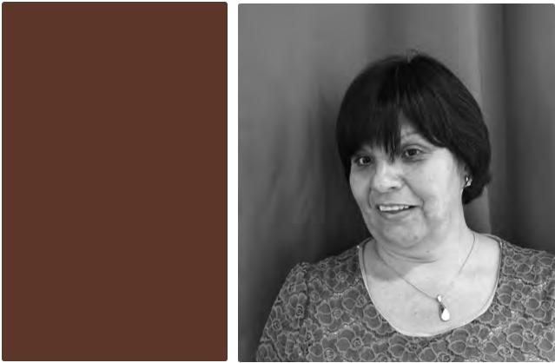
1

- Ileana Lucia Chacon, Women DPO, Costa Rica
- Monica Alexandra Cortes Aviles, AS Down, Columbia
- Lorraine Wapling, Member of the Technical Advisory Committee, UK

- Michael Szporluk, Member of the Technical Advisory Committee, US

- Everlyn Milanoi Koiyiet, Coalition of Violence against Women, Kenya
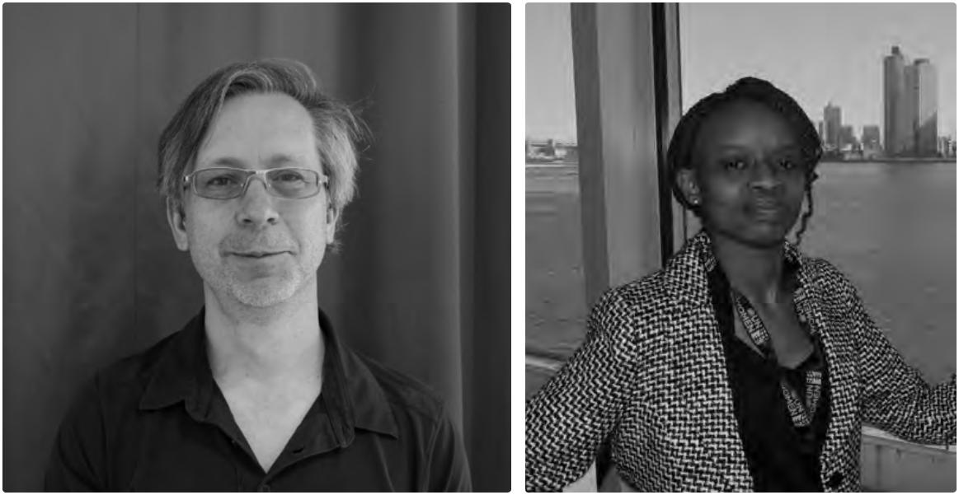

4 5
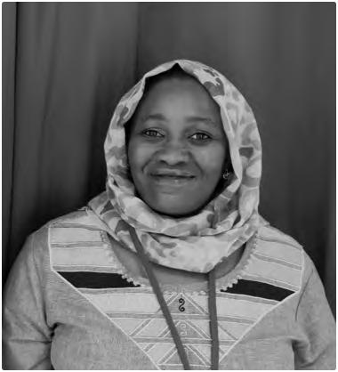
2
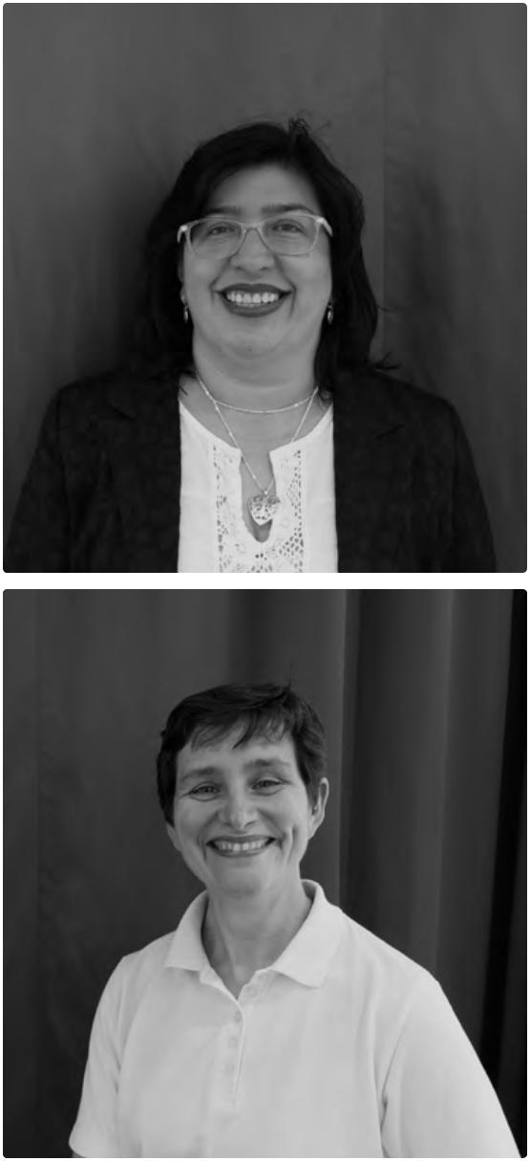

3

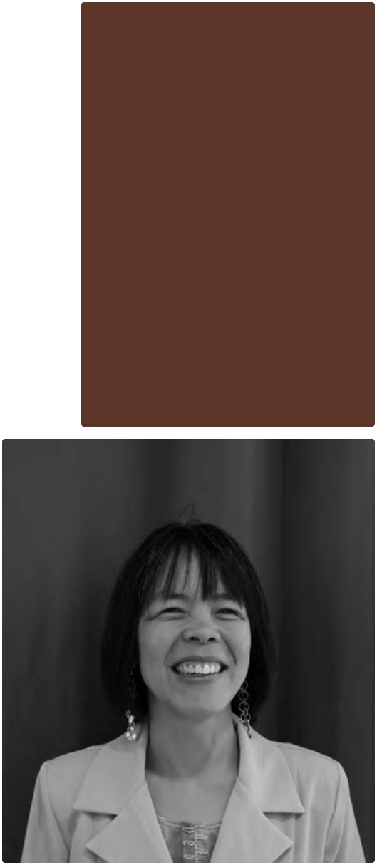

6 7

- Fatma Wangare, Kenyan Association of the Intellectually Handicapped, Kenya

- Silvia Quan,

member of the

CRPD committee

50 and of the Technical

Advisory Committee,

Guatemala

Conclusions

By Stephanie Ortoleva, President

of Women Enabled International, and

on behalf of the Technical Advisory

Committee

Rashida Manjoo, the former UN Special Rapporteur on Violence Against Women, has described the nature and scope of violence against women and girls with disabilities with powerful specificity. She notes that although women with disabilities experience many

of the same forms of violence all women experience, when gender and disability intersect, violence has unique causes, takes on unique forms, and results in unique consequences17.

To address the various elements of this problem the MIW Initiative was designed to ensure the voices of disabled women and girls are heard on how to respond to violence, abuse and exploitation throughout the world. The 11 good and emerging practices were presented during the Gender and Disability Forum held during the CRPD Conference

of States Parties in June 2015. Panelists shared their good practices with attendees, and these practices can be adapted to and implemented in different local and cultural situations to end this pervasive violence. The MIW initiative has informed us that program implementation can be initiated by women with and without disabilities in collaboration with a variety of actors, can engage through multiple and diverse mechanisms, and can address different aspects of the problem.

It is hoped that global actors involved in promoting non-violence can apply the recommendations from the good practice implementers to make their program designs and actions inclusive of women and girls with and without disabilities. The good practices show that it is not difficult to include and involve women and girls with disabilities in such programs.

The good practices have shown there are a few misconceptions regarding addressing violence against women and girls with disabilities:

As was shown by Ma’an in Israel and COVAW in Kenya, program staff can be trained to work with women and girls with disabilities. Both mainstream organizations had worked on ending violence against women, and their inclusion of women and girls with disabilities has allowed them to extend the reach of their work.

KAIH has shown that it is possible (and in fact necessary) to involve men and boys to educate others on the need to end gender-based violence. KAIH engaged young men in self-advocacy.

IRC and WRC have shown that it is possible to address violence against women and girls with disabilities in situations of conflict and natural disasters.

In fact, programs to end violence against women and girls with and without disabilities are successful only if a variety of actors are engaged, including:

Government agencies addressing the rights of women.

Government agencies addressing the rights of people with disabilities.

Organisations with women and/or men with disabilities in leadership.

Non-government organizations addressing the rights of women, especially anti-violence programs.

Non-government agencies addressing the rights of people with disabilities.

Individual parents and caregivers and their organizations.

Religious and cultural institutions. Partnerships between and among the above actors.

The eleven good practices highlighted in this report demonstrate that change can be achieved through a wide variety of spheres and mechanisms according to each implementor’s unique circumstances and capacities. Some specific examples include: Using international and regional legal

systems for advocacy by bringing

Conclusions.

51

Conclusions

individual or systemic claims to these mechanisms, submitting shadow reports to UN mechanisms, or other actions.

Using and influencing national legal systems for advocacy, including government programs and legislation.

Raising awareness of and educating those involved in the legal system regarding issues such as accessibility and alternative communication strategies, including for judges, prosecutors and police.

Educating and training health care providers to provide health care to women and girls with disabilities, to ensure facilities are accessible, to develop materials and information that is accessible and in plain language, as well as to identify signs of abuse and violence, and how to address them.

Engaging and educating the media and the general public on violence against women and girls with disabilities, using appropriate language, and using the media to highlight abuses.

Working with parents and guardians and their organizations on the rights of persons with disabilities, including their sexual and reproductive rights and the right to health.

Assisting and supporting women and girls with disabilities to create their own organizations and to take action themselves to address their rights concerning violence against them.

Educating women and girls with disabilities on their rights and strategies for action through the development and implementation of trainings and toolkits. Educating anti-sexual and gender-based violence program providers on the concerns of women and girls with disabilities and how to make their programs and facilities accessible to them.

Organizations and agencies can improve their work to prevent and eliminate violence against women and girls with disabilities by using the good practices as a guide for learning, and for designing disability inclusive public policies and laws. The partnership between the implementers of the good practices, the staff of Handicap International and the members of this project’s Technical Advisory Committee provides a model for action and collaboration. We welcome all opportunities for collaboration so that in the near future the incidence of violence against women and girls with disabilities will be reduced and hopefully eliminated worldwide.

52

By Manuel Patrouillard, General Director, Handicap International

When Handicap International developed the Making It Work methodology almost ten years ago we, together with our partners, wanted to respond to the needs expressed by a wide range of stakeholders to have firsthand information and evidence on how to implement the UN Convention on the Rights of Persons with Disabilities.

Since then, we tested and have been using the MIW methodology in more than 25 countries. We were successful in documenting good practices in a variety of areas, such as inclusive local governance in Western Africa, political participation and access to information in South East Asia, or access to justice in in Central America, to name a few. These practices and recommendations drawn from them are being used by different stakeholders to promote change through awareness-raising, advocacy or policy reform.

Within Handicap International, the MIW methodology helps us to draw from the wealth of existing successful examples to implement our mandate, working alongside people with disabilities to promote respect for persons with disabilities’ dignity and fundamental rights. MIW is essential for us to capture innovations that are relevant to our target groups, and promote these to accelerate change.

Confronted through our field actions to widespread discriminations against women and girls with disabilities, we felt a few years back that we had to go a step further. In 2014, we therefore designed this MIW initiative to ensure that women with disabilities lead the process of identifying and documenting good practices, and to create opportunities for grassroots’ experts to advocate themselves for better responses to violence through global policies.

The good practices of this MIW Initiative, collected for the first time through a global call, show the way forward on preventing, eliminating and responding to violence against women and girls with disabilities. They show how much can be achieved if women with disabilities are in leadership and empowered to address violence. Women with disabilities involved in this initiative together with Handicap International are already engaged in advocacy for further learning, replication or scaling-up of these successful examples. We hope this will contribute to reach the 5th Goal of Agenda 2030 on Gender Equality, without leaving women and girls with disabilities behind.


Yet these eleven good practices are just a start—too many women are still exposed to violence. As Handicap International, we wish to stimulate more action on gender and disability, and to expand the wealth of good practices and to recommendations inspire others to do more. In today’s world, data and evidence are essential to “make the invisible visible” and “leave no one behind”. Making it Work will continue to be a central component of the more proactive role that Handicap International aims to play in the coming years to facilitate the identification and sharing of knowledge and innovation to advance the rights of persons with disabilities.

Conclusions.

53

Annex—The Making it Work methodology in a nutshell

Introduction

The Making it Work (MIW) methodology is a set of tools to guide you through the process of identifying, documenting and analysing good practices that advance the rights enshrined in the United Nations Convention on the Rights of Persons with Disabilities (CRPD) and using this information to advance action for change. It is a method usable across sectors in development

and humanitarian action to explore most significant change as experienced by persons with disabilities. It was developed over the years by Handicap International, its partners and collaborators in projects using MIW.
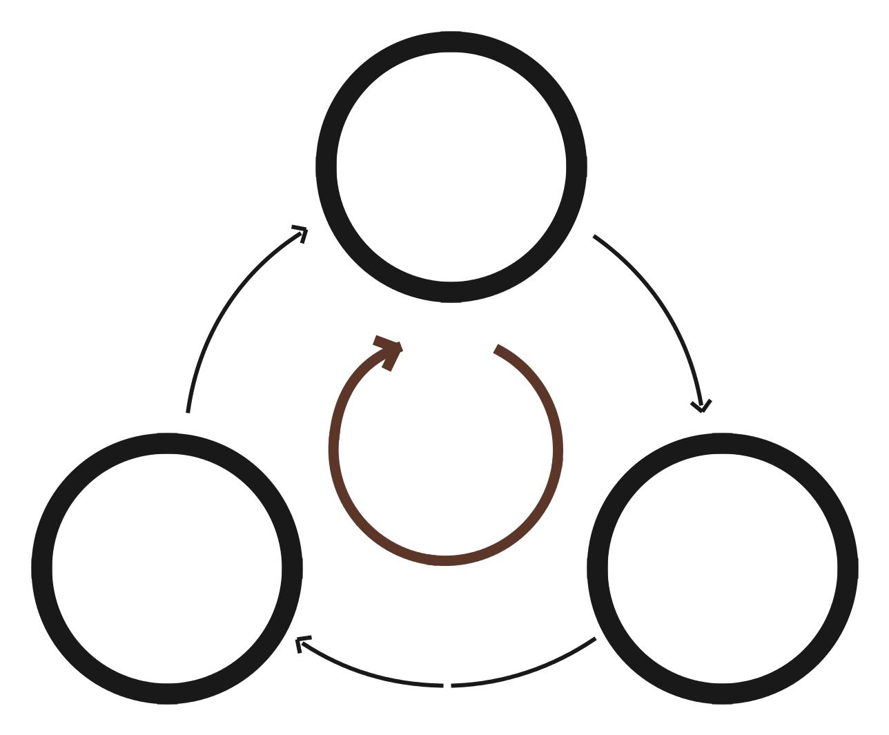

MIW encourages collaboration between key actors in which people with disabilities and their representative organisations play a central role. In the MIW process groups define the types of changes they want to see at public policy, services, community and/or legal level, the types of good practices needed
to influence these changes and then develop action to affect change accordingly.
Action to affect change includes advocacy, awareness raising, sensitization and/or knowledge transfer.

MIW aims to provide users with support through tools and guidance enabling them to increase, in the broader community, the impact of their work and other organizations’ work towards inclusive societies. It values civil society engagement, especially from people with disabilities, in promoting human rights for all, and helps to structure knowledge management and advocacy in simple steps.

Step 1

Building

multi-stakeholder

engagement and

agreeing on common

criteria for good

practice

 | People with
 | disabilities
Step 3 | co- or leading
Action for | Step 2
change, including | Collection, analysis
advocacy based | and documentation
on good practice | of good practices
evidence

54

Making it Work Methodology

Each step of the MIW process has its own tools to assist the practice and is captured in a guide 18.

Step 1—Establishing multi-stakeholder engagement

The tools used to establish multi-stakeholder engagement will guide you on how to select appropriate stakeholders to participate in your initiative. There is also a tool to help you establish clear roles using Terms of Reference (TOR) for a multi-stakeholder committee.

Step 2—Documenting and analysing good practices

The tools developed for this step guide you and the committee established in step 1 through the process of collecting information and providing a good practice template with interview questions. These tools also help to support teams in analysing good practices to draw up recommendations and produce a publication of the good practice, highlighting the factors that helped to achieve the most significant change as perceived by people with disabilities and other actors engaged.

It also highlights recommendations around replication or scaling up.

Step 3—Actions for change

These tools provide guidance and help generate ideas for activities to influence change, using your reports, based on the outcomes of step 2. The tools provide support on how to strategize and utilize the various ways of disseminating information. They also suggest ways of engaging with target groups.

What is a good practice in MIW?

When we talk about good practices, we mean practices that facilitated the “full and effective participation in society for people with disabilities on an equal basis with others” (CRPD, Preamble) and, actions that people with disabilities have confirmed as having a positive impact. Initiatives using MIW establish their own criteria to identify the practices

in a multi-stakeholder process. We propose standard criteria together with the general principles of the CRPD, providing a useful starting point to be adapted to each context:

- Demonstrable Impact: achieving clear changes and recording positive impact. The impact is not just validated by the organization, but also by partners and beneficiaries. We use testimonies to describe positive changes—in terms of quality of life, quality of services.

- Replicability: a specific action, approach or technique that could feasibly be replicated, adapted or scaled up in other contexts.

- Sustainability: potential for local actors to be able to develop or sustain this action, approach or technique in the future.
- Efficient: a practice which is efficient in terms of time, finances, human resources.

- Person centred: practices related to service provision which respect the concept of individual users being actively involved in any decisions that concern them.

- Conforming to the general principles of the CRPD (article 3):
Respect for inherent dignity, individual autonomy including the freedom to make one's own choices, and independence of persons;

Non-discrimination;

Full and effective participation and inclusion in society;

Respect for difference and acceptance of persons with disabilities as part of human diversity and humanity;

Equality of opportunity;

Accessibility;

Equality between men and women;

Respect for the evolving capacities of children with disabilities and respect for the rights of children with disabilities to preserve their identities.

Annex. 


55
Annex—The Making it Work methodology in a nutshell

What is the added value of Making it Work?

Making it Work is particularly useful and relevant to organisations and individuals wanting to influence change in the lives of people with disabilities and promote inclusion in accordance with CRPD principles.

 | Making it Work can be used as a tool for:
 | Learning: Sharing experiences and learning
 | across communities, countries and regions
 | are integral part of the approach. By using a
 | multi-stakeholder dynamic and a collective
 | review, organisations have an opportunity
 | to learn from experts as well as to bring
 | greater visibility of disability issues by
 | involving stakeholders from all sectors.
 | Collaboration: Making it Work requires
 | multi-stakeholder action whereby several
 | organisations work together to define,
 | select and validate good practices and
 | then use this knowledge for collective,
 | evidence-based action for change,
 | most commonly advocacy. Different
 | stakeholders include, but are not limited
 | to, DPOs, service providers, government
 | authorities, civil society organisations,
 | development organisations, human
 | rights entities and universities. The
 | collaborative approach helps to initiate
 | partnerships and alliances and supports
 | network building. More broadly, the MIW
 | online Good Practice Database provides a
 | global platform for sharing good practices
 | regarding disability-inclusive development.
 | This can reinforce and inspire collective
 | efforts on the CRPD.
 | Empowerment: Making it Work is a
 | specific platform to hear voices of people
 | with disabilities and their representative
 | organisations to say what has worked well
 | and how they think it could be replicated
 | or scaled-up. This is an empowering
 | process. It also gives them the opportunity
 | to analyse development practices and
 | formulate evidence-based claims or
 | recommendations to promote their rights.
56 | recommendations to promote their rights.

Evidence-based advocacy and action for change: This methodology can be used to influence change through advocacy or a wider range of actions, such as lobbying, awareness-raising, technical training, more long-term support, or mentoring. The good practices collected can provide evidence, credibility and qualitative information on the types of change that are desired. In other words, it enables people to explain why change is important and how it is possible.

Brief examples of other initiatives

It has been used by organisations in over

30 countries and has proven its worth as

a tool for change. Regional programmes, as

well as national projects and local initiatives

applied it. The methodology has been applied

to a range of topics, including water and

sanitation, health, communication, education,

employment, disaster risk-reduction,

land-mine action, rehabilitation and local

governance.

Notes

1. In his 2006 In-Depth Study on All Forms of Violence against Women, the Secretary-General observed that surveys conducted in Europe, North America and Australia have shown that over half of women with disabilities have experienced physical abuse, compared to one third of non-disabled women. A/61/122/ Add.1, para. 152, Citing to Human Rights Watch, “Women and girls with disabilities”, available at: http://hrw.org/women/disabled.html

2. UN Habitat, The rights to adequate housing for persons with disabilities living in cities, available at: http://unhabitat.org/books/the-right-to-adequate-housing-for-persons-with-disabilities-living-in-cities

3. Country of residence of applying organization and/or country where practice was implemented.
4. Emerging Practice.

5. Please refer to annex to know more about the Making It Work methodology.

6. https://www.youtube.com/ watch?v=5KU5xHZK8VQ
7. Women Enabled International and Center for Reproductive Rights, Submission to the United Nations Universal Periodic Review (September 13, 2014), citing Matthew Brault, Americans with Disabilities: 2010, U.S. Census Bureau, Current Population Reports, pg. 12 (July 2012), available at www.census.gov/prod/2012pubs/ p70-131.pdf [hereinafter Americans with Disabilities 2010].

8. Women Enabled International and Center for Reproductive Rights, Submission to the United Nations Universal Periodic Review by (September 13, 2014), citing U. S. Dep’t of Labor, Women, Office of Disability Employment Pol’y, available at http://www.dol.gov/odep/topics/ women.htm

9. | Based on 2010 data, 18.4% of
 | women with severe disabilities and
 | 11.7% of women with non-severe
 | disabilities have less than a high
 | school diploma compared to just
 | 8.8% of non-disabled women 25 and
 | older; 13.5% of women with severe
 | disabilities have a Bachelor’s degree
 | or higher compared to 34.1% of
 | non-disabled women. Americans with
 | Disabilities 2010, supra note 1 at 22.
10. | Women Enabled International
 | and Center for Reproductive
 | Rights, Submission to the United
 | Nations Universal Periodic Review
 | (September 13, 2014), citing U.S.
 | Dep’t of State & USAID, United
 | States Strategy to Prevent and
 | Respond to Gender-based Violence
 | Globally, 7 (Aug. 10, 2012), available
 | at http://www.state.gov/documents/
 | organization/196468.pdf (noting
 | that “[w]omen with a disability are
 | two to three times more likely to
 | suffer physical and sexual abuse
 | than women with no disability”);
 | see also Special Rapporteur on
 | Violence against Women, its Causes
 | and Consequences, Report of the
 | Special Rapporteur on Violence
 | against Women, its Causes and
 | Consequences, paras. 31–32, U.N.
 | Doc. A/67/227 (Aug. 3, 2012)
 | (by Rashida Manjoo).
11. | This has been reported by women with
 | disabilities to Disability Rights Fund
 | (DRF) program staff in many countries
 | where DRF works including Uganda,
 | Haiti, Bangladesh and Indonesia.
12. | Spanish acronym.
13. | Emerging Practice.
14. | UNCHR Burundi Factsheet, October
 | 2014.
15. | VSLAs are self-selected groups of
 | women created to increase savings
 | opportunities and access to economic
 | resources. Participants contribute to
 | a savings fund on a weekly basis and
 | then cash out with interest after 8–12
 |  |  |  |  | Notes.
 | months. During the cycle, participants
 | can take loans from the savings that |  |  |  | 57
Notes Credits

must be paid back within an agreed upon time-frame.
16. https://www.rescue.org/sites/default/ files/resource-file/Burundi%20 EASE%20Imact%20Eval%20 Formatted%20Final.pdf

17. Report of the Special Rapporteur on violence against women, its causes and consequences, Rashida Manjoo, Report on violence against women with disabilities, A/67/227 3 August 2012, available at: http://www.un.org/ ga/search/view_doc.asp?symbol=A %2F67%2F227+&Submit=Search& Lang=E

18. Making it Work: Good practices for disability-inclusive development and humanitarian action. Handicap International, 2015. Available at: http://www.hiproweb.org/uploads/ tx_hidrtdocs/MIWGuidelines_PG17.pdf

Photo credits

Cover: © Ulrike Last/Handicap International (Survivor of violence with Agnes Mutuku, the Director of Kibwezi DPO from Kenya, working in collaboration with the INGO Advantage Africa to end violence against women with disabilities in and around Kibwezi, in Kenya, 2015)

Page 12: Ulrike Last/Handicap International (2015)
Page 50: Ulrike Last/Handicap International (2015)

Editor

Handicap International Federation 138, avenue des Frères Lumière CS 88379

69371 Lyon Cedex 08

France

publications@handicap-international.org

Printing

NEVELLAND

GRAPHICS c.v.b.a. — s.o

Industriepark-drongen 21

9031 Gent

Belgium

Imprint in December 2015

Registration of copyright: December 2015

58




Making it Work initiative on gender and disability

inclusion: Advancing equity for women and girls

with disabilities

In May 2014, the MIW Gender and Disability Technical Advisory Committee launched an international call for good practices which have successfully addressed or shown progress in preventing, eliminating or responding to violence, exploitation and abuse against women and girls with disabilities.

Ten good practices and one emerging practice have been selected based on their potential to raise awareness, inform global advocacy initiatives, and build the capacity of women and girls with and without disabilities, their organizations and womens’ rights organisations across South, Central, and North America as well as Asia, the Middle East and Africa.

According to the main issues addressed by the local

and grassroots organizations, their practices are grouped around three broad themes:
- Legal advocacy and policy change;

- Awareness raising;

- Empowerment.

This report presents the key findings of this initiative

according to those three themes.

HANDICAP INTERNATIONAL FEDERATION

138, avenue des Frères Lumière

CS 88379

69371 Lyon cedex 08

France

T. +33 (0) 4 78 69 79 79

F. +33 (0) 4 78 69 79 94

publications@handicap-international.org

