“MAKING IT WORK!” Good Practice case study

How autonomy and self-empowerment of persons with disabilities is enabled through psycho-social activities initiated by the association of persons with disabilities?

Title: Psycho-social support group of youth with disabilities.
Organisation/project: Tibet Association of Persons with Physical Disabilities
Location: Lhasa, TAR - CHINA
Scope: Local

Related articles of the CRPD
This practice relates to article 6, 19, 29, 30 concerning women with disabilities; living independently and being included in the community; participation in political and public life; participation in cultural life, recreation, leisure and sport.

Related article of the China National Law of the Protection of Persons with Disabilities (2008)
This practice relates to :
Article 7 “(…) self-management organizations in urban and rural communities should perform their respective functions on disability. ”
Article 8 “ (…) local organizations shall represent the common interests of persons with disabilities, protect their lawful rights and interests, unite persons with disabilities and enhance education among them and provide service for them.”
Article 10 “ The State encourages persons with disabilities to have a sense of self-respect, self-confidence, self-strength and self-reliance, and make contribution to socialist development.”
Article 44 “ The government and society shall encourage and assist persons with disabilities to engage in literature, art, education, science, technology and other creative work beneficial to the people.”
Article 45 “The government and society shall promote mutual understanding and exchanges between persons with disabilities and their fellow-citizens, publicize the work on disability and deeds of assisting persons with disabilities, advocate self-accomplishment among people with disabilities, and foster a social environment of unity, friendship and mutual help.”

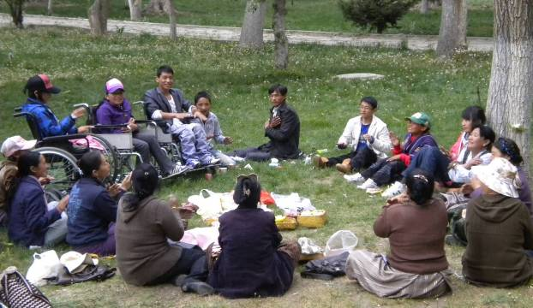 | SELF-CONFIDENCE  EQUAL  OPPORTUNITY  PARTICIPATION SELF-EMPOWERMENT SOCIAL MODEL OF DISABILITY
Self-support group gathering | Key words

Background and context
In Tibet, religious beliefs around disability are very strong. People believe that impairments are the result of bad deeds in previous lives. As a consequence, persons with disabilities tend to be stigmatised and do not have self-confidence. In parallel, Buddhism encourages people to be as good and compassionate as possible toward vulnerable persons. The general population is generally helpful to persons with disabilities and families tend to over-protect persons with disabilities.

Description of the practice
The Tibet Association of Persons with Physical disabilities was activated in 2010, with the mandate to empower the persons with physical disabilities in the Tibet Autonomous Region. The key objectives are to provide guidance and support to access to education and livelihood opportunities for persons with physical disabilities, to raise the public awareness on the rights of persons with disabilities, and to lobby and advocate decision making instances to improve the situation of persons with physical disabilities and laws enforcement. During the first year, the organisation started to implement some activities and a need assessment was conducted among all the association members. The goal was to assess the barriers, needs and demands for the persons with disabilities. One of the key findings of the survey was that most of the members, in particular women, view themselves as less worth than other persons.

A service was set up by the association to answer to this need: the Sunday Club was initiated with the objective to develop the self-esteem and contribute to the empowerment of association members. The concept of the service is that members are sharing their concern and identifying solutions together. The action plan was developed in a participatory manner, with most of the actions specifically aiming at improving the self-confidence and boosting members self-concept to accept themselves as they are. The emphasis is put on viewing disability as one component of the life, but not the only component. Another issue for the members was to better deal with discrimination and stereotypes from society. Main actions initiated by the service are :
- Sharing sessions: members expose their concerns and problems, the group try to identify solutions when possible.
- Motivation speech of outstanding persons with or without disabilities from the community once a month.
- Discussions around movies speaking about disabilities: developing concept of how people with disabilities in other cultures and countries have overcame some barriers.
- Gathering in public places in large group (café, cinema, library, and museum) to demonstrate the barriers faced to access public facilities.
- Sessions on positive attitude to work (body language, personal grooming)
- Training on the disability models, disability laws and disability rights.
- Inter-active sessions on health education, including reproductive health and HIV/AIDs prevention
- Motivation sessions: people are encouraged to speak about themselves are described all the positive aspects about themselves.
- Women empowerment sessions: specific issues faced by women are shared and discussed.
- Communication skills : English and Chinese language

Process involved
- Association members have expressed their needs and developed a participatory action plan.
- An additional staff, a woman with disability with good self-confidence and facilitation skills, was employed full time at the association to coordinate the Sunday psycho-social activities.
- Activities above mentioned are conducted on a weekly base with an average of 30 participants.
- Outings in public places are planed on a monthly base.
- Service quality is evaluated on an annual basis to assess service-users’ level of satisfaction.
- A monthly newsletter is produced by the service users to share and promote their actions toward community and local authorities.

Resources required
  - 2 staff from the Tibet Association of Persons with Physical Disabilities to coordinate the activities and regular gatherings.
  - Volunteers teachers for Chinese, English and motivation sessions.
  - Budget allocated by the Support to Disabled Persons Organisations project –Handicap International in partnership with the TAR Disabled Persons’ Federation.

The factors that made this practice possible
- Facilitation and close guidance from Handicap International at the start.
- Strong commitment of Tibet Association of Persons with Physical Disabilities operational staff
- Use of social media and micro-blogging to rapidly inform and federate all the service users.
- Recognition from the local authorities and progressive handover to the Tibet Disabled Persons’ Federation to support general coordination and activity funding.

Some of the difficulties encountered
- Initially, the activity faced some resistance from some parents and care takers, worried about the security of persons with disabilities with limited mobility and possible traffic accidents.
- Meetings were organized to explain the association role and the possible benefits their family members could get from attending the services.

The effects / impact of the practice
  - In less than 2 years, most of members have visibly developed their autonomy and confidence. Association members are more willing to speak up and meet the local authorities to expose their problems. The society powerfully influences persons with disabilities concept about themselves.
  - The work of the association give the members the chance to re-evaluate their self-concept and re-shape their own identities to reflect what they believe is more accurate. Most of the members have a more open personality and are better dealing with their disability and peoples' attitudes toward disability.
  - As a consequence, the local community has become more aware of the capacity of persons with disabilities.

Possible improvement
- Due to the geographical setting and other reasons, people in TAR tend to be isolated from the rest of the world. They wish to be more expose to new models, possible actions in the field of disability and to have more exchanges with persons with disabilities and their representatives organisations’ around the world.
- Field trips and public actions should be developed to give more visibility to persons with disabilities and develop their role as active citizen.
- Building and developing relationships and partnerships with other key Government departments can support the promotion of this practice.
- The association is also planning to develop sports activities, known to have a positive impact on the development of the confidence of persons with disabilities.

Recommendations for the replication of this practice
- Activity should start with a small group of motivated people and try to expand progressively.
- Association staff should be trained in counseling and listening skills, and have a high level of motivation and be able to build up a good group dynamic.
- Patience toward members is necessary, many of them have undergone trauma and need time to develop their self-confidence.
- Parents and family members should be well informed about the activities objective and possible benefit for persons with disabilities on the long run.

More information

Drolma Lazorn, Tibetan Association of Persons with Physical Disabilities drolmalazorn@ymail.com
Kalsang Lamo, Support to DPOs Project Manager TAR.dpopm@handicap-int.org.cn
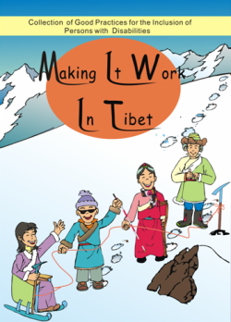

Full project report: Collection of good practices for the inclusion of people with disabilities

Criteria for the good practices: see page 8 (Part 1 of the report)

Recommendations from the good practices: Part 3 of the report

