

Good Practice case study

How can Disabled People’s Organisations participate in civil society movements and ensure disability issues are included in decision-making processes?

Relevant articles of the CRPD: 29
Country: Republic of Benin
Region: West Africa
Languages available: English, French

Participation of the Savalouase Association of People with Motor Disabilities in the Social Watch of Savalou

Description of the practice and the process involved

Savalou is a municipality located in central-western Benin, in the Département des Collines, 218 km from Cotonou. It has about 104,745 inhabitants.
In this locality, where tradition is very strong, people with disabilities are considered as «Tohossou», which means «fetishes» in the local language. They face discrimination, marginalization and a lack of social support.
As a result, the Savalouase Association of People with Motor Disabilities (ASHAM) has emerged with the aim of promoting the rights of persons with disabilities through awareness raising and theatre. ASHAM has always wanted to ensure that people with disabilities regain their dignity and participate fully in the social, cultural, economic and political life of their environment.

In 2007, the City of Savalou invited all NGOs working in the area to attend a meeting to establish a platform for local civil society organizations. Sixteen NGOs responded to the invitation, including the Savalouase Association of People with Motor Disabilities.
The platform in question was the local branch of Social Watch, an international network of citizen organizations. Social Watch holds governments, the UN system and international organizations accountable for the fulfillment of national, regional and international commitments to eradicate poverty.
At the meeting for the establishment of the local branch of Social Watch Benin and the election of the coordination officers, the President of the Savalouase Association of People with Motor Disabilitiesn (ASHAM) was elected to the position of Rapporteur of the Social Watch branch of Savalou. Since then, Social Watch sits in on almost all the sessions of the council, and a disabled person is in charge of reporting back on the meetings.

The factors that made this practice possible

The reputation and dynamism of ASHAM was confirmed during the discussion of local development issues and was decisive in obtaining this position. ASHAM, which works with people with disabilities and also with women’s groups, has managed to gain the attention and the respect of the people of Savalou.

Some of the difficulties encountered

No major difficulties were encountered in the implementation of this practice, since ASHAM is regarded highly at the local level. Even local authorities have strongly supported the candidacy of ASHAM because they knew how dynamic it was and how it could contribute to the development of the locality.
However, there was some hesitation within ASHAM and debates on the actual capacity of the organization to assume such an important role as Rapporteur for the local branch of Social Watch.

The effects / impact of the practice

- The participation of ASHAM in the local civil society platform has allowed people with disabilities to contribute to debate and decision-making on development issues in the municipality of Savalou. Through this participation, all the members of Social Watch and of the municipal council have become familiar with disability issues.
- Particular attention was paid to the needs of people with disabilities and concrete actions were developed. Thus, Social Watch organized training for people with disabilities on various issues, for example the means of preventing common diseases. People with disabilities have also received support from another project regarding the establishment of small stores.
- The participation of Social Watch has allowed some members of ASHAM to receive training in agro-pastoral techniques, management and simplified accounting for income-generating activities, and hygiene and sanitation. They have also received credits to start their activities.
- Being in this social network has enabled the association of people with disabilities to establish links with various development stakeholders at the local, national and international levels.

Related articles of the CRPD

The involvement of the Savalouase Association of People with Motor Disabilities in the civil society platform of Savalou reflects the principles of Articles 29 of the Convention on the political participation of people with disabilities, so that they can be fully integrated into the civil society movement and fight for their needs to be taken into account just like those of other citizens.

For more information, contact:

Paulin Gbaguidi, President of ASHAM and Rapporteur of Social WATCH
E-mail: gbafap@yahoo.fr.
Denami Dieudonné, ASHAM Administrative Manager
Tel: 00 229 95 46 76 45.

Background and context
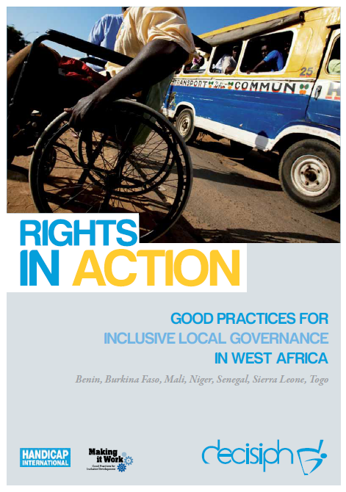
Full project report: Rights in Action – Good Practices for Local Inclusive Governance in West Africa (Handicap International 2010)

Criteria for the good practices: see pages 43-44 of the full report.

Recommendations from the good practices: see pages 98-111 of the full report.

Links to further resources:
Full text on CRPD article 29

